**Attendance Management System**

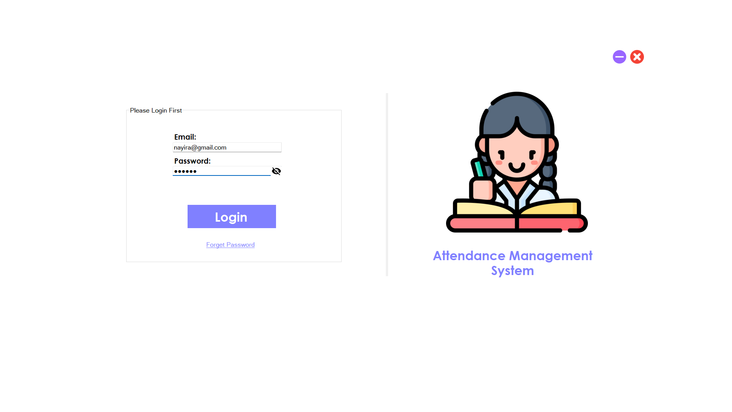

**Done By:**

**Mohamed Selmy**

**Nada Atef**

**Nayira Talaat Top of Form**

Table of Contents

Introduction 3

Login 3

Admin Dashboard 3

1. Dashboard: 3

2. Add New Student, Class, or Teacher: 4

3. Generate Report: 5

4. Edit Student, Class, Teacher: 6

5. Save and Load: 7

6. Search: 8

7. Language Setting: 8

Teacher 10

1. Take Attendance 10

2. Generate Report 11

3. Edit Password 11

4. Search 12

5. Change Language 13

Student 14

1. Dashboard 14

2. Generate Report 15

3. Change Language 15

Conclusion 16

**Attendance Documentation System Guide**

# Introduction

The Attendance Documentation System is designed to track the attendance of users in various educational settings, providing administrators, teachers, and students with efficient tools for managing attendance records.

# Login

Users start the application by opening the login form where they enter their email and password. Upon successful authentication, users are directed to their respective dashboards based on their roles.



# Admin Dashboard

## **Dashboard**:

View an overview of system statistics and the students that need warning

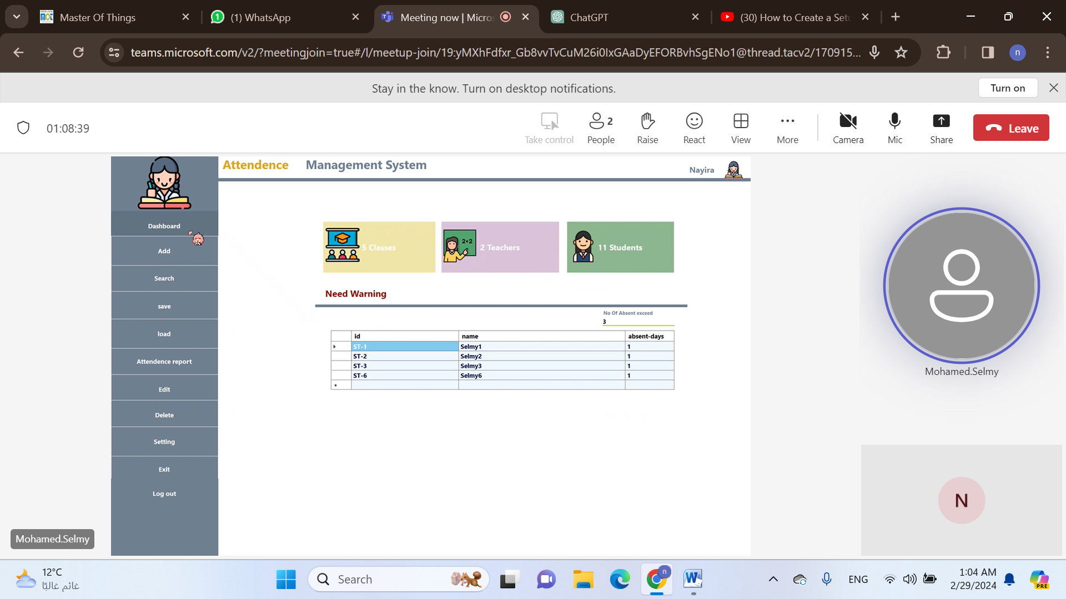

## Add New Student, Class, or Teacher:

The admin has the ability to add new students, classes, and teachers., where he can assign classes to students and teachers during creation.

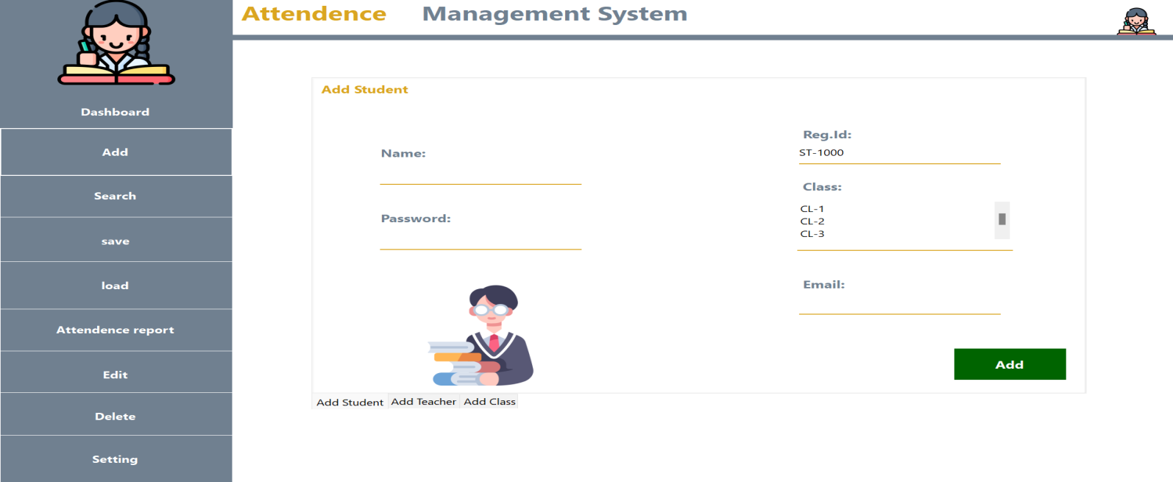

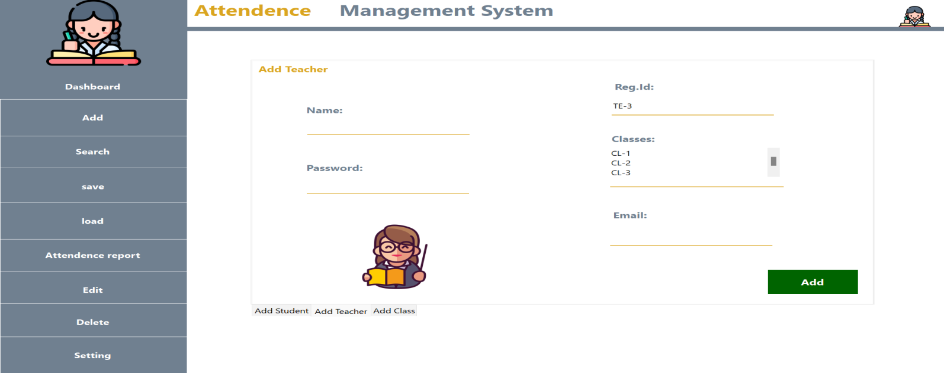

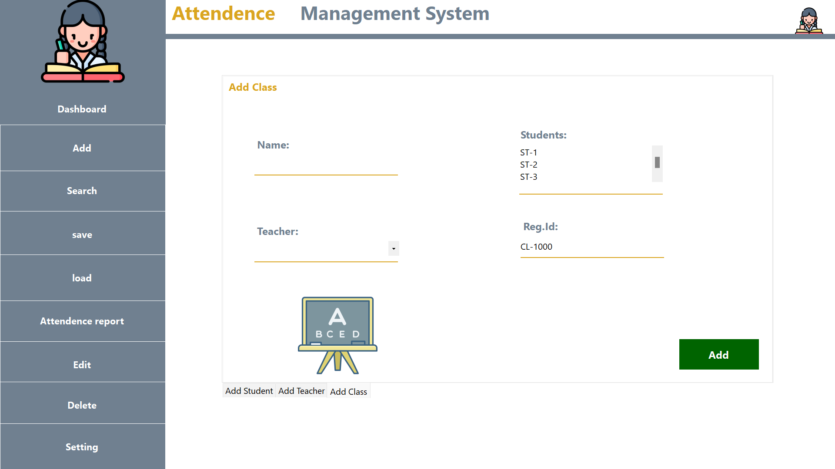

## Generate Report:

The admin can generate attendance reports for specific date ranges, students, or classes, where it Filter reports based on date range, specific students, or classes. Where those reports could be extracted as PDF or Excel

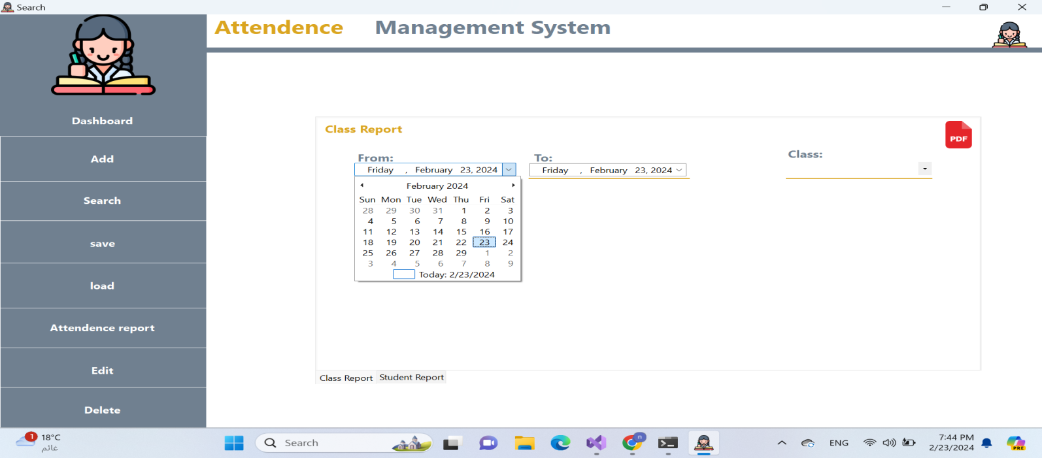

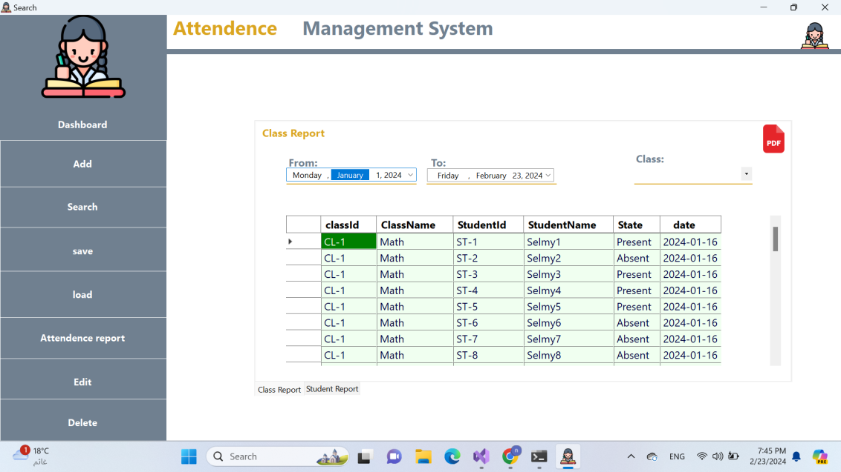 generated PDF

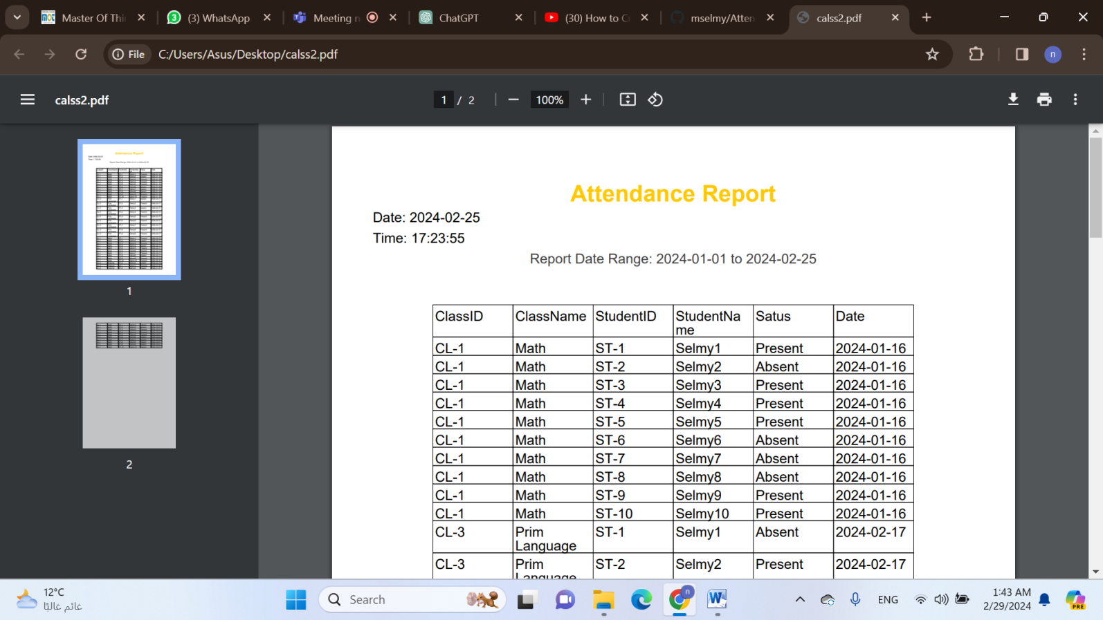

## Edit Student, Class, Teacher:

The Admin can Modify existing student, class, or teacher information. Where he can Update details such as names, IDs, or assigned classes.

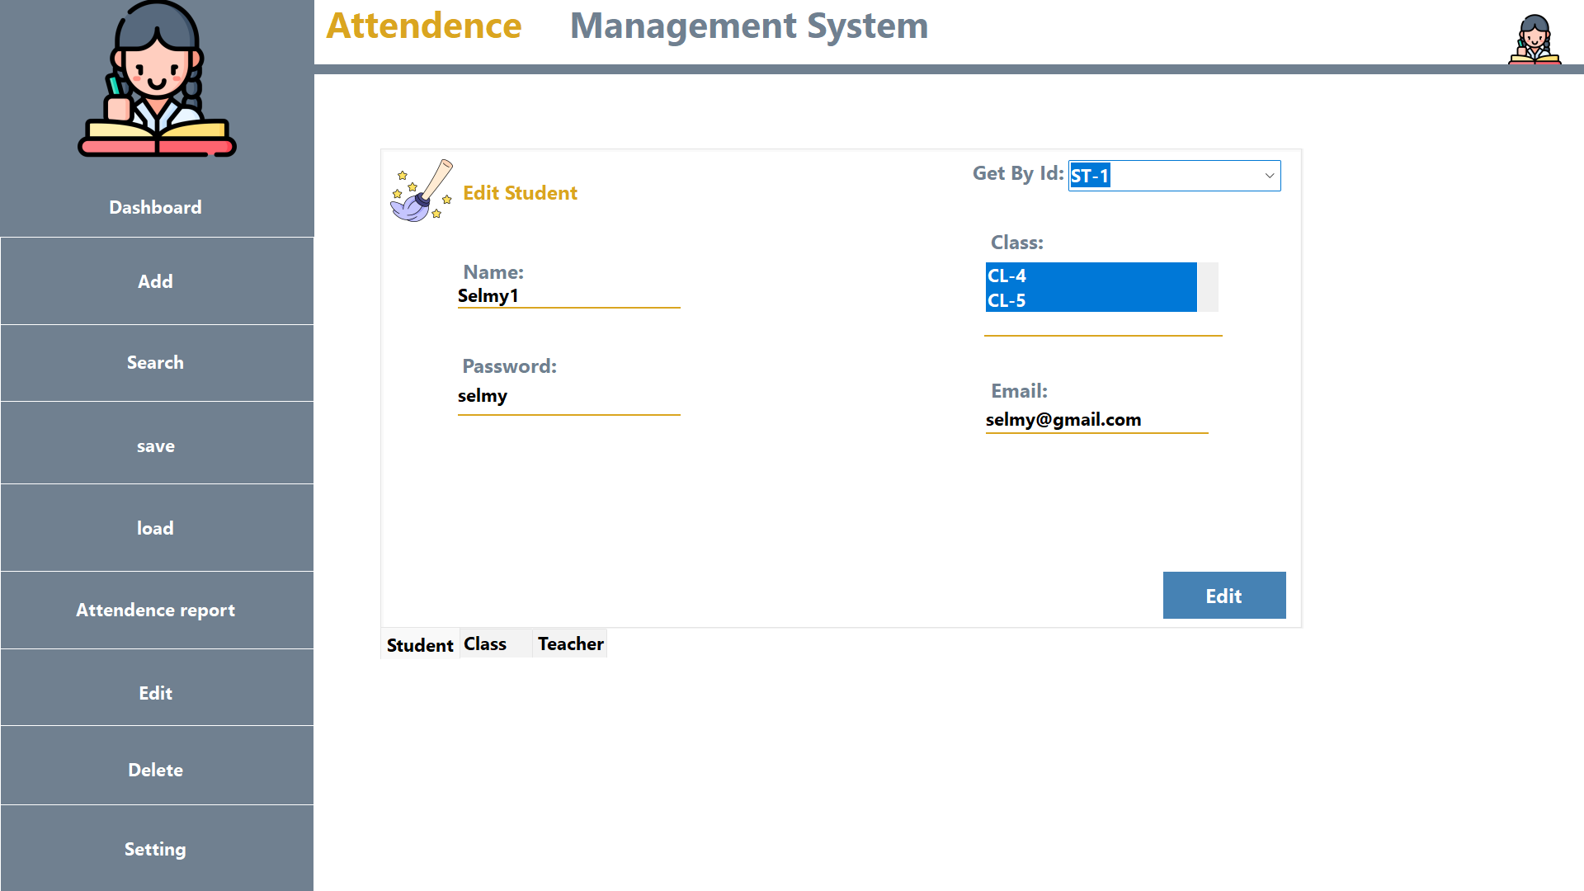

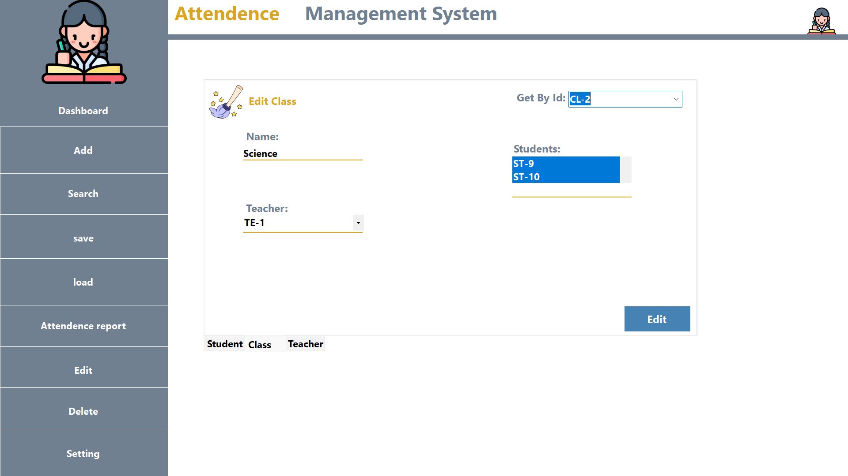

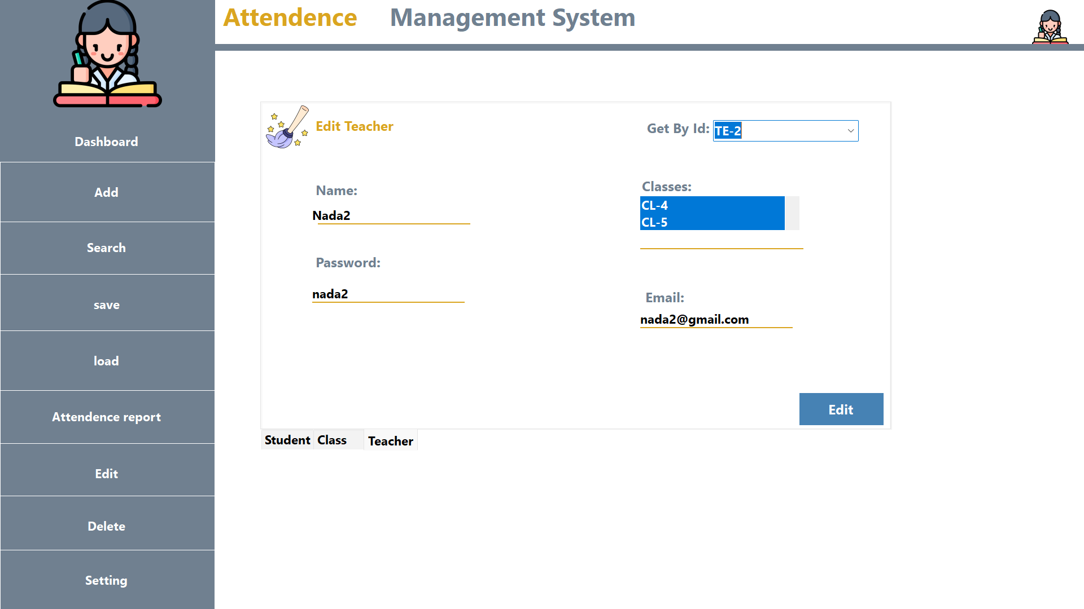

## Save and Load:

Enable the Admin to Save and load attendance data to ensure data persistence.

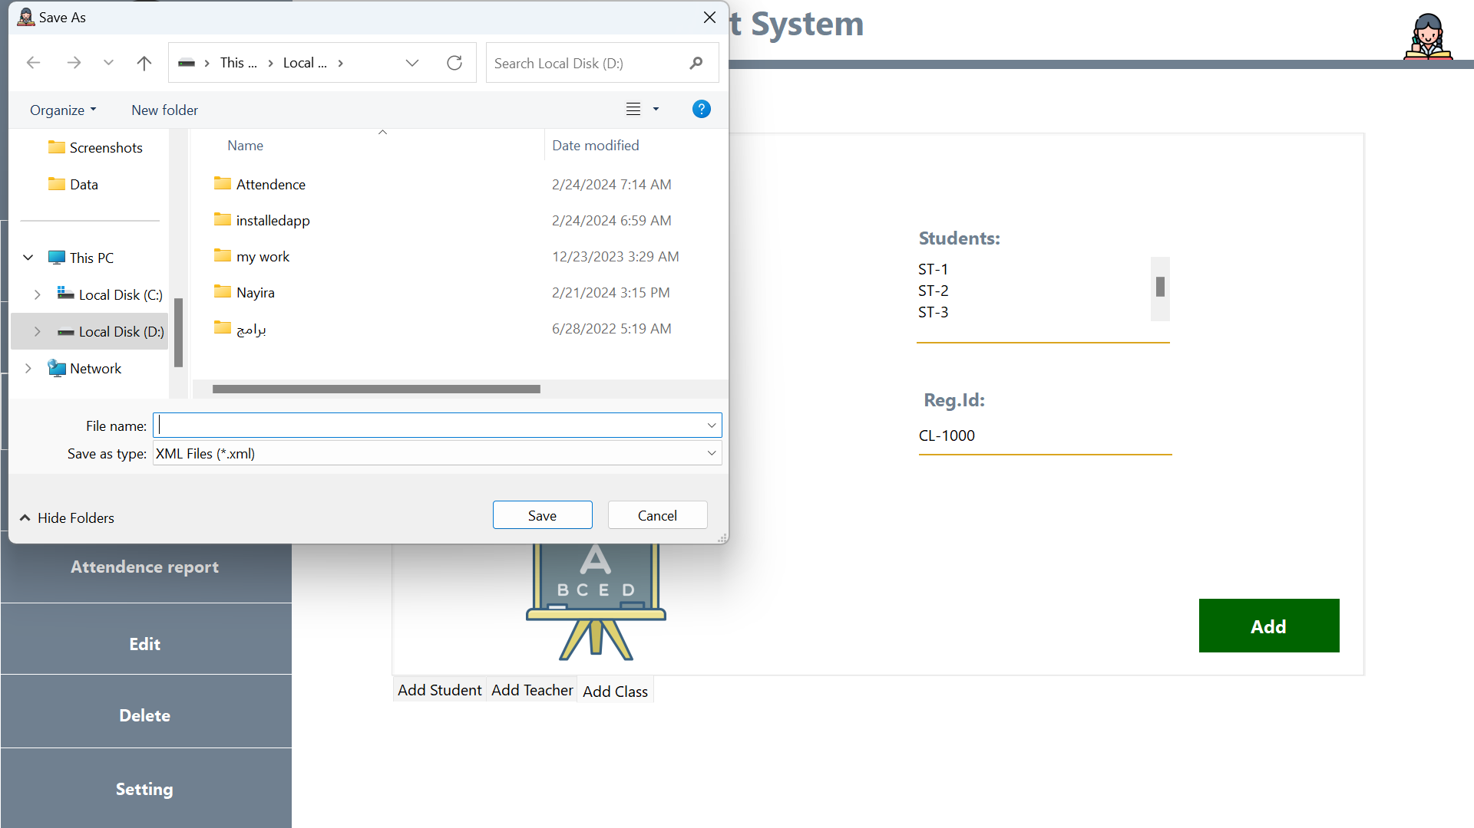

## Search:

Admin could Search for specific student, class, or teacher entries.

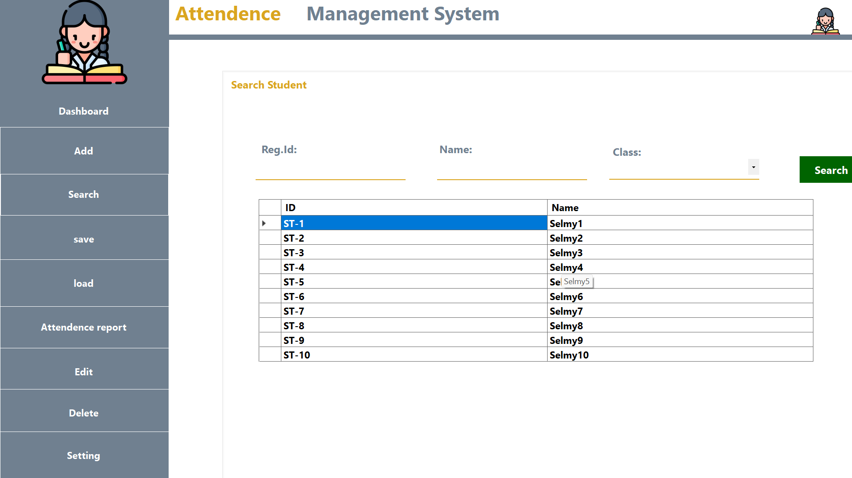

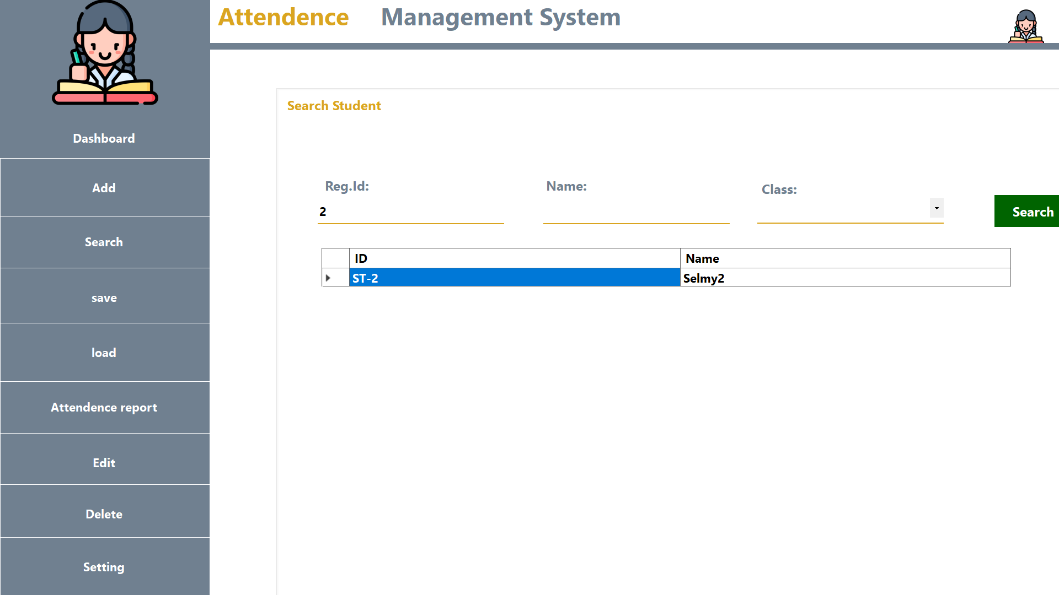

## Language Setting:

Change the language setting of the system interface.

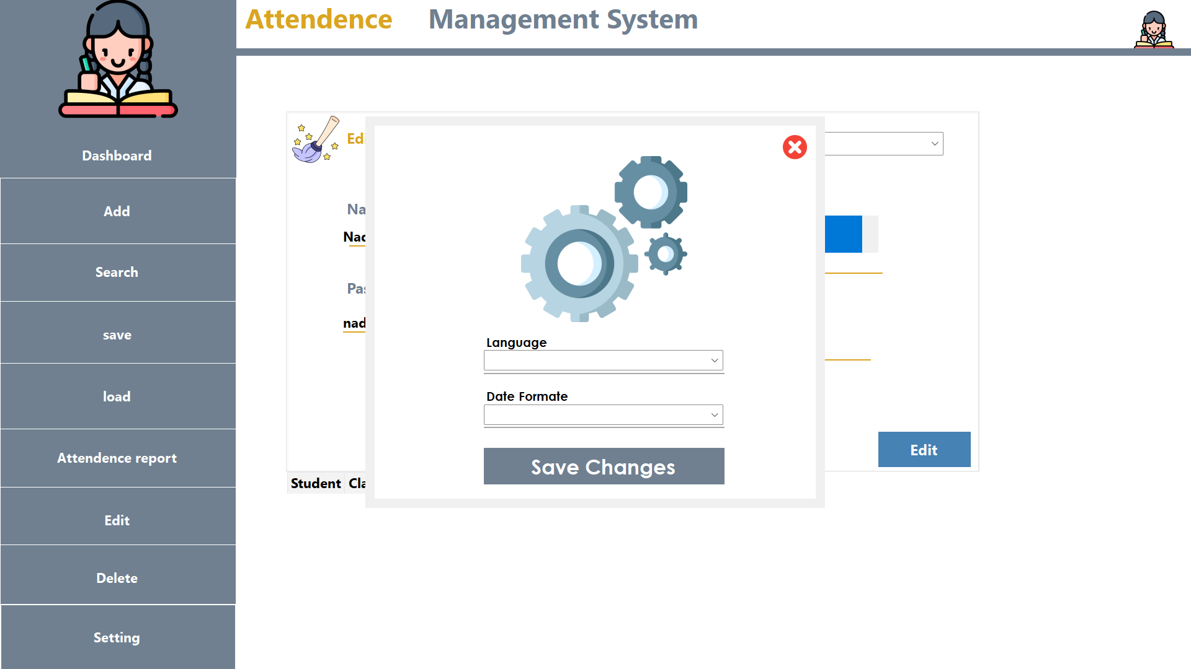

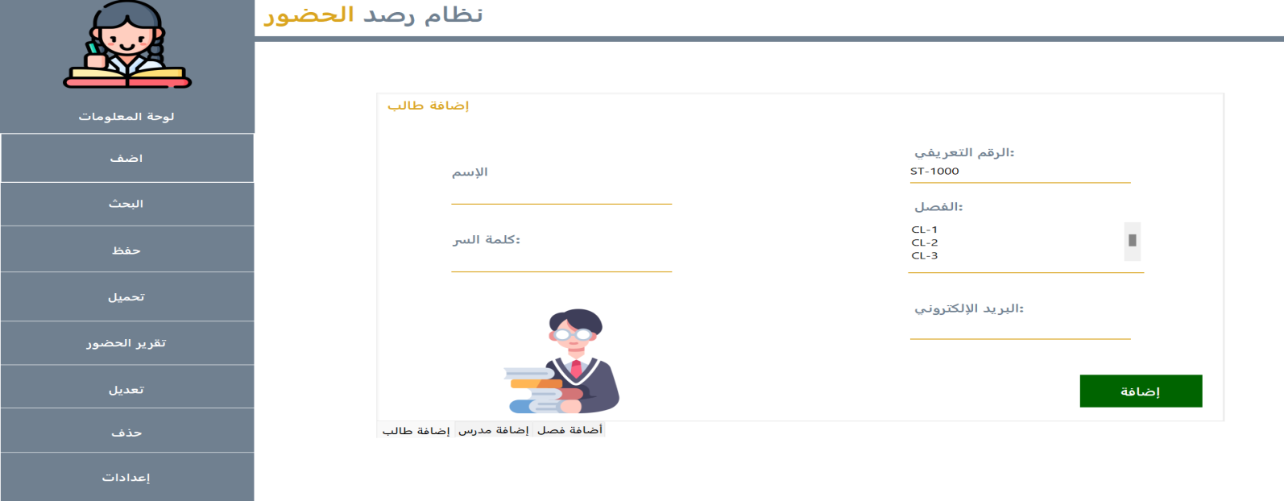

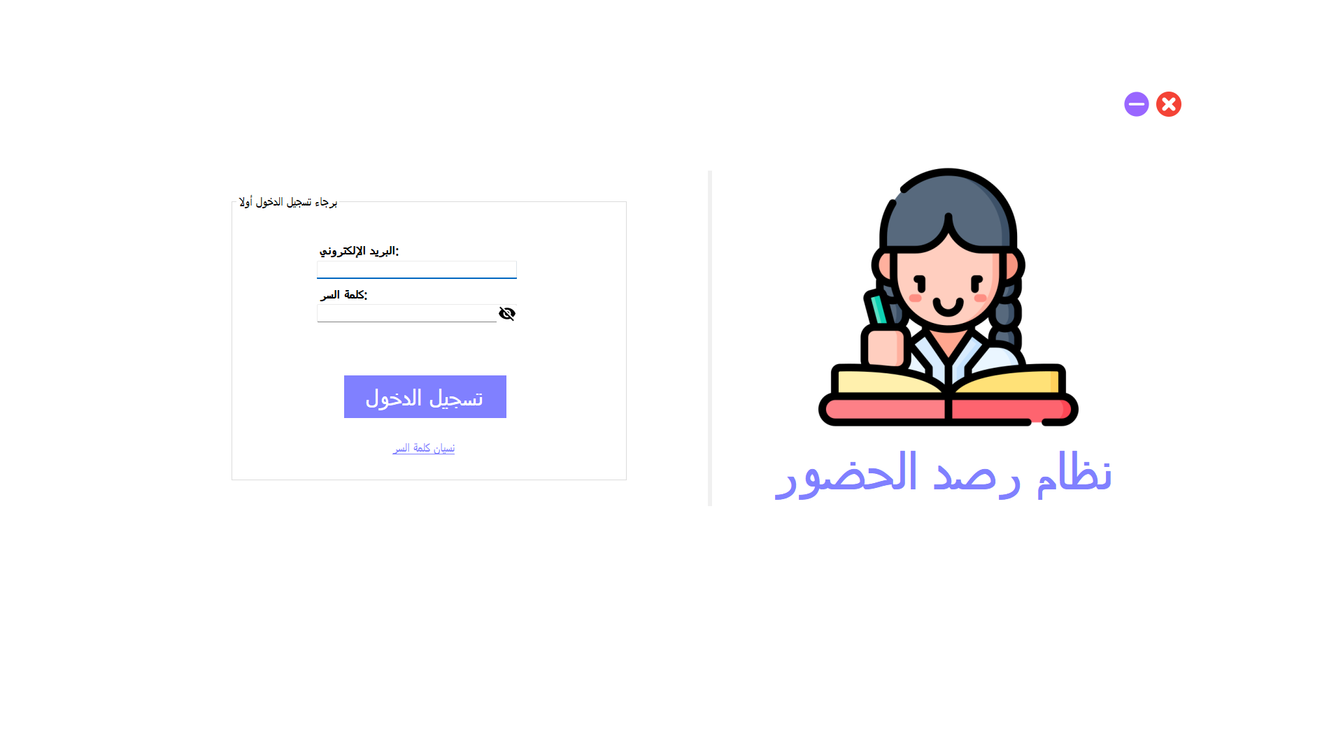

# 

# Teacher

## Take **Attendance**

**Teacher can** Record attendance for assigned classes. Mark students as present, absent, or tardy.

Capture attendance data for specific dates and classes.

Take a new attendance record

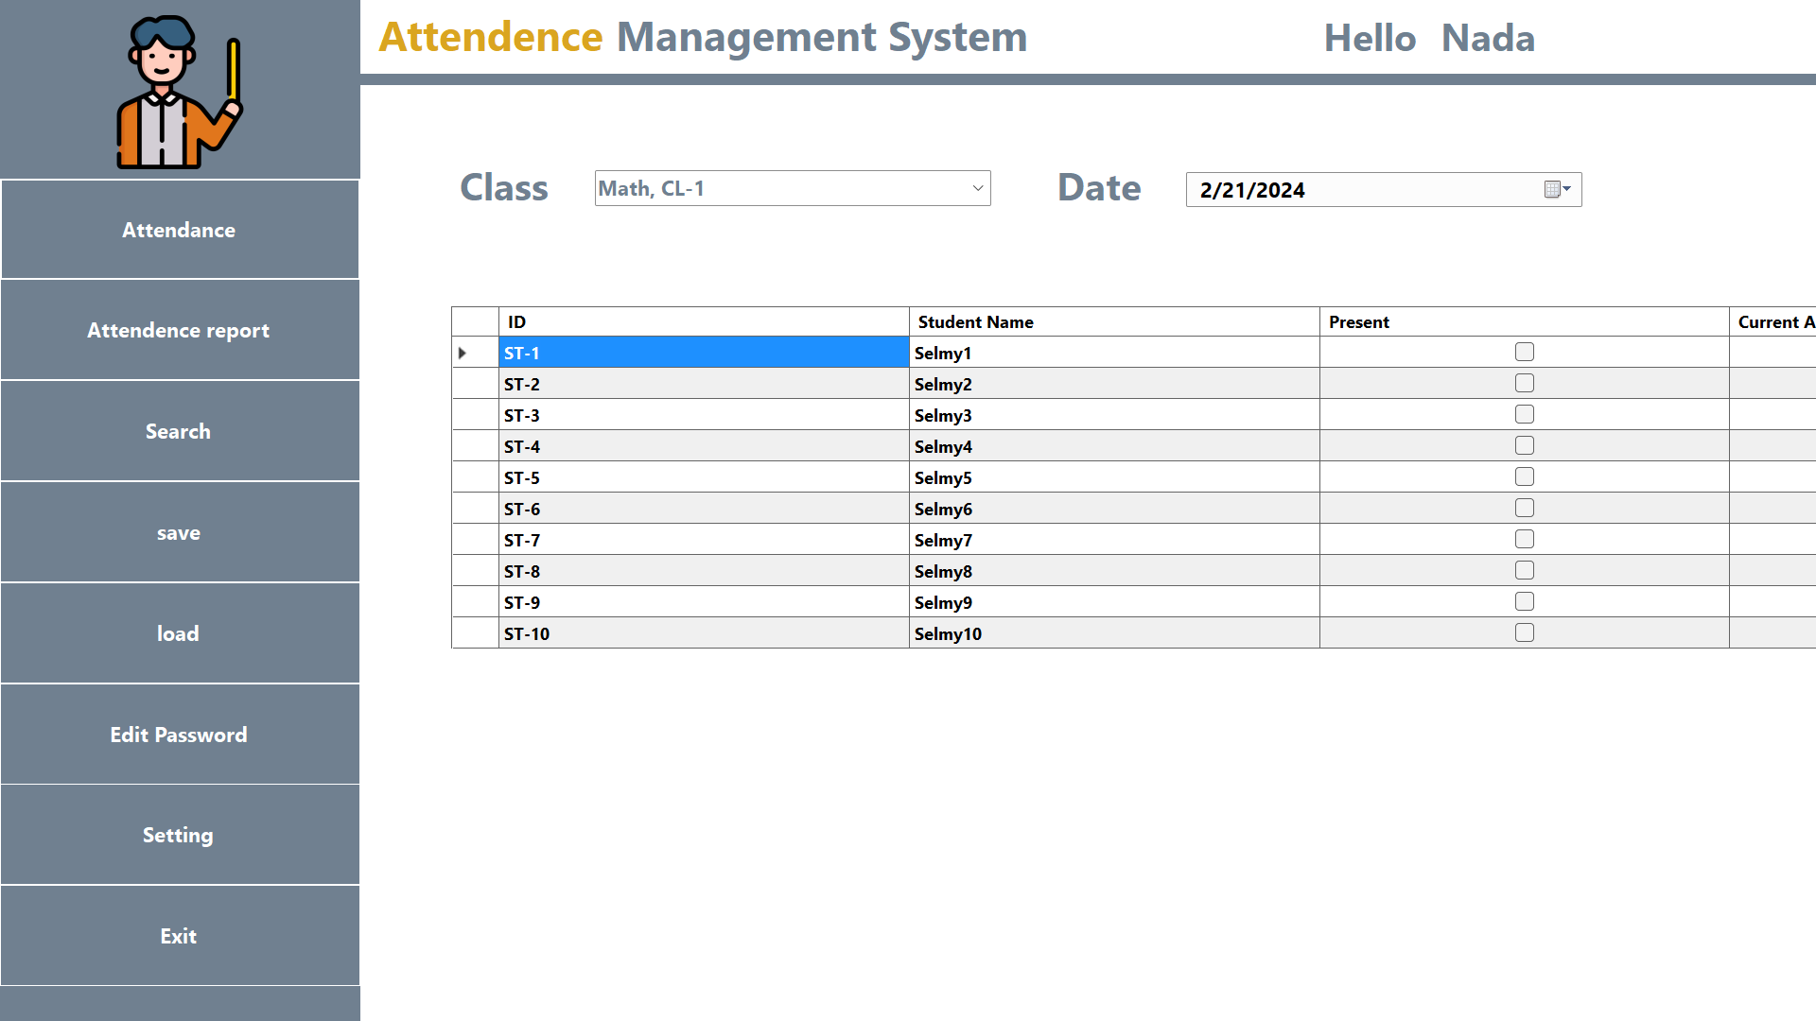

Or modify existing one

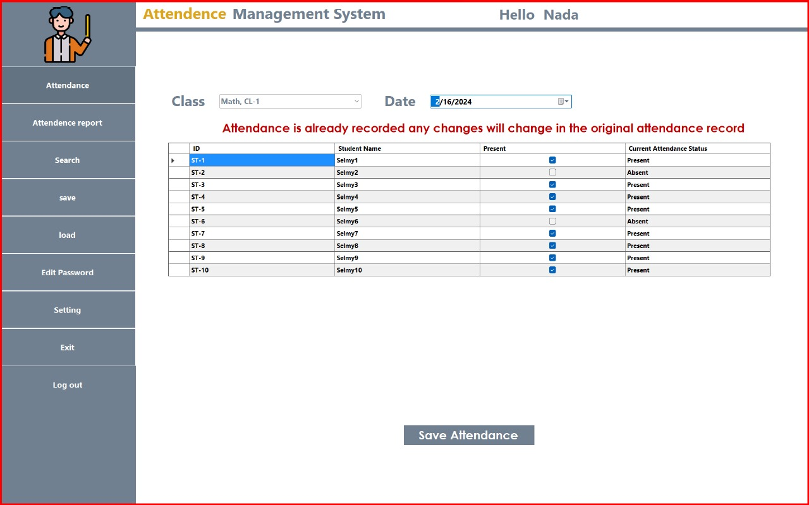

## Generate Report

**Teachers can**  Generate attendance reports for assigned classes. Where he can Filter reports based on date range, class, or individual students.

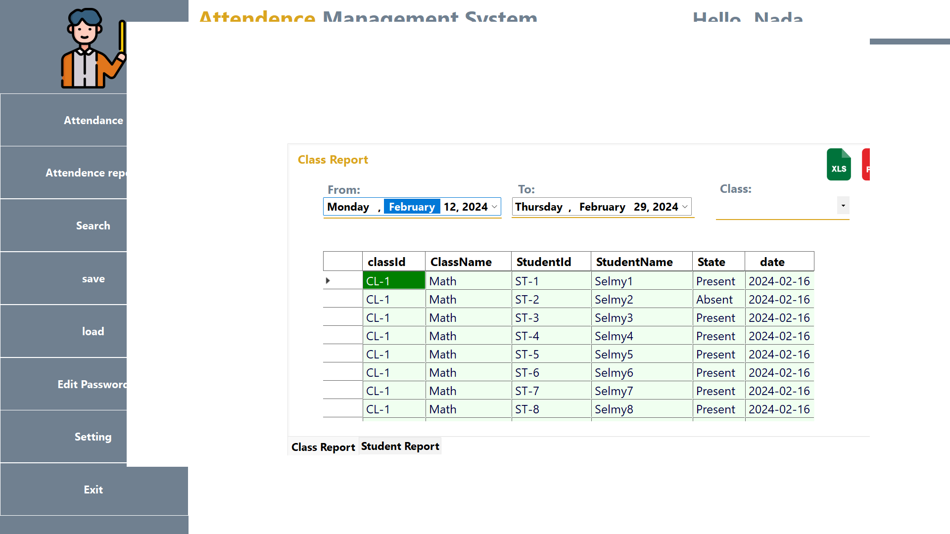

Present attendance data in a structured and readable format. Also he can extract the m into PDF or Excel

## Edit Password

Update the teacher's password for account security., Provide a secure mechanism for changing passwords.

Validate password strength and enforce security measures.

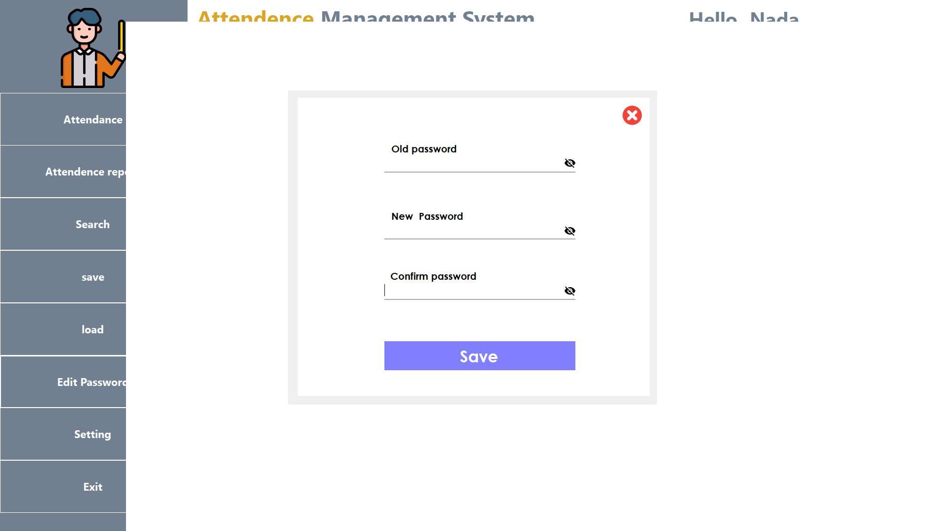

## Search

**Teachers can** Search for specific information related to classes or students. Allow teachers to search for classes, students, or attendance records by name, ID, or other criteria.

Provide quick access to relevant information for efficient management.





## **Change** Language

**Teacher can** Adjust the language settings for the interface., Offer multiple language options to accommodate user preferences. Update interface elements and text dynamically based on the selected language.

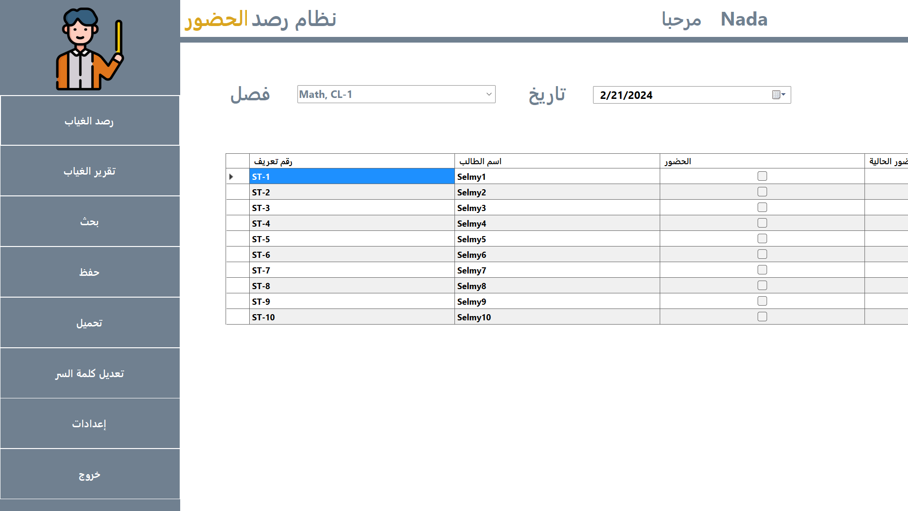

# Student

## Dashboard

View a summary of enrolled classes and attendance status., Display class schedules, attendance records, and other relevant information. Provide a user-friendly interface for easy navigation and access to data.

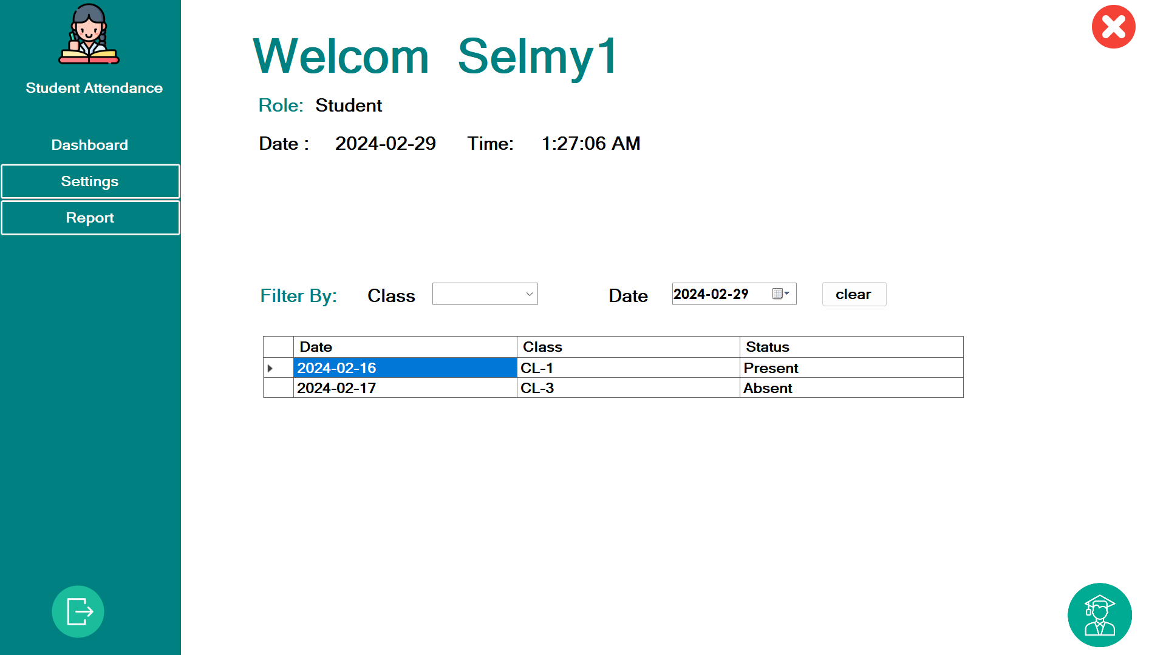

## Generate Report

**Student can** View attendance data for specific classes or date ranges. ,Access detailed reports to track attendance history and patterns.

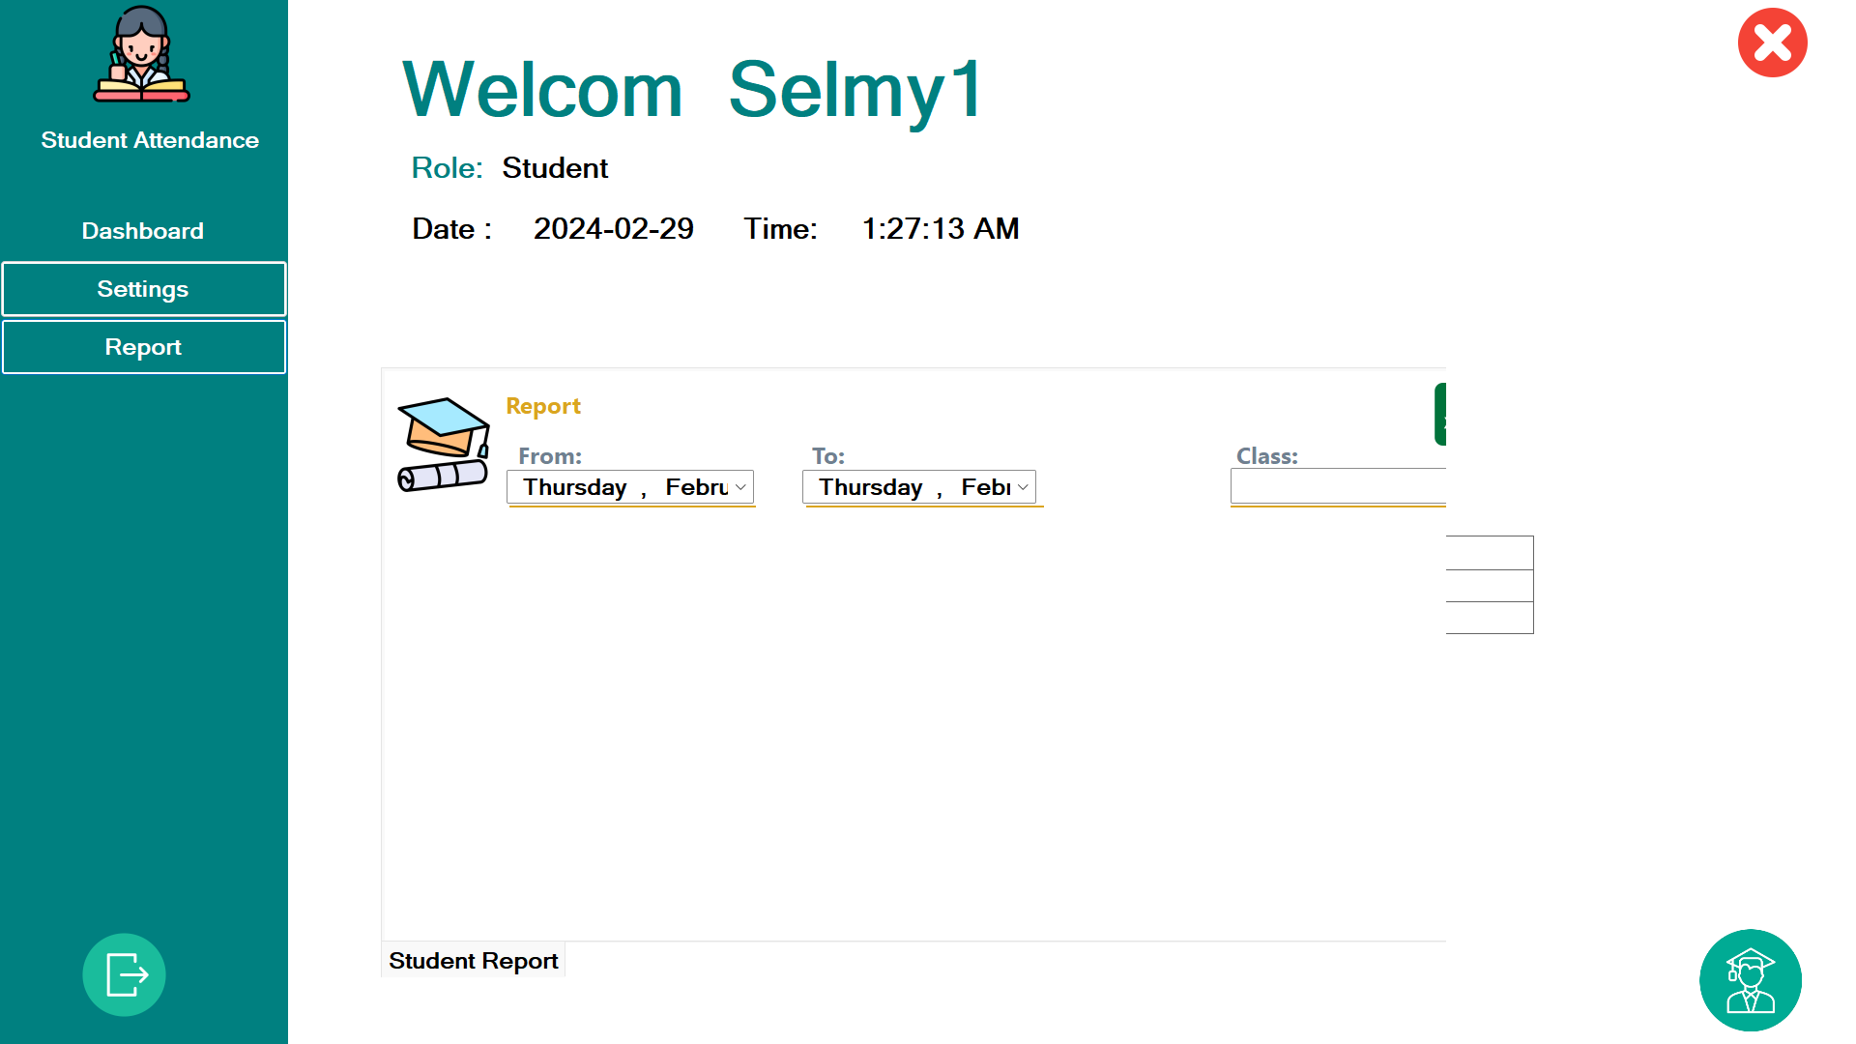

## **Change** Language

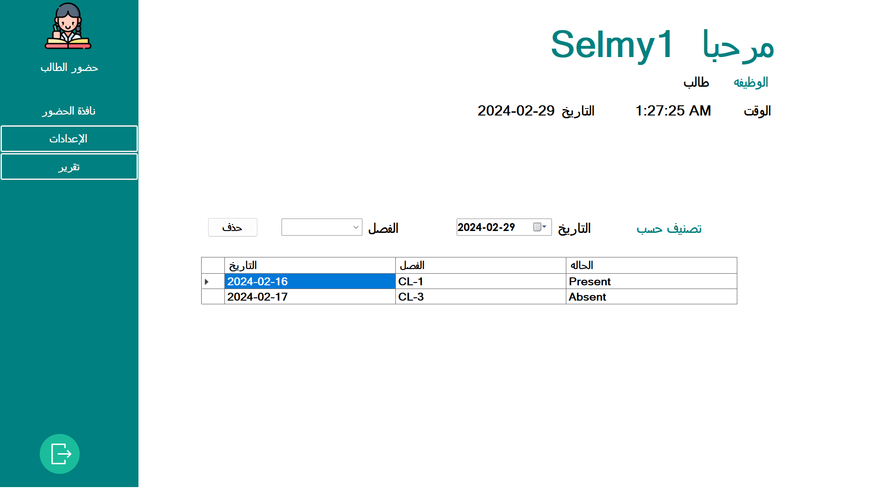

# Conclusion

The Attendance Documentation System offers a comprehensive solution for managing attendance records in educational settings. By providing a range of features tailored to the needs of administrators, teachers, and students, the system aims to streamline attendance management processes and enhance overall efficiency.

By incorporating robust validation mechanisms, data integrity measures, and user-friendly interfaces, the system ensures accurate attendance tracking while promoting ease of use and accessibility for all users.