



**MRRM – AI/ML**

**Requirements Specification**

**Document History**

|  |  |  |  |  |  |
| --- | --- | --- | --- | --- | --- |
| **S. No** | **Version** | **List of changes** | **Date of Release** | **Prepared/ Updated By** | **Reviewed/ Approved By** |
| 1 | 1.0 | Initial draft | 03/31/2023 | Jaishri Iyengar | Selvakumar Muthupandi |
|  |  |  |  |  |  |

Table of Contents

1.1 Purpose for AI/ML for MRRM: 4

1.2 Indexing Activity within MRRM 4

1.2.1 Categories is the type of the page/document is labeled by a categories. 4

1.2.2 DOS (Date Of Service): 4

1.2.3 Facility/Provider: 4

1.2.4 Header: 4

1.3 Starting and ending page: 4

1.4 Client wise category list and additional fields: 5

1.4.1 Category list: 5

1.4.2 Client wise additional fields: (WIP) 10

1.5 Format of pdf: (TBD) 11

1.6 Deduplication: 12

Reference Documents 13

## Purpose for AI/ML for MRRM:

Number of clients and volume of the files that are expected to share with Preludesys will multiply in the future. To handle the change, we need to make use of AI/ML to automatically detect a category, Date of Service, Facility/ Provider and Header of the page

## Indexing Activity within MRRM

### Categories is the type of the page/document is labeled by a categories.

* + Example categories: Billing, Doctor notes, etc.,
  + Categories wont be universal across all clients, depending their clients and kind of compensation they deal with categories for the client varies

### DOS (Date Of Service):

* + Date on which document is prepared or generated or executed or visited on
  + Apart from valid date, DOS can we ‘illegible’ or ‘undated’
  + Keywords for DOS: (TBD)
    - Date
    - Prepared on/ Prepared date
    - Generated on/ Generated date
    - Collected on/ Collected date
    - Visited on/ Visited date

### Facility/Provider:

* + Facility is the place where the patient is treated or met the physician
    - Facility can be hospital or doctor’s clinic
  + Provider is the person whom the customer meets
    - Provider can be doctor, nurse, assisting physician etc.,

### Header:

* + Header will be title of the page/ document
  + Example: Prescription, Discharge Summary, Declaration etc.,

## Starting and ending page:

* **Starting Page:**
  + Title/header of the page
* **Ending Page:**
  + Below are few examples to define an ending page of the document:
    - Large white space
    - Signature

## Client wise category list and additional fields:

### Category list:

|  |  |  |  |  |  |  |  |  |
| --- | --- | --- | --- | --- | --- | --- | --- | --- |
| **Category** | **Go Republic** | **NBKL** | **Unisource Index** | **Medical Evaluation Management** | **Arrow head** | **Certified Medical Consultant** | **De- Duplication** | **Logica Ratio** |
| Review | No | No | No | No | Yes | No | No | No |
| Non-Review | No | No | No | No | Yes | No | No | No |
| Legal | No | No | No | No | No | No | No | Yes |
| Others | No | No | No | No | No | No | No | Yes |
| Job description | No | Yes | Yes | No | No | No | No | No |
| Medical | No | Yes | Yes | No | No | Yes | No | No |
| First report of injury | No | Yes | Yes | No | No | No | No | No |
| Physical Therapy records | No | Yes | Yes | No | No | No | No | No |
| Copy service paper | Yes | No | No | Yes | No | No | Yes | No |
| Reports | Yes | No | No | Yes | No | No | Yes | No |
| Doctor Notes | Yes | No | No | Yes | No | No | Yes | No |
| Radiology | Yes | No | No | Yes | No | No | Yes | No |
| Nursing Reports | No | No | No | No | No | No | Yes | No |
| Nursing Notes | Yes | No | No | Yes | No | No | No | No |
| Laboratory | Yes | No | No | Yes | No | No | No | No |
| General Med | Yes | No | No | Yes | No | No | Yes | No |
| General Admin | Yes | No | No | Yes | No | No | Yes | No |
| Other person | Yes | Yes | Yes | Yes | No | No | No | No |
| Blank pages | Yes | No | No | Yes | No | No | No | No |
| Affidavit | Yes | No | No | No | No | No | No | Yes |
| Go Republic Memo sheet | Yes | No | No | No | No | No | No | No |
| Handwritten | Yes | No | Yes | Yes | No | No | No | Yes |
| Utilization | No | Yes | No | No | No | No | No | No |
| NonMedical | No | Yes | Yes | No | No | No | No | No |
| Duplicates | No | Yes | Yes | No | No | No | Yes | No |
| Claims | No | No | No | No | No | No | Yes | No |
| Medical Record Present | No | Yes | Yes | No | No | No | No | No |
| Miscellaneous | No | No | Yes | No | No | No | No | No |
| Police Report | No | No | No | No | No | Yes | No | No |
| Legal Documents | No | No | No | No | No | Yes | No | No |
| Bills | No | No | No | No | No | Yes | No | No |
| Trash | No | No | No | No | No | Yes | No | No |
| Vehicle Estimates | No | No | No | No | No | Yes | No | No |
| Medical record after | No | No | No | No | No | No | No | No |
| MB - Medical Record Before | No | Yes | Yes | No | No | No | No | No |

#### Example for few categories:

* Sample page which is categorized as ‘Legal’

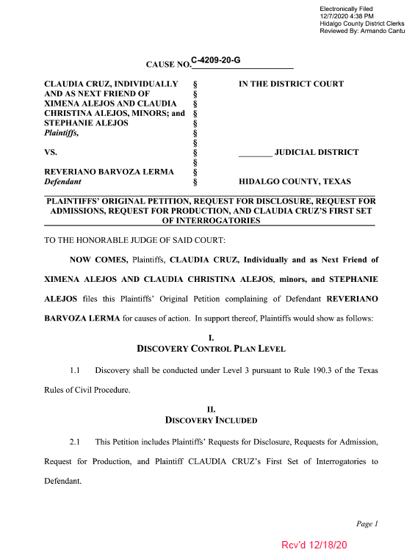

* Sample page which is categorized as ‘Affidavit’

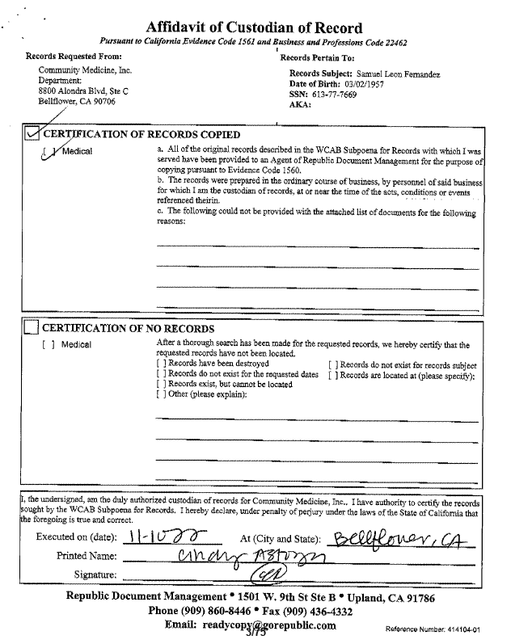

* Sample page categorized as Laboratory:

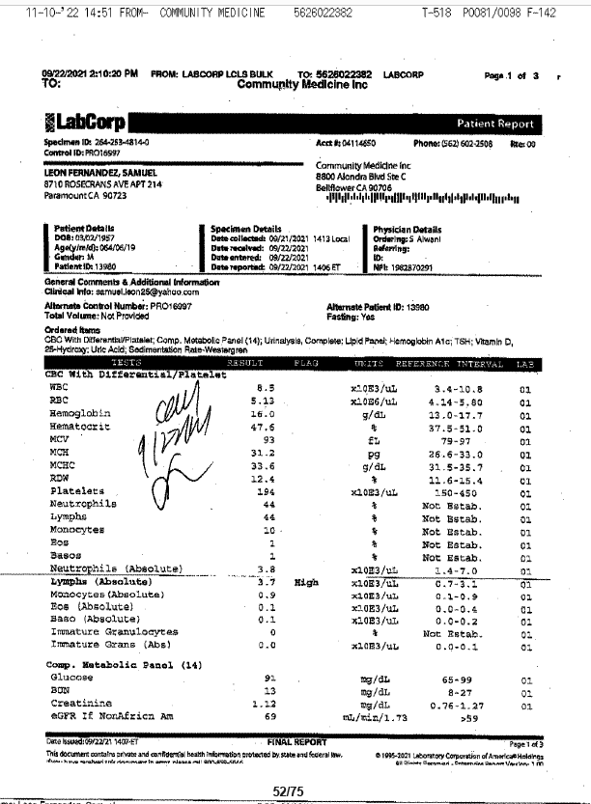

* Sample page categorized as Doctor Notes:

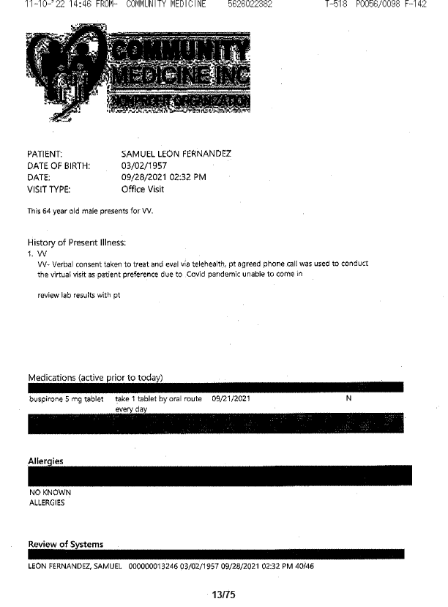

### Client wise additional fields: (WIP)

|  |  |  |  |
| --- | --- | --- | --- |
| **Client** | **Additional Fields** | **Type** | **Remarks** |
| CMC | Facility Grouping | Checkbox | If first page of the document if mentioned as to be grouped by 'Facility' for 'Medical' category, the checkbox has to be checked, and textbox should have 'Facility name' |
| CMC | Facility Grouping | Textbox |
| Logica Ratio | Patient Name | Textbox | Name of the patient |
| Logica Ratio | Child Header | Textbox |  |
| Logica Ratio | Radiology | Checkbox | To be check the page is related to Radiology |
| Logica Ratio | Future Recommended | Checkbox | To be check the page is related to Future Recommended |
| Logica Ratio | Depos | Checkbox | To be check the page is related to Depos |
| Logica Ratio | Order | Checkbox | To be check the page is related to Order |
| Logica Ratio | Opinion | Checkbox | To be check the page is related to Opinion |
| Logica Ratio | ODI | Checkbox | To be check the page is related to ODI |
| Logica Ratio | Session | Checkbox | To be check the page is related to Session |
| Logica Ratio | Single Bill End | Textbox | If the billing statement has more than 1 page, then Bill end date has to be filled with a date. Applicable for Billing category only |

#### Example for CMC:

‘Is Facility’ checkbox will be automatically checked if first page of the document is mentioned as to grouped by Facility and ‘Facility Grouping’ textbox will be filled with the Facility name

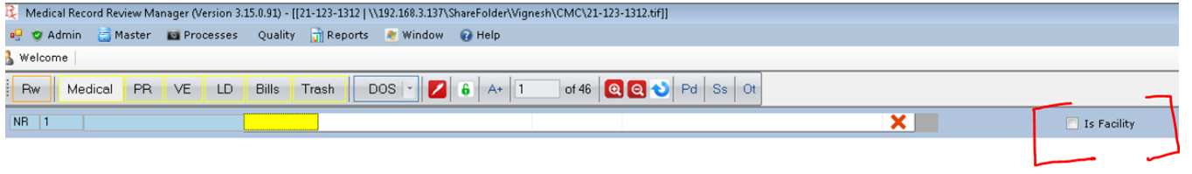

#### Example for Logica Ratio

Below fields should be automatically filled based on the page in the document

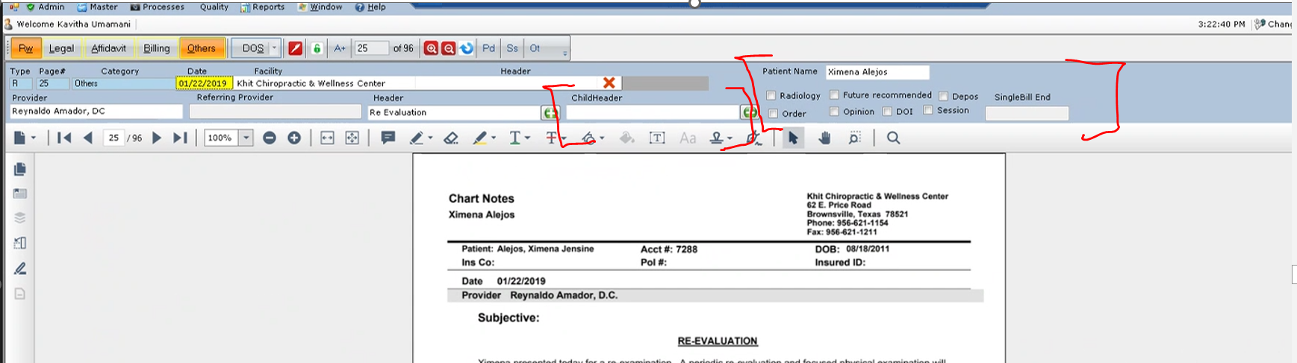

## Format of pdf: (TBD)

## Deduplication:

* Deduplication is to identify duplicate pages among the group of files shared for each patient. Reviewing lots of pages/files for each patient is time consuming and lot of money has to be paid for Medical Experts. To reduce time and money, we need to identify duplicate pages, and deliver the file without duplicates.
* We will receive files from:
  + Attorney (Law firm)
  + Payer (Insurance firm)
* We might receive files for a patient either from Attorney or Payer or Both
* If Attorney and Payer files are there,
  + We start indexing Attorney files first, followed by Payer files
* There is no particular to start indexing if either Attorney or Payer files are there
* If Attorney files are available, then we start indexing Attorney files first.
  + 1st Attorney file is indexed,
  + Duplicates are marked within each file and also any number of files within the group of files for each patient
  + First occurrence of the duplicate is the parent, and subsequent occurrence will be considered as child.
  + Page number of the linked duplicates has to be kept a track of to compile in to a table/grid

# Reference Documents

| **Document** | **Publishing Organization** | **Location** |
| --- | --- | --- |
| Sample Output files per client |  | https://preludesysinc-my.sharepoint.com/:f:/g/personal/jaishrivijay_i_preludesys_com/EnOmP-yWjkZFkV33og-4J4gBjZlQ6_sQFpq61Bt5GNsohw?e=QaqvB3 |
|  |  |  |
|  |  |  |
|  |  |  |