Downloading .tbwx and Tableau Navigation Instructions for "Broadband Access and Customer Churn: An Accessible and Interactive Dashboard for Decision-Making"
Jen Sengbe
Representation and Reporting
July 1, 2025

INSTALLATION INSTRUCTIONS
To install and view the dashboard, begin by downloading the packaged Tableau workbook .twbx file that is included with this submission. In-order-to do that, you’ll click on the .twbx file which will cause the file to be automatically downloaded to the device in use. This packaged workbook contains all necessary data files embedded, so no separate data connections are required. Once the file is saved to your viewing device (for example, a desktop computer), you will need Tableau Public installed to open and view it. If Tableau Public is not already installed, you may download it by visiting the official Tableau Public download page at https://public.tableau.com/en-us/s/download. On this page, complete the required form by entering your first name, last name, email address, role, country/region, and state in the provided fields. After filling out the form, click the “Download the app” button.
Once the download begins, locate the Tableau installer file in your device’s designated downloads folder (for example, the “Downloads” folder on a Windows computer or MacBook). Double-click the installer file to launch it. Once the setup window appears, follow the on-screen instructions step-by-step to complete the installation process. On Windows, this may involve agreeing to the license terms and clicking “Install” before waiting for the progress bar to finish. On a Mac, you may be prompted to drag the Tableau Public icon into the “Applications” folder to complete the installation.
After installation, locate Tableau Public on your device. On Windows, this may be in the Start menu under “Tableau Public,” and on a Mac, it will appear in the “Applications” folder. Click the application icon to launch Tableau Public. Once Tableau Public is open, navigate to File on the menu bar at the very top of your Tableau viewing screen and select Open. In the file selection window that appears, browse to the location where you saved the D210.twbx file, select it, and click Open. Tableau will then load the workbook and display the dashboard as the first page in view. The dashboard will be interactive immediately upon opening, and no additional configuration is required.
NAVIGATION INSTRUCTIONS
This is a multi-media presentation on navigating Tableau. When the packaged workbook opens in Tableau Public, the first dashboard that appears is the Customer Overview. To expand the dashboard, you will want to put it into presentation mode by clicking the presentation mode icon as seen in the following screenshot:
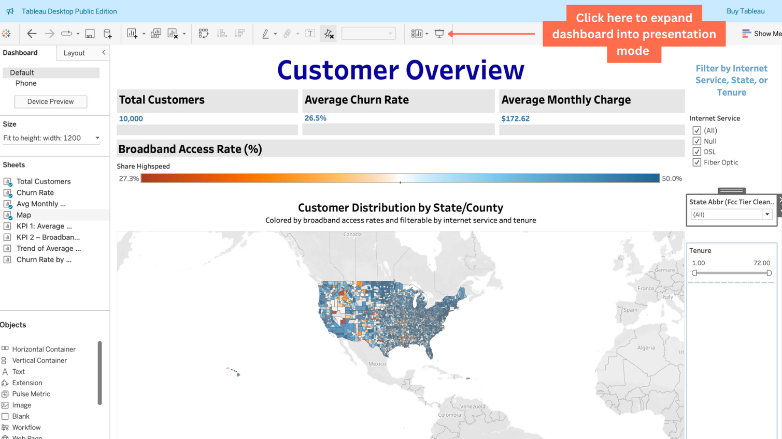
Once in presentation mode, you’ll be able to explore the Customer Overview dashboard better. The Customer Overview screen provides a high-level summary of the dataset, designed for intuitive use. At the top, three large Key Performance Indicators (KPIs) are displayed: Total Customers, Average Churn Rate, and Average Monthly Charge. These values automatically update whenever filters are applied. Directly below, the Broadband Access Rate (%) bar shows the share of high-speed broadband coverage across the dataset, giving users a quick sense of overall internet availability. The lower portion of the dashboard contains a U.S. map shaded by broadband access rates at the county level. To interact with the map, users can hover the cursor over any county to display tooltips with details such as broadband access, churn rate, and the types of internet service available.
On the right-hand side of the dashboard, a filter panel allows exploration of the data. The Internet Service filter provides checkboxes for DSL, Fiber Optic, Null, or All. You may click in each check box to select or unselect the internet service options you’re interested in exploring. The State Abbreviation dropdown menu enables users to focus on a specific state by allowing users to click in each box to select or unselect the state options they’re interested in to explore the customer overview for that region. The Tenure slider allows users to drag the handles to adjust the customer tenure range in months. Adjusting any of these filters automatically updates the KPIs, the broadband rate bar, and the map.
To proceed with viewing the remaining dashboards and worksheets in my packaged .twbx file, refer to the following screenshot for details on how to navigate through the available tabs:
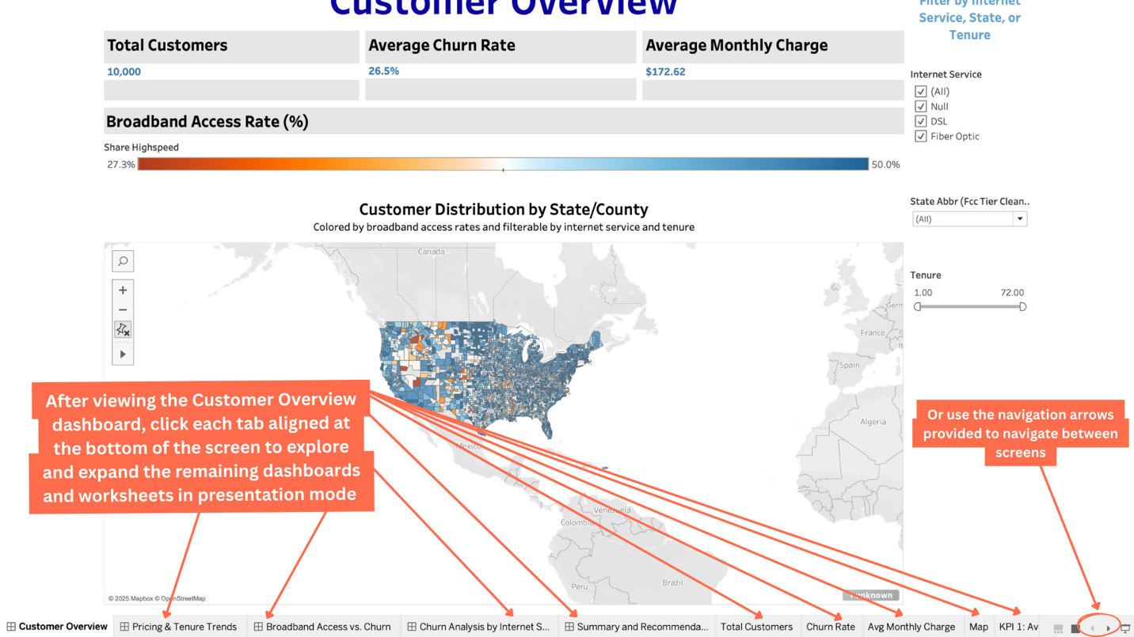
The second dashboard, Pricing and Tenure Trends, focuses on customer charges across states and tenure. At the top is the Average Monthly Charge by State clustered bar chart, where each bar is color-coded to show DSL, Fiber Optic, or Null services. Hovering your mouse over each bar in the clustered bar chart will display a tooltip detailing internet service type, state name, average monthly charge, and average share of high-speed. Just beneath this chart, a KPI labeled Average Monthly Charge provides a benchmark, displayed here as $172.62. The next visualization, Average Monthly Charge by Tenure, shows how charges evolve, broken down by internet service type. This chart allows the user to trace how pricing fluctuates for DSL compared to Fiber Optic customers as their months of service increase. At the bottom of the dashboard, the filter controls provide multiple ways to interact with the data. The Internet Service dropdown allows users to focus on customers with no service, DSL customers, or Fiber customers. The Tenure slider enables precise control of customer time ranges by allowing the user to drag the handles to adjust the customer tenure range in months. The Share Highspeed dropdown can be used to compare pricing between regions with low and high broadband penetration. The user can use the dropdown menu to select or unselect high-speed share percentages to further explore. Selecting or adjusting any of these filters instantly updates all the visualizations on the dashboard.
The third dashboard, Broadband Access vs. Churn, is designed to show how broadband penetration relates to customer retention. At the top, a KPI highlights the average churn rate of 26.5% and notes that broadband penetration above ~40% is associated with a churn reduction of about three to five percent. The main visualization is a scatter plot titled Broadband Access vs. Churn. Each dot represents a state, with the x-axis showing Average Share Highspeed and the y-axis showing Average Churn. DSL, Fiber Optic, and Null are separated by color, and trend lines are displayed to show the overall relationship between broadband access and churn for each service type. Hovering over each point on the line chart will provide the user with a tooltip displaying the county name, internet service type, churn rate, and share high-speed rate details. Filters on the right allow users to drill into the scatter plot. For example, dragging the Tenure slider to show only 12–24 months will recalculate the scatter plot specifically for those customers. Similarly, selecting “DSL” from the Internet Service dropdown shows churn trends only for DSL users, while the State dropdown can be used to isolate specific geographies.
The fourth dashboard, Churn Analysis by Internet Service, uses a tree map to show churn broken down by service type. Each block represents one service category, and the size and color of the block correspond to its churn rate. For example, the large orange DSL block highlights that DSL customers have the highest churn at 32%, while Fiber Optic is shown with a smaller blue block at 23.6%. A KPI summary above the visualization restates the average churn across all services. At the bottom, the filter controls allow the same interactivity as previous dashboards. For example, selecting a single state, such as Texas in the State dropdown menu will update the tree map to show churn rates specifically for customers in that state.
The fifth dashboard, Executive Summary and Key Recommendations, brings together insights from the previous dashboards. At the top, the same KPIs for Total Customers, Average Churn Rate, and Average Monthly Charge are repeated for consistency. Below the KPIs are three of the same filter controls previously used in other dashboards and placed for convenience to allow the user to filter the KPIs aforementioned by state, internet service type, and tenure groups. Below that, the Key Insights section highlights three major findings, such as pricing stabilization around $160–$170 after 24 months of tenure and the significantly higher churn rate for DSL customers. The lower half of the dashboard is divided into three recommendation columns, each labeled with a headline, a “Why” section, and a “How” section, supported by quantified business impacts. For example, one recommendation states that DSL loyalty perks could reduce churn by ~5%, potentially retaining 500 customers annually. At the bottom of the dashboard, a Call-to-Action box suggests next steps such as implementing churn-reduction campaigns and conducting a pricing audit on long-tenure accounts.
Each of the dashboards is built from supporting worksheets, which can be accessed through the tabs at the bottom of Tableau Public. These include Total Customers, Churn Rate, Average Monthly Charge, Map, KPI 1: Average Monthly Charge by State, KPI 2: Broadband Access vs. Churn, Trend of Average Monthly Charge by Tenure, and Churn Rate by Internet Service. Clicking a worksheet tab will open the visualization independently, making it easier to explore in isolation. For example, opening Trend of Average Monthly Charge by Tenure shows the line chart by itself, enabling the user to focus solely on how pricing changes over customer tenure.
At any time, users can restore a dashboard to its original configuration. To do this, they can click on Worksheet in the top menu and select Revert to Saved or click the “Revert” button in the toolbar at the top of Tableau Public. This resets all filters and visuals back to the default state set by the designer.

