Optimal policy for visual search

Task
- Assume that a subject observes one item within each (discrete) time step, no parallel process.
- Assume no memory leak, no misperception of items, no noise on time perception/subjective generative model.
- In each trial, the subject judges whether the target is “present” or “absent” and receive a fixed amount of reward for a correct response.
$t$: time steps ($t=1,2,3,…$)
$N$: the number of items
$x^{*}$: (the percept of) target item
$x_{t}$: observed item at time step $t$
$ξ_{t}$: a state variable reflecting how many times the subject has detected the target in time steps $t$ ($ξ_{t}=0$ if $x^{*}∉\left\{x_{1},…,x_{t}\right\}$; $ξ_{t}=\left|\left\{t^{'}|0<t^{'}≤t,x_{t^{'}}=x^{*}\right\}\right|$)
$P_{FN}$: the probability of mistaking the target with non-target (i.e., the ‘false negative’ rate)
$P_{FP}$: the probability of mistaking a non-target target with the target (i.e., the ‘false positive’ rate)

Generative model
$q_{t}$: the probability of detecting no target in the initial $t$ steps when the target is present

Without misperception
- Dynamic condition (= sampling with replacement):
$$q_{t}:=P\left(ξ_{t}=0|present\right)={\left(1-\frac{1}{N}\right)}^{t}$$
- Static condition (=sampling without replacement) ($t≤N$):
$$q_{t}:=P\left(ξ_{t}=0|present\right)=1-\frac{t}{N}$$
*Static condition with a leaky memory (forgetting an observed item at rate$λ$ for each time step):
$$q_{t+1}=q_{t}\sum_{t^{'}=0}^{t}{{{}_{t}^{}C}_{t^{'}} λ^{t^{'}}{\left(1-λ\right)}^{{1-t}^{'}}\left(1- \frac{1}{N-t+t^{'}}\right) }$$
$$q_{0}=1$$
$$q_{1}=1-\frac{1}{N}$$
This is not analytic although it is bounded by the dynamic ($λ=1$) and non-leaky static ($λ=0$) conditions in the above.

With misperception
- Dynamic condition (= sampling with replacement):
$$q_{t}:=P\left(ξ_{t}=0|present\right)={\left(1-\frac{1}{N}\right)}^{t}{\left(1-P_{FP}\right)}^{t}+\left(1-{\left(1-\frac{1}{N}\right)}^{t}\right)P_{FN}$$
$$P\left(ξ_{t}=0|absent\right)={\left(1-P_{FP}\right)}^{t}$$
- Static condition (=sampling without replacement) ($t≤N$):
$$q_{t}:=P\left(ξ_{t}=0|present\right)=\left(1-\frac{t}{N}\right){\left(1-P_{FP}\right)}^{t}+\frac{t}{N}P_{FN}$$
$$P\left(ξ_{t}=0|absent\right)={\left(1-P_{FP}\right)}^{t}$$

Posterior probability
$p_{0}$: the prior probability of target being present (e.g., the fraction of “present” trials)

Without misperception
$$p_{t}≔P\left(present|ξ_{t}=0\right)=\frac{q_{t}p_{0}}{\left(q_{t}-1\right)p_{0}+1}$$
$$1-p_{t}=P\left(absent|ξ_{t}=0\right)=\frac{1-p_{0}}{\left(q_{t}-1\right)p_{0}+1}$$
$$P\left(present|ξ_{t}≥1\right)=1$$
$$P\left(absent|ξ_{t}≥1\right)=0$$

Without misperception
$$p_{t}≔P\left(present|ξ_{t}=0\right)=\frac{q_{t}p_{0}}{q_{t}p_{0}+{\left(1-P_{FP}\right)}^{t}{(1-p}_{0})}$$
$$1-p_{t}=P\left(absent|ξ_{t}=0\right)=\frac{{\left(1-P_{FP}\right)}^{t}{(1-p}_{0})}{q_{t}p_{0}+{\left(1-P_{FP}\right)}^{t}{(1-p}_{0})}$$
$$P\left(present|ξ_{t}≥1\right)=\frac{\left(1-q_{t}\right)p_{0}}{\left(1-q_{t}\right)p_{0}+\left(1-{\left(1-P_{FP}\right)}^{t}\right)\left(1-p_{0}\right)}$$
$$P\left(absent|ξ_{t}≥1\right)=\frac{\left(1-{\left(1-P_{FP}\right)}^{t}\right)\left(1-p_{0}\right)}{\left(1-q_{t}\right)p_{0}+\left(1-{\left(1-P_{FP}\right)}^{t}\right)\left(1-p_{0}\right)}$$
$$p_{t}\left(k\right)≔P\left(present|ξ_{t}=k\right)=…$$
$$1-p_{t}\left(k\right)=P\left(absent|ξ_{t}=k\right)=…$$

Bellman equation and the optimal decision time
$V(t,ξ_{t})$: value at time $t$, in a state $ξ_{t}$
$V_{d}(t,ξ_{t})$: value for deciding (i.e. finish waiting and answering “present” or “absent”) at time $t$, in a state $ξ_{t}$
$ρ$: reward rate (expected reward per unit time)
$c$: inherent cost accumulating evidence per unit time (e.g. cognitive effort)
$Δt$: the length of a single time step (i.e., the decision maker observes one item every $Δt$)
$r$: reward for a correct response (assuming equal rewards for the correct detection and the correct rejection)
$t_{w}$: non-decision time + ITI
$T_{0}$: the optimal time for stopping the item observation to answer “absent” when detecting no target item

Without false positives ($P_{FP}=0$)
The (average-adjusted) value function for a long trial sequence is given as follows (it reduces to a single-trial case when we set $t_{w}=∞$, $ρ=0$ and $ρt_{w}=0$).
$$V\left(t,ξ_{t}≥1\right)=V_{d}\left(t,ξ_{t}≥1\right)=r-ρt_{w}$$
$$V\left(t,ξ_{t}=0\right)=\max\left\{V_{d}\left(t,ξ_{t}=0\right),{〈V\left(t+1,ξ_{t+1}\right)〉}_{ξ_{t+1}|ξ_{t}=0}-\left(c+ρ\right)Δt\right\}$$
$${〈V\left(t+1,ξ_{t+1}\right)〉}_{ξ_{t+1}|ξ_{t}=0}=\left(1-α_{t}\right)V\left(t+1,ξ_{t+1}=0\right)+α_{t}V\left(t+1,ξ_{t+1}=1\right)$$
$$=\left(1-α_{t}\right)V\left(t+1,ξ_{t+1}=0\right)+α_{t}\left(r-ρt_{w}\right)$$
$α_{t}≔P(ξ_{t+1}=1|ξ_{t}=0)$: the probability of detecting the target item in the next time step
- Dynamic condition: $α_{t}=p_{t}/N$
- Static condition: $α_{t}=p_{t}/(N-t)$
$V_{d}\left(t,ξ_{t}=0\right)$ is given in an explicit form as follows:
$$V_{d}\left(t,ξ_{t}=0\right)=r\max\left\{p_{t},1-p_{t}\right\}-ρt_{w}$$
$$=\frac{rp_{0}}{\left(q_{t}-1\right)p_{0}+1}\max\left\{q_{t},\frac{1}{p_{0}}-1\right\}-ρt_{w}$$
The first element in $\max\left\{⋅,⋅\right\}$ corresponds to the choice answering “present” whereas the second corresponds to the “absent” choice. Note that $q_{t}≤1$ by definition, which means that, if $p_{0}≤0.5$, you should never answer “present” until actually detecting the target item. In that case,
$$V_{d}\left(t,ξ_{t}=0\right)=r\left(1-p_{t}\right)-ρt_{w}$$
Together,
$$V\left(t,ξ_{t}=0\right)=\max\left\{r\left(1-p_{t}\right)-ρt_{w},\left(1-α_{t}\right)V\left(t+1,ξ_{t+1}=0\right)+α_{t}\left(r-ρt_{w}\right)-\left(c+ρ\right)Δt\right\}$$
$$=r\left(1-p_{t}\right)-ρt_{w}+\max\left\{0,\left(1-α_{t}\right)\left(V\left(t+1,ξ_{t+1}=0\right)-r+ρt_{w}\right)+rp_{t}-\left(c+ρ\right)Δt\right\}$$
To summarize, the optimal policy is:
- to wait until hitting the target or time reaches a fixed limit $t=T$,
- then answer “present” if target was hit, say “absent” otherwise.
The optimal stopping time $T_{0}$ is the minimum of $t$’s that satisfy the following condition:
$$V_{d}\left(t,0\right)≥{〈V\left(t+1,ξ_{t+1}\right)〉}_{ξ_{t+1}|ξ_{t}=0}-\left(c+ρ\right)Δt$$
$$⇔0≥\left(1-α_{t}\right)\left(V\left(t+1,ξ_{t+1}=0\right)-r+ρt_{w}\right)+rp_{t}-\left(c+ρ\right)Δt$$
For all $t$, $V\left(t+1,ξ_{t+1}=0\right)≥V_{d}\left(t+1,ξ_{t+1}=0\right)=r\left(1-p_{t}\right)-ρt_{w}$. The equality holds for $t≥T_{0}$ by the definition of the stopping time. Thus, the optimal stopping time $T$ is given as follows:
$$T_{0}=\underset{t}{argmin}\left\{α_{t}p_{t+1}≤\frac{c+ρ}{r}Δt\right\}$$

With false positives ($P_{FP}>0$) [to be completed]
With a nonzero false positive rate, it is not trivial whether the subject should answer present even if she thought she detected the target ($ξ_{t}≥1$). Thus, we need to consider the stopping times depending on the states $ξ_{t}$, such that
$$T_{k}=\underset{t}{argmin}\left\{V_{d}\left(t,ξ_{t}=k\right)≥{〈V\left(t+1,ξ_{t+1}\right)〉}_{ξ_{t+1}|ξ_{t}=k}-\left(c+ρ\right)Δt\right\}$$
where $k=0,1,2,…$ . The value function is
$$V\left(t,ξ_{t}=k\right)=\max\left\{V_{d}\left(t,ξ_{t}=k\right),{〈V\left(t+1,ξ_{t+1}\right)〉}_{ξ_{t+1}|ξ_{t}=k}-\left(c+ρ\right)Δt\right\}$$
$${〈V\left(t+1,ξ_{t+1}\right)〉}_{ξ_{t+1}|ξ_{t}=k}=\left(1-α_{t}^{k}\right)V\left(t+1,ξ_{t+1}=k\right)+α_{t}^{k}V\left(t+1,ξ_{t+1}=k+1\right)$$
$$α_{t}^{k}≔P\left(ξ_{t+1}=k+1 | ξ_{t}=k\right)$$
$$=P\left(ξ_{t+1}=k+1 | present,ξ_{t}=k\right)P\left(present | ξ_{t}=k\right)+P\left(ξ_{t+1}=k+1 | absent,ξ_{t}=k\right)P\left(absent | ξ_{t}=k\right)$$
$$=P\left(ξ_{t+1}=k+1 | present,ξ_{t}=k\right)p_{t}\left(k\right)+P_{FP}\left(1-p_{t}\left(k\right)\right)$$
- Dynamic condition:
$$P\left(ξ_{t+1}=k+1 | present,ξ_{t}=k\right)=\frac{\left(1-P_{FN}\right)}{N}$$,
$$α_{t}^{k}:=\frac{\left(1-P_{FN}\right)p_{t}\left(k\right)}{N}+P_{FP}\left(1-p_{t}\left(k\right)\right)$$
- Static condition:
$$P\left(ξ_{t+1}=k+1 | present,ξ_{t}=k\right)=\underset{\begin{aligned}When the true target \\ has been observed\end{aligned}}{\underbrace{\frac{kP_{FP}}{N}}}+\underset{\begin{aligned}When the true target \\ has not been observed\end{aligned}}{\underbrace{\left(\frac{1-P_{FN}}{N-k}+\frac{\left(N-k-1\right)P_{FP}}{N-k}\right)\left(1-\frac{k}{N}\right)}}$$
$$=\frac{1-N}{N}P_{FP}+\frac{1-P_{FN}}{N}$$
$$α_{t}^{k}:=\left(\frac{1-N}{N}P_{FP}+\frac{1-P_{FN}}{N}\right)p_{t}\left(k\right)+P_{FP}\left(1-p_{t}\left(k\right)\right)$$

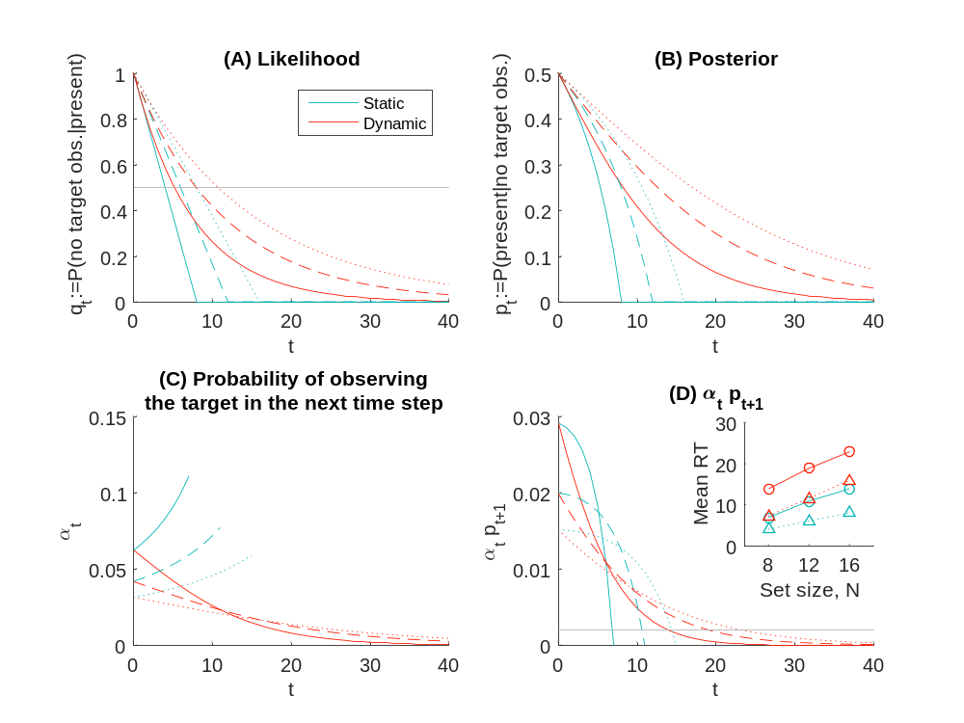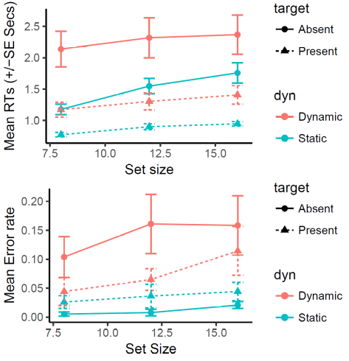
$p_{0}=0.5$; $r=1$; $N=8$ (solid) , 12 (dashed) or 16 (dotted), assuming a single trial model ($ρ=0$).
(A) Horizontal line: $q_{t}=0.5$ (indicating the median RT for “present” answers)
(B) Horizontal line: $α_{t}p_{t+1}=cΔt/r=0.002$ (indicating the RT for “absernt” answers): this is a tunable threshold.
(D, inset) Mean RT for “Absent” (solid, circle) and “Presnt” (dotted, triangle) responses
The right column: copied from the experimental note.

- Copied from the experimental note -
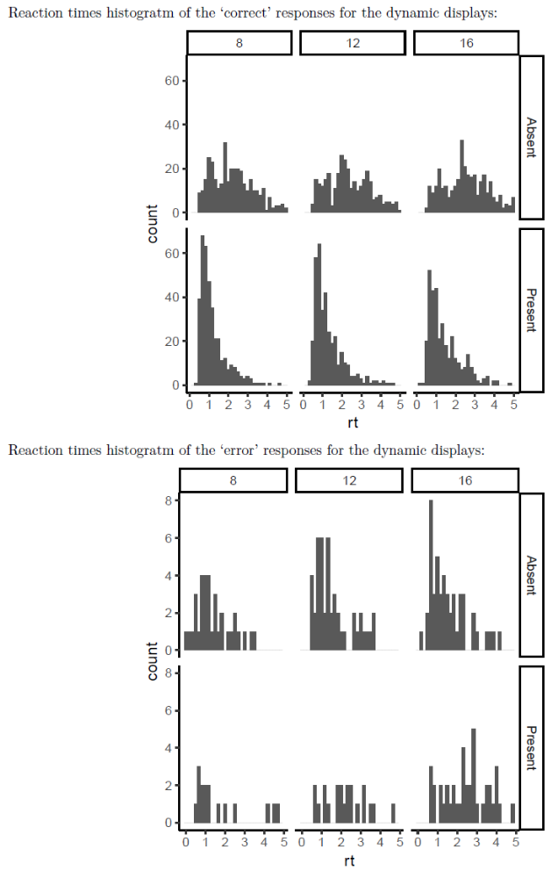
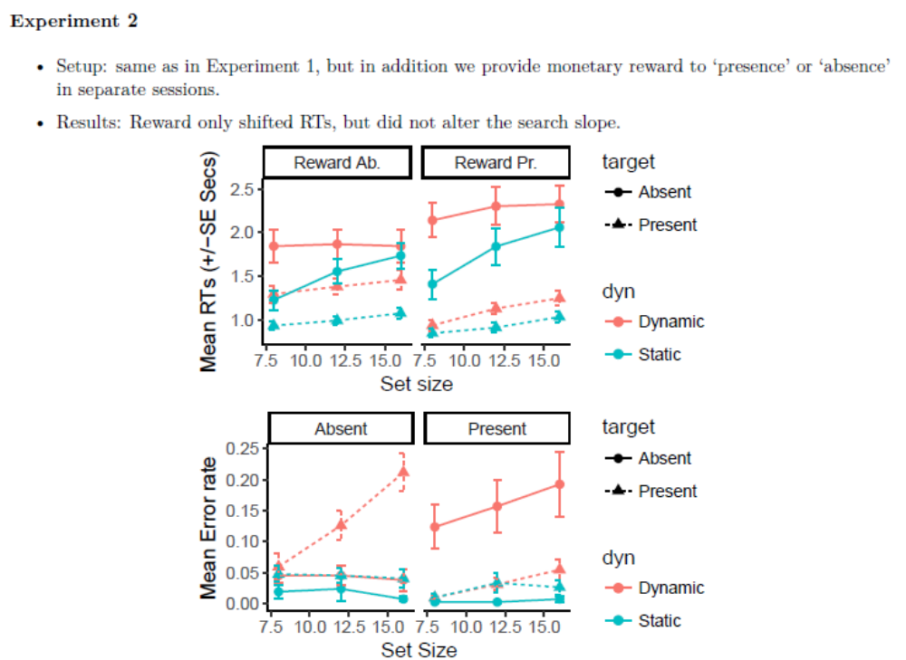

Model:
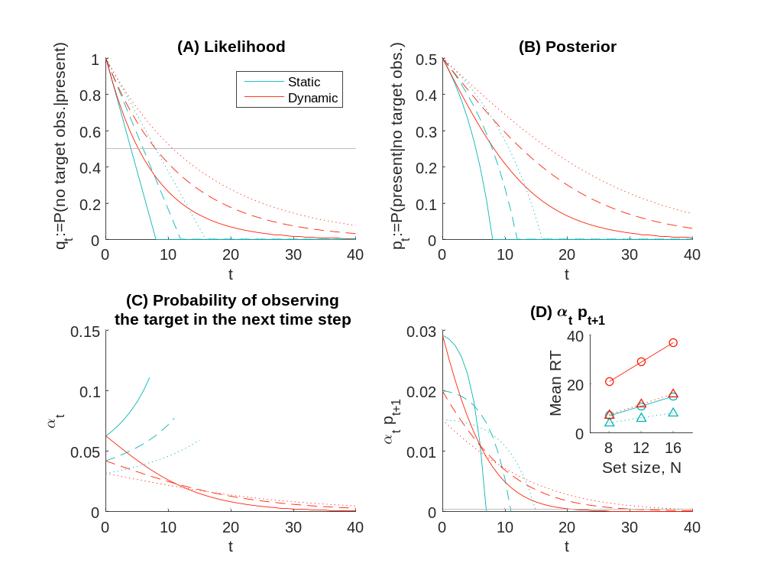
(Left) Smaller reward ($cΔt/r=0.002$); (Right) Larger reward ($cΔt/r=0.0004$).

