Strust ile E-ticaret Örneği

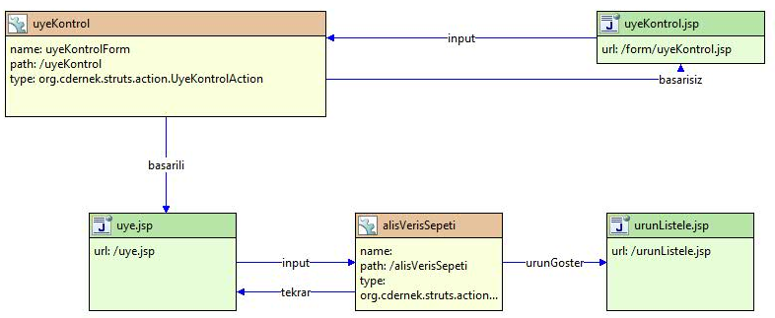
uyeKontrol.jsp
<body>
<html:form action="/uyeKontrol">
password : <html:password property="password"/><html:errors property="password"/><br/>
user : <html:text property="user"/><html:errors property="user"/><br/>
<html:submit/><html:cancel/>
</html:form>
</body>

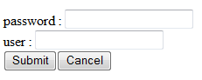
UyeKontrolAction.java
public ActionForward execute(ActionMapping mapping, ActionForm form,
HttpServletRequest request, HttpServletResponse response) {
UyeKontrolForm uyeKontrolForm = (UyeKontrolForm) form;// TODO Auto-generated method stub
String user = uyeKontrolForm.getUser();
String password = uyeKontrolForm.getPassword();
if (user.equals("ahmet") && password.equals("123"))
return mapping.findForward("basarili");
return mapping.findForward("basarisiz");
}

uye.jsp
<body><font size="5"><strong>&Uuml;r&uuml;n Listesi</strong></font><br><br>

<table width="508" border="1" height="168">
<tbody><tr>
<td>&nbsp;&Uuml;r&uuml;n kod<br></td>
<td>&nbsp;İsmi</td>
<td>&nbsp;Miktarı</td>
<td>&nbsp;Fiyatı</td>
<td>&nbsp;Durum</td>
<td>&nbsp;A&ccedil;ıklama</td></tr>
<tr>
<td>&nbsp;elma1</td>
<td>&nbsp;Kirmizi&nbsp; renkli elma <br></td>
<td>&nbsp;</td>
<td>&nbsp;1</td>
<td>&nbsp;<html:link action="/alisVerisSepeti.do?kod=0">Sepete Ekle</html:link><br></td>
<td>&nbsp;Ayrıntı</td></tr>
<tr>
<td>&nbsp;port1</td>
<td>&nbsp;Portakal renkli<br></td>
<td>&nbsp;</td>
<td>&nbsp;2</td>
<td>&nbsp;<html:link action="/alisVerisSepeti.do?kod=1">Sepete Ekle</html:link></td>
<td>&nbsp;Ayrıntı</td></tr>
<tr>
<td>&nbsp;nar1</td>
<td>&nbsp;Kırmızı</td>
<td>&nbsp;</td>
<td>&nbsp;1</td>
<td>&nbsp;<html:link action="/alisVerisSepeti.do?kod=2">Sepete Ekle</html:link></td>
<td>&nbsp;Ayrıntı</td></tr>
</tbody></table><br><font size="5"><html:link action="/alisVerisSepeti.do?durum=1">Sepeti G&ouml;ster</html:link><br></font><br>
</body>

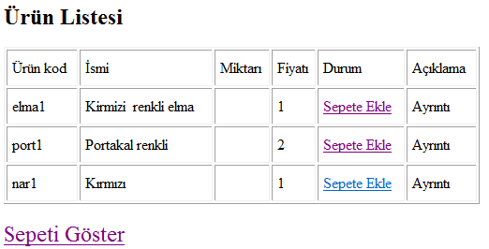
AlisVerisSepetiAction.java
public ActionForward execute(ActionMapping mapping, ActionForm form,
HttpServletRequest request, HttpServletResponse response) {
// TODO Auto-generated method stub

String kod = request.getParameter("kod");
String durum = request.getParameter("durum");
HttpSession session = request.getSession();
if (durum==null) {
Sepet sep = (Sepet) session.getAttribute("sepet");
if (sep == null) {
sep = new Sepet();
session.setAttribute("sepet", sep);
}

sep.ekle(new Urunler().getUrun(kod));
System.out.println(kod);
return mapping.findForward("tekrar");
}
return mapping.findForward("urunGoster");
}

urunListele.jsp
<%@ taglib uri="http://jakarta.apache.org/struts/tags-bean"
prefix="bean"%>
<%@ taglib uri="http://jakarta.apache.org/struts/tags-logic"
prefix="logic"%>
<%@ taglib uri="http://java.sun.com/jsp/jstl/core" prefix="c"%>
<html>

<body>
urun listele
<%--
<ul>
<c:forEach var="urun" items="${sepet.urunler}">
<li>
<c:out value="${urun.ad}"/>
</li>
</c:forEach>
</ul>
--%>
<hr />
<table border="1">
<tr>
<th>
Urun Ad
</th>
<th>
Fiyat
</th>
</tr>
<logic:iterate id="urun" name="sepet" property="urunler">
<tr>
<td>
<bean:write name="urun" property="ad" />
</td>
<td>
<bean:write name="urun" property="fiyat" />
</td>

</tr>
</logic:iterate>

</table>
</body>
</html>

Sepet.java
package org.cdernek.struts.action;
import java.util.ArrayList;
import java.util.List;

public class Sepet implements java.io.Serializable{

private List urunler;

public Sepet() {
urunler=new ArrayList();
//System.out.println("sepet constr");
}

public void ekle(Urun urun){
urunler.add(urun);
System.out.println(urunler.size());
}

public List getUrunler(){
return urunler;
}

public boolean sil(Urun urun){
return urunler.remove(urun);
}

}

Urun.java
package org.cdernek.struts.action;

public class Urun implements java.io.Serializable{
private String ad;
private String kod;
private double fiyat;

public Urun() {
}

public Urun(String ad, String kod, double fiyat) {
super();
this.ad = ad;
this.kod = kod;
this.fiyat = fiyat;
}

public String getAd() {
return ad;
}

public void setAd(String ad) {
this.ad = ad;
}

public String getKod() {
return kod;
}

public void setKod(String kod) {
this.kod = kod;
}

public double getFiyat() {
return fiyat;
}

public void setFiyat(double fiyat) {
this.fiyat = fiyat;
}

}

Urunler.java
package org.cdernek.struts.action;

import java.util.ArrayList;
import java.util.List;

public class Urunler implements java.io.Serializable {

/**
*
*/

private List<Urun> urunler;

public Urunler() {
// TODO Auto-generated constructor stub
urunler = new ArrayList<Urun>();
urunler.add(new Urun("elma", "elm", 5));
urunler.add(new Urun("portakal", "port", 4));
urunler.add(new Urun("nar", "nr", 6));
}

public Urun getUrun(String kod1) {
int kod = Integer.parseInt(kod1);
return (Urun) urunler.get(kod);
}
}

