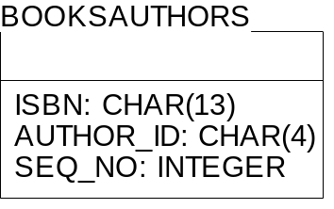
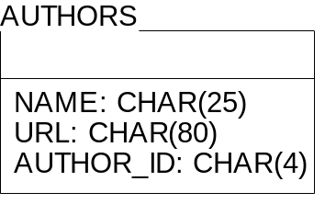

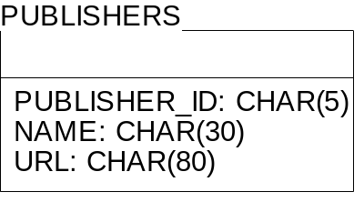
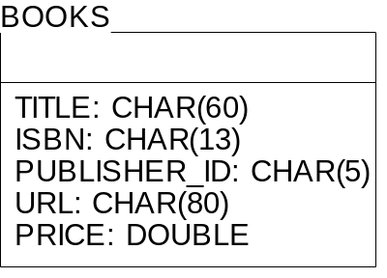
String authorPublisherQuery =
"SELECT Books.Price, Books.Title " +
"FROM Books, BooksAuthors, Authors, Publishers " +
"WHERE Authors.Author_Id = BooksAuthors.Author_Id AND " +
"BooksAuthors.ISBN = Books.ISBN AND " +
"Books.Publisher_Id = Publishers.Publisher_Id AND " +
"Authors.Name = ? AND " +
"Publishers.Name = ?";

