http://docs.oracle.com/javafx/index.html

What Is JavaFX?
The JavaFX platform is the evolution of the Java client platform designed to enable application developers to easily create and deploy rich internet applications (RIAs) that behave consistently across multiple platforms. Built on Java technology, the JavaFX platform provides a rich set of graphics and media API with high-performance hardware-accelerated graphics and media engines that simplify development of data-driven enterprise client applications.
Investing in the JavaFX platform provides the following advantages to Java developers and companies that are part of the Java ecosystem:
- Because the JavaFX platform is written in Java, Java developers can leverage their existing skills and tools to develop JavaFX applications.
- Because Java is widely used, it is easy to find experienced Java developers who can quickly become productive building JavaFX applications.
- By using a homogenous set of Java technologies for both the server and the client platforms, the JavaFX platform reduces the risk of investment by reducing the complexity of the business solutions.
- Development costs are also reduced because of the aforementioned advantages.
- The JavaFX platform provides developers with a development framework and runtime environment to create enterprise and business applications that run across multiple platforms that support Java.

A Brief History of JavaFX
At the JavaOne 2007 conference, Sun Microsystems introduced the JavaFX platform to help content developers and application developers to create content-rich applications for mobile devices, desktops, televisions, and other consumer devices. The initial offering consisted of the JavaFX Mobile platform and the JavaFX Script language. Multiple public releases were delivered after the initial announcement; the 1.3 version was released on April 22, 2010.
After Oracle's acquisition of Sun Microsystems, Oracle announced during the JavaOne 2010 conference that support for the JavaFX Script language would be discontinued. However, it was also announced that the JavaFX Script APIs will be ported to Java and would be released as part of the JavaFX 2 product. This announcement meant that the JavaFX capabilities will become available to all Java developers, without the need for them to learn a new scripting language. With this announcement, Oracle has committed to making JavaFX the premier environment for rich client applications.

What's New in JavaFX 2?
The main focus areas for the JavaFX 2 release include the following features, many of which are also described in the JavaFX Architecture and Framework document:
- Java APIs for JavaFX that provide all the familiar language features (such as generics, annotations, and multithreading) that Java developers are accustomed to using. The APIs are designed to be friendly to alternative JVM languages, such as JRuby and Scala. Because the JavaFX capabilities are available through Java APIs, you can continue to use your favorite Java developer tools (such as IDEs, code refactoring, debuggers, and profilers) to develop JavaFX applications.
- A new graphics engine to handle modern graphics processing units (GPUs). The basis of this new engine is a hardware accelerated graphics pipeline, called Prism, that is coupled with a new windowing toolkit, called Glass. This graphics engine provides the foundation for current and future advancements for making rich graphics simple, smooth, and fast.
- FXML, a new declarative markup language that is XML-based and is used for defining the user interface in a JavaFX application. It is not a compiled language and, hence, does not require you to recompile the code every time you make a change to the layout.
- A new media engine that supports playback of the web multimedia content. It provides a stable, low latency media framework that is based on the GStreamer multimedia framework.
- A web component that gives the capability of embedding web pages within a JavaFX application using the WebKit HTML rendering technology. Hardware accelerated rendering is made available using Prism.
- A refreshed browser plug-In for JavaFX 2 that allows the loading of JavaFX applets based on Prism.
- A wide variety of built-in UI controls, which include Charts, Tables, Menus, and Panes. Additionally, an API is provided to allow third parties to contribute UI controls that the user community can use.
- Sample applications that showcase the different features of the JavaFX 2 technology, along with a large number of code samples and snippets.
- An updated doclet used with the Javadoc tool to generate JavaFX API documentation in HTML format. Detailed information on how to use this updated doclet can be found in Using a Doclet with JavaFX.

JavaFX Architecture and Framework
The JavaFX 2 platform is a rich client platform built on Java technology and designed to enable application developers to easily create and deploy rich Internet applications (RIAs) that behave consistently across platforms
Figure 1 illustrates the architectural components of the JavaFX 2 platform. The sections following the diagram describe each component and how the parts interconnect. Below the JavaFX public APIs lies the engine that runs your JavaFX code. It is composed of subcomponents that include the new JavaFX high performance graphics engine, called Prism; the new small and efficient windowing system, called Glass; a media engine, and a web engine. Although these components are not exposed publicly, their descriptions can help you to better understand what runs a JavaFX application.
Figure 1 JavaFX 2 Architecture Diagram
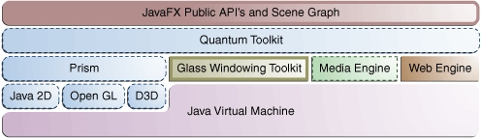
Description of "Figure 1 JavaFX 2 Architecture Diagram"

Scene Graph
The JavaFX scene graph, shown as part of the top layer in Figure 1, is the starting point for constructing a JavaFX application. It is a hierarchical tree of nodes that represents all of the visual elements of the application's user interface. It can handle input and can be rendered.
A single element in a scene graph is called a node. Each node has an ID, style class, and bounding volume. With the exception of the root node of a scene graph, each node in a scene graph has a single parent and zero or more children. It can also have the following:
- Effects, such as blurs and shadows
- Opacity
- Transforms
- Event handlers (such as mouse, key and input method)
- An application-specific state
Unlike in Swing and Abstract Window Toolkit (AWT), the JavaFX scene graph also has the graphics primitives, such as rectangles and text, in addition to having controls, layout containers, images and media.
For most uses, the scene graph simplifies working with UIs, especially when rich UIs are used. Animating various graphics in the scene graph can be accomplished quickly using the javafx.animation APIs, and declarative methods, such as XML doc, also work well.
The javafx.scene API allows the creation and specification of several types of content, such as:
- Nodes: Shapes (2-D and 3-D), images, media, embedded web browser, text, UI controls, charts, groups, and containers
- State: Transforms (positioning and orientation of nodes), visual effects, and other visual state of the content
- Effects: Simple objects that change the appearance of scene graph nodes, such as blurs, shadows, and color adjustment

Java APIs for JavaFX Features
The JavaFX 2 platform includes a complete set of public APIs, also shown in the topmost layer in Figure 1. These APIs provide unparalleled freedom and flexibility to construct rich client applications (RIAs). The JavaFX platform combines the best capabilities of the Java platform with comprehensive, immersive media functionality into an intuitive and comprehensive one-stop development environment. These new Java APIs for JavaFX features:
- Allow the use of powerful Java features, such as generics, annotations, and multithreading.
- Make it easier for Web developers to use JavaFX from other popular dynamic languages, such as JRuby, Groovy, and JavaScript.
- Allow Java developers to use other system languages, such as Groovy, for writing large or complex JavaFX applications.
- Allow the use of binding similar to that in JavaFX Script language. This includes support for high performance lazy binding, binding expressions, bound sequence expressions, and partial bind reevaluation. Alternative languages (like Groovy) can use this binding library to introduce binding syntax similar to that of JavaFX Script.
- Extend the Java collections library to include observable lists and maps, which allow applications to wire user interfaces to data models, observe changes in those data models, and update the corresponding UI control accordingly.
The JavaFX 2 APIs and programming model are a continuation of the JavaFX 1.x product line. Most of the JavaFX APIs have been ported directly to Java. Some APIs, such as Layout and Media, along with many other details, have been improved and simplified based on feedback received from users of the JavaFX 1.x release. JavaFX 2 relies more on web standards, such as CSS for styling controls and ARIA for accessibility specifications. The use of additional web standards is also under review.

Graphics System
The JavaFX Graphics System, shown in blue in Figure 1, is an implementation detail beneath the JavaFX scene graph layer. It supports both 2-D and 3-D scene graphs. It provides software rendering when the graphics hardware on a system is insufficient to support hardware accelerated rendering.
Two graphics accelerated pipelines are implemented on the JavaFX 2 platform:
- Prism processes render jobs. It can run on both hardware and software renderers, including 3-D. It is responsible for rasterization and rendering of JavaFX scenes. The following multiple render paths are possible based on the device being used:
  - DirectX 9 on Windows XP and Windows Vista
  - DirectX 11 on Windows 7
  - OpenGL on Mac, Linux, Embedded
  - Java2D when hardware acceleration is not possible
The fully hardware accelerated path is used when possible, but when it is not available, the Java2D render path is used because the Java2D render path is already distributed in all of the Java Runtime Environments (JREs). This is particularly important when handling 3-D scenes. However, performance is better when the hardware render paths are used.
- Quantum Toolkit ties Prism and Glass Windowing Toolkit together and makes them available to the JavaFX layer above them in the stack. It also manages the threading rules related to rendering versus events handling.

Glass Windowing Toolkit
The Glass Windowing Toolkit, shown in beige in the middle portion of Figure 1, is the lowest level framework for the JavaFX 2 graphics stack. Its main responsibility is to provide native operating services, such as managing the windows, timers, and surfaces. It serves as the platform-dependent layer that connects the JavaFX platform to the native operating system.
The Glass toolkit is also responsible for managing the event queue. Unlike the Abstract Window Toolkit (AWT), which manages its own event queue, the Glass toolkit uses the native operating system's event queue functionality to schedule thread usage. Also unlike AWT, the Glass toolkit runs on the same thread as the JavaFX application. In AWT, the native half of AWT runs on one thread and the Java level runs on another thread. This introduces a lot of issues, many of which are resolved in JavaFX by using the single JavaFX application thread approach.

Threads
The system runs two or more of the following threads at any given time.
- JavaFX application thread: This is the primary thread used by JavaFX application developers. Any “live” scene, which is a scene that is part of a window, must be accessed from this thread. A scene graph can be created and manipulated in a background thread, but when its root node is attached to any live object in the scene, that scene graph must be accessed from the JavaFX application thread. This enables developers to create complex scene graphs on a background thread while keeping animations on 'live' scenes smooth and fast. The JavaFX application thread is a different thread from the Swing and AWT Event Dispatch Thread (EDT), so care must be taken when embedding JavaFX code into Swing applications.
- Prism render thread: This thread handles the rendering separately from the event dispatcher. It allows frame N to be rendered while frame N +1 is being processed. This ability to perform concurrent processing is a big advantage, especially on modern systems that have multiple processors. The Prism render thread may also have multiple rasterization threads that help off-load work that needs to be done in rendering.
- Media thread: This thread runs in the background and synchronizes the latest frames through the scene graph by using the JavaFX application thread.

Pulse
A pulse is an event that indicates to the JavaFX scene graph that it is time to synchronize the state of the elements on the scene graph with Prism. A pulse is throttled at 60 frames per second (fps) maximum and is fired whenever animations are running on the scene graph. Even when animation is not running, a pulse is scheduled when something in the scene graph is changed. For example, if a position of a button is changed, a pulse is scheduled.
When a pulse is fired, the state of the elements on the scene graph is synchronized down to the rendering layer. A pulse enables application developers a way to handle events asynchronously. This important feature allows the system to batch and execute events on the pulse.
Layout and CSS are also tied to pulse events. Numerous changes in the scene graph could lead to multiple layout or CSS updates, which could seriously degrade performance. The system automatically performs a CSS and layout pass once per pulse to avoid performance degradation. Application developers can also manually trigger layout passes as needed to take measurements prior to a pulse.
The Glass Windowing Toolkit is responsible for executing the pulse events. It uses the high-resolution native timers to make the execution.

Media and Images
JavaFX media functionality is available through the javafx.scene.media APIs. JavaFX supports both visual and audio media. Support is provided for MP3, AIFF, and WAV audio files and FLV video files. JavaFX media functionality is provided as three separate components: the Media object represents a media file, the MediaPlayer plays a media file, and a MediaView is a node that displays the media.
The Media Engine component, shown in green in Figure 1, has been completely redesigned for JavaFX 2 to increase stability, improve performance, and provide consistent behavior across platforms. For more information, read the Incorporating Media Assets into JavaFX Applications document.

Embedded Browser
The JavaFX embedded browser is a new JavaFX user interface component that provides a web viewer and full browsing functionality through its API. This Web Engine component, shown in orange in Figure 1, is based on WebKit, which is an open source web browser engine that supports HTML5, CSS, JavaScript, DOM, and SVG. It enables developers to implement the following features in their Java applications:
- Render HTML content from local or remote URL
- Support history and provide Back and Forward navigation
- Reload the content
- Apply effects to the web component
- Edit the HTML content
- Execute JavaScript commands
- Handle events
This embedded browser component is composed of the following classes:
- WebEngine provides basic web page browsing capability.
- WebView encapsulates a WebEngine object, incorporates HTML content into an application's scene, and provides fields and methods to apply effects and transformations. It is an extension of a Node class.
For more detailed overview of the JavaFX embedded browser, see the Adding HTML Content to JavaFX Applications document.

CSS
JavaFX Cascading Style Sheets (CSS) provides the ability to apply customized styling to the user interface of a JavaFX application without changing any of that application's source code. CSS can be applied to any node in the JavaFX scene graph and are applied to the nodes asynchronously. JavaFX CSS styles can also be easily assigned to the scene at runtime, allowing an application's appearance to dynamically change.
Figure 2 demonstrates the application of two different CSS styles to the same set of UI controls.

eFigure 2 CSS Style Sheet Sample
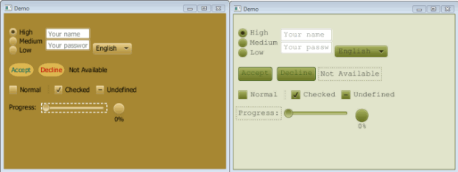
Description of "Figure 2 CSS Style Sheet Sample"
JavaFX CSS is based on the W3C CSS version 2.1 specifications, with some additions from current work on version 3. The JavaFX CSS support and extensions have been designed to allow JavaFX CSS style sheets to be parsed cleanly by any compliant CSS parser, even one that does not support JavaFX extensions. This enables the mixing of CSS styles for JavaFX and for other purposes (such as for HTML pages) into a single style sheet. All JavaFX property names are prefixed with a vendor extension of “-fx-“, including those that might seem to be compatible with standard HTML CSS, because some JavaFX values have slightly different semantics.
For more detailed information about JavaFX CSS, see the Skinning JavaFX Applications with CSS article.

UI Controls
The JavaFX UI controls available through the JavaFX API are built by using nodes in the scene graph. They can take full advantage of the visually rich features of the JavaFX platform and are portable across different platforms. JavaFX CSS allows for theming and skinning of the UI controls.
Figure 3 shows some of the UI controls that are currently supported. New Java UI controls, like TitlePane or Accordion, have been introduced with the JavaFX 2 SDK. These new controls reside in the javafx.scene.control package.
Figure 3 JavaFX UI Controls Sample
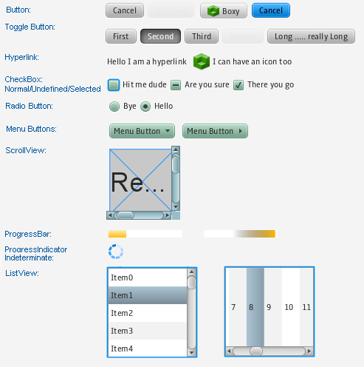
Description of "Figure 3 JavaFX UI Controls Sample"
For more detailed information about all the available JavaFX UI controls, see the Using JavaFX UI Controls document and the API documentation for the javafx.scene.control package.

Layout
Layout containers or panes can be used to allow for flexible and dynamic arrangements of the UI controls within a scene graph of a JavaFX application. The JavaFX Layout API includes the following container classes that automate common layout models:
- The BorderPane class lays out its content nodes in the top, bottom, right, left, or center region.
- The HBox class arranges its content nodes horizontally in a single row.
- The VBox class arranges its content nodes vertically in a single column.
- The StackPane class places its content nodes in a back-to-front single stack.
- The GridPane class enables the developer to create a flexible grid of rows and columns in which to lay out content nodes.
- The FlowPane class arranges its content nodes in either a horizontal or vertical “flow,” wrapping at the specified width (for horizontal) or height (for vertical) boundaries.
- The TilePane class places its content nodes in uniformly sized layout cells or tiles
- The AnchorPane class enables developers to create anchor nodes to the top, bottom, left side, or center of the layout.
To achieve a desired layout structure, different containers can be nested within a JavaFX application.
To learn more about how to work with layouts, see the Working with Layouts in JavaFX article. For more information about the JavaFX layout API, see the API documentation for the javafx.scene.layout package.

2-D and 3-D Transformations
Each node in the JavaFX scene graph can be transformed in the x-y coordinate using the following javafx.scene.tranform classes:
- translate – Move a node from one place to another along the x, y, z planes relative to its initial position.
- scale – Resize a node to appear either larger or smaller in the x, y, z planes, depending on the scaling factor.
- shear – Rotate one axis so that the x-axis and y-axis are no longer perpendicular. The coordinates of the node are shifted by the specified multipliers.
- rotate – Rotate a node about a specified pivot point of the scene.
- affine – Perform a linear mapping from 2-D/3-D coordinates to other 2-D/3-D coordinates while preserving the 'straight' and 'parallel' properties of the lines. This class should be used with Translate, Scale, Rotate, or Shear transform classes instead of being used directly.
To learn more about working with transformations, see the Applying Transformations in JavaFX document. For more information about the javafx.scene.transform API classes, see the API documentation.

Visual Effects
The development of rich client interfaces in the JavaFX scene graph involves the use of Visual Effects or Effects to enhance the look of JavaFX applications in real time. The JavaFX Effects are primarily image pixel-based and, hence, they take the set of nodes that are in the scene graph, render it as an image, and apply the specified effects to it.
Some of the visual effects available in JavaFX include the use of the following classes:
- Drop Shadow – Renders a shadow of a given content behind the content to which the effect is applied.
- Reflection – Renders a reflected version of the content below the actual content.
- Lighting – Simulates a light source shining on a given content and can give a flat object a more realistic, three-dimensional appearance.
For examples on how to use some of the available visual effects, see the Creating Visual Effects document. For more information about all the available visual effects classes, see the API documentation for the javafx.scene.effect package.

Deployment
JavaFX applications can be deployed on a desktop or in a browser in three different deployment modes:
- Standalone – The JavaFX application is installed on a local drive and is run by double-clicking the JAR file. This mode is ideal when users do not need or do not have online access.
- Browser – In this mode, the JavaFX application is embedded in a web page and is started automatically when the web page is accessed. It can interact with the web page through JavaScript.
- Web Start – This mode downloads the application from a central location on the web and then runs it on the desktop. Once it is downloaded, users can start the application by double-clicking the JNLP file.
For more information about these three different modes and how to prepare your JavaFX application for deployment, see the Deploying JavaFX Applications document.

http://docs.oracle.com/javafx/2/get_started/jfxpub-get_started.htm

About This Tutorial
This collection of tutorials is designed to get you started with common JavaFX tasks, including working with layouts, controls, style sheets, and visual effects.
Hello World, JavaFX Style | Form Design in JavaFX | Fancy Design with CSS
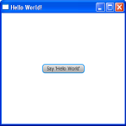 | 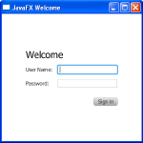 | 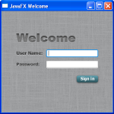
User Interface Design with FXML | Animated Shapes and Visual Effects | Deployment Quickstart
 |  | 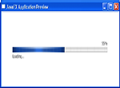

1 Hello World, JavaFX Style
The best way to teach you what it is like to create and build a JavaFX application is with a “Hello World” application. An added benefit of this tutorial is that enables you to test that your JavaFX technology is properly installed.
The tool used in this tutorial is NetBeans IDE 7.1. Before you begin, ensure that the version of NetBeans IDE that you are using supports JavaFX 2. See the System Requirements for details.

Construct the Application
- From the File menu, choose New Project.
- In the JavaFX application category, choose JavaFX Application. Click Next.
- Name the project HelloWorld and click Finish.
NetBeans opens the HelloWorld.java file and populates it with the code for a basic Hello World application, as shown in Example 1-1.
Example 1-1 Hello World
package helloworld;

import javafx.application.Application;
import javafx.event.ActionEvent;
import javafx.event.EventHandler;
import javafx.scene.Scene;
import javafx.scene.control.Button;
import javafx.scene.layout.StackPane;
import javafx.stage.Stage;

public class HelloWorld extends Application {
public static void main(String[] args) {
launch(args);
}

@Override
public void start(Stage primaryStage) {
primaryStage.setTitle("Hello World!");
Button btn = new Button();
btn.setText("Say 'Hello World'");
btn.setOnAction(new EventHandler<ActionEvent>() {

@Override
public void handle(ActionEvent event) {
System.out.println("Hello World!");
}
});

StackPane root = new StackPane();
root.getChildren().add(btn);
primaryStage.setScene(new Scene(root, 300, 250));
primaryStage.show();
}
}
Here are the important things to know about the basic structure of a JavaFX application:
- A JavaFX application defines the user interface container by means of a stage and a scene. The JavaFX Stage class is the top-level JavaFX container. The JavaFX Scene class is the container for all content. Example 1-1 creates the stage and scene and makes the scene visible in a given pixel size.
- In JavaFX, the content of the scene is represented as a hierarchical scene graph of nodes. In this example, the root node is a StackPane object, which is a resizable layout node. This means that the root node's size tracks the scene's size and changes when the stage is resized by a user.
- The root node contains one child node, a button control with text, plus an event handler to print a message when the button is pressed.
Figure 1-1 shows the scene graph for the Hello World application.

Figure 1-1 Hello World Scene Graph
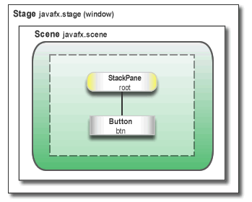
Description of "Figure 1-1 Hello World Scene Graph"

Run the Application
Run the application, click the Say Hello World button, and verify that the text "Hello World!" is printed to the NetBeans output window. Figure 1-2 shows the Hello World application, JavaFX style.
Figure 1-2 Hello World, JavaFX style
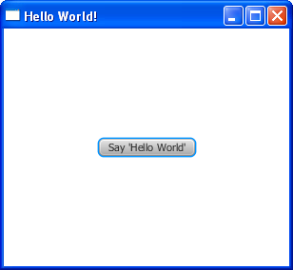
Description of "Figure 1-2 Hello World, JavaFX style"

Where to Go Next
This concludes the basic Hello World tutorial, but continue reading for more lessons on developing JavaFX applications:
- Creating a Form in JavaFX teaches the basics of screen layout, how to add controls to a layout, and how to create input events.
- Fancy Forms with JavaFX CSS provides simple style tricks for enhancing your application, including adding a background image and styling buttons and text.
- Using FXML to Create a User Interface shows an alternate method for creating the login user interface. FXML is an XML-based language that provides the structure for building a user interface separate from the application logic of your code.
- Animation and Visual Effects in JavaFX shows how to bring an application to life by adding timeline animation and blend effects.
- Deploying Your First JavaFX Application describes ho w to run your application outside NetBeans IDE.

2 Creating a Form in JavaFX
Creating a form is a common activity when developing an application. In this tutorial, you will use JavaFX to build the login form shown in Figure 2-1. This tutorial teaches you the basics of screen layout, how to add controls to a layout pane, and how to create input events.
Figure 2-1 Login Form
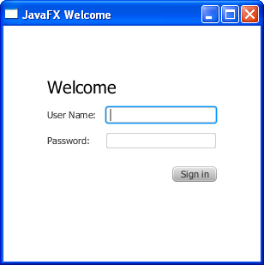
Description of "Figure 2-1 Login Form"
The tool used in this Getting Started tutorial is NetBeans IDE. Before you begin, ensure that the version of NetBeans IDE that you are using supports JavaFX 2. See the System Requirements for details.

Create the Project
Your first task is to create a JavaFX project in NetBeans IDE and name it Login:
- From the File menu, choose New Project.
- In the JavaFX application category, choose JavaFX Application. Click Next.
- Name the project Login and click Finish.
When you create a JavaFX project, NetBeans IDE provides a Hello World application as a starting point, which you have already seen if you followed the Hello World tutorial.
- Remove the start() method that NetBeans IDE generated and replace it with the code in Example 2-1.
Example 2-1 Application Stage
@Override
public void start(Stage primaryStage) {
primaryStage.setTitle("JavaFX Welcome");

primaryStage.show();
}
Tip: After you add sample code into a NetBeans project, press Ctrl (or Cmd) + Shift + I to import the required packages. When there is a choice of import statements, choose the one that starts with javafx.

Create a GridPane Layout
For the login form, use a GridPane layout because it enables you to create a flexible grid of rows and columns in which to lay out controls. You can place controls in any cell in the grid, and you can make controls span cells as needed.
The code to create the GridPane layout is in Example 2-2. Add the code before the line primaryStage.show();
Example 2-2 GridPane with Gap and Padding Properties
GridPane grid = new GridPane();
grid.setAlignment(Pos.CENTER);
grid.setHgap(10);
grid.setVgap(10);
grid.setPadding(new Insets(25, 25, 25, 25));

Scene scene = new Scene(grid, 300, 275);
primaryStage.setScene(scene);
Example 2-2 creates a GridPane object and assigns it to the variable named grid. The alignment property changes the default position of the grid from the top left of the scene to the center. The gap properties manage the spacing between the rows and columns, while the padding property manages the space around the edges of the grid pane. The insets are in the order of top, right, bottom, and left. In this example, there are 25 pixels of padding on each side.
The scene is created with the grid pane as the root node, which is a common practice when working with layout containers. Thus, as the window is resized, the nodes within the grid pane are resized according to their layout constraints. In this example, the grid pane remains in the center when you grow or shrink the window. The padding properties ensure there is a padding around the grid pane when you make the window smaller.
This code sets the scene width and height to 300 by 275. If you do not set the scene dimensions, the scene defaults to the minimum size needed to display its contents.

Add Text, Labels, and Text Fields
Looking at Figure 2-1, you can see that the form requires the title "Welcome " and text and password fields for gathering information from the user. The code for creating these controls is in Example 2-3. Add this code after the line that sets the grid padding property.
Example 2-3 Controls
Text scenetitle = new Text("Welcome");
scenetitle.setFont(Font.font("Tahoma", FontWeight.NORMAL, 20));
grid.add(scenetitle, 0, 0, 2, 1);

Label userName = new Label("User Name:");
grid.add(userName, 0, 1);

TextField userTextField = new TextField();
grid.add(userTextField, 1, 1);

Label pw = new Label("Password:");
grid.add(pw, 0, 2);

PasswordField pwBox = new PasswordField();
grid.add(pwBox, 1, 2);
The first line creates a Text object that cannot be edited, sets the text to Welcome, and assigns it to a variable named scenetitle. The next line uses the setFont() method to set the font family, weight, and size of the scenetitle variable. Using an inline style is appropriate where the style is bound to a variable, but a better technique for styling the elements of your user interface is by using a style sheet. In the next tutorial, Fancy Forms with JavaFX CSS, you will replace the inline style with a style sheet.
The grid.add() method adds the scenetitle variable to the layout grid. The numbering for columns and rows in the grid starts at zero, and scenetitle is added in column 0, row 0. The last two arguments of the grid.add() method set the column span to 2 and the row span to 1.
The next lines create a Label object with text User Name at column 0, row 1 and a Text Field object that can be edited. The text field is added to the grid pane at column 1, row 1. A password field and label are created and added to the grid pane in a similar fashion.
When working with a grid pane, you can display the grid lines, which is useful for debugging purposes. In this case, you set the gridLinesVisible property to true. Then, when you run the application, you see the lines for the grid columns and rows as well as the gap properties, as shown in Figure 2-2.

Figure 2-2 Login Form with Grid Lines
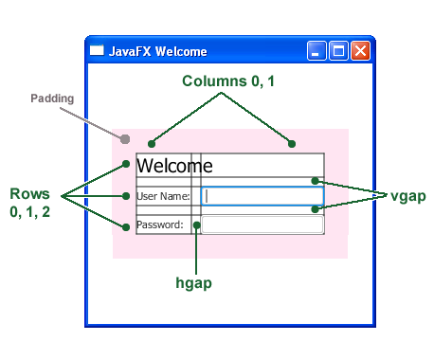
Description of "Figure 2-2 Login Form with Grid Lines"

Add a Button and Text
The final two controls required for the application are a Button control for submitting the data and a Text control for displaying a message when the user presses the button.
First, create the button and position it on the bottom right, which is a common placement for buttons that perform an action affecting the entire form. The code is in Example 2-4. Add this code before the code for the scene.
Example 2-4 Button
Button btn = new Button("Sign in");
HBox hbBtn = new HBox(10);
hbBtn.setAlignment(Pos.BOTTOM_RIGHT);
hbBtn.getChildren().add(btn);
grid.add(hbBtn, 1, 4);
The first line creates a button named btn with the label Sign in, and the second line creates an HBox layout pane named hbBtn with spacing of 10 pixels. The HBox pane sets an alignment for the button that is different from the alignment applied to the other controls in the grid pane. The alignment property has a value of Pos.BOTTOM_RIGHT, which positions a node at the bottom of the space vertically and at the right edge of the space horizontally. The button is added as a child of the HBox pane, and the HBox pane is added to the grid in column 1, row 4.
Now, add a Text control for displaying the message, as shown in Example 2-5. Add this code before the code for the scene.
Example 2-5 Text
final Text actiontarget = new Text();
grid.add(actiontarget, 1, 6);
Figure 2-3 shows the form now. You will not see the text message until you work through the next section of the tutorial, Add Code to Handle an Event.
Figure 2-3 Login Form with Button
Description of "Figure 2-3 Login Form with Button"

Add Code to Handle an Event
Finally, make the button display the text message when the user presses it. Add the code in Example 2-6 before the code for the scene.
Example 2-6 Button Event
btn.setOnAction(new EventHandler<ActionEvent>() {

@Override
public void handle(ActionEvent e) {
actiontarget.setFill(Color.FIREBRICK);
actiontarget.setText("Sign in button pressed");
}
});
The setOnAction() method is used to register an event handler that sets the actiontarget object to Sign in button pressed when the user presses the button. The color of the actiontarget object is set to firebrick red.

Run the Application
Run the application and click the Sign in button. Figure 2-4 shows the results. If you run into problems, then take a look at the code in the Login.java file
Figure 2-4 Final Login Form
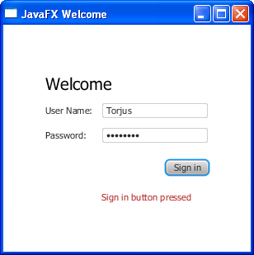
Description of "Figure 2-4 Final Login Form"

/*
* To change this template, choose Tools | Templates
* and open the template in the editor.
*/
package login_fx;

import javafx.application.Application;
import javafx.event.ActionEvent;

import javafx.event.EventHandler;
import javafx.geometry.Insets;
import javafx.geometry.Pos;
import javafx.scene.Scene;
import javafx.scene.control.Button;
import javafx.scene.control.Label;
import javafx.scene.control.PasswordField;
import javafx.scene.control.TextField;
import javafx.scene.layout.GridPane;
import javafx.scene.layout.HBox;
import javafx.scene.paint.Color;
import javafx.scene.text.Font;
import javafx.scene.text.FontWeight;
import javafx.scene.text.Text;
import javafx.stage.Stage;

/**
*
* @author Metin
*/
public class Login_FX extends Application {

@Override
public void start(Stage primaryStage) {
primaryStage.setTitle("JavaFX Welcome");
GridPane grid = new GridPane();
grid.setAlignment(Pos.CENTER);
grid.setHgap(10);
grid.setVgap(10);
grid.setPadding(new Insets(25, 25, 25, 25));
Text scenetitle = new Text("Welcome");
scenetitle.setFont(Font.font("Tahoma", FontWeight.NORMAL, 20));
grid.add(scenetitle, 0, 0, 2, 1);

Label userName = new Label("User Name:");
grid.add(userName, 0, 1);

TextField userTextField = new TextField();
grid.add(userTextField, 1, 1);

Label pw = new Label("Password:");
grid.add(pw, 0, 2);

PasswordField pwBox = new PasswordField();
grid.add(pwBox, 1, 2);

Button btn = new Button("Sign in");
HBox hbBtn = new HBox(10);
hbBtn.setAlignment(Pos.BOTTOM_RIGHT);
hbBtn.getChildren().add(btn);
grid.add(hbBtn, 1, 4);
final Text actiontarget = new Text();
grid.add(actiontarget, 1, 6);

btn.setOnAction(new EventHandler<ActionEvent>() {
@Override
public void handle(ActionEvent event) {
actiontarget.setFill(Color.FIREBRICK);
actiontarget.setText("Sign in button pressed");

}
});

Scene scene = new Scene(grid, 300, 275);
primaryStage.setScene(scene);

primaryStage.show();

}

/**
* The main() method is ignored in correctly deployed JavaFX application.
* main() serves only as fallback in case the application can not be
* launched through deployment artifacts, e.g., in IDEs with limited FX
* support. NetBeans ignores main().
*
* @param args the command line arguments
*/
public static void main(String[] args) {
launch(args);
}

}

Where to Go from Here
This concludes the basic form tutorial, but you can continue reading the following tutorials on developing JavaFX applications.
- Fancy Forms with JavaFX CSS provides tips on how to add a background image and radically change the style of the text, label, and button in the login form.
- Using FXML to Create a User Interface shows an alternate method for creating the login user interface. FXML is an XML-based language that provides the structure for building a user interface separate from the application logic of your code.
- Working With Layouts in JavaFX explains the built-in JavaFX layout panes, and tips and tricks for using them.
- Deploying Your First JavaFX Application provides information on how to run your application outside NetBeans IDE.
Also try out the JavaFX samples, which you can download from http://www.oracle.com/technetwork/java/javafx/downloads/index.html. The Ensemble sample contains examples of layouts and their source code.

3 Fancy Forms with JavaFX CSS
This tutorial is about making your JavaFX application look attractive by adding a Cascading Style Sheet (CSS). You develop a design, create a .css file, and apply the new styles. In this tutorial, you will take a Login form that uses default styles for labels, buttons, and background color, and, with a few simple CSS modifications, turn it into a stylized application, as shown in Figure 3-1.
Figure 3-1 Login Form With and Without CSS
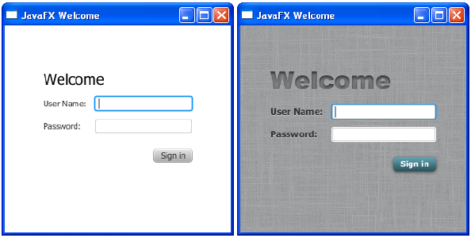
Description of "Figure 3-1 Login Form With and Without CSS"
The tool used in this Getting Started tutorial is NetBeans IDE. Before you begin, ensure that the version of NetBeans IDE that you are using supports JavaFX 2. See the System Requirements for details.

Create the Project
If you followed the Getting Started guide from the start, then you already created the Login project required for this tutorial. If not, download the Login project by right-clicking Login.zip and saving it to your file system. Extract the files from the zip file, and then open the project in NetBeans IDE.

Create the CSS File
Your first task is to create a new CSS file and save it in the same package as the main class of your application. After that, you must make the JavaFX application aware of the newly added Cascading Style Sheet.
- In the NetBeans IDE Projects window, right-click the login folder under the Source Packages directory and choose New, then Other.
- In the New File dialog box, choose Other, then Cascading Style Sheet, and click Next.
- Enter Login and click Finish.
- In the Login.java file, initialize the stylesheets variable of the Scene class to point to the Cascading Style Sheet, by including the following code before the line primaryStage.show();:
scene.getStylesheets().add(Login.class.getResource("Login.css").toExternalForm());

Add a Background Image
A background image helps make your form more attractive. For this tutorial, you add a gray background with a linen-like texture.
First, download the background image by right-clicking background.jpg and saving it to your file system. Then, copy the file into the login folder in the NetBeans project.
Now, add the code for the background-image property to the CSS file. Remember that the path is relative to the style sheet. So, in the code in Example 3-1, the background.jpg image is in the same directory as the Login.css file.
Example 3-1 Background Image
.root {
-fx-background-image: url("background.jpg");
}
The background image is applied to the .root style, which means it is applied to the root node of the Scene instance. The style definition consists of the name of the property (-fx-background-image) and the value for the property (url("background.jpg")).
Figure 3-2 shows the login form with the new gray background.
Figure 3-2 Gray Linen Background
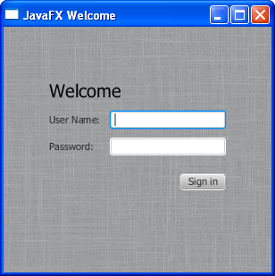
Description of "Figure 3-2 Gray Linen Background"

Style the Labels
The next controls to enhance are the labels. You will use the .label style class, which means the styles will affect all labels in the form. The code is in Example 3-2.
Example 3-2 Font Size, Fill, Weight, and Effect on Labels
.label {
-fx-font-size: 12px;
-fx-font-weight: bold;
-fx-text-fill: #333333;
-fx-effect: dropshadow( gaussian , rgba(255,255,255,0.5) , 0,0,0,1 );
}
This example increases the font size and weight and applies a drop shadow of a gray color (#333333). The purpose of the drop shadow is to add contrast between the dark gray text and the light gray background. See the section on effects in the JavaFX CSS Reference Guide for details on the parameters of the drop shadow property.
The enhanced User Name and Password labels are shown in Figure 3-3.
Figure 3-3 Bigger, Bolder Labels with Drop Shadow
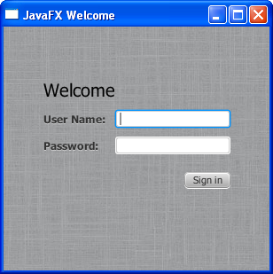
Description of "Figure 3-3 Bigger, Bolder Labels with Drop Shadow"

Style Text
Now, create some special effects on the two Text objects in the form: scenetitle, which includes the text Welcome, and actiontarget, which is the text that is returned when the user presses the Sign in button. You can apply different styles to Text objects used in such diverse ways.
- In the Login.java file, remove the inline styles currently set for the text objects:
scenetitle.setFont(Font.font("Tahoma", FontWeight.NORMAL, 20));
actiontarget.setFill(Color.FIREBRICK);
By switching to CSS over inline styles, you separate the design from the content. This approach makes it easier for a designer to have control over the style without having to modify content.
- Create an ID for each text node by using the setID() method of the Node class:
scenetitle.setId("welcome-text");
actiontarget.setId("actiontarget");
- In the Login.css file, define the style properties for the welcome-text and actiontarget IDs. For the style name, use the ID preceded by a number sign (#), as shown in Example 3-3.
Example 3-3 Text Effect
#welcome-text {
-fx-font-size: 32px;
-fx-font-family: "Arial Black";
-fx-fill: #818181;
-fx-effect: innershadow( three-pass-box , rgba(0,0,0,0.7) , 6, 0.0 , 0 , 2 );
}
#actiontarget {
-fx-fill: FIREBRICK;
-fx-font-weight: bold;
-fx-effect: dropshadow( gaussian , rgba(255,255,255,0.5) , 0,0,0,1 );
}
The size of the Welcome text is increased to 32 points and the font is changed to Arial Black. The text fill color is set to a dark gray color (#818181) and an inner shadow effect is applied, creating an embossing effect. You can apply an inner shadow to any color by changing the text fill color to be a darker version of the background. See the section on effects in the JavaFX CSS Reference Guide for details about the parameters of inner shadow property.
The style definition for actiontarget is similar to what you have seen before.
Figure 3-4 shows the font changes and shadow effects on the two Text objects.
Figure 3-4 Text with Shadow Effects
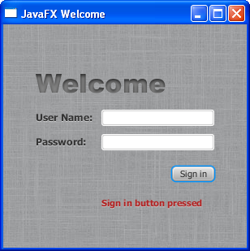
Description of "Figure 3-4 Text with Shadow Effects"

Style the Button
The next step is to style the button, making it change style when the user hovers the mouse over it. This change will give users an indication that the button is interactive, a standard design practice.
First, create the style for the initial state of the button by adding the code in Example 3-4. This code uses the .button style class selector, such that if you add a button to the form at a later date, then the new button will also use this style.
Example 3-4 Drop Shadow for Button
.button {
-fx-text-fill: white;
-fx-font-family: "Arial Narrow";
-fx-font-weight: bold;
-fx-background-color: linear-gradient(#61a2b1, #2A5058);
-fx-effect: dropshadow( three-pass-box , rgba(0,0,0,0.6) , 5, 0.0 , 0 , 1 );
}
Now, create a slightly different look for when the user hovers the mouse over the button. You do this with the hover pseudo-class. A pseudo-class includes the selector for the class and the name for the state separated by a colon (:), as shown in Example 3-5.
Example 3-5 Button Hover Style
.button:hover {
-fx-background-color: linear-gradient(#2A5058, #61a2b1);
}
Figure 3-5 shows the initial and hover states of the button with its new blue-gray background and white bold text.
Figure 3-5 Initial and Hover Button States

Description of "Figure 3-5 Initial and Hover Button States"
Figure 3-6 shows the final application.
Figure 3-6 Final Stylized Application
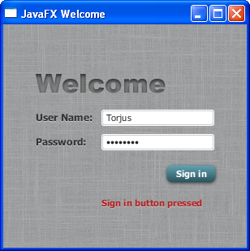
Description of "Figure 3-6 Final Stylized Application"

Where to Go from Here
Here are some things for you to try next:
- See what you can create using CSS. Some documents that can help you are Skinning JavaFX Applications with CSS, Styling Charts with CSS, and the JavaFX CSS Reference Guide.
- See Styling FX Buttons with CSS for examples of how to create common button styles using CSS.
- Try deploying your application outside NetBeans IDE. See Deploying Your First JavaFX Application.

4 Using FXML to Create a User Interface
This tutorial shows the benefits of using JavaFX FXML. If you started this document from the beginning, then you have seen how to create a login application using just JavaFX. Here, you use FXML to create the same login user interface, separating the application design from the application logic, thereby making the code easier to maintain. The login user interface you build in this tutorial is shown in Figure 4-1.
Figure 4-1 Login User Interface
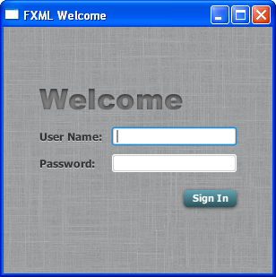
Description of "Figure 4-1 Login User Interface"
This tutorial uses NetBeans IDE. Ensure that the version of NetBeans IDE that you are using supports JavaFX 2.1. See the System Requirements for details.

Set Up the Project
Your first task is to set up a JavaFX FXML project in NetBeans IDE:
- From the File menu, choose New Project.
- In the JavaFX application category, choose JavaFX FXML Application. Click Next.
- Name the project FXMLExample and click Finish.
NetBeans IDE opens an FXML project that includes the code for a basic Hello World application. The application includes three files:
  - FXMLExample.java. This file takes care of the standard Java code required for an FXML application.
  - Sample.fxml. This is the FXML source file in which you define the user interface.
  - Sample.java. This is the controller file for handling the mouse and keyboard input.
- Rename Sample.java to FXMLExampleController.java so that the name is more meaningful for this application.
  - In the Projects window, right-click Sample.java and choose Refactor then Rename.
  - Enter FXMLExampleController, and click Refactor.
- Rename Sample.fxml to fxml_example.fxml.
  - Right-click Sample.fxml and choose Rename.
  - Enter fxml_example and click OK.

Load the FXML Source File
The first file you edit is the FXMLExample.java file. This file includes the code for setting up the application main class and for defining the stage and scene. More specific to FXML, the file uses the FXMLLoader class, which is responsible for loading the FXML source file and returning the resulting object graph.
Make the changes shown in bold in Example 4-1.
Example 4-1 FXMLExample.java
@Override
public void start(Stage stage) throws Exception {
Parent root = FXMLLoader.load(getClass().getResource("fxml_example.fxml"));

stage.setTitle("FXML Welcome");
stage.setScene(new Scene(root, 300, 275));
stage.show();
}
A good practice is to set the height and width of the scene when you create it, in this case 300 by 275; otherwise the scene defaults to the minimum size needed to display its contents.

Modify the Import Statements
Next, edit the fxml_example.fxml file. This file specifies the user interface that is displayed when the application starts. The first task is to modify the import statements so your code looks like Example 4-2.
Example 4-2 XML Declaration and Import Statements
<?xml version="1.0" encoding="UTF-8"?>

<?import javafx.geometry.*?>
<?import javafx.scene.layout.*?>
<?import javafx.scene.control.*?>
<?import javafx.scene.text.*?>
As in Java, class names can be fully qualified (including the package name), or they can be imported using the import statement, as shown in Example 4-2. If you prefer, you can use specific import statements that refer to classes.

Create a GridPane Layout
The Hello World application generated by NetBeans uses an AnchorPane layout. For the login form, you will use a GridPane layout because it enables you to create a flexible grid of rows and columns in which to lay out controls.
Remove the AnchorPane layout and its children and replace it with the GridPane layout in Example 4-3.
Example 4-3 GridPane Layout
<GridPane fx:controller="fxmlexample.FXMLExampleController"
xmlns:fx="http://javafx.com/fxml" alignment="center" hgap="10" vgap="10">
<padding><Insets top="25" right="25" bottom="10" left="25"/></padding>

</GridPane>
In this application, the GridPane layout is the root element of the FXML document and as such has two attributes. The fx:controller attribute is required when you specify controller-based event handlers in your markup. The xmlns:fx attribute is always required and specifies the fx namespace.
The remainder of the code controls the alignment and spacing of the grid pane. The alignment property changes the default position of the grid from the top left of the scene to the center. The gap properties manage the spacing between the rows and columns, while the padding property manages the space around the edges of the grid pane.
As the window is resized, the nodes within the grid pane are resized according to their layout constraints. In this example, the grid remains in the center when you grow or shrink the window. The padding properties ensure there is a padding around the grid when you make the window smaller.

Add Text and Password Fields
Looking back at Figure 4-1, you can see that the login form requires the title “Welcome” and text and password fields for gathering information from the user. The code in Example 4-4 goes inside the GridPane layout.
Example 4-4 Text, Label, TextField, and Password Field Controls
<Text text="Welcome"
GridPane.columnIndex="0" GridPane.rowIndex="0"
GridPane.columnSpan="2"/>

<Label text="User Name:"
GridPane.columnIndex="0" GridPane.rowIndex="1"/>

<TextField
GridPane.columnIndex="1" GridPane.rowIndex="1"/>

<Label text="Password:"
GridPane.columnIndex="0" GridPane.rowIndex="2"/>

<PasswordField fx:id="passwordField"
GridPane.columnIndex="1" GridPane.rowIndex="2"/>
The first line creates a Text object and sets its text value to Welcome. The GridPane.columnIndex and GridPane.rowIndex attributes correspond to the placement of the Text control in the grid. The numbering for rows and columns in the grid starts at zero, and the location of the Text control is set to (0,0), meaning it is in the first row of the first column. The GridPane.columnSpan attribute is set to 2, making the Welcome title span two columns in the grid. You will need this extra width later in the tutorial when you add a style sheet to increase the font size of the text to 32 points.
The next lines create a Label object with text User Name at column 1, row 0 and a TextField object to the right of it at column 1, row 1. Another Label and PasswordField object are created and added to the grid in a similar fashion.
When working with a grid layout, you can display the grid lines, which is useful for debugging purposes. In this case, set the gridLinesVisible property to true. Then, when you run the application, you see the lines for the grid columns and rows as well as the gap properties, as shown in Figure 4-2.
Figure 4-2 Login Form with Grid Lines
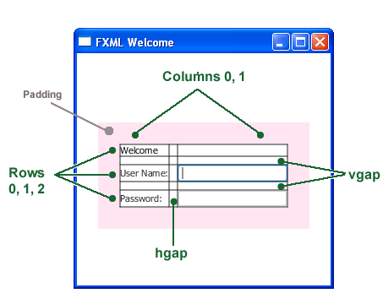
Description of "Figure 4-2 Login Form with Grid Lines"

Add a Button and Text
The final two controls required for the application are a Button control for submitting the data and a Text control for displaying a message when the user presses the button. The code is in Example 4-5. Add this code before </GridPane>.
Example 4-5 HBox, Button, and Text
<HBox spacing="10" alignment="bottom_right"
GridPane.columnIndex="1" GridPane.rowIndex="4">
<Button text="Sign In"
onAction="#handleSubmitButtonAction"/>
</HBox>

<Text fx:id="actiontarget"
GridPane.columnIndex="1" GridPane.rowIndex="6"/>
An HBox pane is needed to set an alignment for the button that is different from the default alignment applied to the other controls in the GridPane layout. The alignment property is set to bottom_right, which positions a node at the bottom of the space vertically and at the right edge of the space horizontally. The HBox pane is added to the grid in column 1, row 4.
The HBox pane has one child, a Button with text property set to Sign in and an onAction property set to handleSubmitButtonAction(). While FXML is a convenient way to define the structure of an application's user interface, it does not provide a way to implement an application's behavior. You implement the behavior for the handleSubmitButtonAction() method in Java code in the next section of this tutorial, Add Code to Handle an Event.
Assigning an fx:id value to an element, as shown in the code for the Text control, creates a variable in the document's namespace, which you can refer to from elsewhere in the code. While not required, defining a controller field helps clarify how the controller and markup are associated.

Add Code to Handle an Event
Now make the Text control display a message when the user presses the button. You do this in the FXMLController.java file. Delete the code that NetBeans IDE generated and replace it with the code in Example 4-6.
Example 4-6 FXMLExampleController.java
package fxmlexample;

import javafx.event.ActionEvent;
import javafx.fxml.FXML;
import javafx.scene.text.Text;

public class FXMLExampleController {
@FXML private Text actiontarget;

@FXML protected void handleSubmitButtonAction(ActionEvent event) {
actiontarget.setText("Sign in button pressed");
}

}
The @FXML annotation is used to tag nonpublic controller member fields and handler methods for use by FXML markup. The handleSubmtButtonAction method sets the actiontarget variable to Sign in button pressed when the user presses the button.
You can run the application now to see the complete user interface. Figure 4-3 shows the results when you type text in the two fields and click the Sign in button. If you have any problems, then you can compare your code against the FXMLLogin example.
Figure 4-3 FXML Login Window
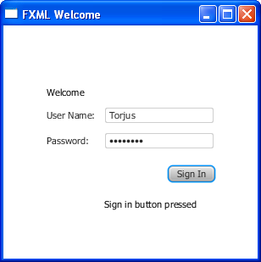
Description of "Figure 4-3 FXML Login Window"

Use a Scripting Language to Handle Events
As an alternative to using Java code to create an event handler, you can create the handler with any language that provides a JSR 223-compatible scripting engine. Such languages include JavaScript, Groovy, Jython, and Clojure.
Optionally, you can try using JavaScript now.
- In the file fxml_example.fxml, add the JavaScript declaration after the XML doctype declaration.
<?language javascript?>
- In the Button markup, change the name of the function so the call looks as follows:
onAction="handleSubmitButtonAction(event);"
- Remove the fx:controller attribute from the GridPane markup and add the JavaScript function in a <script> tag directly under it, as shown in Example 4-7.
Example 4-7 JavaScript in FXML
<GridPane xmlns:fx="http://javafx.com/fxml"
alignment="center" hgap="10" vgap="10">
<fx:script>
function handleSubmitButtonAction() {
actiontarget.setText("Calling the JavaScript");
}
</fx:script>
The result is in Figure 4-4.
Figure 4-4 Login Application Using JavaScript
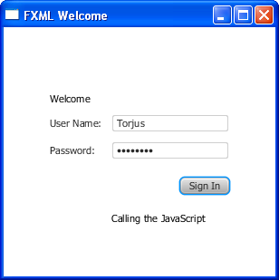
Description of "Figure 4-4 Login Application Using JavaScript"
Alternatively, you can put the JavaScript functions in an external file (such as fxml_example.js) and include the script like this:
<fx:script source="fxml_example.js"/>
If you are considering using a scripting language with FXML, then note that an IDE might not support stepping through script code during debugging.

Style the Application with CSS
The final task is to make the login application look attractive by adding a Cascading Style Sheet (CSS).
- Create a style sheet .
  - In the Project window, right-click the login folder under Source Packages and choose New, then Other.
  - In the New File dialog box, choose Other, then Cascading Style Sheet and click Next.
  - Enter Login and click Finish.
  - Copy the contents of the Login.css file attached to this document into your CSS file. For a description of the classes in the CSS file, see Fancy Forms with JavaFX CSS.
- Download the gray, linen-like image for the background in the background.jpg file and add it to the fxmlexample folder.
- Open the fxml_example.fxml file and add the style sheet to the markup for the GridPane layout as shown in Example 4-8.
Example 4-8 Style Sheet
<GridPane fx:controller="fxmlexample.FXMLExampleController"
stylesheets="fxmlexample/Login.css"
xmlns:fx="http://javafx.com/fxml" alignment="center" hgap="10" vgap="10">
- Create a welcome-text ID for the Welcome Text object so it uses the style #welcome-text defined in the CSS file, as shown in Example 4-9.
Example 4-9 Text ID
<Text id="welcome-text" text="Welcome"
GridPane.columnIndex="0" GridPane.rowIndex="0"
GridPane.columnSpan="2"/>
- Run the application. Figure 4-5 shows the stylized application.
Figure 4-5 Stylized Login Application
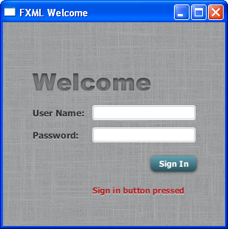
Description of "Figure 4-5 Stylized Login Application"
For information about how to run your application outside NetBeans IDE, see Deploying Your First JavaFX Application.

Where to Go from Here
Now that you are familiar with FXML, look at Introduction to FXML, which provides more information on the elements that make up the FXML language. The document is included in the javafx.fxml package in the API documentation at http://docs.oracle.com/javafx/2/api/javafx/fxml/doc-files/introduction_to_fxml.html.

5 Animation and Visual Effects in JavaFX
You can use JavaFX to quickly develop applications with rich user experiences. In this Getting Started tutorial, you will create the application in Figure 5-1 and learn to create animated objects and attain complex effects with very little coding.
Figure 5-1 Colorful Circles Application

Description of "Figure 5-1 Colorful Circles Application"
Figure 5-2 shows the scene graph for the ColorfulCircles application. Nodes that branch are instantiations of the Group class, and the nonbranching nodes, also known as leaf nodes, are instantiations of the Rectangle and Circle classes.
Figure 5-2 Colorful Circles Scene Graph
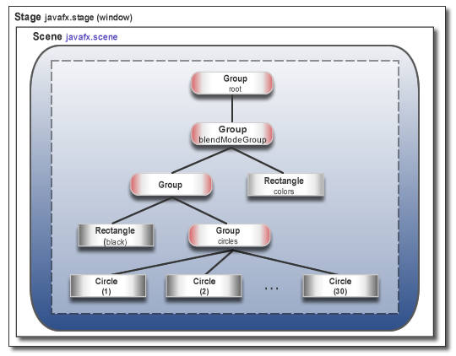
Description of "Figure 5-2 Colorful Circles Scene Graph"
The tool used in this Getting Started tutorial is NetBeans IDE. Before you begin, ensure that the version of NetBeans IDE that you are using supports JavaFX 2. See the System Requirements for details.

Set Up the Application
Set up your JavaFX project in NetBeans IDE as follows:
- From the File menu, choose New Project.
- In the JavaFX application category, choose JavaFX Application. Click Next.
- Name the project ColorfulCircles and click Finish.
- Open the ColorfulCircles.java file, copy the import statements, and paste them into your project, overwriting the import statements that NetBeans IDE generated.
Or, you can generate the import statements as you work your way through the tutorial by using either the code completion feature or the Fix Imports command in NetBeans IDE. When there is a choice of import statements, choose the one that starts with javafx.

Set Up the Project
Delete the ColorfulCircles class that NetBeans IDE generated and replace it with the code in Example 5-1.
Example 5-1 Basic Application
public class ColorfulCircles extends Application {

public static void main(String[] args) {
launch(args);
}

@Override
public void start(Stage primaryStage) {
Group root = new Group();
Scene scene = new Scene(root, 800, 600, Color.BLACK);
primaryStage.setScene(scene);

primaryStage.show();
}
}
For the ColorfulCircles application, it is appropriate to use a group node as the root node for the scene. The size of the group will be dictated by the size of the nodes within it. For most applications, however, you want the nodes to track the size of the scene and change when the stage is resized. In this case, you use a resizable layout node as the root, as described in Creating a Form in JavaFX.
You can compile and run the ColorfulCircles application now, and at each step of the tutorial, to see the intermediate results. If you run into problems, then take a look at the code in the ColorfulCircles.java file. At this point, the application is a simple black window.

Add Graphics
Next, create 30 circles by adding the code in Example 5-2 before the primaryStage.show() line.
Example 5-2 30 Circles
Group circles = new Group();
for (int i = 0; i < 30; i++) {
Circle circle = new Circle(150, Color.web("white", 0.05));
circle.setStrokeType(StrokeType.OUTSIDE);
circle.setStroke(Color.web("white", 0.16));
circle.setStrokeWidth(4);
circles.getChildren().add(circle);
}
root.getChildren().add(circles);
This code creates a group named circles, then uses a for loop to add 30 circles to the group. Each circle has a radius of 150, fill color of white, and opacity level of 5 percent, meaning it is mostly transparent.
To create a border around the circles, the code includes the StrokeType class. A stroke type of OUTSIDE means the boundary of the circle is extended outside the interior by the StrokeWidth value, which is 4. The color of the stroke is white, and the opacity level is 16 percent, making it brighter than the color of the circles.
The final line adds the circles group to the root node. This is a temporary structure. Later, you will modify this scene graph to match the one shown in Figure 5-2.
Figure 5-3 shows the application. Because the code does not yet specify a unique location for each circle, the circles are drawn on top of one another, with the upper left-hand corner of the window as the center point for the circles. The opacity of the overlaid circles interacts with the black background, producing the gray color of the circles.
Figure 5-3 Circles

Description of "Figure 5-3 Circles"

Add a Visual Effect
Continue by applying a box blur effect to the circles so that they appear slightly out of focus. The code is in Example 5-3. Add this code before the primaryStage.show() line.
Example 5-3 Box Blur Effect
circles.setEffect(new BoxBlur(10, 10, 3));
This code sets the blur radius to 10 pixels wide by 10 pixels high, and the blur iteration to 3, making it approximate a Gaussian blur. This blurring technique produces a smoothing effect on the edge of the circles, as shown in Figure 5-4.
Figure 5-4 Box Blur on Circles

Description of "Figure 5-4 Box Blur on Circles"

Create a Background Gradient
Now, create a rectangle and fill it with a linear gradient, as shown in Example 5-4.
Add the code before the root.getChildren().add(circles) line so that the gradient rectangle appears behind the circles.
Example 5-4 Linear Gradient
Rectangle colors = new Rectangle(scene.getWidth(), scene.getHeight(),
new LinearGradient(0f, 1f, 1f, 0f, true, CycleMethod.NO_CYCLE, new
Stop[]{
new Stop(0, Color.web("#f8bd55")),
new Stop(0.14, Color.web("#c0fe56")),
new Stop(0.28, Color.web("#5dfbc1")),
new Stop(0.43, Color.web("#64c2f8")),
new Stop(0.57, Color.web("#be4af7")),
new Stop(0.71, Color.web("#ed5fc2")),
new Stop(0.85, Color.web("#ef504c")),
new Stop(1, Color.web("#f2660f")),}));
root.getChildren().add(colors);
This code creates a rectangle named colors. The rectangle is the same width and height as the scene and is filled with a linear gradient that starts in the lower left-hand corner (0, 1) and ends in the upper right-hand corner (1, 0). The value of true means the gradient is proportional to the rectangle, and NO_CYCLE indicates that the color cycle will not repeat. The Stop[] sequence indicates what the gradient color should be at a particular spot. The final line of code adds the colors rectangle to the root node.
The gray circles with the blurry edges now appear on top of a rainbow of colors, as shown in Figure 5-5.
Figure 5-5 Linear Gradient

Description of "Figure 5-5 Linear Gradient"
Figure 5-6 shows the intermediate scene graph. At this point, the circles group and colors rectangle are children of the root node.
Figure 5-6 Intermediate Scene Graph
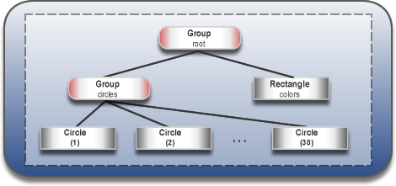
Description of "Figure 5-6 Intermediate Scene Graph"

Apply a Blend Mode
Next, add color to the circles and darken the scene by adding an overlay blend effect. You will remove the circles group and the linear gradient rectangle from the scene graph and add them to the new overlay blend group.
- Remove the following two lines of code:
root.getChildren().add(colors);
root.getChildren().add(circles);
- Add the code in Example 5-5 where you removed the two lines.
Example 5-5 Blend Mode
Group blendModeGroup =
new Group(new Group(new Rectangle(scene.getWidth(), scene.getHeight(),
Color.BLACK), circles), colors);
colors.setBlendMode(BlendMode.OVERLAY);
root.getChildren().add(blendModeGroup);
The group blendModeGroup sets up the structure for the overlay blend. The group contains two children. The first child is a new (unnamed) Group containing a new (unnamed) black rectangle and the previously created circles group. The second child is the previously created colors rectangle.
The setBlendMode() method applies the overlay blend to the colors rectangle. The final line of code adds the blendModeGroup to the scene graph as a child of the root node, as depicted in Figure 5-2.
An overlay blend is a common effect in graphic design applications. Such a blend can darken an image or add highlights or both, depending on the colors in the blend. In this case, the linear gradient rectangle is used as the overlay. The black rectangle serves to keep the background dark, while the nearly transparent circles pick up colors from the gradient, but are also darkened.
Figure 5-7 shows the results. You will see the full effect of the overlay blend when you animate the circles in the next step.
Figure 5-7 Overlay Blend

Description of "Figure 5-7 Overlay Blend"

Add Animation
The final step is to use JavaFX animations to move the circles:
- If you have not done so already, add import static java.lang.Math.random; to the list of import statements.
- Add the animation code in Example 5-6 before the primaryStage.show() line.
Example 5-6 Animation
Timeline timeline = new Timeline();
for (Node circle: circles.getChildren()) {
timeline.getKeyFrames().addAll(
new KeyFrame(Duration.ZERO, // set start position at 0
new KeyValue(circle.translateXProperty(), random() * 800),
new KeyValue(circle.translateYProperty(), random() * 600)
),
new KeyFrame(new Duration(40000), // set end position at 40s
new KeyValue(circle.translateXProperty(), random() * 800),
new KeyValue(circle.translateYProperty(), random() * 600)
)
);
}
// play 40s of animation
timeline.play();
Animation is driven by a timeline, so this code creates a timeline, then uses a for loop to add two key frames to each of the 30 circles. The first key frame at 0 seconds uses the properties translateXProperty and translateYProperty to set a random position of the circles within the window. The second key frame at 40 seconds does the same. Thus, when the timeline is played, it animates all circles from one random position to another over a period of 40 seconds.
Figure 5-8 shows the 30 colorful circles in motion, which completes the application. For the complete source code, see the ColorfulCircles.java file.
Figure 5-8 Animated Circles
Description of "Figure 5-8 Animated Circles"

Where to Go from Here
Here are several suggestions about what to do next:
- Try deploying your application outside NetBeans IDE. See Deploying Your First JavaFX Application.
- Try the JavaFX samples, which you can download from http://www.oracle.com/technetwork/java/javafx/samples/index.html. Especially take a look at the Ensemble application, which provides sample code for animations and effects.
- Read Creating Transitions and Timeline Animation in JavaFX. You will find more details on timeline animation as well as information on fade, path, parallel, and sequential transitions.
- See Creating Visual Effects in JavaFX for additional ways to enhance the look and design of your application, including reflection, lighting, and shadow effects.

6 Deploying Your First JavaFX Application
This page shows how to deploy any of the About This Tutorial tutorials. If you develop your JavaFX application in NetBeans IDE, it is packaged automatically and is easy to deploy.
This page contains the following sections.
- Deployment Modes
- Packaging the Application in NetBeans IDE
- Running the Application Outside NetBeans IDE
- Other Ways to Package JavaFX Applications

Deployment Modes
The Java and JavaFX Runtime installations support the following deployment modes:
- Standalone Mode
Standalone applications run on desktops. The compiled class files are usually packaged into JAR files, and it is the responsibility of the application or deployment team to distribute the application and ensure that it is kept updated.
- Run in Browser Mode
The application runs in a web page in a browser. Applications are packaged by the NetBeans IDE to use the Java Deployment Toolkit, which checks the user's system for the minimum required versions of the Java and JavaFX Runtimes.
- Web Start Mode
The application is generally initiated from a web page link, but the application itself runs outside the browser on the desktop. If the Java Deployment Toolkit is used, then it checks the user's system for the minimum required versions of the Java and JavaFX Runtime installations and can also download application updates.

Packaging the Application in NetBeans IDE
When you run your application in NetBeans IDE or use the Clean and Build command, your application is packaged for all modes of JavaFX deployment, using options that are set as project properties. By default, applications are packaged into the following files:
- A JAR file, containing the compiled class files and images.
- A JNLP file, which contains a deployment descriptor for the two web modes (Web Start and embedded in browser).
- An HTML file, which contains basic code for running both the Web Start application and the embedded application using the Deployment Toolkit.
- A web-files folder, which contains an offline set of files from the Java Deployment Toolkit to assist with starting up your application. For more information about using the Java Deployment Toolkit in JavaFX applications, see "Deployment in the Browser" at
http://docs.oracle.com/javafx/2/deployment/deployment_toolkit.htm

Application Sizing
With standalone and Web Start mode, the window is sized around the width and height values you specify for the scene in the code. If you do not specify a specific width and height in the code, the window automatically sizes itself to fit the application.
Applications that are embedded in a web page require that you set width and height values in the NetBeans project's properties, even if you specify width and height values in the code. You can even specify different width and height values in the project properties from what is specified in the code, so you can experiment to see what looks best in the browser.
To specify application width and height in NetBeans project properties:
- In the Projects pane, right-click your NetBeans project and choose Properties.
- Select the Run category.
- In the section entitled Web Start and Browser Application Properties, specify width and height values.
- If you want to test the application in a browser when you run it inside NetBeans IDE, choose in Browser in the Run field.
- Click OK to close the Properties dialog box.
- Right-click the project and choose Clean and Build.
- If you chose to run the application in the browser in the project properties, you can right-click the project and choose Run. Otherwise, test the HTML file outside the browser by following the instructions in Running the Application Outside NetBeans IDE.

Running the Application Outside NetBeans IDE
To run the packaged application outside NetBeans IDE, go to the dist subdirectory of your application project directory and do the following:
- To run the application in standalone mode, double-click the JAR file.
- To run as a Web Start application, either click the link in the HTML page in your browser or double-click the JNLP file. The advantage of using the link in the browser is that the web page contains logic that uses the Deployment Toolkit, which checks to ensure that the minimum required version of both the Java and JavaFX Runtimes are installed on the user's system.
- To run the application in a web page, open the HTML file in a browser.

Note:
If you open the HTML file in Google Chrome, you might have to click either Run this time or Always run on this site to enable the Java plug-in, as shown in Figure 6-1. Then reload the page to run the applet.

Figure 6-1 Plug-In Message in Google Chrome
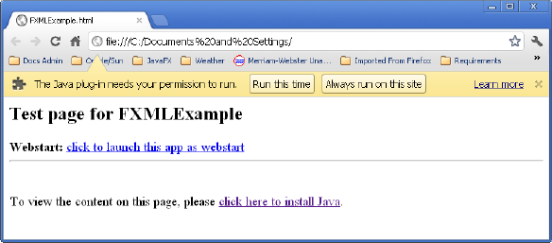

Note:
For applications that include FXML markup, NetBeans IDE adds a digital signature to the JAR file by default to ensure that it will run on the web. For more information about packaging FXML applications and FXML deployment, see
http://docs.oracle.com/javafx/2/fxml_get_started/fxml_deployment.htm

Deploying the Packaged Files
With the Java 7 Runtime and later, you can move the deployment files to other locations without changing any configuration properties in the deployment descriptor (which means the contents of the JNLP file). The files required for each deployment mode are shown in Table 6-1.
Table 6-1 Files Required for Each Deployment Mode
Deployment Mode | Files Required
Standalone | JAR
Run in Browser | JAR, JNLP, HTML
Web Start | JAR, JNLP, HTML

Other Ways to Package JavaFX Applications
Instead of using NetBeans IDE to package your deployment files, you can also use the JavaFX Packager tool or a custom Ant task. All of these tools generate a default HTML file with application launch descriptors that you manually copy into your web page, but you can optionally generate the application launch descriptors directly into your own HTML pages using an input template. You can also customize many other aspects of application startup and execution. For more information, see Deploying JavaFX Applications at
http://docs.oracle.com/javafx/2/deployment/jfxpub-deployment.htm

1 Introduction to JavaFX Media
The active growth of media content on the web has made video and audio an essential part of rich Internet applications. The idea of broadening the horizons of traditional media usage led to the creation of the JavaFX media functionality that is available through a set of Java APIs. The javafx.scene.media package enables developers to create media applications that provide media playback in the desktop window or within a web page on supported platforms.
Figure 1-1 demonstrates a variety of possible media usages in JavaFX applications.

Figure 1-1 Samples of Media Usages
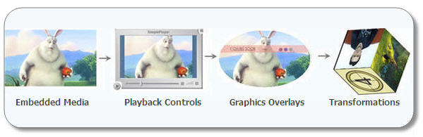
Description of "Figure 1-1 Samples of Media Usages"
The operating systems and Java Runtime Environments (JREs) supported by JavaFX media features are the same as those listed in the JavaFX SDK System Requirements document. Refer to the JavaFX Release Documentation page for the appropriate system requirements information for the version of JavaFX SDK you are using.

Supported Media Codecs
The formats currently supported are the following:
- Audio: MP3; AIFF containing uncompressed PCM; WAV containing uncompressed PCM; MPEG-4 multimedia container with Advanced Audio Coding (AAC) audio
- Video: FLV containing VP6 video and MP3 audio; MPEG-4 multimedia container with H.264/AVC (Advanced Video Coding) video compression

Note:
You may not integrate the On2 VP6 video decoder in the design of a semiconductor or register transfer level (RTL) or any other similar level necessary for development of semiconductor implementation of the On2 VP6 video decoder.

The FLV container is supported by the media stack on the platforms supported by the JavaFX SDK. A single movie encoded in this format works seamlessly on the supported platforms. Standard FLV MIME settings are required on the server side to enable media streaming.
The MPEG-4 multimedia container is also supported on all operating systems supported by the JavaFX SDK. On the Mac OS X and Windows 7 platforms, playback will be functional without requiring additional software. However, the Linux operating system and versions of Windows older than Windows 7 require the installation of readily available third party software packages, as documented in the JavaFX 2.1 Systems Requirements. AAC and H.264/AVC decoding have certain platform-dependent limitations, as described in the JavaFX 2.1 Release Notes.
Decoding of some audio and video compression types relies on operating system-specific media engines. The JavaFX media framework does not attempt to handle all multimedia container formats and media encodings supported by these native engines. Instead, the framework attempts to provide equivalent and well-tested functionality across all platforms on which JavaFX is supported.
Some of the features supported by the JavaFX media stack include the following:
- FLV container with MP3 and VP6
- MP3 audio
- MPEG-4 container with either AAC, H.264, or both
- HTTP, FILE protocol support
- Progressive download
- Seeking
- Buffer progress
- Playback functions (Play, Pause, Stop, Volume, Mute, Balance, Equalizer)

Creating a Media Player
The JavaFX media concept is based on the following entities.
- Media – A media resource, containing information about the media, such as its source, resolution, and metadata
- MediaPlayer – The key component providing the controls for playing media
- MediaView – A Node object to support animation, translucency, and effects
Each element of the media functionality is available through the JavaFX API. Figure 1-2 shows the classes that reside in the javafx.scene.media package. These classes are interdependent and are used in combination to create an embedded media player.
Figure 1-2 Classes in the javafx.scene.media Package
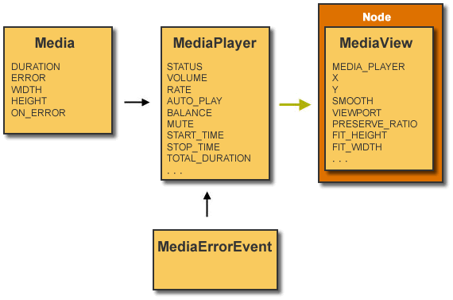
Description of "Figure 1-2 Classes in the javafx.scene.media Package"
The MediaPlayer class provides all the attributes and functions needed to control media playback. You can either set the AUTO_PLAY mode, call the play() function directly, or explicitly specify the number of times that the media should play. The VOLUME variable and the BALANCE variable can be used to adjust the volume level and left-right settings, respectively. The volume level range is from 0 to 1.0 (the maximum value). The balance range is continuous from -1.0 on the far left, 0 at the center, and 1.0 at the right.
The play(), stop(), and pause() functions control media playback. Additionally, a bundle of functions handles specific events when the player does one of the following:
- Buffers data
- Reaches the end of media
- Stalls because it has not received data fast enough to continue playing
- Encounters any of the errors defined in the MediaErrorEvent class
The MediaView class extends the Node class and provides a view of the media being played by the media player. It is responsible mostly for effects and transformations. Its mediaPlayer instance variable specifies the MediaPlayer object by which the media is being played. Other Boolean attributes serve to apply the particular effect provided by the Node class, for example, to enable the media player to be rotated.
For more information about the javafx.scene.media package, see the API documentation.

2 Embedding Media Into a Web Page
In this section, you'll explore how to add an animated media content to your web page by creating a simple media panel. To create a media player you need to implement the structure of the three nested object that is shown in Figure 2-1.
Figure 2-1 Structure of the Embedded Media Player
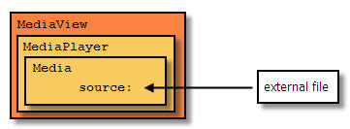
Description of "Figure 2-1 Structure of the Embedded Media Player"

To Get Started
You can build a JavaFX application using any development tool designed for creating a Java application. The tool used in this document is the NetBeans IDE. Do the following steps before continuing to build this document's sample application that uses the JavaFX Media features:
- Use the JavaFX Release Documentation page to find the System Requirements document that you need to verify that your system meets the minimum requirements, including the version of NetBeans IDE.
- Use the Installation Guide on the JavaFX Release Documentation page to get the information on how to install the version of JavaFX SDK software you plan to use.
- Install the required NetBeans IDE using the NetBeans information provided in the JavaFX System Requirements documents available from the JavaFX Release Documentation page.
- If necessary, get acquainted with the following documents to get familiar with JavaFX:
  - What Is JavaFX
  - Getting Started with JavaFX
  - JavaFX Architecture and Framework

Create the Application
- From the NetBeans IDE, set up your JavaFX project as follows:
  - From the File menu, choose New Project.
  - In the JavaFX application category, choose JavaFX Application. Click Next.
  - Name the project EmbeddedMediaPlayer and ensure the Create Application Class field has the value of embeddedmediaplayer.EmbeddedMediaPlayer. Click Finish.
- Copy the import statements in Example 2-1 and paste them in the EmbeddedMediaPlayer.java file, replacing all of the import statements that were automatically generated by the NetBeans IDE.
Example 2-1 Replace Default Import Statements
import javafx.application.Application;
import javafx.scene.Group;
import javafx.scene.Scene;
import javafx.scene.media.Media;
import javafx.scene.media.MediaPlayer;
import javafx.scene.media.MediaView;
import javafx.stage.Stage;
For now, ignore the warnings on the margin since the lines of code that use the Media classes will be added in the next few steps.
- Specify the media file source to be used and the String variable by adding the lines in bold in Example 2-2. For this example, use the animated video located at download.oracle.com or specify your own file. Add the lines after the public class EmbeddedMediaPlayer line.
Example 2-2 Specify the Media File Source
public class EmbeddedMediaPlayer extends Application {

private static final String MEDIA_URL =
"http://download.oracle.com/otndocs/products/javafx/oow2010-2.flv";
private static String arg1;
- Modify the start method so that it looks like Example 2-3. This is will create an empty scene with a group root node and dimension of 540 wide by 210 height.
Example 2-3 Modify the start Method
@Override
public void start(Stage primaryStage) {
primaryStage.setTitle("Embedded Media Player");
Group root = new Group();
Scene scene = new Scene(root, 540, 210);

primaryStage.setScene(scene);
primaryStage.show();
}
- Now, define the Media and the MediaPlayer objects by adding the code in Example 2-4 before the primaryStage.setScene(scene) line. Set the autoPlay variable to true so that the video can start immediately.
Example 2-4 Add media and mediaPlayer Objects
// create media player
Media media = new Media((arg1 != null) ? arg1 : MEDIA_URL);
MediaPlayer mediaPlayer = new MediaPlayer(media);
mediaPlayer.setAutoPlay(true);
- Define the MediaView object and add the media player to the Node-based viewer by copying the comment and two lines of code in Example 2-5 and pasting it right after the mediaPlayer.setAutoPlay(true) line.
Example 2-5 Define MediaView Object
// create mediaView and add media player to the viewer
MediaView mediaView = new MediaView(mediaPlayer);
((Group)scene.getRoot()).getChildren().add(mediaView);
- Right-click on any whitespace and select Format to fix the line formatting after adding the lines of code.
- Right-click the EmbeddedMediaPlayer project node in the Projects pane and select Clean and Build.
- After a successful build, run your application by right-clicking the project node and selecting Run.

package embeddedmediaplayer;
import javafx.application.Application;
import javafx.scene.Group;
import javafx.scene.Scene;
import javafx.scene.media.Media;
import javafx.scene.media.MediaPlayer;
import javafx.scene.media.MediaView;
import javafx.stage.Stage;

public class EmbeddedMediaPlayer extends Application {
private static final String MEDIA_URL = "http://download.oracle.com/otndocs/products/javafx/oow2010-2.flv";
private static String arg1;
public static void main(String[] args) {
launch(args);
}
@Override
public void start(Stage primaryStage) {
primaryStage.setTitle("Embedded Media Player");
Group root = new Group();
Scene scene = new Scene(root, 540, 210);
// create media player
Media media = new Media((arg1 != null) ? arg1 : MEDIA_URL);
MediaPlayer mediaPlayer = new MediaPlayer(media);
mediaPlayer.setAutoPlay(true);
primaryStage.setScene(scene);
primaryStage.show();
// create mediaView and add media player to the viewer
MediaView mediaView = new MediaView(mediaPlayer);
((Group) scene.getRoot()).getChildren().add(mediaView); }
}

Note:
If you are using the media file source used in this tutorial and you are running the application behind a firewall, you might need to set the application's proxy in order for the application to be able to access the media source file. Right-click the EmbeddedMediaPlayer project node in the Project window, select Properties, and in the Project Properties dialog, select Run. Set the VM Options field with something similar to -Dhttp.proxyHost=yourproxyhost.com -Dhttp.proxyPort=somePort#, where yourproxyhost.com is your company's proxy server and somePort# is a port number you are assigned to use.

- Deploy the sample application you just built to a browser by embedding it into your HTML content using the instructions in the Deployment in the Browser document. Copy the code from the EmbeddedMediaPlayer.html file that was automatically generated by the IDE to the target web page.

3 Controlling Media Player
In this section you create a full-functional media player with graphical UI elements that control the playback.
To create a media player you need to implement the structure of the three nested media objects, encode graphical controls, and add some logic for playback functions, as illustrated in the Figure 3-1 below.
Figure 3-1 Structure of Media Player with Playback Controls
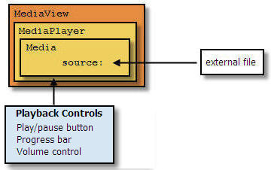
Description of "Figure 3-1 Structure of Media Player with Playback Controls"
You step through adding playback controls to the media player that you created in Lesson 2, "Embedding Media Into a Web Page". If you haven't already done so, complete that media player application before proceeding with the rest of this chapter. The media control panel you add consists of three elements: playButton, progress, and volumeControl.

Creating Controls
In this section you create a new JavaFX source file, MediaControl.java, that will contain the pane and UI controls for the play/pause, progress, and volume features.
- With the EmbeddedMediaPlayer opened as the main project in the NetBeans IDE, create a new JavaFX file to add to the project.
  - Use Ctrl+N or select File > New File from the IDE's main menu.
  - Select Category JavaFX and file type JavaFX Main class. Click Next.
  - In the Name and Location dialog, type MediaControl in the Class Name field.
  - In the Package field, select embeddedmediaplayer from the drop-down list and click Finish.
- Delete all the lines after package embeddedmediaplayer line.
- Add the import statements that are shown in Example 3-1 to the top of the file.
Example 3-1 Import Statements to Add
import javafx.scene.control.Label;
import javafx.scene.control.Slider;
import javafx.scene.layout.BorderPane;
import javafx.scene.layout.HBox;
import javafx.scene.layout.Pane;
import javafx.scene.media.MediaPlayer;
import javafx.scene.media.MediaView;
import javafx.util.Duration;
- Copy and paste the lines of code in Example 3-2 to create the BorderPane that will hold the controls.
Example 3-2 Add MediaControl Class Code
public class MediaControl extends BorderPane {
private MediaPlayer mp;
private MediaView mediaView;
private final boolean repeat = false;
private boolean stopRequested = false;
private boolean atEndOfMedia = false;
private Duration duration;
private Slider timeSlider;
private Label playTime;
private Slider volumeSlider;
private HBox mediaBar;

public MediaControl(final MediaPlayer mp) {
this.mp = mp;
setStyle("-fx-background-color: #bfc2c7;");
mediaView = new MediaView(mp);
Pane mvPane = new Pane() { };
mvPane.getChildren().add(mediaView);
mvPane.setStyle("-fx-background-color: black;");
setCenter(mvPane);
}
}
- Copy the lines of code in Example 3-3 and paste them immediately after the line that says setCenter(mvPane). This code adds the Media toolbar and the Play button.
Example 3-3 Add Media Toolbar and Play Button
mediaBar = new HBox();
mediaBar.setAlignment(Pos.CENTER);
mediaBar.setPadding(new Insets(5, 10, 5, 10));
BorderPane.setAlignment(mediaBar, Pos.CENTER);

final Button playButton = new Button(">");
mediaBar.getChildren().add(playButton);
setBottom(mediaBar);
}
}
- Add the import statements shown in Example 3-4 to the top of the list of import statements.
Example 3-4 Add More Import Statements
import javafx.geometry.Insets;
import javafx.geometry.Pos;
import javafx.scene.control.Button;
- Add the remainder of the UI controls to the control pane. Put the lines of code in Example 3-5 after the mediaBar.getChildren().add(playButton); line and before the setBottom(mediaBar) line.
Example 3-5 Add the Rest of the UI Controls
// Add spacer
Label spacer = new Label(" ");
mediaBar.getChildren().add(spacer);

// Add Time label
Label timeLabel = new Label("Time: ");
mediaBar.getChildren().add(timeLabel);

// Add time slider
timeSlider = new Slider();
HBox.setHgrow(timeSlider,Priority.ALWAYS);
timeSlider.setMinWidth(50);
timeSlider.setMaxWidth(Double.MAX_VALUE);
mediaBar.getChildren().add(timeSlider);

// Add Play label
playTime = new Label();
playTime.setPrefWidth(130);
playTime.setMinWidth(50);
mediaBar.getChildren().add(playTime);

// Add the volume label
Label volumeLabel = new Label("Vol: ");
mediaBar.getChildren().add(volumeLabel);

// Add Volume slider
volumeSlider = new Slider();
volumeSlider.setPrefWidth(70);
volumeSlider.setMaxWidth(Region.USE_PREF_SIZE);
volumeSlider.setMinWidth(30);

mediaBar.getChildren().add(volumeSlider);
- Add more import statements shown in Example 3-6 to the top of the file.
Example 3-6 Add More Import Statements
import javafx.scene.layout.Priority;
import javafx.scene.layout.Region;

Add the Functional Logic Code
After all the controls have been created and added to the control panel, add the functional logic to manage the media playback and make your application interactive.
- Add the event handler and listener for the Play button. Copy and paste the lines of code in Example 3-7 after the final Button playButton = new Button(">") line and before the mediaBar.getChildren().add(playButton) line.
Example 3-7 Add Play Button's Event Handler and Listener
playButton.setOnAction(new EventHandler<ActionEvent>() {
public void handle(ActionEvent e) {
Status status = mp.getStatus();

if (status == Status.UNKNOWN || status == Status.HALTED)
{
// don't do anything in these states
return;
}

if ( status == Status.PAUSED
|| status == Status.READY
|| status == Status.STOPPED)
{
// rewind the movie if we're sitting at the end
if (atEndOfMedia) {
mp.seek(mp.getStartTime());
atEndOfMedia = false;
}
mp.play();
} else {
mp.pause();
}
}
});
- The import statements used by the code you just added from Example 3-7 could have been added beforehand to avoid getting errors. But this time, to eliminate all of marked errors, press Ctrl+Shift+I or right-click anywhere and select Fix Imports. From the Fix All Imports dialog, select javafx.event.ActionEvent, javafx.scene.media.MediaPlayer.Status, and javafx.event.EventHandler from the drop-down menus. Click OK.
- Add the following lines of code immediately after the lines of code you added from Example 3-7 and before the line that says mediaBar.getChildren().add(playButton). This code will handle the listener.
Example 3-8 Add Listener Code
mp.currentTimeProperty().addListener(new InvalidationListener()
{
public void invalidated(Observable ov) {
updateValues();
}
});

mp.setOnPlaying(new Runnable() {
public void run() {
if (stopRequested) {
mp.pause();
stopRequested = false;
} else {
playButton.setText("||");
}
}
});

mp.setOnPaused(new Runnable() {
public void run() {
System.out.println("onPaused");
playButton.setText(">");
}
});

mp.setOnReady(new Runnable() {
public void run() {
duration = mp.getMedia().getDuration();
updateValues();
}
});

mp.setCycleCount(repeat ? MediaPlayer.INDEFINITE : 1);
mp.setOnEndOfMedia(new Runnable() {
public void run() {
if (!repeat) {
playButton.setText(">");
stopRequested = true;
atEndOfMedia = true;
}
}
});
Note that the errors that appear will be fixed by adding more code in the next steps.
- Add listener for the time slider by adding the following code snippet after the line that says timeSlider.setMaxWidth(Double.MAX_VALUE) and before the line that says mediaBar.getChildren().add(timeSlider).
Example 3-9 Add Listener for Time Slider
timeSlider.valueProperty().addListener(new InvalidationListener() {
public void invalidated(Observable ov) {
if (timeSlider.isValueChanging()) {
// multiply duration by percentage calculated by slider position
mp.seek(duration.multiply(timeSlider.getValue() / 100.0));
}
}
});
- Add listener for the volume slider control by adding the following code snippet after the line that says volumeSlider.setMinWidth(30) and before the mediabar.getChildren().add(volumeSlider).
Example 3-10 Add Listener for the Volume Control
volumeSlider.valueProperty().addListener(new InvalidationListener() {
public void invalidated(Observable ov) {
if (volumeSlider.isValueChanging()) {
mp.setVolume(volumeSlider.getValue() / 100.0);
}
}
});
- Create Method updateValues used by the playback controls. Add it after the public MediaControl() method.
Example 3-11 Add UpdateValues Method
protected void updateValues() {
if (playTime != null && timeSlider != null && volumeSlider != null) {
Platform.runLater(new Runnable() {
public void run() {
Duration currentTime = mp.getCurrentTime();
playTime.setText(formatTime(currentTime, duration));
timeSlider.setDisable(duration.isUnknown());
if (!timeSlider.isDisabled()
&& duration.greaterThan(Duration.ZERO)
&& !timeSlider.isValueChanging()) {
timeSlider.setValue(currentTime.divide(duration).toMillis()
* 100.0);
}
if (!volumeSlider.isValueChanging()) {
volumeSlider.setValue((int)Math.round(mp.getVolume()
* 100));
}
}
});
}
}
- Add the private method formatTime() that calculates the elapsed time the media has been playing and formats it to be displayed on the control toolbar.
Example 3-12 Add Method for Calculating Elapsed Time
private static String formatTime(Duration elapsed, Duration duration) {
int intElapsed = (int)Math.floor(elapsed.toSeconds());
int elapsedHours = intElapsed / (60 * 60);
if (elapsedHours > 0) {
intElapsed -= elapsedHours * 60 * 60;
}
int elapsedMinutes = intElapsed / 60;
int elapsedSeconds = intElapsed - elapsedHours * 60 * 60
- elapsedMinutes * 60;

if (duration.greaterThan(Duration.ZERO)) {
int intDuration = (int)Math.floor(duration.toSeconds());
int durationHours = intDuration / (60 * 60);
if (durationHours > 0) {
intDuration -= durationHours * 60 * 60;
}
int durationMinutes = intDuration / 60;
int durationSeconds = intDuration - durationHours * 60 * 60 -
durationMinutes * 60;
if (durationHours > 0) {
return String.format("%d:%02d:%02d/%d:%02d:%02d",
elapsedHours, elapsedMinutes, elapsedSeconds,
durationHours, durationMinutes, durationSeconds);
} else {
return String.format("%02d:%02d/%02d:%02d",
elapsedMinutes, elapsedSeconds,durationMinutes,
durationSeconds);
}
} else {
if (elapsedHours > 0) {
return String.format("%d:%02d:%02d", elapsedHours,
elapsedMinutes, elapsedSeconds);
} else {
return String.format("%02d:%02d",elapsedMinutes,
elapsedSeconds);
}
}
}
- Lastly, fix the imports. Right-click in any white space and select javafx.application.Platform and javafx.beans.Observable from the Fix All Imports dialog. Click OK.

Modify the EmbeddedMediaPlayer.java
To add the control, modify the EmbeddedMediaPlayer.java file that you created in the previous chapter and add the code to add the MediaControl object.
- Copy the lines of code in Example 3-13 and paste them right after the mediaPlayer.setAutoPlay(true) line.
Example 3-13 Add the Source Code to Create MediaControl Object
MediaControl mediaControl = new MediaControl(mediaPlayer);
scene.setRoot(mediaControl);
- Delete the three lines shown in Example 3-14, which previously created the mediaView and mediaPlayer objects.
Example 3-14 Delete Lines of Code
// create mediaView and add media player to the viewer
MediaView mediaView = new MediaView(mediaPlayer);
((Group)scene.getRoot()).getChildren().add(mediaView);
- Adjust the size of the scene's height to accommodate the addition of the media controls.
Example 3-15 Change the Scene's Height
Scene scene = new Scene(root, 540, 241);

Compile and Run the EmbeddedMedia
Now build the application you just created in the previous section and run it.
- Right-click the EmbeddedMediaPlayer project node and select Clean and Build.
- If there are no build errors, right-click the node again and select Run. The media player with control appears, similar to Figure 3-2 and begins to play.
Figure 3-2 Media Player with Playback Controls
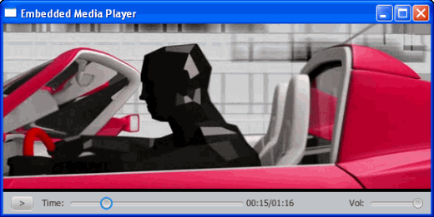
Description of "Figure 3-2 Media Player with Playback Controls"
- Stop and resume the video using the play/pause control button. Move forwards or backwards through the video using the progress bar. Adjust the volume using the volume control button.
Find the complete application code in the EmbeddedMediaPlayer.zip file.

Working with the JavaFX Scene Graph
JavaFX makes it easy to create modern-looking graphical user interfaces (GUIs) with sophisticated visual effects. This tutorial explores the JavaFX Scene Graph Application Programming Interface (API), the underlying framework that renders your GUI to the screen.

Overview
If you are an experienced Java developer, then chances are good that at some point you have created an application with a graphical user interface. This could be anything from small programs in web pages, to standalone Swing applications on the desktop. And if you have ever done any custom painting, you are familiar with the Graphics class and its related methods. The traditional approaches — as powerful as they are — have always required some amount of effort on the developer's part to correctly render the graphics to the screen. This work is often separate from the bulk of the application logic.
The JavaFX Scene Graph API makes graphical user interfaces easier to create, especially when complex visual effects and transformations are involved. A scene graph is a tree data structure, most commonly found in graphical applications and libraries such as vector editing tools, 3D libraries, and video games. The JavaFX scene graph is a retained mode API, meaning that it maintains an internal model of all graphical objects in your application. At any given time, it knows what objects to display, what areas of the screen need repainting, and how to render it all in the most efficient manner. Instead of invoking primitive drawing methods directly, you instead use the scene graph API and let the system automatically handle the rendering details. This approach significantly reduces the amount of code that is needed in your application.
The individual items held within the JavaFX scene graph are known as nodes. Each node is classified as either a branch node (meaning that it can have children), or a leaf node (meaning that it cannot have children). The first node in the tree is always called the root node, and it never has a parent.
Figure 1 Root, Branch, and Leaf Nodes
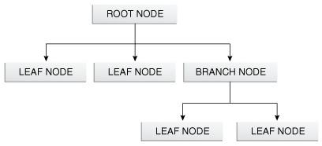
Description of "Figure 1 Root, Branch, and Leaf Nodes"
The JavaFX API defines a number of classes that can act as root, branch or leaf nodes. When substituted with actual class names, this same figure might resemble that shown in Figure 2 in a real application.
Figure 2 Specific Root, Branch, and Leaf Classes
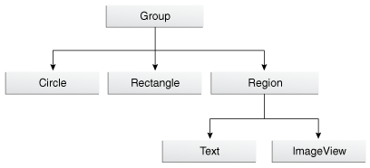
Description of "Figure 2 Specific Root, Branch, and Leaf Classes"
In Figure 2, a Group object acts as the root node. The Circle and Rectangle objects are leaf nodes, because they do not (and cannot) have children. The Region object (which defines an area of the screen with children than can be styled using CSS) is a branch node that contains two more leaf nodes (Text and ImageView). Scene graphs can become much larger than this, but the basic organization — that is, the way in which parent nodes contain child nodes — is a pattern that repeats in all applications.

Exploring the API
So what does this all mean in terms of code? Let us start by setting up a basic application frame, populated with only the root node, as shown in Example 1.
Example 1 Creating the Application Frame
package scenegraphdemo;

import javafx.application.Application;
import javafx.scene.Group;
import javafx.scene.Scene;
import javafx.scene.paint.Color;
import javafx.stage.Stage;

public class Main extends Application {

@Override
public void start(Stage stage) {
Group root = new Group();
Scene scene = new Scene(root, 500, 500, Color.BLACK);
stage.setTitle("JavaFX Scene Graph Demo");
stage.setScene(scene);
stage.show();
}

public static void main(String[] args) {
launch(args);
}
}
This code produces a window that looks like what is shown in Figure 3.
Figure 3 Creating a Scene with Root Node Only
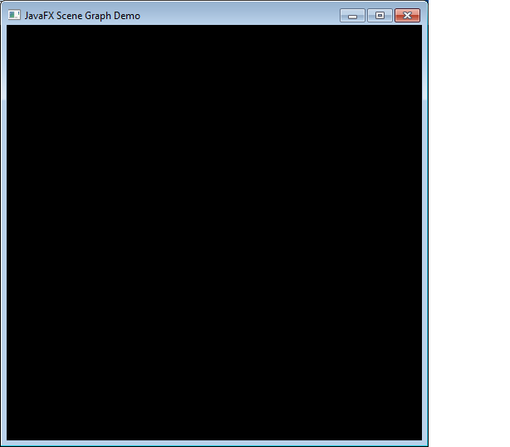
Description of "Figure 3 Creating a Scene with Root Node Only"
The important points to consider are as follows:
- The Main class is an extension of the javafx.application.Application class. Its start method is overridden and receives a Stage object (a top-level GUI container) as its only parameter.
- The root node (in this case, an instance of the javafx.scene.Group class) is created and passed to the scene's constructor, along with the scene's width, height, and fill.
- The stage's title, scene, and visibility are all set.
- The main method invokes the Application.launch() method.
The resulting application appears as it does because black is the scene's fill color. Because the root node currently has no children, there is nothing else to display. Adding a child to the root node can be accomplished with the modifications shown in Example 2.
Example 2 Adding a Leaf Node
package scenegraphdemo;

import javafx.application.Application;
import javafx.scene.Group;
import javafx.scene.Scene;
import javafx.scene.paint.Color;
import javafx.scene.shape.Rectangle;
import javafx.stage.Stage;

public class Main extends Application {

@Override
public void start(Stage stage) {
Group root = new Group();
Scene scene = new Scene(root, 500, 500, Color.BLACK);

Rectangle r = new Rectangle(25,25,250,250);
r.setFill(Color.BLUE);
root.getChildren().add(r);

stage.setTitle("JavaFX Scene Graph Demo");
stage.setScene(scene);
stage.show();
}

public static void main(String[] args) {
launch(args);
}
}
With the change shown in Example 2, a blue rectangle (leaf node) that is 250x250 pixels will appear at the specified X and Y coordinates. (By default, X increases from left to right, and Y increases from top to bottom. This can be affected by transformations, however.) Figure 4 shows the result of adding a leaf node.
Figure 4 Adding a Leaf Node
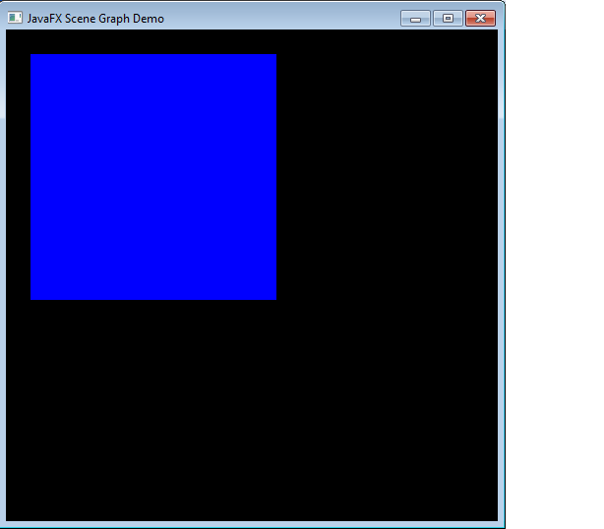
Description of "Figure 4 Adding a Leaf Node"
Because the graphical objects are managed by the scene graph, you can achieve some interesting effects with very little extra code. For example, you could easily animate the rectangle to bounce back and forth across the screen while rotating, changing its size, and transitioning its color from blue to red.
Example 3 uses transitions to make this happen:
Example 3 Animating the Scene
package scenegraphdemo;

import javafx.animation.FillTransition;
import javafx.application.Application;
import javafx.scene.Group;
import javafx.scene.Scene;
import javafx.scene.paint.Color;
import javafx.scene.shape.Rectangle;
import javafx.stage.Stage;
import javafx.animation.Timeline;
import javafx.animation.ParallelTransition;
import javafx.animation.RotateTransition;
import javafx.animation.ScaleTransition;
import javafx.animation.TranslateTransition;
import javafx.util.Duration;

public class Main extends Application {

@Override
public void start(Stage stage) {
Group root = new Group();
Scene scene = new Scene(root, 500, 500, Color.BLACK);
Rectangle r = new Rectangle(0, 0, 250, 250);
r.setFill(Color.BLUE);
root.getChildren().add(r);

TranslateTransition translate =
new TranslateTransition(Duration.millis(750));
translate.setToX(390);
translate.setToY(390);

FillTransition fill = new FillTransition(Duration.millis(750));
fill.setToValue(Color.RED);

RotateTransition rotate = new RotateTransition(Duration.millis(750));
rotate.setToAngle(360);

ScaleTransition scale = new ScaleTransition(Duration.millis(750));
scale.setToX(0.1);
scale.setToY(0.1);

ParallelTransition transition = new ParallelTransition(r,
translate, fill, rotate, scale);
transition.setCycleCount(Timeline.INDEFINITE);
transition.setAutoReverse(true);
transition.play();

stage.setTitle("JavaFX Scene Graph Demo");
stage.setScene(scene);
stage.show();
}

public static void main(String[] args) {
launch(args);
}
}
Or, you could use builders to accomplish the same thing:
Example 4 Using Builders
package scenegraphdemo;

import javafx.application.Application;
import javafx.scene.Group;
import javafx.scene.Scene;
import javafx.scene.paint.Color;
import javafx.scene.shape.Rectangle;
import javafx.stage.Stage;
import javafx.animation.Timeline;
import javafx.animation.ParallelTransition;
import javafx.animation.FillTransitionBuilder;
import javafx.animation.RotateTransitionBuilder;
import javafx.animation.ScaleTransitionBuilder;
import javafx.animation.TranslateTransitionBuilder;
import javafx.util.Duration;

public class Main extends Application {

@Override
public void start(Stage stage) {

Group root = new Group();
Scene scene = new Scene(root, 500, 500, Color.BLACK);
Rectangle r = new Rectangle(0, 0, 250, 250);
r.setFill(Color.BLUE);
root.getChildren().add(r);

ParallelTransition transition = new ParallelTransition(r,
TranslateTransitionBuilder.create()
.duration(Duration.millis(750))
.toX(390)
.toY(390)
.build(),
FillTransitionBuilder.create()
.duration(Duration.millis(750))
.toValue(Color.RED)
.build(),
RotateTransitionBuilder.create()
.duration(Duration.millis(750))
.toAngle(360)
.build(),
ScaleTransitionBuilder.create()
.duration(Duration.millis(750))
.toX(0.1)
.toY(0.1)
.build());
transition.setCycleCount(Timeline.INDEFINITE);
transition.setAutoReverse(true);
transition.play();
stage.setTitle("JavaFX Scene Graph Demo");
stage.setScene(scene);
stage.show();
}

public static void main(String[] args) {
launch(args);
}
}
While these examples may be simple, they identify and demonstrate some important concepts that you will use in most graphical applications.
The javafx.scene package defines more than a dozen classes, but three in particular are most important when it comes to learning how the API is structured:
- Node: The abstract base class for all scene graph nodes.
- Parent: The abstract base class for all branch nodes. (This class directly extends Node).
- Scene: The base container class for all content in the scene graph.
These base classes define important functionality that will subsequently be inherited by subclasses, including paint order, visibility, composition of transformations, support for CSS styling, and so on. You will also find various branch node classes that inherit directly from the Parent class, such as Control, Group, Region, and WebView. The leaf node classes are defined throughout a number of additional packages, such as javafx.scene.shape and javafx.scene.text.

