Factory
In object-oriented computer programming, a factory is an object for creating other objects. It is an abstraction of a constructor, and can be used to implement various allocation schemes. For example, using this definition, singletons implemented by the singleton pattern are formal factories.
A factory object typically has a method for every kind of object it is capable of creating. These methods optionally accept parameters defining how the object is created, and then return the created object.
Factory objects are used in situations where getting hold of an object of a particular kind is a more complex process than simply creating a new object. The factory object might decide to create the object's class (if applicable) dynamically, return it from an object pool, do complex configuration on the object, or other things.
These kinds of objects have proven useful and several design patterns have been developed to implement them in many languages. For example, several "GoF patterns", like the "Factory method pattern", the "Builder" or even the "Singleton" are implementations of this concept. The "Abstract factory pattern" instead is a method to build collections of factories.

Usage
Factory objects are common in toolkits and frameworks where library code needs to create objects of types which may be subclassed by applications using the framework. They are also used in test-driven development to allow classes to be put under test^{[1]}.
Factories determine the actual concrete type of object to be created, and it is here that the object is actually created. As the factory only returns an abstract pointer, the client code does not know - and is not burdened by - the actual concrete type of the object which was just created. However, the type of a concrete object is known by the abstract factory. In particular, this means:
- The client code has no knowledge whatsoever of the concrete type, not needing to include any header files or class declarations relating to the concrete type. The client code deals only with the abstract type. Objects of a concrete type are indeed created by the factory, but the client code accesses such objects only through their abstract interface.
- Adding new concrete types is done by modifying the client code to use a different factory, a modification which is typically one line in one file. This is significantly easier than modifying the client code to instantiate a new type, which would require changing every location in the code where a new object is created.

Factory method pattern
The factory method pattern is an object-oriented design pattern to implement the concept of factories. Like other creational patterns, it deals with the problem of creating objects (products) without specifying the exact class of object that will be created. The creation of an object often requires complex processes not appropriate to include within a composing object. The object's creation may lead to a significant duplication of code, may require information not accessible to the composing object, may not provide a sufficient level of abstraction, or may otherwise not be part of the composing object's concerns. The factory method design pattern handles these problems by defining a separate method for creating the objects, which subclasses can then override to specify the derived type of product that will be created.
Some of the processes required in the creation of an object include determining which object to create, managing the lifetime of the object, and managing specialized build-up and tear-down concerns of the object. Outside the scope of design patterns, the term factory method can also refer to a method of a factory whose main purpose is creation of objects.
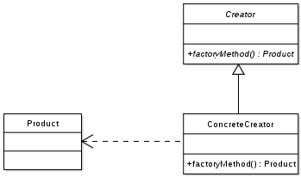

Definition
The essence of the Factory method Pattern is to "Define an interface for creating an object, but let the subclasses decide which class to instantiate. The Factory method lets a class defer instantiation to subclasses."^{[1]}

Concept
Main article: Factory (software concept)
In object-oriented computer programming, a factory is an object for creating other objects. However, this article is not about the concept of factory, but rather on its implementation, the so called "Factory Method".
A factory object has typically a method for every kind of object it is capable of creating. These methods optionally accept parameters defining how the object is created and return the object created.
Factory Methods are used in situations where getting hold of an object is more complex than simply creating a new one. The factory object might decide to create the object's class (if applicable) dynamically, return it from a pool, initialise the object, or perform other manipulations on the object instance.
Factory Methods are the basis for several design patterns. The "Factory method pattern", the "Builder" or the "Singleton" are one of several "GoF patterns" that realise this concept. The "Abstract factory pattern" generalises this method to build collections of factories.

Common usage
Factory methods are common in toolkits and frameworks where library code needs to create objects of types which may be subclassed by applications using the framework.
Parallel class hierarchies often require objects from one hierarchy to be able to create appropriate objects from another.
Factory methods are used in test-driven development to allow classes to be put under test.^{[2]} If such a class Foo creates another object Dangerous that can't be put under automated unit tests (perhaps it communicates with a production database that isn't always available), then the creation of Dangerous objects is placed in the virtual factory method createDangerous in class Foo. For testing, TestFoo (a subclass of Foo) is then created, with the virtual factory method createDangerous overridden to create and return FakeDangerous, a fake object. Unit tests then use TestFoo to test the functionality of Foo without incurring the side effect of using a real Dangerous object.

Applicability
The factory pattern can be used when:
- The creation of an object precludes its reuse without significant duplication of code.
- The creation of an object requires to access information or resources that should not be contained within the composing class.
- The lifetime management of the generated objects needs to be centralised to ensure a consistent behaviour within the application.

Other benefits and variants
Although the motivation behind the factory method pattern is to allow subclasses to choose which type of object to create, there are other benefits to using factory methods, many of which do not depend on subclassing. Therefore, it is common to define "factory methods" that are not polymorphic to create objects in order to gain these other benefits. Such methods are often static.

Descriptive names
A factory method has a distinct name. In many object-oriented languages, constructors must have the same name as the class they are in, which can lead to ambiguity if there is more than one way to create an object (see overloading). Factory methods have no such constraint and can have descriptive names. As an example, when complex numbers are created from two real numbers the real numbers can be interpreted as Cartesian or polar coordinates, but using factory methods, the meaning is clear (the following examples are in Java and VB.NET):
class Complex {
public static Complex fromCartesian(double real, double imaginary) {
return new Complex(real, imaginary);
}

public static Complex fromPolar(double modulus, double angle) {
return new Complex(modulus * cos(angle), modulus * sin(angle));
}

private Complex(double a, double b) {
//...
}
}

Complex c = Complex.fromPolar(1, pi);

Public Class Complex

When factory methods are used for disambiguation like this, the constructor is often made private to force clients to use the factory methods.

Encapsulation
Factory methods encapsulate the creation of objects. This can be useful if the creation process is very complex, for example if it depends on settings in configuration files or on user input.
Consider as an example a program to read image files and make thumbnails from them. The program supports different image formats, represented by a reader class for each format:
public interface ImageReader
{
public DecodedImage getDecodedImage();
}

public class GifReader implements ImageReader
{
public DecodedImage getDecodedImage()
{
// ...
return decodedImage;
}
}

public class JpegReader implements ImageReader
{
public DecodedImage getDecodedImage()
{
// ...
return decodedImage;
}
}
Each time the program reads an image it needs to create a reader of the appropriate type based on some information in the file. This logic can be encapsulated in a factory method:
public class ImageReaderFactory
{
public static ImageReader getImageReader(InputStream is)
{
int imageType = determineImageType(is);

switch(imageType)
{
case ImageReaderFactory.GIF:
return new GifReader(is);
case ImageReaderFactory.JPEG:
return new JpegReader(is);
// etc.
}
}
}
The code fragment in the previous example uses a switch statement to associate an imageType with a specific factory object. Alternatively, this association could also be implemented as a mapping. This would allow the switch statement to be replaced with an associative array lookup.

Example Implementations

Java
A maze game may be played in two modes, one with regular rooms that are only connected with adjacent rooms, and one with magic rooms that allow players to be transported at random (this Java example is similar to one in the book Design Patterns). The regular game mode could use this template method:
public class MazeGame {
public MazeGame() {
Room room1 = makeRoom();
Room room2 = makeRoom();
room1.connect(room2);
this.addRoom(room1);
this.addRoom(room2);
}

protected Room makeRoom() {
return new OrdinaryRoom();
}
}
In the above snippet, makeRoom is a template method. It encapsulates the creation of rooms such that other rooms can be used in a subclass. To implement the other game mode that has magic rooms, it suffices to override the makeRoom method:
public class MagicMazeGame extends MazeGame {
@Override
protected Room makeRoom() {
return new MagicRoom();
}
}

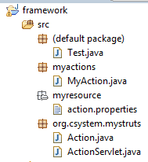
package org.csystem.mystruts;

public abstract class Action {

public abstract void execute();

}

package org.csystem.mystruts;

import java.util.ResourceBundle;

public class ActionServlet {
public ActionServlet(){
String key=ResourceBundle.getBundle("myresource/action").getString("action1");
try {
Action action=(Action)Class.forName(key).newInstance();
action.execute();
} catch (InstantiationException e) {
// TODO Auto-generated catch block
e.printStackTrace();
} catch (IllegalAccessException e) {
// TODO Auto-generated catch block
e.printStackTrace();
} catch (ClassNotFoundException e) {
// TODO Auto-generated catch block
e.printStackTrace();
}
}
}

package myactions;

import org.csystem.mystruts.Action;

public class MyAction extends Action {

public void execute() {
System.out.println("my action execute");

}

}

Action.properties
action1=myactions.MyAction

import org.csystem.mystruts.ActionServlet;

public class Test {
public static void main(String[] args) {
new ActionServlet();

}
}

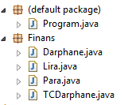 | 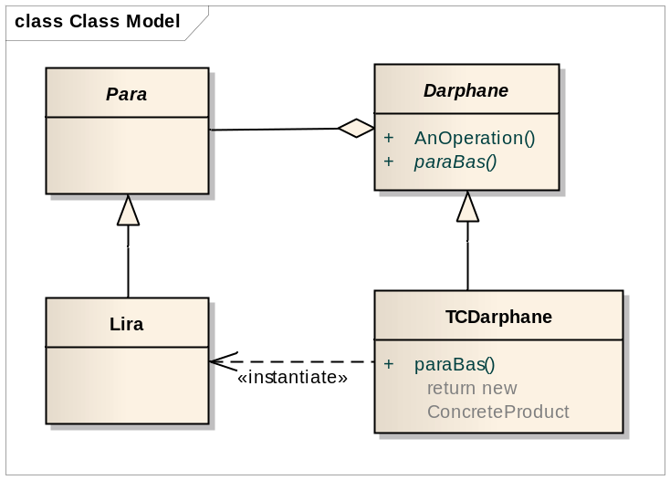

package Finans;

public abstract class Darphane {
public abstract Para ParaBas(int nominalDeger);
}

package Finans;

public class TCDarphane extends Darphane
{

@Override
public Para ParaBas(int nominalDeger) {
Para l = new Lira(nominalDeger, "TL");
return l;
}

@Override
public String toString() {

return "Türkiyenin darphanesi";
}

}

package Finans;

public abstract class Para {
protected int nominalDegeri;
protected String sembol;

Para()
{
nominalDegeri = 0;
sembol ="";
}
}

package Finans;

public class Lira extends Para
{
protected Lira(int nominalDeger, String sembol)
{
super.nominalDegeri = nominalDeger;
super.sembol = sembol;
}

@Override
public String toString()
{
return nominalDegeri + " " + sembol;
}
}

import Finans.*;

public class Program {
public static void main(String[] args) {
//Lira tl = new Lira();
TCDarphane drp = new TCDarphane();
Lira tl = (Lira) drp.ParaBas(50);
System.out.println(tl.toString());

}
}

