Factory Pattern Örnekler

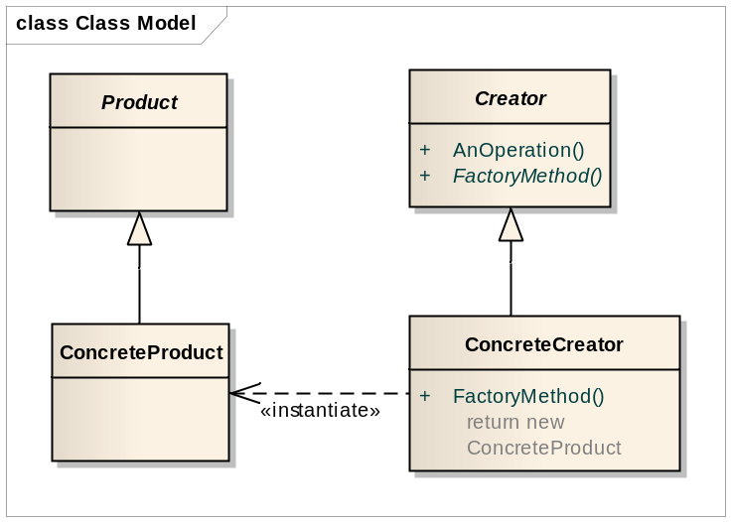

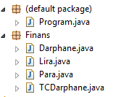 | 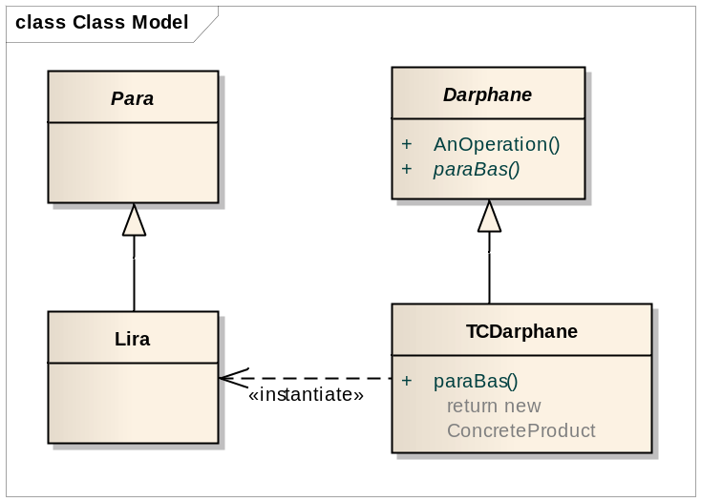

package Finans;

public abstract class Darphane {
public abstract Para ParaBas(int nominalDeger);
}

package Finans;

public class TCDarphane extends Darphane
{
@Override
public Para ParaBas(int nominalDeger) {
Para l = new Lira(nominalDeger, "TL");
return l;
}
public String toString() {

return "Türkiyenin darphanesi";
}
}

package Finans;

public abstract class Para {
protected int nominalDegeri;
protected String sembol;

Para()
{
nominalDegeri = 0;
sembol ="";
}
}

package Finans;

public class Lira extends Para
{
protected Lira(int nominalDeger, String sembol)
{
super.nominalDegeri = nominalDeger;
super.sembol = sembol;
}

@Override
public String toString()
{
return nominalDegeri + " " + sembol;
}
}

import Finans.*;
public class Program {
public static void main(String[] args) {
//Lira tl = new Lira();
TCDarphane drp = new TCDarphane();
Lira tl = (Lira) drp.ParaBas(50);
System.out.println(tl.toString());
}
}

Framework Örneği (Factory Method ?)
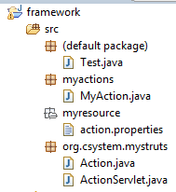
package org.csystem.mystruts;

public abstract class Action {

public abstract void execute();

}

package org.csystem.mystruts;

import java.util.ResourceBundle;

public class ActionServlet {
public ActionServlet(){
String key=ResourceBundle.getBundle("myresource/action").getString("action1");
try {
Action action=(Action)Class.forName(key).newInstance();
action.execute();
} catch (InstantiationException e) {
// TODO Auto-generated catch block
e.printStackTrace();
} catch (IllegalAccessException e) {
// TODO Auto-generated catch block
e.printStackTrace();
} catch (ClassNotFoundException e) {
// TODO Auto-generated catch block
e.printStackTrace();
}
}
}

package myactions;

import org.csystem.mystruts.Action;

public class MyAction extends Action {

public void execute() {
System.out.println("my action execute");

}

}

Action.properties
action1=myactions.MyAction

import org.csystem.mystruts.ActionServlet;

public class Test {
public static void main(String[] args) {
new ActionServlet();
}
}

MVC FrameWork
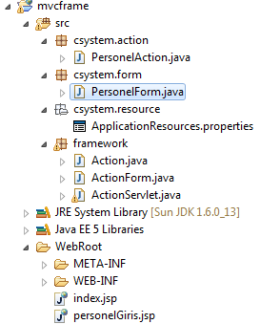

import java.lang.reflect.Method;

public class RunMthdRef {
public int add(int a, int b) {
return a+b;
}

public int sub(int a, int b) {
return a-b;
}

public int mul(int a, int b) {
return a*b;
}

public int div(int a, int b) {
return a/b;
}

public void setFonk(String ad){

System.out.println(ad);
}
public static void main(String[] args) {
try {
Integer[] input={new Integer(2),new Integer(6)};
Class cl=Class.forName("RunMthdRef");
Class[] par=new Class[2];
par[0]=Integer.TYPE;
par[1]=Integer.TYPE;
Class[] argTypes = new Class[] { String.class };

Method mthd=cl.getMethod("add",par);
Method mthd1=cl.getMethod("setFonk",argTypes);

Integer output=(Integer)mthd.invoke(new RunMthdRef(),input);
System.out.println(output.intValue());
mthd1.invoke(new RunMthdRef(),"deneme");
} catch (Exception e) {
e.printStackTrace();
}
}
}

package framework;
import java.io.IOException;
import java.lang.reflect.InvocationTargetException;
import java.lang.reflect.Method;
import java.util.Enumeration;
import java.util.HashMap;
import java.util.ResourceBundle;
import java.util.Set;
import javax.servlet.ServletException;
import javax.servlet.http.HttpServlet;
import javax.servlet.http.HttpServletRequest;
import javax.servlet.http.HttpServletResponse;
public class ActionServlet extends HttpServlet {
public ActionServlet() {
}// constr
protected void doGet(HttpServletRequest req, HttpServletResponse resp)
throws ServletException, IOException {
fonk(req, resp);
}
protected void doPost(HttpServletRequest req, HttpServletResponse resp)
throws ServletException, IOException {
// TODO Auto-generated method stub
fonk(req, resp);
}
private void fonk(HttpServletRequest req, HttpServletResponse resp) {
Enumeration params = req.getParameterNames();
String actkey = ResourceBundle.getBundle( "csystem.resource/ApplicationResources").getString("action1"); String formkey = ResourceBundle.getBundle( "csystem.resource/ApplicationResources").getString("form1"); try {
Action action = (Action) Class.forName(actkey).newInstance();
ActionForm form = (ActionForm) Class.forName(formkey).newInstance();
Class cls = form.getClass();
Method[] methods = cls.getMethods();
int index = 0;
HashMap<String, Method> setMeths = new HashMap<String, Method>();
for (int i = 0; i < methods.length; i++) {
Method method = methods[i];
if (method.getName().startsWith("set")) {
String str = method.getName().substring(3, 4).toLowerCase() .concat(method.getName().substring(4)); setMeths.put(str, method);
}// if
}// for
while (params.hasMoreElements()) {
String temp = (String) params.nextElement();
Set<String> methKeys = setMeths.keySet();
for (String metName : methKeys) {
if (metName.equals(temp)) {
setMeths.get(metName).invoke(form, req.getParameter(temp));
System.out.println(temp);
}
}
}
action.execute(form, req, resp);
} catch (InstantiationException e) {
// TODO Auto-generated catch block
e.printStackTrace();
} catch (IllegalAccessException e) {
// TODO Auto-generated catch block
e.printStackTrace();
} catch (ClassNotFoundException e) {
// TODO Auto-generated catch block
e.printStackTrace();
} catch (IllegalArgumentException e) {
// TODO Auto-generated catch block
e.printStackTrace();
} catch (InvocationTargetException e) {
// TODO Auto-generated catch block
// e.printStackTrace();
} catch (SecurityException e) {
// TODO Auto-generated catch block
e.printStackTrace();
}
}
}

package csystem.action;
import javax.servlet.http.HttpServletRequest;
import javax.servlet.http.HttpServletResponse;
import csystem.form.PersonelForm;
import framework.Action;
import framework.ActionForm;
public class PersonelAction extends Action {
public void execute(ActionForm form, HttpServletRequest request,
HttpServletResponse response) {
PersonelForm per=(PersonelForm)form;
System.out.println(per.getAd());
System.out.println(per.getSoyad());
System.out.println(per.getEmail());
}
}

package framework;
import javax.servlet.http.HttpServletRequest;
import javax.servlet.http.HttpServletResponse;
public abstract class Action {
public abstract void execute(ActionForm form,
HttpServletRequest request, HttpServletResponse response);
}

package csystem.action;
import javax.servlet.http.HttpServletRequest;
import javax.servlet.http.HttpServletResponse;
import csystem.form.PersonelForm;
import framework.Action;
import framework.ActionForm;
public class PersonelAction extends Action {
public void execute(ActionForm form, HttpServletRequest request,
HttpServletResponse response) {
PersonelForm per=(PersonelForm)form;
System.out.println(per.getAd());
System.out.println(per.getSoyad());
System.out.println(per.getEmail());
}
}

ApplicationResources.properties
action1=csystem.action.PersonelAction
form1=csystem.form.PersonelForm

personelGiris.jsp
<html>
<body>
<form action="servlet/ActionServlet">
Ad : <input type="text" name="ad"> <br>
Soyad : <input type="text" name="soyad"> <br>
Email : <input type="text" name="email"> <br>
<input type="submit" value="gonder"/>
</form>
</body>
</html>

