JSF Facelet
Facelets is a templating language developed from the ground up with
JavaServer™ Faces (JSF™) in mind. Because Facelets has come about as a
result of many of the concerns with JavaServer™ Pages (JSP™) API when
building JSF views, it steps outside of the JSP specification and provides a
highly performant, JSF-centric view technology. Its top properties are
templating, code reuse, and ease of development.
Focusing on these priorities allows Facelets to help make JSF suitable for
large-scale projects. For example, one of the first things a Facelets
developer finds is that the technology immediately leads to a reduction in
user interface (UI) code. Take our advice: use Facelets in your applications instead of JSP.

Facelets

When JavaServer Faces (JSF) was devised, the intention was to reuse JSP
as the main technology to create pages, as it was already a standard in the
web community. The idea was to simplify the adoption of JavaServer Faces
by using a familiar tag language that already had a large adoption rate
within the Java community.
Unfortunately, JSP and JSF don’t naturally complement each other. JSP is
used to create static or dynamic web content but not to create component
trees. Its elements are processed in a page from top to bottom with the
basic objective of creating a response to a request. JSF, however, has a
more complex life cycle, and component generation and rendering happen
in clearly separated phases. When used together, JSP and JSF both write
output to the response, but they do so differently: the JSP container creates
output as soon as it finds JSP content, whereas JSF components dictate its
own rendering.

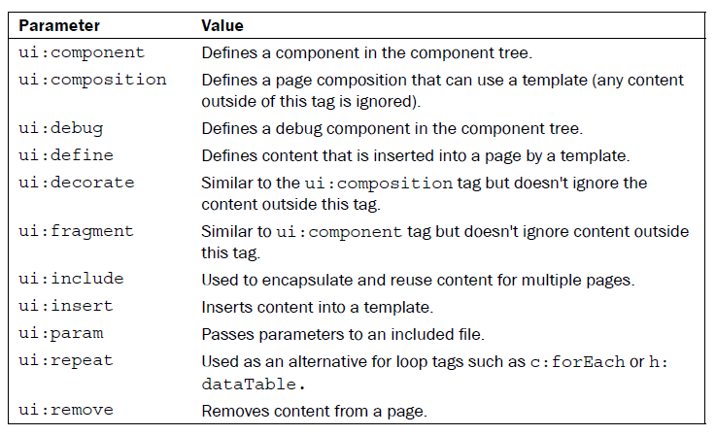
Facelet Template (Şablon) Örnekleri
template.xhtml
<?xml version="1.0" encoding="UTF-8"?>
<!DOCTYPE html PUBLIC "-//W3C//DTD XHTML 1.0 Transitional//EN" "http://www.w3.org/TR/xhtml1/DTD/xhtml1-transitional.dtd">

<html xmlns="http://www.w3.org/1999/xhtml" xmlns:ui="http://java.sun.com/jsf/facelets" xmlns:h="http://java.sun.com/jsf/html" xmlns:f="http://java.sun.com/jsf/core" xml:lang="en" lang="en">
<head>
<title>facelet test</title>
<style type="text/css">
#header {
text-align: center;
height: 50px;
border: 1px solid black;
font-size: 48px;
padding: 10px;
}

#menu {
height: 20px;
background-color: #ecdfec;
border-left: 1px solid black;
border-right: 1px solid black;
border-bottom: 1px solid black;
vertical-align: middle;
padding: 5px;
}
#content {
padding: 10px;
}
</style>
</head>
<body>
<div id="header">Burası başlık</div>
<div id="menu">Menu Item 1 , Menu Item 2 , Menu Item 3...</div>
<div id="content">
<ui:insert name="content" />
</div>
</body>
</html>

test.xhtml
<body>
<ui:composition template="/template.xhtml">
<ui:define name="content">
Bu test sayfasıdır
</ui:define>
</ui:composition>
</body>

Şimdi de ayrı ayrı parçalari kullanarak bir sayfa oluşturmayı görelim:
style.css
#header {
text-align: center;
height: 50px;
border: 1px solid black;
font-size: 48px;
padding: 10px;
}
#menu {
height: 20px;
background-color: #ecdfec;
border-left: 1px solid black;
border-right: 1px solid black;
border-bottom: 1px solid black;
vertical-align: middle;
padding: 5px;
}
#content {
padding: 10px;
}

header.xhtml
<ui:composition>
Burası başlık
</ui:composition>

menu.xhtml
<ui:composition>
Menu Item 1 , Menu Item 2 , Menu Item 3...
</ui:composition>

template.xhtml
<?xml version="1.0" encoding="UTF-8"?>
<!DOCTYPE html PUBLIC "-//W3C//DTD XHTML 1.0 Transitional//EN" "http://www.w3.org/TR/xhtml1/DTD/xhtml1-transitional.dtd">

<html xmlns="http://www.w3.org/1999/xhtml"
xmlns:ui="http://java.sun.com/jsf/facelets"
xmlns:h="http://java.sun.com/jsf/html"
xmlns:f="http://java.sun.com/jsf/core" xml:lang="en" lang="en">
<head>
<title>My Facelets Page</title>
<meta http-equiv="keywords" content="enter,your,keywords,here" />
<meta http-equiv="description"
content="A short description of this page." />
<meta http-equiv="content-type" content="text/html; charset=UTF-8" />
<link rel="stylesheet" type="text/css" href="style.css" />
</head>
<body>
<div id="header">
<ui:include src="/header.xhtml" />
</div>
<div id="menu">
<ui:include src="/menu.xhtml" />
</div>
<div id="content">
<ui:insert name="content" />
</div>

</body>
</html>

test.xhtml
<ui:composition template="/template.xhtml">
<ui:define name="content">
Bu test sayfasıdır
</ui:define>
</ui:composition>

