Üyelik Kontrolu (Veritabanından bean yardımıyla kontrol)

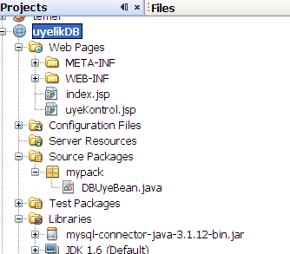 | Top of Form  User :  Password:  Bottom of Form

- DBUyeBean.java
package mypack;

import java.sql.SQLException;
import java.sql.Connection;
import java.sql.DriverManager;
import java.sql.ResultSet;
import java.sql.Statement;

/**
*
* @author user
*/
public class DBUyeBean {

private String user;
private String password;
private boolean uye = false;
private Statement stmt;

public DBUyeBean() {
try {
Class.forName("com.mysql.jdbc.Driver");
Connection con = DriverManager.getConnection("jdbc:mysql://localhost:3306/javatest", "root", "");
stmt = con.createStatement();
} catch (Exception ex) {
System.out.println(ex);
}//catch
}

public void setUser(String user) {
this.user = user;
}

public void setPassword(String password) {
this.password = password;
}

public boolean isUye() {
String sql = "SELECT user, password FROM uye WHERE user='" + user + "' AND password = '" + password + "'";
try {
ResultSet rs = stmt.executeQuery(sql);
uye = rs.next();
} catch (SQLException e) {
e.printStackTrace();
}
return uye;

}
}

- index.jsp
<body>
<form action="uyeKontrol.jsp" method="POST">
User : <input type="text" name="user" value="" /> <br>
Password:<input type="text" name="password" value="" /> <br>
<input type="submit" value="kontrol" />
</form>
</body>

- uyekontrol.jsp
<body>
<jsp:useBean id="mybean" scope="page" class="mypack.DBUyeBean" />
<jsp:setProperty name="mybean" property="*" />
<%
if (mybean.isUye()) {
out.println("uyemiz");
} else {
out.println("uyemiz degil");
}
%>

</body>

