- Veri tabanı uygulaması
<%@page import="java.sql.*" %>
<% Class.forName("com.mysql.jdbc.Driver");
Connection con = DriverManager.getConnection("jdbc:mysql://localhost:3306/javatest","root","");
Statement stmt=con.createStatement();
ResultSet res=stmt.executeQuery("select * from adres");
while(res.next())
out.println(res.getString(2)+"-"+res.getString(3)+"<p>");
%>
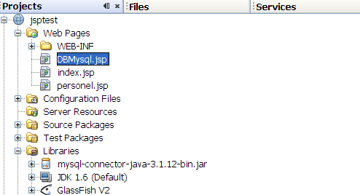

DAO (Data Access Object)

Personel
public class Personel {

private int id;
private String ad;
private String soyad;
private int maas;
. . . . . .

PersonelDAO
public class PersonelDAO {
private Connection con;

public void create(Personel personel) {
}

public void delete(Personel personel) {
}

public Personel findById(int id) {
Connection connect=getConnection();
Personel personel=null;
try {
Statement stmt = connect.createStatement();
ResultSet rs = stmt.executeQuery("select * from personel where id="+id);
rs.next();
personel=new Personel();
personel.setId(id);
personel.setAd(rs.getString("ad"));
personel.setSoyad(rs.getString("soyad"));
personel.setMaas(rs.getInt("maas"));
} catch (SQLException e) {
// TODO Auto-generated catch block
e.printStackTrace();
}
return personel;
}

public List findAll() {
return null;

}

public Connection getConnection() {
if (con == null) {
try {
Class.forName("org.apache.derby.jdbc.ClientDriver");
con = DriverManager.getConnection("jdbc:derby://localhost:1527/myeclipse", "classiccars", "classiccars");
} catch (ClassNotFoundException e) {
// TODO Auto-generated catch block
e.printStackTrace();
} catch (SQLException e) {
// TODO Auto-generated catch block
e.printStackTrace();
}

}
return con;
}
}

PersonelTest
PersonelDAO perDAO = new PersonelDAO();
Personel pers = perDAO.findById(1);
System.out.println(pers.getAd());

