UML
Unified Modeling Language (UML) is a standardized general-purpose modeling language in the field of object-oriented software engineering. The standard is managed, and was created, by the Object Management Group. It was first added to the list of OMG adopted technologies in 1997, and has since become the industry standard for modeling software-intensive systems.
UML includes a set of graphic notation techniques to create visual models of object-oriented software-intensive systems.

Overview
The Unified Modeling Language (UML) is used to specify, visualize, modify, construct and document the artifacts of an object-oriented software-intensive system under development. UML offers a standard way to visualize a system's architectural blueprints, including elements such as:
- activities
- actors
- business processes
- database schemas
- (logical) components
- programming language statements
- reusable software components.
UML combines techniques from data modeling (entity relationship diagrams), business modeling (work flows), object modeling, and component modeling. It can be used with all processes, throughout the software development life cycle, and across different implementation technologies. UML has synthesized the notations of the Booch method, the Object-modeling technique (OMT) and Object-oriented software engineering (OOSE) by fusing them into a single, common and widely usable modeling language. UML aims to be a standard modeling language which can model concurrent and distributed systems. UML is a de facto industry standard, and is evolving under the auspices of the Object Management Group (OMG).
UML models may be automatically transformed to other representations (e.g. Java) by means of QVT-like transformation languages. UML is extensible, with two mechanisms for customization: profiles and stereotypes.

History

Before UML 1.x
After Rational Software Corporation hired James Rumbaugh from General Electric in 1994, the company became the source for the two most popular object-oriented modeling approaches of the day: Rumbaugh's Object-modeling technique (OMT), which was better for object-oriented analysis (OOA), and Grady Booch's Booch method, which was better for object-oriented design (OOD). They were soon assisted in their efforts by Ivar Jacobson, the creator of the object-oriented software engineering (OOSE) method. Jacobson joined Rational in 1995, after his company, Objectory AB, was acquired by Rational. The three methodologists were collectively referred to as the Three Amigos.
In 1996, Rational concluded that the abundance of modeling languages was slowing the adoption of object technology, so repositioning the work on a unified method, they tasked the Three Amigos with the development of a non-proprietary Unified Modeling Language. Representatives of competing object technology companies were consulted during OOPSLA '96; they chose boxes for representing classes rather than the cloud symbols that were used in Booch's notation.
Under the technical leadership of the Three Amigos, an international consortium called the UML Partners was organized in 1996 to complete the Unified Modeling Language (UML) specification, and propose it as a response to the OMG RFP. The UML Partners' UML 1.0 specification draft was proposed to the OMG in January 1997. During the same month the UML Partners formed a Semantics Task Force, chaired by Cris Kobryn and administered by Ed Eykholt, to finalize the semantics of the specification and integrate it with other standardization efforts. The result of this work, UML 1.1, was submitted to the OMG in August 1997 and adopted by the OMG in November 1997
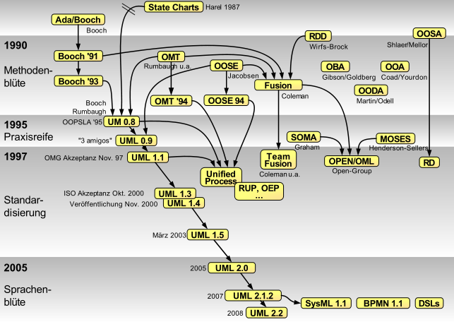
History of object-oriented methods and notation

UML 1.x
As a modeling notation, the influence of the OMT notation dominates (e. g., using rectangles for classes and objects). Though the Booch "cloud" notation was dropped, the Booch capability to specify lower-level design detail was embraced. The use case notation from Objectory and the component notation from Booch were integrated with the rest of the notation, but the semantic integration was relatively weak in UML 1.1, and was not really fixed until the UML 2.0 major revision.
Concepts from many other OO methods were also loosely integrated with UML with the intent that UML would support all OO methods. Many others also contributed, with their approaches flavouring the many models of the day, including: Tony Wasserman and Peter Pircher with the "Object-Oriented Structured Design (OOSD)" notation (not a method), Ray Buhr's "Systems Design with Ada", Archie Bowen's use case and timing analysis, Paul Ward's data analysis and David Harel's "Statecharts"; as the group tried to ensure broad coverage in the real-time systems domain. As a result, UML is useful in a variety of engineering problems, from single process, single user applications to concurrent, distributed systems, making UML rich but also large.
The Unified Modeling Language is an international standard:
ISO/IEC 19501:2005 Information technology – Open Distributed Processing – Unified Modeling Language (UML) Version 1.4.2

UML 2.x
UML has matured significantly since UML 1.1. Several minor revisions (UML 1.3, 1.4, and 1.5) fixed shortcomings and bugs with the first version of UML, followed by the UML 2.0 major revision that was adopted by the OMG in 2005.
Although UML 2.1 was never released as a formal specification, versions 2.1.1 and 2.1.2 appeared in 2007, followed by UML 2.2 in February 2009. UML 2.3 was formally released in May 2010. UML 2.4.1 was formally released in August 2011.
There are four parts to the UML 2.x specification:
- The Superstructure that defines the notation and semantics for diagrams and their model elements
- The Infrastructure that defines the core metamodel on which the Superstructure is based
- The Object Constraint Language (OCL) for defining rules for model elements
- The UML Diagram Interchange that defines how UML 2 diagram layouts are exchanged
The current versions of these standards follow: UML Superstructure version 2.4.1, UML Infrastructure version 2.4.1, OCL version 2.3.1, and UML Diagram Interchange version 1.0.
Although many UML tools support some of the new features of UML 2.x, the OMG provides no test suite to objectively test compliance with its specifications.

Modeling
It is important to distinguish between the UML model and the set of diagrams of a system. A diagram is a partial graphic representation of a system's model. The model also contains documentation that drives the model elements and diagrams (such as written use cases).
UML diagrams represent two different views of a system model:
- Static (or structural) view: emphasizes the static structure of the system using objects, attributes, operations and relationships. The structural view includes class diagrams and composite structure diagrams.
- Dynamic (or behavioral) view: emphasizes the dynamic behavior of the system by showing collaborations among objects and changes to the internal states of objects. This view includes sequence diagrams, activity diagrams and state machine diagrams.
UML models can be exchanged among UML tools by using the XMI interchange format.

Diagrams overview
UML 2.2 has 14 types of diagrams divided into two categories. Seven diagram types represent structural information, and the other seven represent general types of behavior, including four that represent different aspects of interactions. These diagrams can be categorized hierarchically as shown in the following class diagram:

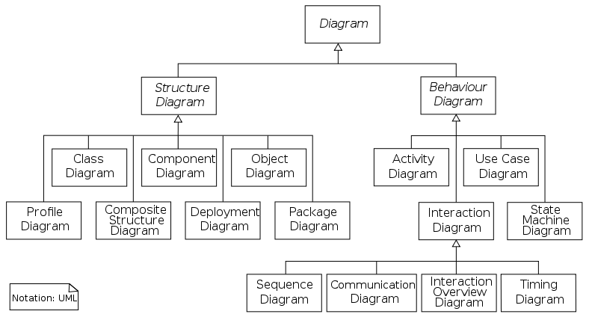UML does not restrict UML element types to a certain diagram type. In general, every UML element may appear on almost all types of diagrams; this flexibility has been partially restricted in UML 2.0. UML profiles may define additional diagram types or extend existing diagrams with additional notations.
In keeping with the tradition of engineering drawings, a comment or note explaining usage, constraint, or intent is allowed in a UML diagram.

Class Diagram
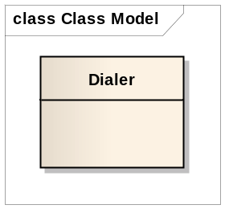class | public class Dialler  {}
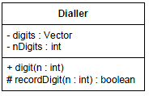  (-) denotes private, hash (#) denotes protected, and plus (+) denotes public. | public class Dialler  {  private Vector digits;  int nDigits;  public void digit(int n);  protected boolean  recordDigit(int n);  }
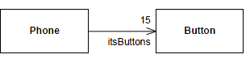  Association | public class Phone  {  private Button itsButtons[15];  }
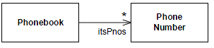  Multiplicity (Association) | public class Phonebook  {  private Vector itsPnos;  }
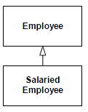  Generalization (inheritance) | public class Employee  {  ...  }  public class SalariedEmployee extends Employee  {  ...  }
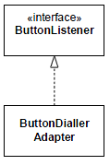  Realizes | interface ButtonListener  {  ...  }  public class ButtonDiallerAdapter  implements ButtonListener  {  ...  }
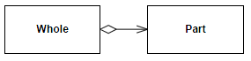  Aggregation | public class Whole  {  private Part itsPart;  }
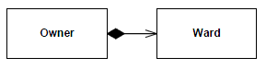  Composition | public class Owner  {  private Ward itsWard;  }

Association streotypes
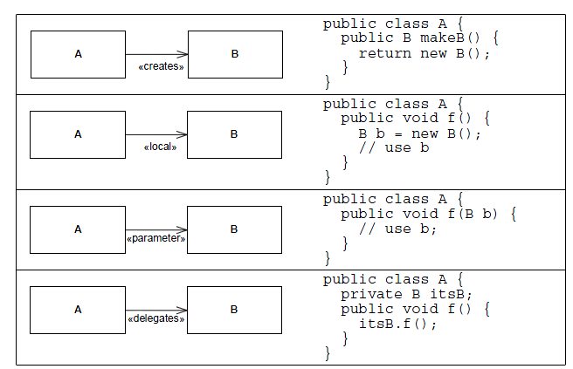

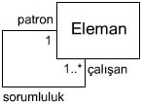 | Patron bir eleman olmasına rağmen kendisi gibi eleman olan birden çok çalışan 'dan sorumludur.

Elements of aggregation
Aggregation is a special type of association used to indicate that the participating objects
are not just independent objects that know about each other. Instead, they are assembled or
configured together to create a new, more complex object. For example, a number of different
parts are assembled to create a car, a boat, or a plane. You could even create a logical
assembly like a team where the parts are not physically connected to one another but they
still operate as a unit.
To model aggregation on a Class diagram:
1. Draw an association (a line) between the class that represents the member and the
class that represents the assembly or aggregation. In Figure 11-2, that would mean
a line between the Team class and the Player class.
2. Draw a diamond on the end of the association that is attached to the assembly or
aggregate class. In Figure 11-2, the diamond is next to the Team class that represents
a group of players.
3. Assign the appropriate multiplicities to each end of the association, and add any
roles and/or constraints that may be needed to define the rules for the relationship.
Figure 11-2 shows that a Player may be a member of no more than one Team,
but a Player does not have to be on a Team all the time (0..1). The Team is always
comprised of exactly nine Players (9..9 or just 9). A Player is considered a member
(role name) of a Team. Every Player is constrained by the fact that she must have a
current contract in order to be a member of a Team.
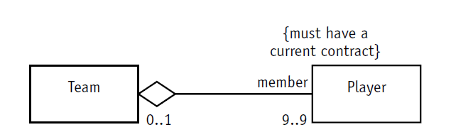

Elements of composition
Composition is used for aggregations where the life span of the part depends on the life
span of the aggregate. The aggregate has control over the creation and destruction of the
part. In other words, the member object cannot exist apart from the aggregation. Draw this
stronger form of aggregation simply by making the aggregation diamond solid (black).
In Figure 11-3, the team example uses aggregation, the hollow diamond. Players are
assembled into a team. But if the Team is disbanded, the players live on (depending of
course on how well they performed). The Book example uses composition, the solid diamond.
A Book is composed of Chapters. The Chapters would not continue to exist elsewhere
on their own. They would cease to exist along with the Book.
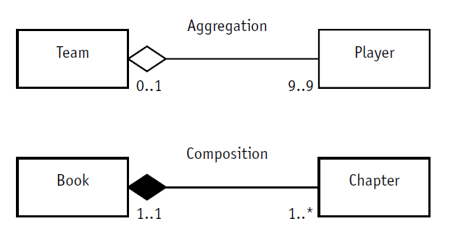
Creating aggregation and composition relationships
Problem statement: “Our Company maintains a group of race cars. Our cars use some of our
new 8-cylinder engines and new transmissions. Once the engines are assembled, the pistons,
carburetor, and plugs cannot be swapped between engines due to changes caused by the
high temperatures.
“We want to keep records of the performance achieved by each engine in each car and each
transmission in combination with each engine. Our drivers evaluate each car to give us their
assessment of the handling. We need a system to track the configurations and the drivers’
assessments.”
Figure 11-4 shows that each car can be configured with different engine and transmission
combinations. The configuration is built using an engine and a transmission (aggregation).
The drivers test the car configurations. The association class ConfigurationAssessment contains
the details of the drivers’ evaluations for each configuration.

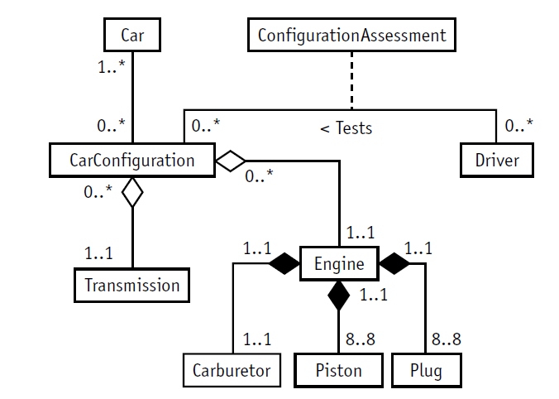

Building the Class diagram
To build the Class diagram, follow the steps described in Sessions 9 through 11:
1. Identify the classes, name them, and define them so you know why they are part
of the model. Turn to Session 9 for a reminder if you get stuck.
2. Identify, name, and define the associations between pairs of classes. Watch out for
reflexive associations as well. Assign multiplicity and constraints where needed. If
naming an association is difficult, try role names. Session 10 provides an explanation
of each of these model elements.
3. Evaluate each association to determine whether it should be defined as aggregation.
If it is aggregation, then could it be composition? If you need help remembering the
distinction between aggregation and composition, turn to Session 11.
4. Evaluate the classes for possible specialization or generalization. Check out
Session 11 if you get stuck.
Figure 12-1 illustrates the completed Class diagram. You can try building the diagram on
your own, then compare your results with Figure 12-1, or you can go ahead and examine
the diagram. In the numbered list that accompanies the figure, I explain each of the model
elements.
1. “Customers place orders for one or more items, but we acknowledge interested
customers in the system whether they have purchased yet or not.”
On the “places” association between Customer and Order, the multiplicity of
1..1 means that every Order must be placed by a Customer. An Order cannot
exist on its own.
This sounds kind of like composition, doesn’t it? But it can’t be composition
if it doesn’t first satisfy the rules for aggregation. That is, the order would
have to be part of the customer. Because the order is not part of the
customer, the relationship is a simple association.

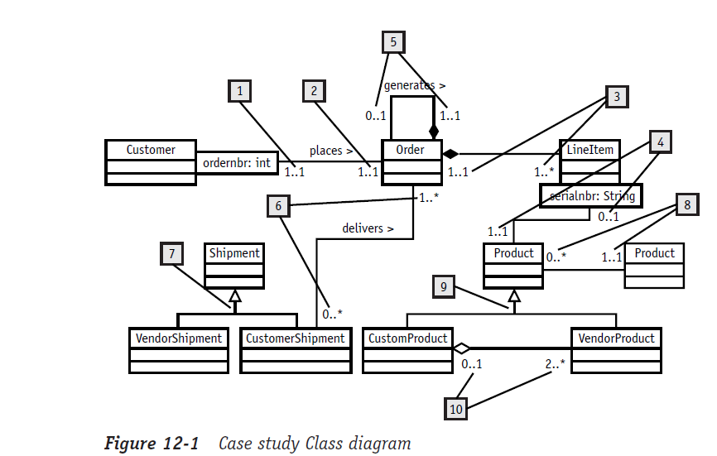
2. “Customers place orders for one or more items, but we acknowledge interested customers
in the system whether they have purchased yet or not. The Customer may
inquire on the status of his Orders using the order number.”
On the “places” association between Customer and Order, some customers may
not yet have placed any orders while others may have been doing business
with us for a long time. The Order multiplicity should be 0..*. But a Customer
can use the order number as a qualifier to look up a specific Order (qualified
association), so the multiplicity with the qualifier is 1..1.
3. “Customers place orders for one or more items. . . .”
An Order is constructed using one or more Line Items. Each Line Item includes
information like a price and any applicable discount. But every Line Item
exists only as part of an Order represented by composition and a multiplicity
of 1..1 on the Order. There must be at least one item on the Order so the
LineItem multiplicity is 1..*.
4. “Each item corresponds to a product. We identify each product using a unique serial
number.”
Each Line Item is associated with a specific Product (1..1). The Line Item
refers to the Product using a serial number as a qualifier (qualified association).
A Product might not ever be ordered, so the multiplicity on the Line
Item end is zero to one (0..1). In other words, a Product might not yet be
associated with a Line Item.
5. “Any items that have not been shipped are placed on a backorder with a reference to
the original order.”
An Order that is not filled completely will generate another Order that it
refers to as a backorder (role name) and that backorder is associated with the
Order that generated it (reflexive composition). Each backorder refers to
exactly one other Order, its source (1..1). But each Order may or may not
generate backorders (0..*).
6. “Customer orders are shipped as the products become available, so there may be
more than one shipment to satisfy a single customer order. But a single shipment
may contain products from multiple orders.”
The Order is shipped to the Customer via a Customer Shipment. When the
Order has not yet been shipped, the multiplicity on the Customer Shipment is
zero (that is, there is no Shipment associated with the Order). When more
than one Shipment is needed to fill the Order (for example, the items are
being shipped from multiple locations or are restricted by shipping requirements),
the multiplicity is “many.” Hence the complete multiplicity range is
0..*. A shipment may contain products from many orders, resulting in an
Order multiplicity of 1..*.
7. “Shipments of products from vendors are received and placed into stock. . . .
Customer orders are shipped as the products become available.”
Customer Shipment is just one type of Shipment (generalization). Another
type of Shipment is the incoming Vendor Shipment referred to in the receiving
process. CustomerShipment and VendorShipment are specializations of
Shipment and so inherit all the properties of Shipment.
8. “Each product is assigned to a location so that we can easily find it later when
filling orders. Each location has a unique location identifier.”
Many Products or no Products may be in a given Location (0..*). But in order
for you to record a Product into inventory, you have to assign it to a Location.
So there will never be a Product that is not associated with a Location. This
requires a multiplicity of 1..1 on the Location end of the association.
9. “These products may be purchased directly from vendors and resold as is, or we can
package vendor products together to make our own custom product.”
VendorProduct and CustomProduct are both types of Product (generalization),
specializations of the class Product. Both can be ordered and shipped. But
CustomProducts are configurations of VendorProducts and VendorProducts are
standalone items that are ordered and shipped independently, not in a configuration
of other Products.
10. “. . . we can package vendor products together to make our own custom product.”
We can create custom products using VendorProducts; for example, a home
entertainment system might consist of a receiver, CD player, speakers, TV, and
so on (aggregation). Why is it aggregation and not composition? Because the
VendorProducts, like the CD player, may exist and be sold separately from the
entertainment system. The multiplicity on VendorProduct is 2..* because a
CustomProduct is only a logic entity made up of a combination of at least two
VendorProducts. A VendorProduct may be sold individually and does not have
to be part of any CustomProduct configuration (0..1).

