Primeface

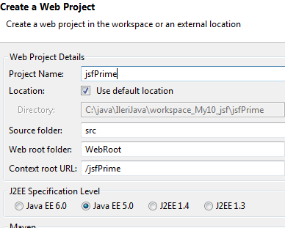 | 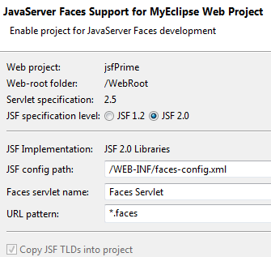

<?xml version="1.0" encoding="UTF-8"?>
<web-app xmlns:xsi="http://www.w3.org/2001/XMLSchema-instance"
xmlns="http://java.sun.com/xml/ns/javaee" xmlns:web="http://java.sun.com/xml/ns/javaee/web-app_2_5.xsd"
xsi:schemaLocation="http://java.sun.com/xml/ns/javaee http://java.sun.com/xml/ns/javaee/web-app_2_5.xsd"
version="2.5">
<display-name></display-name>
<welcome-file-list>
<welcome-file>index.jsp</welcome-file>
</welcome-file-list>
<servlet>
<servlet-name>Resource Servlet</servlet-name>
<servlet-class>org.primefaces.resource.ResourceServlet</servlet-class>
</servlet>
<servlet-mapping>
<servlet-name>Resource Servlet</servlet-name>
<url-pattern>/primefaces_resource/*</url-pattern>
</servlet-mapping>
<servlet>
<servlet-name>Faces Servlet</servlet-name>
<servlet-class>javax.faces.webapp.FacesServlet</servlet-class>
<load-on-startup>1</load-on-startup>
</servlet>
<servlet-mapping>
<servlet-name>Faces Servlet</servlet-name>
<url-pattern>*.faces</url-pattern>
</servlet-mapping>
</web-app>
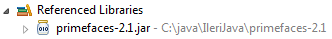
prime.xhtml
<html xmlns="http://www.w3c.org/1999/xhtml"
xmlns:f="http://java.sun.com/jsf/core"
xmlns:h="http://java.sun.com/jsf/html"
xmlns:p="http://primefaces.prime.com.tr/ui">
<h:head>
</h:head>
<h:body>
<p:editor />
</h:body>
</html>

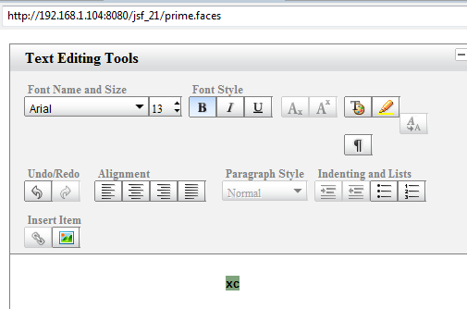

Dikkat: primefaces’in yeni versiyonlarında web.xml’de bir değişikliğe gerek yok, ancak namespace’de değişiklik olmuş. xmlns:p="http://primefaces.prime.com.tr/ui yerine http://primefaces.org/ui kullanılıyor.
<html xmlns="http://www.w3.org/1999/xhtml"
xmlns:h="http://java.sun.com/jsf/html"
xmlns:f="http://java.sun.com/jsf/core"
xmlns:p="http://primefaces.org/ui">

<h:head>

</h:head>

<h:body>

<p:editor />

</h:body>
</html>

Bu örnekte primefaces-3.2.jar kullanıldı. Ayrıntılar prime faces_users_ guide_3_2.pdf’den öğrenilebilir.

package org.csystem.beans;

import java.util.Date;

import javax.faces.bean.ManagedBean;
import javax.faces.bean.SessionScoped;

@ManagedBean
@SessionScoped

public class CalendarBean {

private Date date1;

private Date date2;

private Date date3;

public Date getDate1() {
return date1;
}

public void setDate1(Date date1) {
this.date1 = date1;
}

public Date getDate2() {
return date2;
}

public void setDate2(Date date2) {
this.date2 = date2;
}

public Date getDate3() {
return date3;
}

public void setDate3(Date date3) {
this.date3 = date3;
}
}

calendar.xhtml
<html xmlns="http://www.w3.org/1999/xhtml"
xmlns:h="http://java.sun.com/jsf/html"
xmlns:f="http://java.sun.com/jsf/core"
xmlns:p="http://primefaces.org/ui">

<h:head>

</h:head>

<h:body>
<h:form id="form">

<h3>Inline</h3>
<p:calendar value="#{calendarBean.date1}" mode="inline" id="inlineCal"/>

<h3>Popup</h3>
<p:calendar value="#{calendarBean.date2}" id="popupCal" />

<h3>Popup Button</h3>
<p:calendar value="#{calendarBean.date3}" id="popupButtonCal" showOn="button" />

<p:commandButton value="Submit" update="display" oncomplete="dialog.show()" />

<p:dialog header="Selected Dates" widgetVar="dialog"
showEffect="fade" hideEffect="fade">

<h:panelGrid id="display" columns="2" cellpadding="5">

<h:outputText value="Inline Date:" />
<h:outputText value="#{calendarBean.date1}" id="inlineDate">
<f:convertDateTime pattern="d/M/yyyy"/>
</h:outputText>

<h:outputText value="Popup Date:" />
<h:outputText value="#{calendarBean.date2}" id="popupDate">
<f:convertDateTime pattern="d/M/yyyy"/>
</h:outputText>

<h:outputText value="Popup Button Date: " />
<h:outputText value="#{calendarBean.date3}" id="popupButtonDate">
<f:convertDateTime pattern="d/M/yyyy"/>
</h:outputText>

</h:panelGrid>

</p:dialog>

</h:form>

</h:body>
</html>

Çalıştırırken calendar.faces diye yazılmalı.

package org.csystem.beans;

import java.io.Serializable;

import javax.faces.bean.ManagedBean;
import javax.faces.bean.SessionScoped;

import org.primefaces.model.chart.PieChartModel;

@ManagedBean
@SessionScoped
public class ChartBean implements Serializable {

private PieChartModel pieModel;

public ChartBean() {
createPieModel();
}

public PieChartModel getPieModel() {
return pieModel;
}

private void createPieModel() {
pieModel = new PieChartModel();

pieModel.set("Brand 1", 540);
pieModel.set("Brand 2", 325);
pieModel.set("Brand 3", 702);
pieModel.set("Brand 4", 421);
}
}

pieChart.faces
<html xmlns="http://www.w3.org/1999/xhtml"
xmlns:h="http://java.sun.com/jsf/html"
xmlns:f="http://java.sun.com/jsf/core"
xmlns:p="http://primefaces.org/ui">

<h:head>

</h:head>

<h:body>
<p:pieChart id="sample" value="#{chartBean.pieModel}"
legendPosition="w" title="Sample Pie Chart"
style="width:400px;height:300px" />

<p:pieChart id="custom" value="#{chartBean.pieModel}"
legendPosition="e" fill="false" title="Custom Options"
style="width:400px;height:300px" sliceMargin="5" diameter="150" />

</h:body>
</html>

