Struts 2
Struts 2 is a second-generation web application framework that implements the Model-View-Controller (MVC) design pattern. Struts 2 is built from the ground up on best practices and proven, community-accepted design patterns. This was also true for the first version of Struts. In fact, one of the primary goals of the first Strutswas incorporating the MVC pattern from the desktop application world into a web application framework. The resulting pattern is occasionally called the Model 2 pattern.
This was a critical step in the evolution of well-designed web applications, as it provided the infrastructure for easily achieving the MVC separation of concerns. This allowed developers with few resources for such architectural niceties to tap into a ready-made best practice solution. Struts 1 can claim responsibility for many of At some point, the Struts community became aware of the limitations in the first framework. With such an active community, identifying the weak and inflexible points in the framework wasn’t hard to accomplish. Struts 2 takes advantage of the many lessons learned to present a cleaner implementation of MVC. At the same time, it introduces several new architectural features that make the framework cleaner and more flexible. These new features include interceptors for layering cross-cutting concerns away from action logic; annotation-based configuration to reduce or eliminate XML configuration; a powerful expression language, Object-Graph Navigation Language (OGNL), that transverses the entire framework; and a mini-MVC–based tag API that
supports modifiable and reusable UI components. the better-designed web applications of the last 10 years.
How Struts 2 works

In this section, we’ll detail processing a request within the framework. As you’ll see, the framework has more than just its MVC components. We said that Struts 2 provides a cleaner implementation of MVC. These clean lines are only possible with the help of a few other key architectural components that participate in processing every request. Chief among these are the interceptors, OGNL, and the ValueStack. We’ll learn what each of these does in the following walkthrough of Struts 2 request processing. Figure shows the request processing workflow.
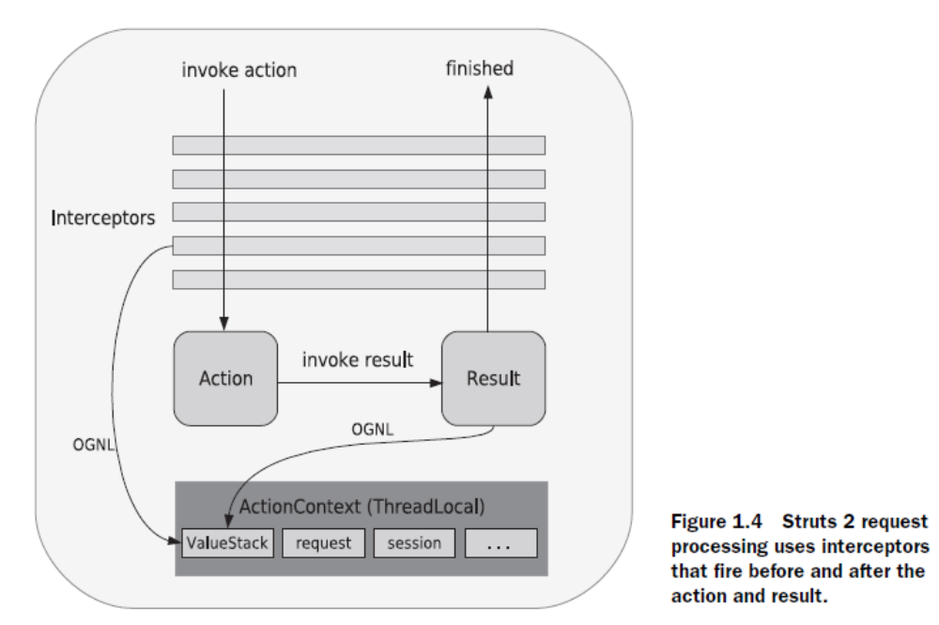
Interceptors are Struts 2 components that execute both before and after the rest of the request processing. They provide an architectural component in which to define various workflow and cross-cutting tasks so that they can be easily reused as well as separated from other architectural concerns. What kinds of work should be done in interceptors? Logging is a good example.
THE VALUESTACK AND OGNL

While interceptors may not absorb a lot of your daily development energies, the ValueStack and OGNL will be constantly on your mind. In a nutshell, the ValueStack is a storage area that holds all of the data associated with the processing of a request. You could think of it as a piece of scratch paper where the framework does its work while solving the problems of request processing. Rather than passing the data around, Struts 2 keeps it in a convenient, central location—the ValueStack. OGNL is the tool that allows us to access the data we put in that central repository. More specifically, it is an expression language that allows you to reference and manipulate
the data on the ValueStack. Developers new to Struts 2 probably ask more questions about the ValueStack and OGNL than anything else. If you’re coming from Struts 1, you’ll find that these are a couple of the more exotic features of the new framework.
The tricky, and powerful, thing about the ValueStack and OGNL is that they don’t belong to any of the individual framework components. Looking back to figure 1.4, note that both interceptors and results can use OGNL to target values on the ValueStack. The data in the ValueStack follows the request processing through all phases; it slices through the whole length of the framework. It can do this because it is stored in a
ThreadLocal context called the ActionContext.
OGNL is a powerful expression language (and more) that is used to reference and manipulate properties on the ValueStack.

Instead of a servlet controller like the ActionServlet class in Struts 1, Struts 2 uses a filter to perform the same task.
• There are no action forms in Struts 2. In Struts 1, an HTML form maps to an ActionForm instance. You can then access this action form from your action class and use it to populate a data transfer object. In Struts 2, an HTML form maps directly to a POJO. You don't need to create a data transfer object and, since there are no action forms, maintenance is easier and you deal with fewer classes.
• Now, if you don't have action forms, how do you programmatically validate user input in Struts 2? By writing the validation logic in the action class.
• Struts 1 comes with several tag libraries that provides custom tags to be used in JSPs. The most prominent of these are the HTML tag library, the Bean tag library, and the Logic tag library. JSTL and the Expression Language (EL) in Servlet 2.4 are often used to replace the Bean and Logic tag libraries. Struts 2 comes with a tag library that covers all. You don't need JSTL either, even though in some cases you may still need the EL.
• In Struts 1 you used Struts configuration files, the main of which is called struts-config.xml (by default) and located in the WEB-INF directory of the application. In Struts 2 you use multiple configuration files too, however they must reside in or a subdirectory of WEB-INF/classes.
.Java 5 and Servlet 2.4 are the prerequisites for Struts 2. Java 5 is needed because annotations, added to Java 5, play an important role in Struts 2. Considering that Java 6 has been released and Java 7 is on the way at the time of writing, you're probably already using Java 5 or Java 6.
• Struts 1 action classes must extend org.apache.struts.action.Action. In Struts 2 any POJO can be an action class. However, "Actions and Results" it is convenient to extend the ActionSupport class in Struts 2. On top of that, an action class can be used to service related actions.
• Instead of the JSP Expression Language and JSTL, you use OGNL to display object models in JSPs.
• Tiles, which started life as a subcomponent of Struts 1, has graduated to an independent Apache project. It is still available in Struts 2 as a plug-in.

Two mechanisms for declaring your architecture

There are two ways to do this: through XML-based configuration files or through Java annotations. Figure demonstrates the dual interface to the declarative architecture.

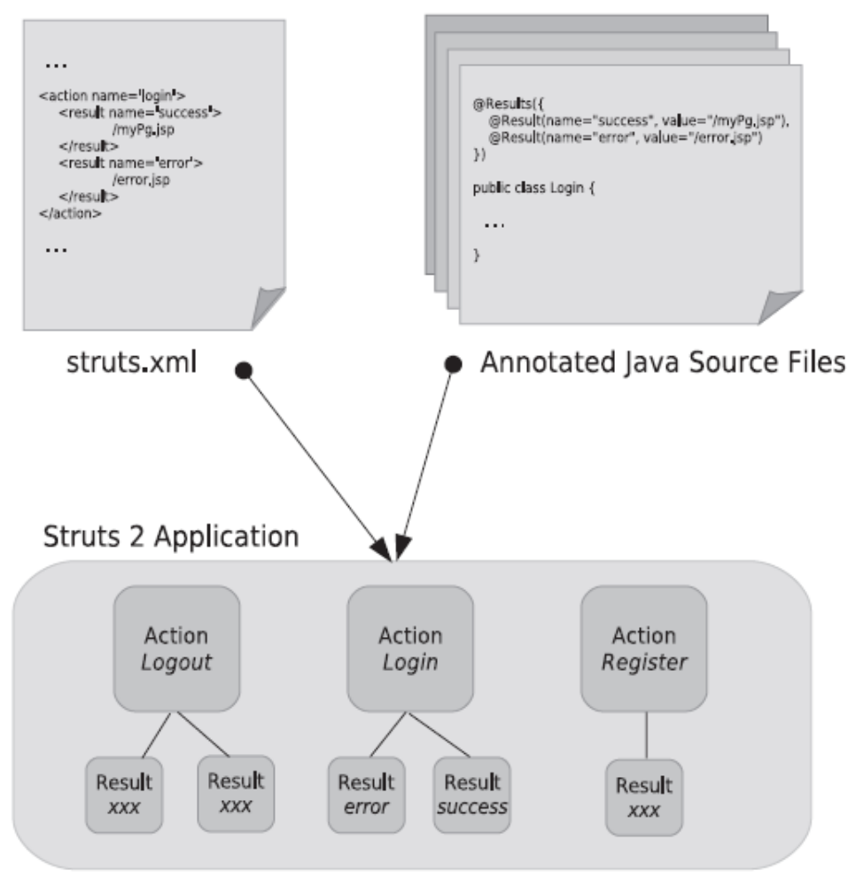
As you can see, whether your application’s Struts 2 components are declared in XML
or in annotations, the framework translates them into the same runtime components. In the case of the XML, we have the familiar XML configuration document with elements describing your application’s actions, results, and interceptors. With annotations, the XML is gone. Now, the metadata is collected in Java annotations that reside directly within the Java source for the classes that implement your actions. Regardless of which method you use, the framework produces the same runtime application. The two mechanisms are redundant in the sense that you can use whichever you like without functional consequence. The declarative architecture is the real concept here. Which style of declaration you choose is largely a matter of taste. For now, let’s meet the candidates and see how each works.
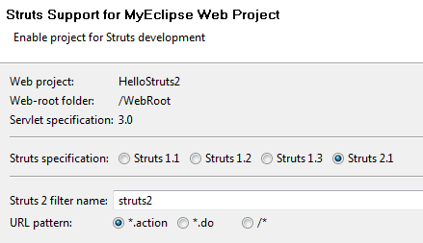

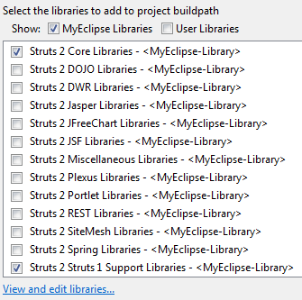

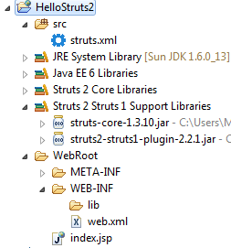
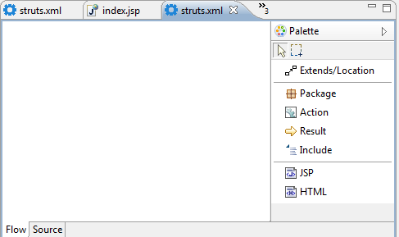

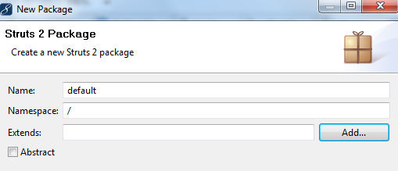
Tıkla
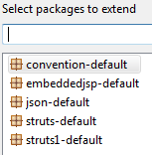
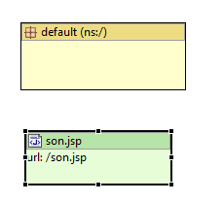
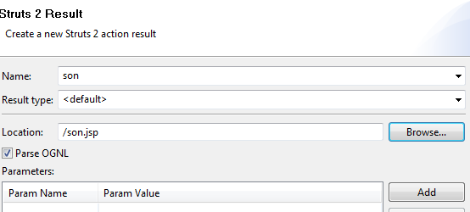
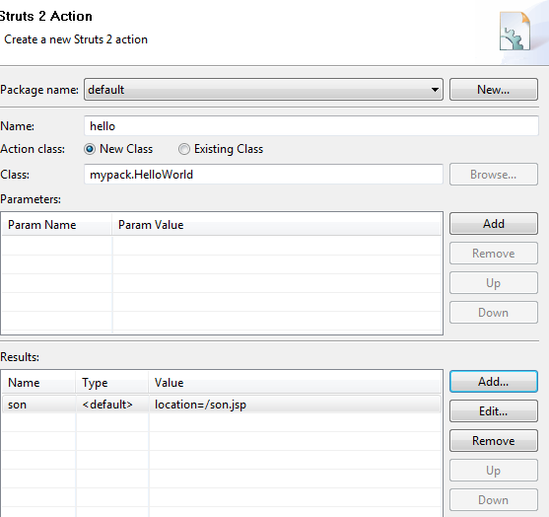
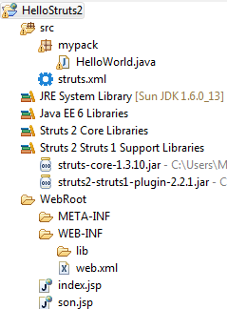

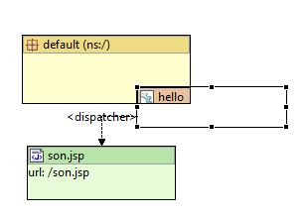

<?xml version="1.0" encoding="UTF-8" ?>
<!DOCTYPE struts PUBLIC "-//Apache Software Foundation//DTD Struts Configuration 2.1//EN" "http://struts.apache.org/dtds/struts-2.1.dtd">
<struts>

<package name="default" namespace="/" extends="struts-default">
<action name="hello" class="mypack.HelloWorld">
<result name="son">/son.jsp</result>
</action></package></struts>

package mypack;

import com.opensymphony.xwork2.ActionSupport;

public class HelloWorld extends ActionSupport {

/**
* @return
*/
public String execute() {
// TODO Auto-generated method stub
return “son”;
}
}

http://localhost:8080/HelloStruts2/hello.action

<?xml version="1.0" encoding="UTF-8"?>
<web-app version="3.0" xmlns="http://java.sun.com/xml/ns/javaee"
xmlns:xsi="http://www.w3.org/2001/XMLSchema-instance"
xsi:schemaLocation="http://java.sun.com/xml/ns/javaee
http://java.sun.com/xml/ns/javaee/web-app_3_0.xsd">
<display-name></display-name>
<welcome-file-list>
<welcome-file>index.jsp</welcome-file>
</welcome-file-list>
<filter>
<filter-name>struts2</filter-name>
<filter-class>
org.apache.struts2.dispatcher.ng.filter.StrutsPrepareAndExecuteFilter</filter-class>
<init-param>
<param-name>actionPackages</param-name>
<param-value>mypack</param-value>
</init-param>
</filter>
<filter-mapping>
Myeclipse bu kısmı koymuyor. Konulduğunda tag’lar çalışıyor.
<filter-name>struts2</filter-name>
<url-pattern>/*</url-pattern>
</filter-mapping>

<filter-mapping>
<filter-name>struts2</filter-name>
<url-pattern>*.action</url-pattern>
</filter-mapping>
</web-app>

index.jsp
<%@ page language="java" import="java.util.*" pageEncoding="ISO-8859-1"%>

<%@ taglib prefix="s" uri="/struts-tags"%>
<!DOCTYPE HTML PUBLIC "-//W3C//DTD HTML 4.01 Transitional//EN">
<html>
<body>
<h4>
Enter your name
</h4>
<s:form action="hello">
<s:textfield name="name" label="Your name" />
<s:submit />
</s:form>
</body>
</html>

Girilen bilginin alinmasi ve başka sayfaya gönderilmesi

You might still have questions about how the data gets from the front to the back of this process. Let’s trace the path of data as it comes into, flows through, and ultimately exits the HelloWorld application. First, let’s clear up some potential confusion regarding the location of data in the framework. In chapter 1, we learned that the framework provides something called the ValueStack for storing all of the domain data during the processing of a request. We also said that the framework uses a powerful expression language, OGNL, to reference and manipulate that data from various regions of the framework. But, as we’ve just learned, the action itself holds the domain data. In the case of the HelloWorld action, that data is held on JavaBeans properties exposed on the action itself. So, what gives? In short, both are true. The data is both stored in the action and in the ValueStack. Here’s how. First, domain data is always stored in the action. We’ll see variants on this, but it’s essentially true. This is great because it allows convenient access to data from the action’s execute() method. So that the rest of the framework can access the data, the action object itself is placed on the ValueStack. The mechanics of the ValueStack are such that all properties of the action will then be exposed as toplevel properties of the ValueStack itself and, thus, accessible via OGNL. Figure 2.7 demonstrates how this works with the Hello-World action as an example. As figure 2.7 shows, the action holds the data, giving its own Java code convenient access. At the same time, the framework makes the properties of the action available on the ValueStack so that other regions of the framework can access the data as well. In terms of our HelloWorld application, the two most important places this occurs are on the incoming form and the outgoing result page. In the case of the incoming request, the form field name attribute is interpreted as an OGNL expression. The expression is used to target a property on the ValueStack; in this case, the name property from our action. The value from the form field is automatically moved onto that property by the framework. On the other end, the result JSP pulls data off the customGreeting property by likewise using an OGNL expression, inside a tag, to reference a property on the ValueStack. Obviously, this complicated process needs more than a quick sketch.
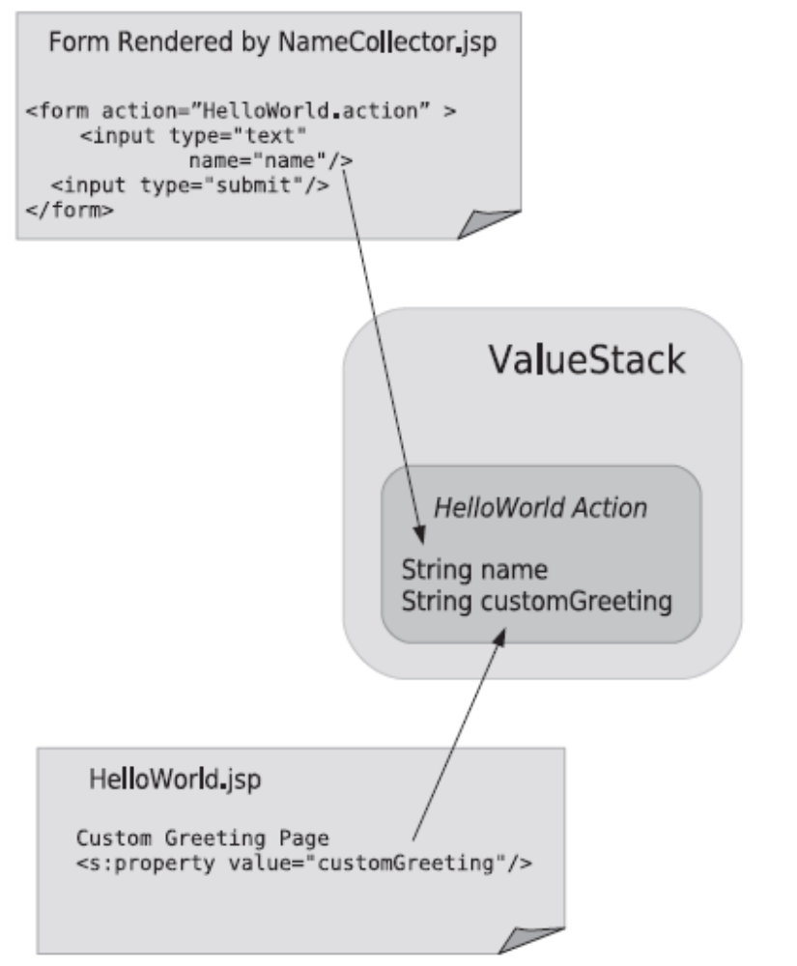

index.jsp
<%@ taglib prefix="s" uri="/struts-tags"%>
<!DOCTYPE HTML PUBLIC "-//W3C//DTD HTML 4.01 Transitional//EN">
<html>
<body>
<h4>
Enter your name
</h4>
<s:form action="hello">
<s:textfield name="name" label="Your name" />
<s:submit />
</s:form>
</body>
</html>

public class HelloWorld extends Action {

private String name;

public String getName() {
return name;
}

public void setName(String name) {
this.name = name;
}

/**
* @return
*/
public String execute() {
// TODO Auto-generated method stub
return "son";
}
}

son.jsp
<%@ page language="java" import="java.util.*" pageEncoding="ISO-8859-1"%>

<%@ taglib prefix="s" uri="/struts-tags"%>
<!DOCTYPE HTML PUBLIC "-//W3C//DTD HTML 4.01 Transitional//EN">
<html>
<head>
…

<body>
<h4>Merhaba <s:property value="name"/></h4>
</body>
</html>

Form Bilgilerinin İşlenmesi
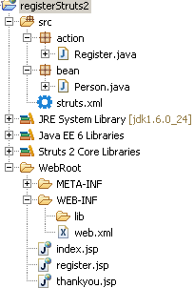
struts.xml
<?xml version="1.0" encoding="UTF-8" ?>
<!DOCTYPE struts PUBLIC "-//Apache Software Foundation//DTD Struts Configuration 2.1//EN" "http://struts.apache.org/dtds/struts-2.1.dtd">
<struts>
<package name="default" namespace="/" extends="struts-default">
<action name="register" class="action.Register">
<result name="success">/thankyou.jsp</result></action>
<action name="index">
<result>/index.jsp</result>
</action>
</package>
</struts>

Person.java
package bean;

public class Person {
private String firstName;
private String lastName;
private String email;
private int age;

public String getFirstName() {
return firstName;
}

public void setFirstName(String firstName) {
this.firstName = firstName;
}

public String getLastName() {
return lastName;
}

public void setLastName(String lastName) {
this.lastName = lastName;
}

public String getEmail() {
return email;
}

public void setEmail(String email) {
this.email = email;
}

public int getAge() {
return age;
}

public void setAge(int age) {
this.age = age;
}

public String toString() {
return "First Name: " + getFirstName() + " Last Name: "
+ getLastName() + " Email: " + getEmail() + " Age: "
+ getAge();
}

}

Register.java
package action;

import bean.Person;

import com.opensymphony.xwork2.ActionSupport;

public class Register extends ActionSupport {

/**
*
*/
private static final long serialVersionUID = 1L;
private Person personBean;

public Person getPersonBean() {
return personBean;
}

public void setPersonBean(Person personBean) {
this.personBean = personBean;
}

public static long getSerialversionuid() {
return serialVersionUID;
}

/**
* @return
*/
public String execute() {
// TODO Auto-generated method stub
return SUCCESS;
}
}

register.jsp
<?xml version="1.0" encoding="ISO-8859-1" ?>
<%@ taglib prefix="s" uri="/struts-tags" %>
<%@ page language="java" contentType="text/html; charset=ISO-8859-1"
pageEncoding="ISO-8859-1"%>
<!DOCTYPE html PUBLIC "-//W3C//DTD XHTML 1.0 Transitional//EN" "http://www.w3.org/TR/xhtml1/DTD/xhtml1-transitional.dtd">
<html xmlns="http://www.w3.org/1999/xhtml">
<head>
<meta http-equiv="Content-Type" content="text/html; charset=ISO-8859-1" />
<title>Register</title>
</head>
<body>
<h3>Register for a prize by completing this form.</h3>

<s:form action="register">

<s:textfield name="personBean.firstName" label="First name" />
<s:textfield name="personBean.lastName" label="Last name" />
<s:textfield name="personBean.email" label ="Email"/>
<s:textfield name="personBean.age" label="Age" />

<s:submit/>

</s:form>

</body>
</html>

thankyou.jsp
<?xml version="1.0" encoding="ISO-8859-1" ?>
<%@ taglib prefix="s" uri="/struts-tags"%>
<%@ page language="java" contentType="text/html; charset=ISO-8859-1"
pageEncoding="ISO-8859-1"%>
<!DOCTYPE html PUBLIC "-//W3C//DTD XHTML 1.0 Transitional//EN" "http://www.w3.org/TR/xhtml1/DTD/xhtml1-transitional.dtd">
<html xmlns="http://www.w3.org/1999/xhtml">
<head>
<meta http-equiv="Content-Type"
content="text/html; charset=ISO-8859-1" />
<title>Registration Successful</title>
</head>
<body>
<h3>
Thank you for registering for a prize.
</h3>

<p>
Your registration information:
<s:property value="personBean" />
</p>

<p>
<a href="<s:url action='index' />">Return to home page</a>.
</p>

</body>
</html>

index.jsp
<body>
<p><a href="register.jsp">Please register</a> for our prize drawing.</p>
</body>

ActionError ActionMessage Örneği

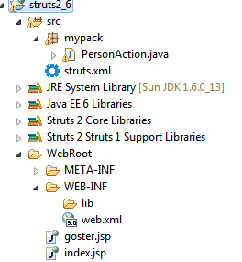
<?xml version="1.0" encoding="UTF-8" ?>
<!DOCTYPE struts PUBLIC "-//Apache Software Foundation//DTD Struts Configuration 2.1//EN" "http://struts.apache.org/dtds/struts-2.1.dtd">
<struts>

<package name="default" namespace="/" extends="struts-default">

<action name="person" class="mypack.PersonAction">
<result name="son">/goster.jsp</result>
<result name="input">/index.jsp</result>
</action>
</package>
</struts>

package mypack;

import com.opensymphony.xwork2.ActionSupport;

public class PersonAction extends ActionSupport {

private String ad, soyad;

public String getAd() {
return ad;
}

public void setAd(String ad) {
this.ad = ad;
}

public String getSoyad() {
return soyad;
}

public void setSoyad(String soyad) {
this.soyad = soyad;
}

public String execute() {
// TODO Auto-generated method stub
return "son";
}

// simple validation
public void validate() {
if (ad.equals("Ahmet"))

addActionMessage("Siz Bizim Uyemizsiniz!");
else
addActionError("Bizim Uyemiz Degilsiniz!");

}

}

goster.jsp
<%@ page language="java" import="java.util.*" pageEncoding="ISO-8859-1"%>
<%@ taglib prefix="s" uri="/struts-tags"%>

<!DOCTYPE HTML PUBLIC "-//W3C//DTD HTML 4.01 Transitional//EN">
<html>
<head>
<style type="text/css">
.goster {
background-color: #DDFFDD;
border: 1px solid #009900;
width: 200px;
}

.goster li {
list-style: none;
}
</style>
</head>

<body>
<s:if test="hasActionMessages()">
<div class="goster">
<s:actionmessage />
</div>
</s:if>
Merhaba
<s:property value="ad" />
</body>
</html>

index.jsp
<%@ page language="java" import="java.util.*" pageEncoding="ISO-8859-1"%>
<%@ taglib prefix="s" uri="/struts-tags"%>

<!DOCTYPE HTML PUBLIC "-//W3C//DTD HTML 4.01 Transitional//EN">
<html>
<head>
<style type="text/css">
.hata {
background-color: #DDFFDD;
border: 1px solid #009900;
width: 200px;
}

.hata li {
list-style: none;
}
</style>

</head>

<body>

<s:if test="hasActionErrors()">
<div class="hata">
<s:actionerror />
</div>

</s:if>
<s:form action="person">
<s:textfield name="ad" label="ad" />
<s:textfield name="soyad" label="soyad" />
<s:submit />

</s:form>

</body>
</html>

Validation
<?xml version="1.0" encoding="UTF-8" ?>
<!DOCTYPE struts PUBLIC "-//Apache Software Foundation//DTD Struts Configuration 2.1//EN" "http://struts.apache.org/dtds/struts-2.1.dtd">
<struts>
<package name="default" namespace="/" extends="struts-default">

<action name="index">
<result>/index.jsp</result>
</action>

<action name="register" class="action.Register">
<result name="success">/thankyou.jsp</result>
<result name="input">/register.jsp</result>
</action>
</package>
</struts>

package action;

import bean.Person;

import com.opensymphony.xwork2.ActionSupport;

public class Register extends ActionSupport {

/**
*
*/
private static final long serialVersionUID = 1L;
private Person personBean;

public Person getPersonBean() {
return personBean;
}

public void setPersonBean(Person personBean) {
this.personBean = personBean;
}

public static long getSerialversionuid() {
return serialVersionUID;
}

/**
* @return
*/
public String execute() {
// TODO Auto-generated method stub
return SUCCESS;
}

public void validate() {

if (personBean.getFirstName().length() == 0) {

addFieldError("personBean.firstName", "First name is required.");

}

if (personBean.getEmail().length() == 0) {

addFieldError("personBean.email", "Email is required.");

}

if (personBean.getAge() < 18) {

addFieldError("personBean.age",
"Age is required and must be 18 or older");

}

}

}

Hata olunca çıkan ekran
Age is required and must be 18 or older
Age: | 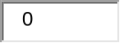

Bottom of Form

Message Resource Files
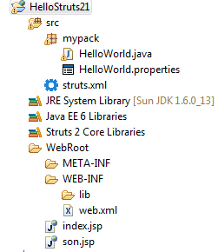
package mypack;

import com.opensymphony.xwork2.ActionSupport;

public class HelloWorld extends ActionSupport {
private String name;

public String getName() {
return name;
}

public void setName(String name) {
this.name = name;
}
public String execute() {
// TODO Auto-generated method stub
return "son";
}
}

HelloWorld.properties
firstName=ad

index.jsp
<%@ page language="java" import="java.util.*" pageEncoding="ISO-8859-1"%>
<%@ taglib prefix="s" uri="/struts-tags" %>

<!DOCTYPE HTML PUBLIC "-//W3C//DTD HTML 4.01 Transitional//EN">
<html>

<body>
<s:form action="hello">
<s:textfield name="firstName" label="ad" />
<s:submit/>
</s:form>

</body>
</html>

Interceptors
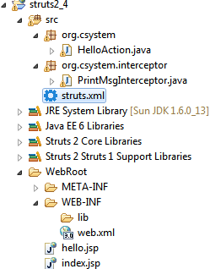
struts.xml
<?xml version="1.0" encoding="UTF-8" ?>
<!DOCTYPE struts PUBLIC "-//Apache Software Foundation//DTD Struts Configuration 2.1//EN" "http://struts.apache.org/dtds/struts-2.1.dtd">
<struts>

<package name="default" namespace="/" extends="struts-default">
<interceptors>
<interceptor name="printMsgInterceptor"
class="org.csystem.interceptor.PrintMsgInterceptor"></interceptor>

<interceptor-stack name="newStack">
<interceptor-ref name="printMsgInterceptor" />
<interceptor-ref name="defaultStack" />
</interceptor-stack>

</interceptors>

<action name="helloAction" class="org.csystem.HelloAction">
<interceptor-ref name="newStack" />
<result name="success">/hello.jsp</result>
</action>
</package>
</struts>

package org.csystem;

import com.opensymphony.xwork2.ActionSupport;

public class HelloAction extends ActionSupport {

/**
* @return
*/
public String execute() {
// TODO Auto-generated method stub
return SUCCESS;
}
}

package org.csystem.interceptor;

import com.opensymphony.xwork2.ActionInvocation;
import com.opensymphony.xwork2.interceptor.Interceptor;

public class PrintMsgInterceptor implements Interceptor {

@Override
public void destroy() {
System.out.println("CustomInterceptor destroy() is called...");

}

@Override
public void init() {
System.out.println("CustomInterceptor init() is called...");

}

@Override
public String intercept(ActionInvocation invocation) throws Exception {
System.out.println("CustomInterceptor, before invocation.invoke()...");

String result = invocation.invoke();

System.out.println("CustomInterceptor, after invocation.invoke()...");

return result;

}

}

