Take-home SQL Assignment

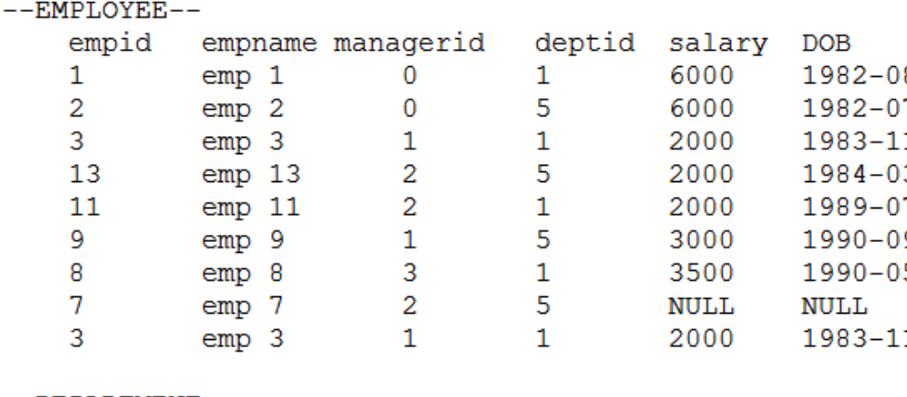

- Write a SQL query to delete duplicate records from employee table which has no primary key.
Solution

“DELETE SUB FROM (SELECT ROW_NUMBER() OVER (PARTITION BY empid, empname, managerid,deptid,salary,DOB) cnt FROM Employee) SUB WHERE SUB.cnt > 1;”

- Suppose there is a table called REGION with columns (regid, regname). Before you could insert any data in it you realize that you no longer need this table in your database. You execute the below query to drop this table. What will be its result? Provide explanation

IF EXISTS (SELECT TOP 1 * FROM dbo.region)
BEGIN
DROP TABLE dbo.region;
END

Solution
The above query will result in error ERROR we need to use DDL statements in PL/SQL blocks, you have to use dynamic SQL

Write a query to get employee details whose department id is not valid or department id is not present in the department table. There is more than one way to write this query. Which method would you least recommend to another developer?
Solution
SELECT * FROM EMPLOYEE E WHERE NOT EXISTS (SELECT * FROM DEPARTMENT D WHERE E.deptid = D.deptid )

also we use another approach with a left anti semi join,Which compromises the plan compared with NOT EXISTS

NOT IN will give false results if there is an Employee who has no Department. NOT IN with a NULL in the list fails

SELECT * FROM EMPLOYEE E EXCEPT SELECT * FROM DEPARTMENT D JOIN E where E.deptid = D.deptid

