Ultra-high-throughput microbial community analysis on the Illumina HiSeq and MiSeq platforms
Supplementary Methods
PCR and sequencing were performed using a modified version of the protocol presented in , adapted for the Illumina HiSeq2000 and MiSeq. Briefly, the V4 region of the 16S rRNA gene was amplified with region-specific primers that included the Illumina flowcell adapter sequences. The reverse amplification primer also contained a twelve base barcode sequence that supports pooling of up to 2,167 different samples in each lane. After cluster formation on a HiSeq or MiSeq instrument, the amplicons were sequenced with custom primers. These sequencing primers were designed to be complimentary to the V4 amplification primers to avoid sequencing of the primers, and the barcode is read using a third sequencing primer in an additional cycle. The amplification primers were adapted from the (Caporaso, et al., 2010) protocol to include nine extra bases in the adapter region of the forward amplification primer that support paired-end sequencing on the HiSeq/MiSeq. The amplification and sequencing primers additionally contain a new pad region to avoid primer-dimer formation with the modified adapter. The primer sequences, including the 2,167 valid, secondary-structure checked Golay-barcoded reverse primers, are provided in Supplementary File 1.
Quality filtering of reads was applied as described previously . Reads were truncated at their first low-quality base (defined by an ‘A’ or ‘B’ quality score). Reads shorter than 75 bases were then discarded, as were reads whose barcode did not match an expected barcode. Sequence counts before and after quality filtering are provided in Supplementary File 2. In addition to the twenty-four experimental samples, the MiSeq run also contained a control library made from phiX174 which, in this run, accounted for 47% of reads. The phiX control was used because of the limited sequence diversity among the 16S amplicons.
Reads were assigned to OTUs using a closed-reference OTU picking protocol using the QIIME toolkit , where uclust was applied to search sequences against a subset of the Greengenes database filtered at 97% identity. Reads were assigned to OTUs based on their best hit to this database at greater than or equal to 97% sequence identity. Reads that did not match a reference sequence were discarded. Median sequence counts per sample after OTU picking were 1,319,792, 1,102,905, and 1,126,194 for the three HiSeq 5’ read replicates; 718,186, 918,249, and 1,011,406 for the three HiSeq 3’ read replicates; 43,966 for the MiSeq 5’ reads; and 46,232 for the MiSeq 3’ reads. Taxonomy was assigned to each read by accepting the Greengenes taxonomy string of the best matching Greengenes sequence. Weighted Unifrac distances were computed between all samples in each replicate, and principal coordinates analysis was applied to visualize the results.
HiSeq preparation and sequencing protocol
16S library pools were initially analyzed by Bioanalyzer (Agilent Technologies, using DNA1000 chips) to ascertain library quality and average size distribution. The concentration of the pools was determined via Qubit (Invitrogen, using High Sensitivity reagents), and the pools diluted to 2nM. Following NaOH denaturation, the libraries were applied to a v2.5 TruSeq Paired End HiSeq flow cell/cluster kit (Illumina Inc.) at 4pM per manufacturer’s instructions. For clustering, sequencing of read 1, sequencing of the index read and sequencing of read 2, customsequencing primers (IDT) were used at a final concentration of 500nMin Illumina's hybridization buffer (HT1). Sequencing on the HiSeq (v1 SBS reagents) was done according to manufacturer’s instructions. Application of the library pools resulted in approximately 340k clusters/mm2 and 38M reads pass-filter. Base calling was performed using CASAVA-1.7.0 (Illumina, Inc.).
MiSeq preparation and sequencing protocol
Quantify the library that is to be sequenced. Concentration should be recorded in Molarity. The most accurate way to quantify the sample is by conducting qPCR. Common, alternative methods include using the Agilent Bioanalyzer or the Invitrogen Qubit.
Use the concentration determined to dilute the sample first to 10nM, then to 2nM in a serial dilution. If the concentration of the amplicon pool is very high, it may be necessary to take the sample through a more gradual serial dilution with a final goal of 2nM.
Once the sample has been brought down to 2nM, the MiSeq Protocol provided by Illumina should be followed for preparation of the library for sequencing. Once the final desired concentration is reached, 15-30% denatured PhiX must be run with the amplicon pool. Add the appropriate volumes of PhiX and amplicon pool to a separate tube to maintain the appropriate concentration (Do not just spike in 25ul of PhiX into a 1000ul tube of sample). This spike helps balance the extreme base bias present in 16S amplicon samples. Up to 50% PhiX can be used to be extremely conservative when sequencing samples that require fewer reads per index, or when completing the first amplicon run to gauge the appropriate sample loading concentration.
Sequencing on the MiSeq requires the use of aMiSeq Reagent Cartridge. When sequencing custom 16S rRNA amplicons, the 300-cycle PE kit is used. The reagent cartridge must be thawed for about 1-1.5hrs before use. This should be thawed in a bath of room temperature ultrapure water, no higher than the water line. Once the cartridge has been thawed, place it in the 4°C refrigerator. The box containing the cartridge also contains Hybridization Buffer HT1, which should be thawed on the benchtop, then placed in the 4°C until use.
The MiSeq uses a “Sample Sheet” .csv file set-up through the Illumina Experiment Manager on a separate PC to dictate the parameters of each run. These instructions are based on version 1.0.31 of the Illumina Experiment Manager. When creating the sample sheet for this run, under “Select Workflow” choose “MiSeq Reporter” and then select “de novo Assembly”.(“Metagenomics” can also be selected at this stage. The important point is to select “MiSeq Reporter” as this will allow you to obtain sequences that are not demultiplexed, so demultiplexing can be performed with QIIME. This is important because QIIME can correct barcode errors while the MiSeq instrument software does not attempt to correct barcode errors.) Under the field “Select Compatible Assay” select “TruSeq DNA/RNA” (see Screenshot 1). Fill in the number listed on the cartridge you’ll be using in the “Sample Sheet Name*” adding two zeros before the 300 (e.g. MS0002657-00300). Then, select “Paired End,” 1 Index Read, Index Cycles 6, and 151x151bp (see Screenshot 2). Note that despite the barcodes being 12 bases, you should set Index Cycles to 6 in this step – this will be corrected manually in a subsequent step. On the next screen (no screenshots), fill in a Sample ID and select one of the standard barcodes Illumina provides (e.g. A001). Once the required columns have been filled-in, click in any box to see the word “valid” in green and then proceed.
Once this .csv file is created, it will need to be edited manually to instruct the MiSeq to conduct a 12bp index read. This is achieved by opening the appropriate sample sheet for the run in a text editor (e.g. Notepad on Windows, TextEdit on Mac, or gedit on Linux). The columns in this sheet are comma separated, so it is crucial to include/remove the appropriate amount of commas when editing the file. On the line directly under [Settings] include the command OnlyGenerateFASTQ,1. Next, under [Data] replace the 6bp barcode with a 12bp barcode (any will do) to indicate to the instrument you want a 12bp index read. You will also need to remove the field 17_Index_ID,by removing both the column name and comma. In order to check that the columns appropriately align in your edited .csv, open the Sample Sheet in Excel. In Excel, you should see that the columns line-up and that the column containing I7_Index_ID is gone (see Screenshot 3, which is an example of what the csv should look like after you’ve edited it).
When preparing the sequencing cartridge, pierce the foil with a 1000ul pipette tip and add 600ul of the denatured library plus PhiX in the “Load Sample” well. Next, pierce the foil seals with a pipette tip and add 3.4ul of Index Sequencing Primer (100uM) to reservoir 13, 3.4ul of Read 1 Sequencing Primer (100uM) into reservoir 12, and 3.4ul of Read 2 Sequencing Primer (100um) to reservoir 14. Next, mix the contents of each of the reservoirs (12, 13, and 14) with a Pasteur pipette to ensure that the primers added by the user are mixed with the standard Illumina cocktail already in the reservoirs. Note that you should mix the contents of each reservoir with itself so each internal mixture is homogenous - do not mix the contents of different reservoirs with one another.
After loading the flow cell, buffer, and MiSeq cartridge, the machine will search for the sample sheet based on the barcode on the cartridge. If edited properly, the MiSeq will have no trouble accessing your Sample Sheet, and will indicate that the run is 314 cycles (151bp x 12bp x 151bp). The machine will throw an error that this run requires more cycles than the 300 cycle kit can complete, and that there could be sequence quality issues. Ignore the error and continue with the sequencing run. There are enough reagents in the cartridge for 323 cycles.
As of this writing the current version of the MiSeq Control Software (MCS) is RTA 1.13.0. RTA1.14 is currently in development, and will provide better handling of high-density data. If you’re interested in using RTA1.14 before it is released you should contact Illumina for a software patch and instructions for installing it.

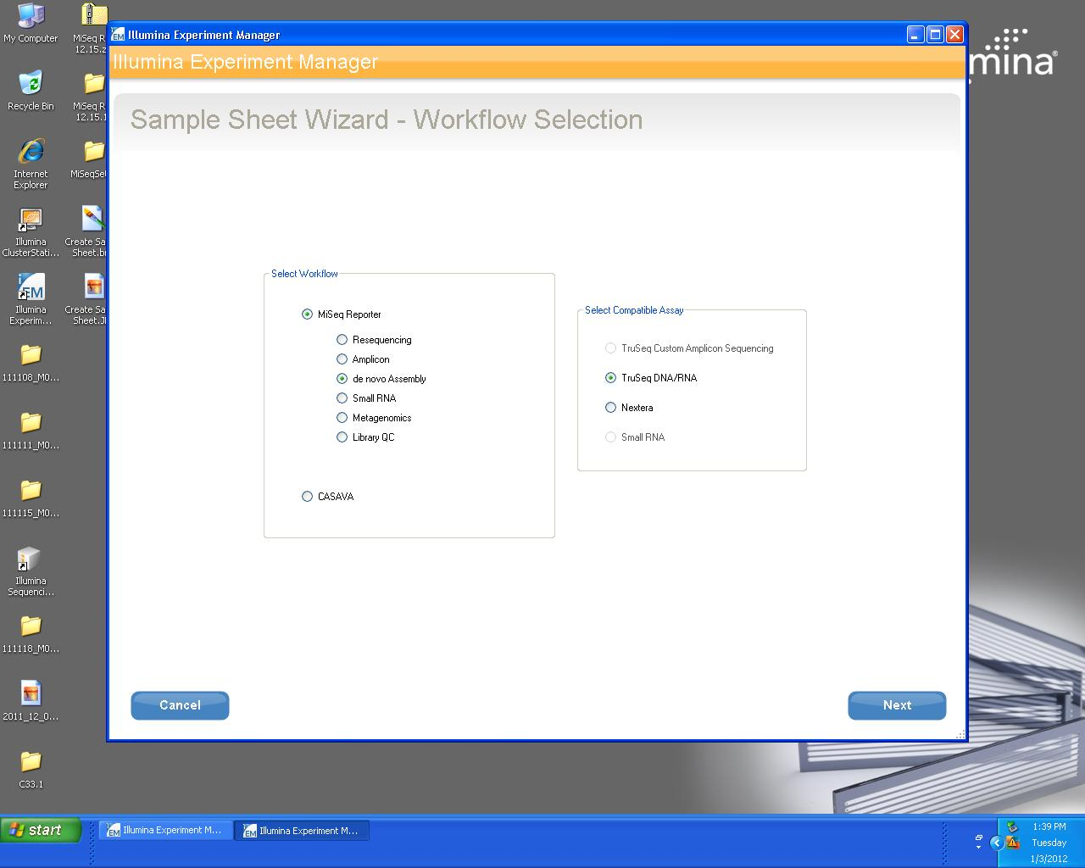
Screenshot 1: Worflow selection.
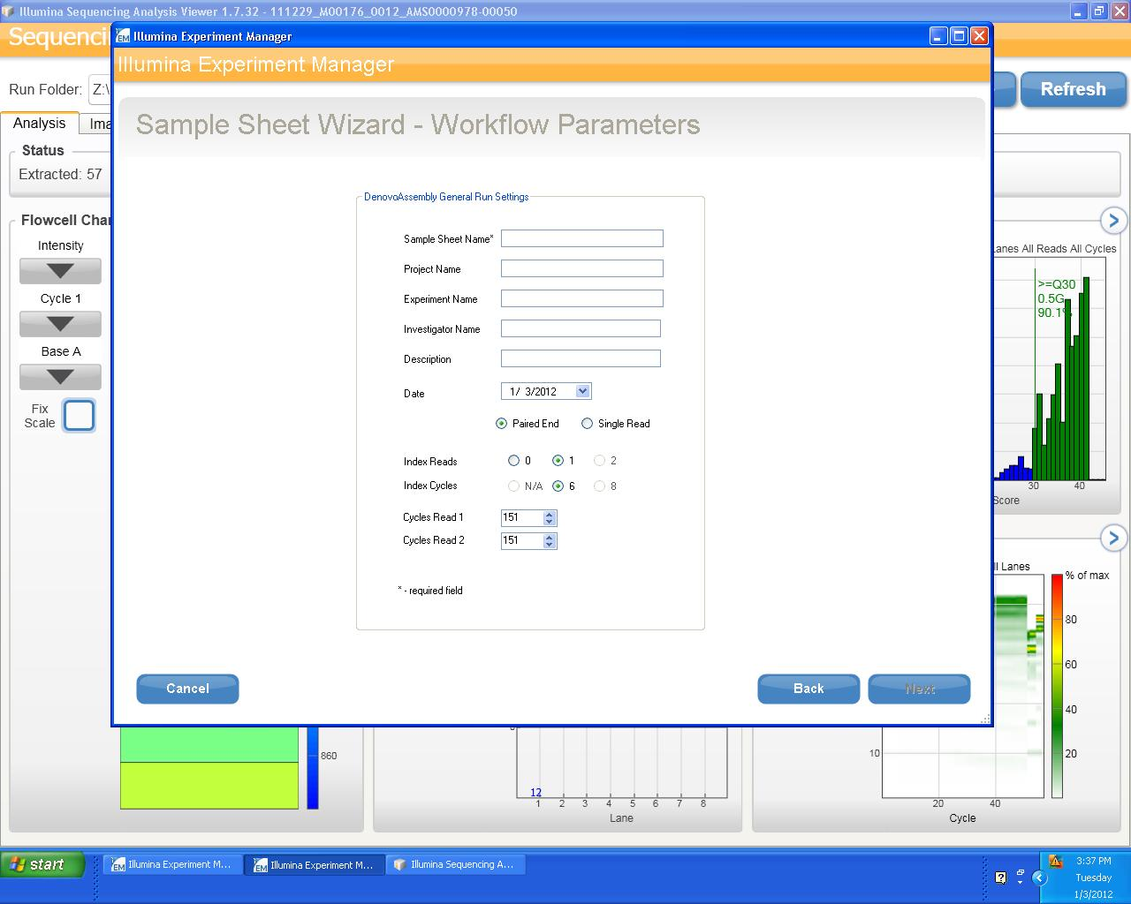
Screenshot 2: Worflow parameters.

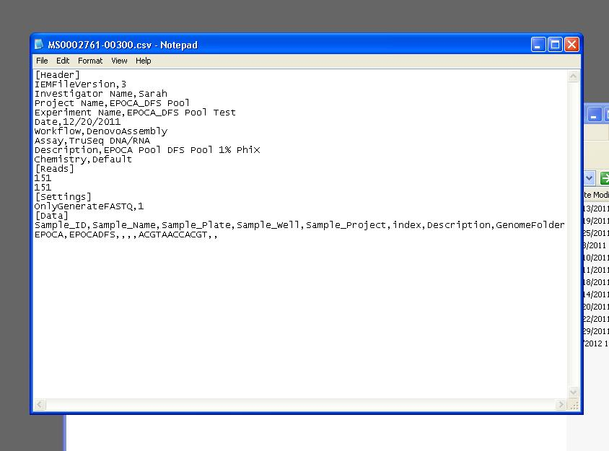
Screenshot 3: Example csv file after editing.

References
Caporaso JG, Kuczynski J, Stombaugh J, Bittinger K, Bushman FD, Costello EK et al (2010a). QIIME allows analysis of high-throughput community sequencing data. Nat Methods7: 335-336.

Caporaso JG, Lauber CL, Walters WA, Berg-Lyons D, Lozupone CA, Turnbaugh PJ et al (2010b). Global patterns of 16S rRNA diversity at a depth of millions of sequences per sample. Proc Natl Acad Sci U S A.

DeSantis TZ, Hugenholtz P, Larsen N, Rojas M, Brodie EL, Keller K et al (2006). Greengenes, a chimera-checked 16S rRNA gene database and workbench compatible with ARB. Appl Environ Microbiol72: 5069--5072.

Edgar RC (2010). Search and clustering orders of magnitude faster than BLAST. Bioinformatics26: 2460-2461.

