Project Design Phase-II
Data Flow Diagram & User Stories
Auto Ticket Classification using Flow Designer
Date | 31 January 2025
Team ID | [Enter Team ID]
Project Name | Auto Ticket Classification using Flow Designer
Maximum Marks | 4 Marks

1. Data Flow Diagram
The data flow describes how an IT support request moves through the solution. A student or teacher enters the request, the ticket is stored in the Incident WorkFlow custom table, and Flow Designer evaluates the short description. The resulting Category and Subcategory are written back to the ticket. After classification, an email notification is sent to the caller.
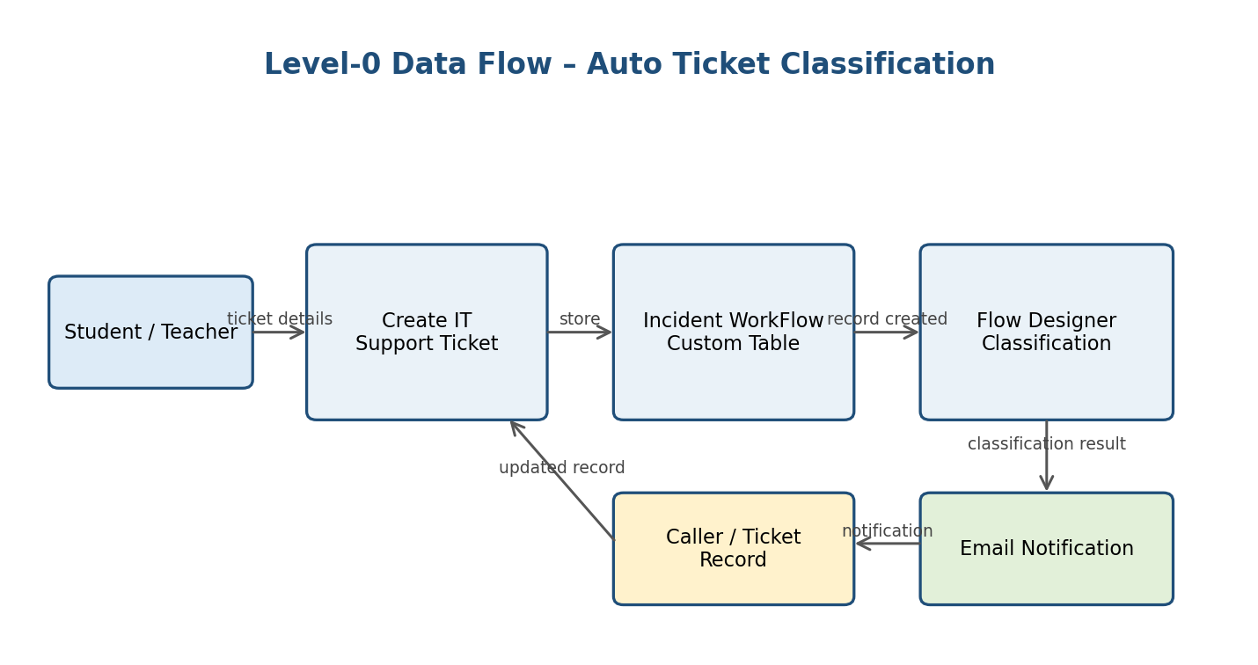
Figure 1. Level-0 data flow for the proposed solution.

2. Data Flow Description
Step | Process | Data / Result
1 | Ticket creation | Caller and issue description are entered.
2 | Record storage | The ticket is stored in the Incident WorkFlow custom table.
3 | Flow trigger | A Record Created trigger starts the classification flow.
4 | Keyword evaluation | The short description is checked against predefined issue keywords.
5 | Classification | Category and Subcategory are assigned according to the matching rule.
6 | Notification | A confirmation email is sent to the caller.

3. User Stories
The following stories are written from the perspective of the users who interact with the school IT helpdesk process. The release column is used as a simple implementation grouping for this project.
User Type | Functional Requirement (Epic) | User Story Number | User Story / Task | Acceptance criteria | Priority | Release
Student / Teacher | Ticket Creation | USN-1 | As a student or teacher, I can create an IT support ticket by entering my caller details and issue description. | A ticket record is created and receives a unique ticket number. | High | Release-1
Student / Teacher | Ticket Creation | USN-2 | As a student or teacher, I can describe my IT problem using a short description. | The short description is saved with the ticket. | High | Release-1
Student / Teacher | Ticket Classification | USN-3 | As a student or teacher, I can submit a ticket without manually selecting the final Category and Subcategory. | The flow classifies the ticket after creation. | High | Release-1
IT Helpdesk Staff | Automatic Classification | USN-4 | As an IT helpdesk staff member, I can have Wi-Fi issues classified as Network / Wi-Fi. | A matching Wi-Fi ticket contains Category = Network and Subcategory = Wi-Fi. | High | Release-1
IT Helpdesk Staff | Automatic Classification | USN-5 | As an IT helpdesk staff member, I can have projector issues classified as Hardware / Projector. | A matching projector ticket contains Category = Hardware and Subcategory = Projector. | High | Release-1
IT Helpdesk Staff | Automatic Classification | USN-6 | As an IT helpdesk staff member, I can have password or login issues classified as Access / Forgot Password. | A matching password/login ticket receives the expected classification. | High | Release-1
IT Helpdesk Staff | Automatic Classification | USN-7 | As an IT helpdesk staff member, I can have slow or hanging computer issues classified as Performance / Slow Computer. | A matching ticket receives the expected classification. | High | Release-1
Student / Teacher | Notification | USN-8 | As a caller, I receive an email confirmation after my ticket is processed. | A confirmation email is generated for the caller. | Medium | Release-1
IT Helpdesk Staff | Data Consistency | USN-9 | As an IT helpdesk staff member, I can use dependent Category and Subcategory choices. | Only valid Subcategory choices are available for the selected Category. | Medium | Release-1
Administrator | Maintenance | USN-10 | As an administrator, I can maintain the classification flow and ticket configuration. | The solution can be updated through ServiceNow configuration without changing application code. | Medium | Release-1

4. User Story Coverage
Together, the stories cover the main user journey: create a ticket, classify the issue, maintain valid category relationships, notify the caller, and maintain the configuration.

Reference to Project Requirement
The project specification requires automatic classification, dependent Category/Subcategory choices, structured ticket storage, and automated caller email notification.

