Project Design Phase-II
Technology Stack (Architecture & Stack)
Auto Ticket Classification using Flow Designer
Date | 31 January 2025
Team ID | [Enter Team ID]
Project Name | Auto Ticket Classification using Flow Designer
Maximum Marks | 4 Marks

1. Technical Architecture
The application is implemented as a ServiceNow cloud-based configuration. The user interacts with a ServiceNow ticket form. The custom Incident WorkFlow table stores ticket information. Flow Designer provides the application logic for automatic classification and email notification. The current solution does not use a separate external API, separate cloud database, or machine-learning model.
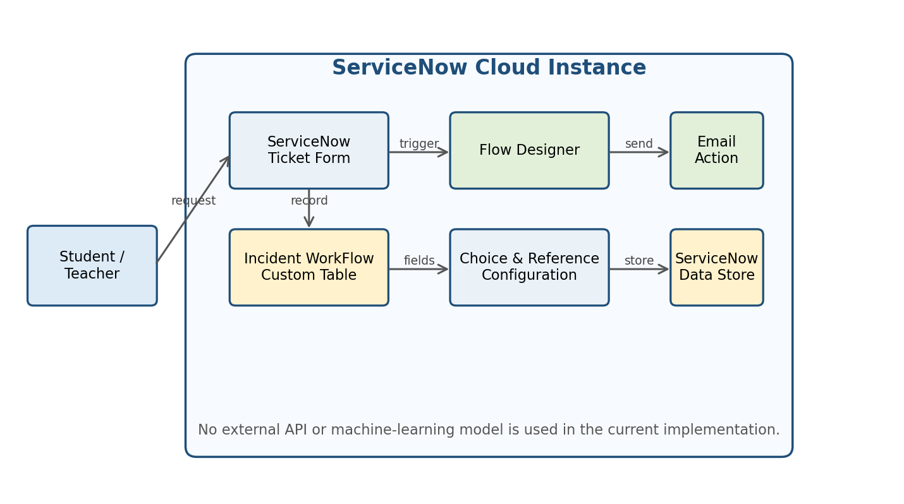
Figure 1. Technical architecture of the current implementation.

2. Components & Technologies
S.No | Component | Description | Technology
1 | User Interface | ServiceNow ticket form used by students/teachers and support users. | ServiceNow UI / Forms
2 | Application Logic-1 | Trigger and keyword-based ticket classification. | ServiceNow Flow Designer
3 | Application Logic-2 | Dependent Category/Subcategory behavior. | ServiceNow Choice / Dictionary Configuration
4 | Application Logic-3 | Email confirmation after ticket processing. | Flow Designer – Send Email action
5 | Database | Stores ticket records and configured fields such as caller, category, subcategory and state. | ServiceNow platform database / Custom Table
6 | Cloud Database | No separate cloud database is used by the project. | Not applicable – data remains within ServiceNow
7 | File Storage | No application file-storage service is required for the current workflow. | Not applicable
8 | External API-1 | No external API is used in the current implementation. | Not applicable
9 | External API-2 | No external API is used in the current implementation. | Not applicable
10 | Machine Learning Model | No machine-learning model is used; classification is rule-based. | Not applicable
11 | Infrastructure (Server / Cloud) | The solution runs on the ServiceNow cloud platform / project instance. | ServiceNow Cloud Instance

3. Application Characteristics
S.No | Characteristics | Description | Technology
1 | Open-Source Frameworks | No separate open-source application framework is required for the current ServiceNow configuration. | Not applicable
2 | Security Implementations | The application uses ServiceNow's platform access and authorization mechanisms. Ticket data should only be accessible to authorized users according to the instance configuration. | ServiceNow access controls / roles
3 | Scalable Architecture | The solution is configuration-based. New issue categories and conditions can be added to the existing table and Flow Designer logic as requirements grow. | ServiceNow Tables, Choice Fields, Flow Designer
4 | Availability | The application is hosted within the ServiceNow environment. Availability is therefore dependent on the ServiceNow instance and platform. | ServiceNow Cloud
5 | Performance | The classification logic uses simple keyword conditions and record updates rather than a separate model or heavy processing. No request-per-second benchmark was measured for this academic project. | Flow Designer / ServiceNow platform

4. Why These Technologies Were Used
- ServiceNow provides the environment in which the ticket table, form, choices and user references can be configured.
- Flow Designer allows the classification workflow to be implemented without custom scripting.
- Choice and dependent-field configuration helps keep Category and Subcategory values consistent.
- The built-in email action allows the caller to receive a confirmation without a separate messaging service.
- Update Sets provide a way to capture the configuration changes made during the project.

References
C4 model architecture guidance: https://c4model.com/
IBM architecture reference supplied in the template: https://www.ibm.com/cloud/architecture
AWS architecture reference supplied in the template: https://aws.amazon.com/architecture

