Project Design Phase
Solution Architecture
Auto Ticket Classification using Flow Designer
Date | 15 February 2025
Team ID | [Enter Team ID]
Project Name | Auto Ticket Classification using Flow Designer
Maximum Marks | 4 Marks

1. Solution Architecture
The solution architecture describes how the business requirement for automatic IT ticket classification is translated into a ServiceNow implementation. The architecture separates the user-facing ticket form, ticket data storage, workflow logic, classification rules and notification step while keeping these components within the ServiceNow environment.
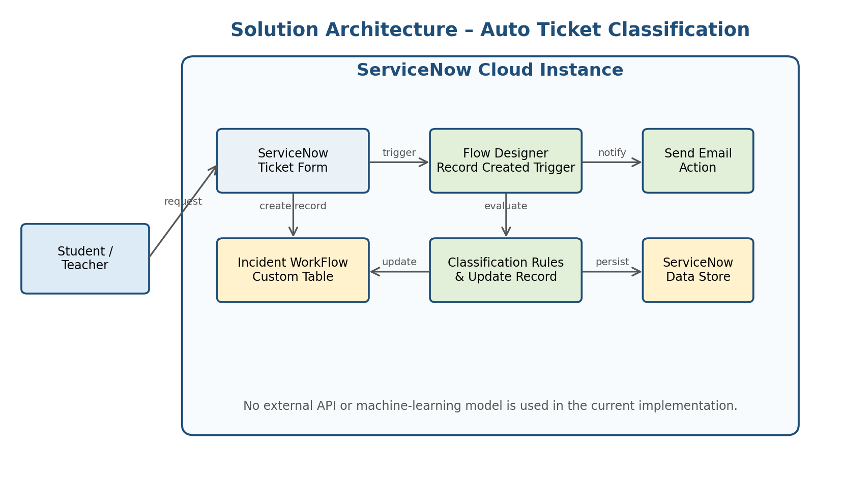
Figure 1. Architecture and data flow of the proposed solution.

2. Architecture Components
Component | Responsibility
Student / Teacher | Creates the IT support request and provides caller information and a short description of the issue.
ServiceNow Ticket Form | Provides the interface through which the support request is entered.
Incident WorkFlow Custom Table | Stores the ticket record and fields such as Number, Caller, Category, Subcategory, Short Description, Description, State, Assigned Group and Assigned To.
Flow Designer | Starts when a new record is created and controls the automatic classification workflow.
Classification Rules | Checks the Short Description against predefined issue keywords and assigns the corresponding Category and Subcategory.
Choice / Dependency Configuration | Maintains valid Category and Subcategory relationships.
Update Record | Writes the classification result back to the current ticket record.
Send Email Action | Sends the confirmation message to the caller.
ServiceNow Data Store | Maintains the configured ticket records within the ServiceNow platform.

3. End-to-End Processing Flow
- 1. A student or teacher opens the ServiceNow ticket form.
- 2. The user enters the caller information and Short Description and submits the request.
- 3. ServiceNow creates a record in the Incident WorkFlow custom table.
- 4. The Record Created trigger starts the Auto Classify School IT Tickets flow.
- 5. The flow evaluates the Short Description using the configured classification conditions.
- 6. The matching condition updates the Category and Subcategory fields.
- 7. The updated classification is stored in the ticket record.
- 8. The Send Email action sends a confirmation to the caller.

4. Classification Layer
Issue / Keyword | Category | Subcategory
WiFi / Wi-Fi | Network | Wi-Fi
Projector | Hardware | Projector
Password / Login | Access | Forgot Password
Slow / Hanging | Performance | Slow Computer

5. Data and Configuration Design
The Incident WorkFlow table acts as the central record structure for the project. The table uses reference fields for user-related information, choice fields for controlled values, and text fields for the issue description. The Subcategory field is configured as dependent on Category so that the classification relationship remains consistent.
Field | Type | Purpose
Number | Auto Number | Unique ticket identifier.
Caller | Reference – sys_user | Identifies the person raising the request.
Category | Choice | Stores Network, Hardware, Access or Performance.
Subcategory | Choice / Dependent | Stores the issue subtype associated with the Category.
Short Description | String | Primary text evaluated by the classification flow.
Description | String | Provides additional issue details.
State | Choice | Tracks the ticket lifecycle state.
Assigned Group | Reference – sys_user_group | Identifies the support group.
Assigned To | Reference – sys_user | Identifies the assigned support user.

6. Architecture Characteristics
- Platform: ServiceNow cloud environment.
- Automation: ServiceNow Flow Designer.
- Data storage: Incident WorkFlow custom table within ServiceNow.
- External interfaces: No external API is required by the current implementation.
- Machine learning: Not used; classification is based on predefined keyword rules.
- Notification: ServiceNow Flow Designer Send Email action.
- Configuration management: Project Update Set.

7. Architecture Boundary
The current architecture is intentionally limited to the components required for the academic project. It does not include an external application server, separate database, third-party API or machine-learning service. Future enhancements can introduce additional components only when they are required and implemented.

8. Stakeholder View
From the user perspective, the system remains simple: provide the issue description and submit the request. From the IT helpdesk perspective, the system provides a structured record and automatic classification. From the administrator perspective, the classification rules and table configuration can be maintained through ServiceNow configuration.

