Project Planning Phase
Project Planning Template
Auto Ticket Classification using Flow Designer
Date | 15 February 2025
Team ID | [Enter Team ID]
Project Name | Auto Ticket Classification using Flow Designer
Maximum Marks | 5 Marks

1. Product Backlog, Sprint Schedule and Estimation
The backlog below translates the implemented project into Epics and User Stories. Story points follow the Fibonacci-style scale specified in the Planning Logic document.
Sprint | Functional Requirement (Epic) | User Story No. | User Story / Task | Points | Priority | Team Members
Sprint-1 | Epic 1 – Requirement Analysis | USN-1 | Document business use case and project requirements | 2 | Medium | Vimalraj Arul
Sprint-1 | Epic 2 – Platform Configuration | USN-2 | Create Project Update Set and make it current | 1 | Medium | Team Lead
Sprint-1 | Epic 2 – Platform Configuration | USN-3 | Create Incident WorkFlow custom table | 3 | High | Bala Chander
Sprint-1 | Epic 2 – Platform Configuration | USN-4 | Create fields and configure data types | 3 | High | Bala Chander
Sprint-1 | Epic 2 – Platform Configuration | USN-5 | Configure Category/Subcategory dependency | 3 | High | Bala Chander
Sprint-2 | Epic 3 – Automation | USN-6 | Create Auto Classify School IT Tickets flow | 5 | High | Murugan R
Sprint-2 | Epic 3 – Automation | USN-7 | Configure classification rules for issue types | 3 | High | Murugan R
Sprint-2 | Epic 3 – Automation | USN-8 | Configure caller email notification | 2 | Medium | Murugan R
Sprint-2 | Epic 4 – Testing | USN-9 | Execute classification and email test scenarios | 5 | High | Vimalraj Arul / Murugan R / Diwan Kumar M
Sprint-2 | Epic 5 – Deployment | USN-10 | Complete and export Project Update Set | 2 | Medium | Team Lead
Sprint-2 | Epic 6 – Documentation | USN-11 | Prepare documentation, screenshots and project evidence | 3 | High | Team

2. Sprint Tracker
The supplied template requires actual sprint dates and completed points. The source files do not provide your team's actual execution dates, so these fields are intentionally marked for entry rather than invented.
Sprint | Total Points | Duration | Start (Planned) | End (Planned) | Completed | Release (Actual)
Sprint-1 | 12 | 6 Days | [Enter actual] | [Enter actual] | [Enter actual] | [Enter actual]
Sprint-2 | 20 | 6 Days | [Enter actual] | [Enter actual] | [Enter actual] | [Enter actual]

3. Velocity
Using the planned backlog: 32 total story points / 2 planned sprints = 16 story points per sprint. Actual velocity should be recalculated from the completed-points column after the real sprint results are entered.

4. Planned Burndown
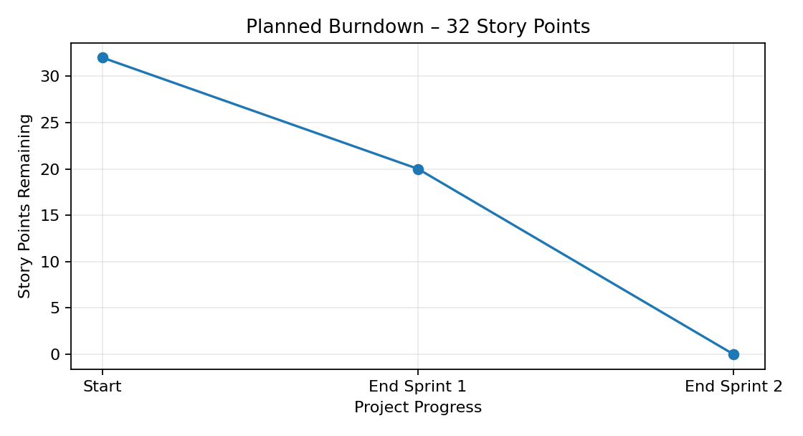

5. Sprint Deliverables
Sprint | Deliverables | Evidence
Sprint-1 | Requirements, Update Set, custom table, fields and dependent choices | ServiceNow configuration screenshots
Sprint-2 | Flow, classification, email, testing, deployment and documentation | Flow/test/email/Update Set evidence

6. Submission Notes
- Story points represent relative effort, not hours.
- Enter the team's actual sprint dates before submission.
- Enter actual Story Points Completed based on evidence.
- Use the actual release date for each sprint.
- Do not present the planning baseline as measured historical velocity.

