FINAL PROJECT DOCUMENTATION
Auto Ticket Classification using Flow Designer
ServiceNow System Administration / Flow Designer Project

Project Detail | Value
Project Title | Auto Ticket Classification using Flow Designer
Team ID | [Enter Team ID]
Submission Date | 03 October 2026
Platform | ServiceNow
Primary Technology | Flow Designer
Project Type | School IT Helpdesk Automation

Team Members
Member | Role / Contribution
Team Lead | Project coordination, integration, Update Set and final submission
Bala Chander | Custom table, fields, data types and dependent choice configuration
Murugan R | Flow Designer automation, classification rules and testing
Vimalraj Arul | Business use case, validation and documentation support
Diwan Kumar M | Navigation, testing and documentation support

Document Contents
1. Introduction
2. Project Overview
3. Architecture
4. Setup Instructions
5. Folder / Configuration Structure
6. Running the Application
7. API Documentation
8. Authentication and Authorization
9. User Interface
10. Testing
11. Screenshots and Demo
12. Known Issues
13. Future Enhancements
14. Project Implementation Summary
15. Conclusion
Note: The supplied final-report template is written for a MERN application. This report keeps its section structure but adapts the content to the actual ServiceNow implementation. Sections that are not applicable to a ServiceNow configuration, such as Node.js package installation and custom REST APIs, are explicitly marked as such rather than being filled with unrelated information.

1. Introduction
Auto Ticket Classification using Flow Designer is a ServiceNow-based school IT helpdesk automation project. The project addresses a common support-process problem: incoming IT requests need to be reviewed and classified before they can be processed consistently.
The implementation uses a custom Incident WorkFlow table, controlled Category and Subcategory choices, dependent-field configuration and a Flow Designer workflow. When a new ticket is created, the workflow evaluates the Short Description and assigns the appropriate classification. A confirmation email is then sent to the caller.

1.1 Team
The project was completed as a team implementation. Responsibilities were divided across configuration, automation, testing, documentation and final integration.

2. Project Overview

2.1 Purpose
The purpose of the project is to reduce repetitive manual ticket classification in a school IT helpdesk. The user provides the caller information and issue description, while the system handles the classification according to predefined rules.

2.2 Objectives
- Create a structured custom table for school IT support tickets.
- Store ticket information using appropriate ServiceNow field types.
- Automatically classify supported IT issues using Flow Designer.
- Maintain valid Category and Subcategory relationships.
- Send an automated confirmation email to the caller.
- Provide a maintainable no-code configuration for future rule changes.

2.3 Key Features
Feature | Description
Custom Ticket Table | Incident WorkFlow stores the project ticket records.
Auto Number | Each ticket receives a unique ticket number.
Reference Fields | Caller, Assigned Group and Assigned To use ServiceNow reference data.
Controlled Choices | Category, Subcategory and State use defined choice values.
Dependent Subcategory | Subcategory values depend on the selected Category.
Automatic Classification | Flow Designer evaluates the Short Description and updates classification.
Email Notification | The caller receives an automated confirmation.
Update Set | Project configuration can be captured and exported using the Project Update Set.

2.4 Classification Rules
Issue / Keyword | Category | Subcategory
WiFi / Wi-Fi | Network | Wi-Fi
Projector | Hardware | Projector
Password / Login | Access | Forgot Password
Slow / Hanging | Performance | Slow Computer

3. Architecture
Unlike the MERN example in the supplied report format, this project does not have a separate React frontend, Node.js/Express backend or MongoDB database. The application is implemented inside the ServiceNow platform.
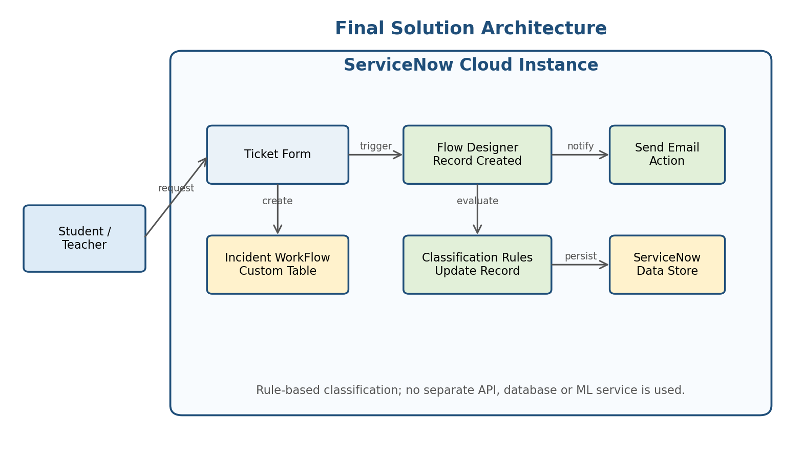
Figure 1. ServiceNow solution architecture.

3.1 Application / User Interface
The ServiceNow form is the user-facing interface. A caller provides the required request information, including Caller and Short Description. The final Category and Subcategory are handled by the configured workflow rather than requiring manual classification.

3.2 Application Logic
Flow Designer provides the workflow logic. The flow is triggered when a record is created and checks the Short Description against the configured conditions. A matching branch updates the current record with Category and Subcategory.

3.3 Data Storage
Ticket data is stored in the Incident WorkFlow custom table within the ServiceNow platform. No separate MongoDB, MySQL or other external database is used.

3.4 Notification
The flow uses the Send Email action to send a confirmation to the caller. The notification is part of the same ServiceNow workflow.

3.5 Technology Stack
Layer | Technology / Configuration
Platform | ServiceNow
Workflow | Flow Designer
Data Table | Incident WorkFlow custom table
Fields | Choice, Reference, String and Auto Number
Dependency | ServiceNow dependent choice configuration
Notification | Flow Designer Send Email action
Configuration Management | Local Update Set

4. Setup Instructions
The original supplied template asks for Node.js, MongoDB and environment-variable setup. Those steps do not apply to this project because the implementation is entirely within ServiceNow.

4.1 Prerequisites
- Access to the team's ServiceNow instance.
- A user account with sufficient permissions to configure tables, fields, flows and update sets.
- The completed project configuration or the exported Project Update Set XML, if deploying to another instance.

4.2 Initial Configuration
- Open the ServiceNow instance.
- Create or open the Project Update Set and make it the current set.
- Create the Incident WorkFlow custom table.
- Configure the required fields and choice values.
- Configure Subcategory as dependent on Category.
- Create the Auto Classify School IT Tickets flow.
- Configure classification branches and Send Email action.
- Activate the flow after testing.

5. Folder / Configuration Structure
There is no conventional client/server source-code folder structure because this is a ServiceNow configuration project. For the GitHub submission, the project evidence can be organized as follows:
Auto-Ticket-Classification-Flow-Designer/
│
├── README.md
├── Project-Documentation/
│ ├── Final-Report/
│ ├── Ideation-Phase/
│ ├── Requirement-Analysis/
│ ├── Project-Design/
│ ├── Project-Planning/
│ └── Project-Development/
│ ├── Performance-Testing/
│ └── User-Acceptance-Testing/
│
├── Screenshots/
│ ├── Update-Set/
│ ├── Custom-Table/
│ ├── Fields/
│ ├── Dependency/
│ ├── Flow-Designer/
│ ├── Testing/
│ └── Email/
│
└── Deployment/
└── Project-Update-Set.xml (if permitted by course)

6. Running the Application
The project does not run through npm start or a local Node.js server. The application runs inside the ServiceNow instance.
- Log in to the ServiceNow instance.
- Open the Incident WorkFlow table or the configured module.
- Create a new ticket with a caller and issue description.
- Save the record.
- Allow the Record Created flow to process the ticket.
- Reload/open the record and verify the Category and Subcategory.
- Check the ServiceNow email records to verify the caller notification.

7. API Documentation
No custom REST API or external backend API was developed for this project. The workflow uses native ServiceNow table operations and Flow Designer actions. Therefore, a conventional API endpoint table with HTTP methods, request parameters and JSON responses is not applicable.
Interface | Type | Purpose
Incident WorkFlow table | ServiceNow platform data interface | Create and update project ticket records.
Flow Designer Record Created trigger | Internal workflow event | Starts classification when a new record is created.
Update Record action | Internal workflow operation | Writes Category and Subcategory to the ticket.
Send Email action | Internal workflow operation | Sends the confirmation notification.

8. Authentication and Authorization
Authentication is provided by the ServiceNow instance rather than by a custom login module developed for this project. Access to the application and its records is controlled by the ServiceNow instance's configured users, roles and access controls.
The project itself does not implement custom JWT tokens, password hashing, session storage or a separate authentication server.

9. User Interface
The user interface is provided by ServiceNow forms. The important screens for the final report are the ticket form, the configured Category/Subcategory fields, and the resulting classified record.
Screenshot to Insert | What it should demonstrate
UI-01 – New Ticket Form | Caller and Short Description fields before classification.
UI-02 – Classified Ticket | Category and Subcategory after the flow runs.
UI-03 – Dependent Choice | Subcategory values corresponding to the selected Category.
UI-04 – Flow Designer | The complete classification workflow.
UI-05 – Email Record | The confirmation email generated by the flow.

Insert the team's actual ServiceNow screenshots in this section before final submission.

10. Testing
Testing covered data validation, classification rules, dependent choices and email notification. The main test inputs were selected from the issue types implemented in the flow.
Test ID | Input | Expected Classification | Expected Notification
TC-01 | WiFi not working in library | Network / Wi-Fi | Caller receives confirmation
TC-02 | Projector not turning on | Hardware / Projector | Caller receives confirmation
TC-03 | Forgot password for portal | Access / Forgot Password | Caller receives confirmation
TC-04 | Computer is slow and hanging | Performance / Slow Computer | Caller receives confirmation
TC-05 | Category/Subcategory dependency | Only relevant Subcategory choices | Not applicable

For the final submission, attach the actual screenshots or ServiceNow records used by the team as evidence for each completed test.

11. Screenshots and Demo
The final submission should contain a short demonstration of the implemented workflow. The demo should show the ticket being created, the automatic classification, the resulting record and the notification evidence.

11.1 Recommended Demo Sequence
- Introduce the problem and project objective.
- Open the Incident WorkFlow ticket form.
- Enter a sample issue such as 'WiFi not working in library'.
- Save the ticket.
- Open/reload the record and show Network / Wi-Fi classification.
- Show the Flow Designer workflow.
- Show the email record/preview.
- Briefly demonstrate another issue type, such as Projector.
- Conclude with the benefits and future enhancements.
Demo Link: [Paste your final demo link here]
GitHub Repository: [Paste your GitHub repository link here]

12. Known Issues
- Classification is rule-based and depends on the keywords/conditions configured in the Flow Designer.
- A ticket containing wording outside the configured rules may not receive the intended classification.
- The current project supports the defined issue types only: Wi-Fi, Projector, Password/Login and Slow/Hanging computer issues.
- No external integration or machine-learning classification is included in the current implementation.
- Performance results in this academic report are functional observations; no formal load benchmark is claimed without measured test data.

13. Future Enhancements
- Add more IT issue categories and classification rules.
- Add automatic assignment to support groups based on Category/Subcategory.
- Introduce SLA tracking and escalation workflows.
- Add dashboards and reports for ticket volume and category trends.
- Integrate additional ServiceNow notification channels where required.
- Evaluate more advanced classification methods if rule-based matching becomes insufficient.
- Add stronger handling for ambiguous descriptions and unmatched tickets.

14. Project Implementation Summary
Area | Implemented Result
Requirement Analysis | Business use case, requirements, user stories and problem analysis completed.
Data Configuration | Incident WorkFlow custom table and required fields configured.
Field Dependency | Category and Subcategory relationship configured.
Automation | Flow Designer classifies supported tickets using predefined rules.
Notification | Caller confirmation email configured.
Testing | Classification, dependency and notification scenarios documented.
Deployment | Project Update Set can be completed and exported for deployment evidence.
Documentation | Project phases and final report prepared for submission.

15. Conclusion
The Auto Ticket Classification using Flow Designer project demonstrates how ServiceNow can be configured to reduce a repetitive helpdesk task without introducing a separate application stack. The completed solution provides a structured ticket record, controlled field values, dependent Category/Subcategory choices, automatic rule-based classification and caller notification.
The implementation is intentionally focused on the requirements defined for the project. Its rule-based design keeps the workflow understandable and maintainable, while the identified future enhancements provide a path for expanding the solution to additional helpdesk scenarios.

Final Submission Checklist
- Replace [Enter Team ID] with the actual Team ID.
- Insert actual ServiceNow screenshots in Section 9.
- Add the final GitHub repository link in Section 11.
- Add the final demo link in Section 11.
- Attach actual test evidence to the Testing section.
- Attach/export the final Update Set XML if the course requires it.
- Review team member names and roles before submission.

