Task -2 (13-102026)

https://www.geeksforgeeks.org/print-1-to-n-without-using-loops/

class Solution:
def printNos(self, n: int) -> None:
# Code here
if n<=0:
return

self.printNos(n-1)
print(n,end=" ")

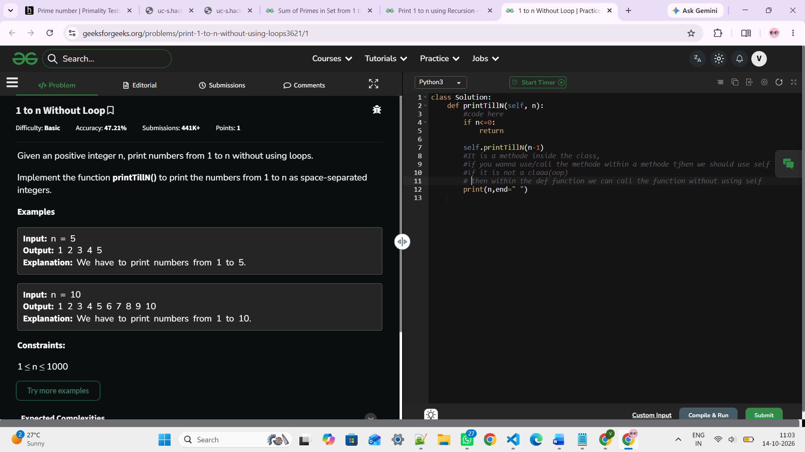

https://www.geeksforgeeks.org/print-n-to-1-without-loop/

class Solution:
def printNos(self, n: int) -> None:
# Code here
if n<=0:
return

print(n,end=" ")
self.printNos(n-1)

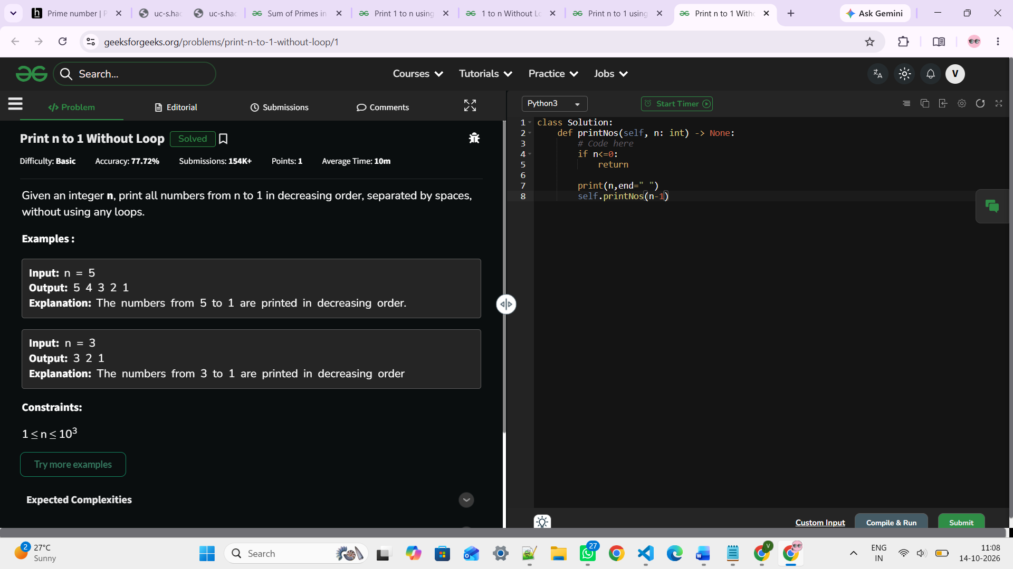

https://www.geeksforgeeks.org/write-a-program-to-reverse-digits-of-a-number/

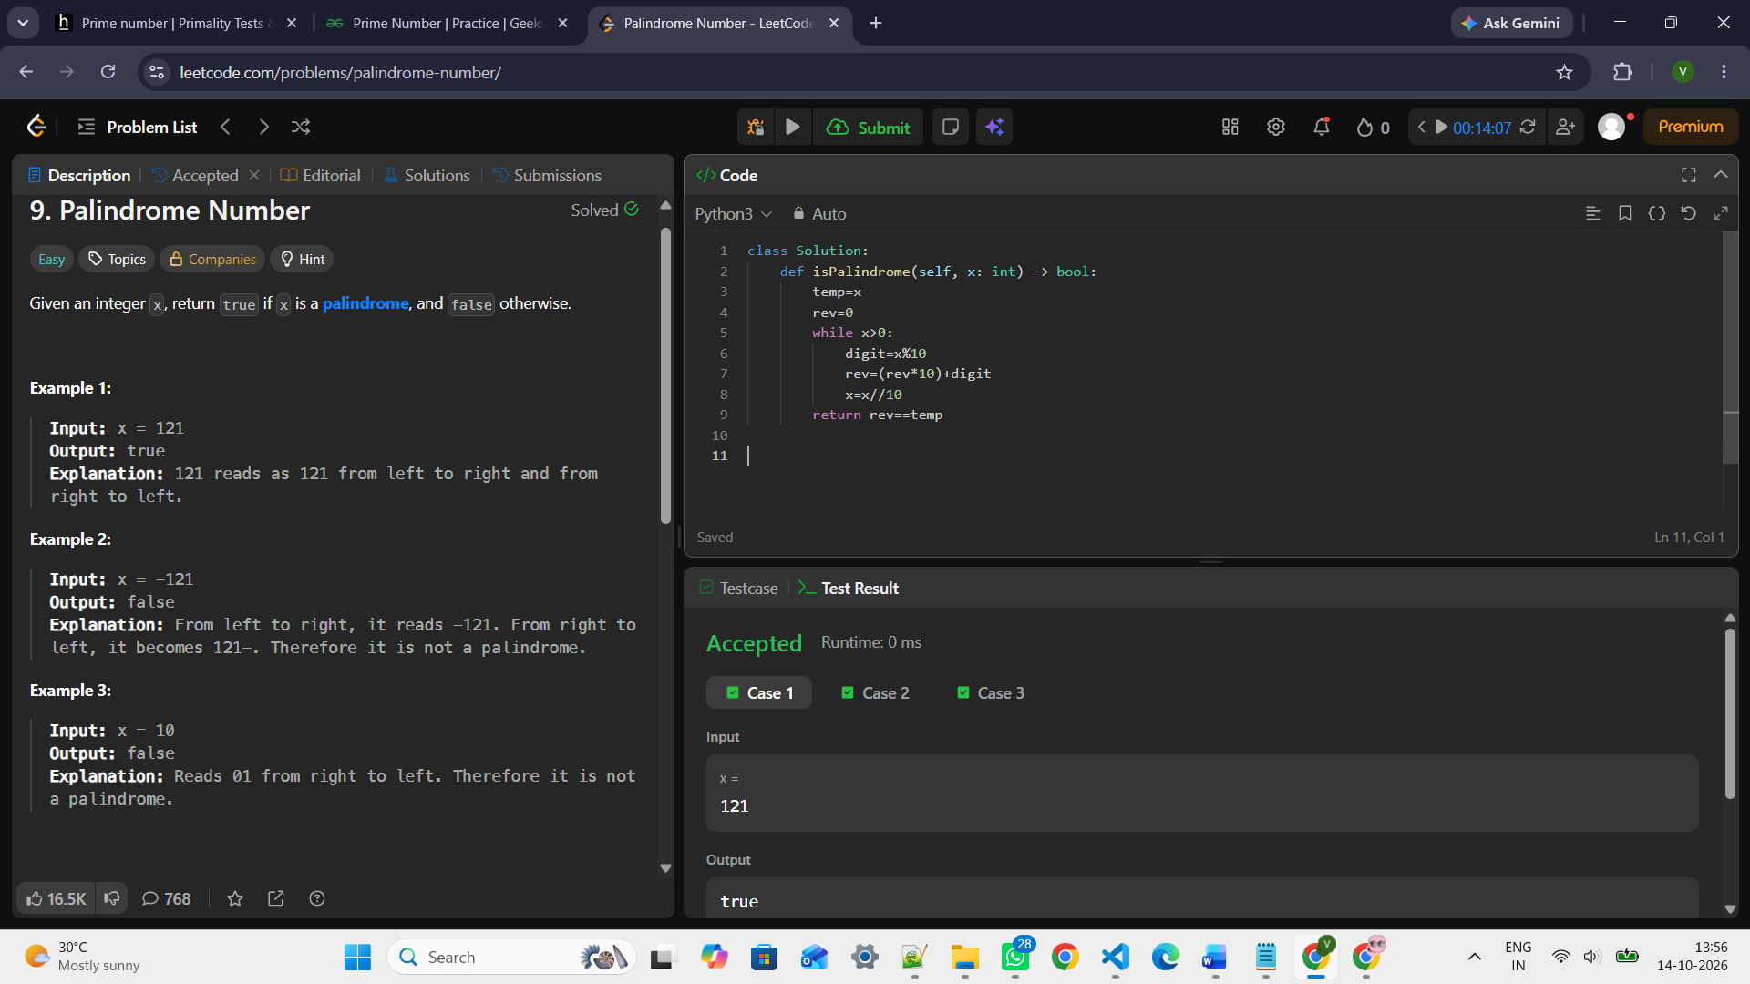

https://www.geeksforgeeks.org/sum-digit-number-using-recursion/

def digitSum(n,res):
if n<=0:
return res
digit=n%10

return digitSum(n//10,res+digit)

n=int(input("Enter the number: "))
print(digitSum(n,0))

def digitSum(n,res):
if n<=0:
return res
digit=n%10
res=res+digit
n//=10

return digitSum(n,res)

n=int(input("Enter the number: "))
print(digitSum(n,0))

https://leetcode.com/problems/palindrome-number/
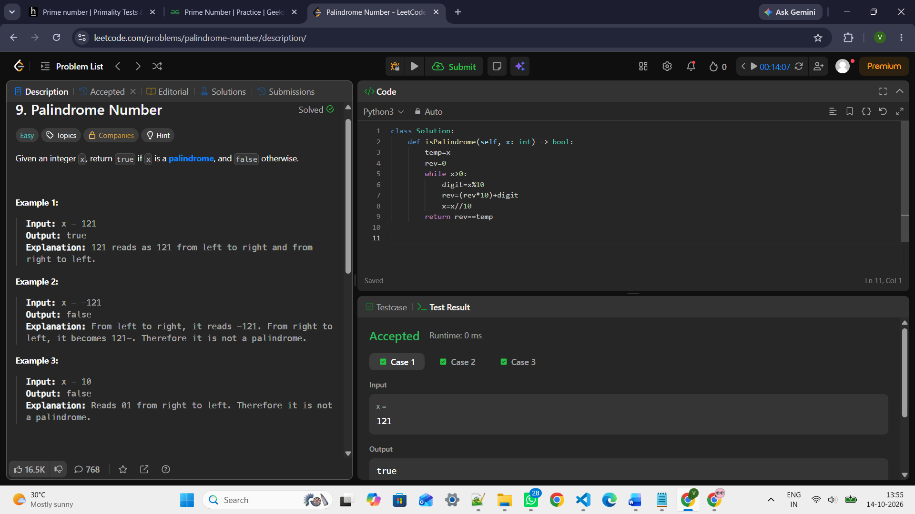

https://leetcode.com/problems/fibonacci-number/
