Star Patterns:
1 * * * * *
* * * * *
* * * * *
* * * * *
* * * * *

n=int(input("Enter a number: "))

for i in range(1,n+1):
for j in range(1,n+1):
print("*",end=" ")

print()

2.
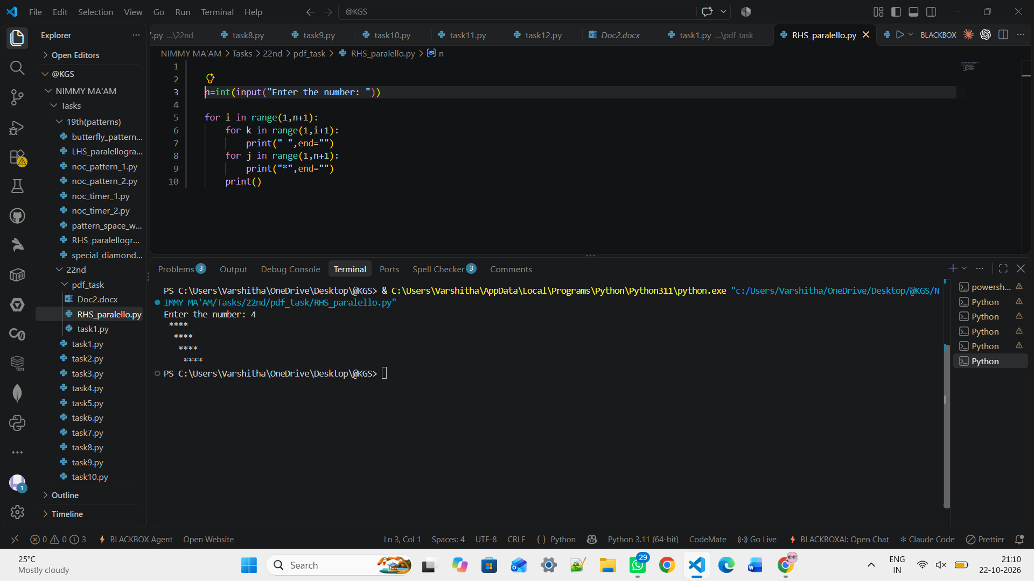

3. 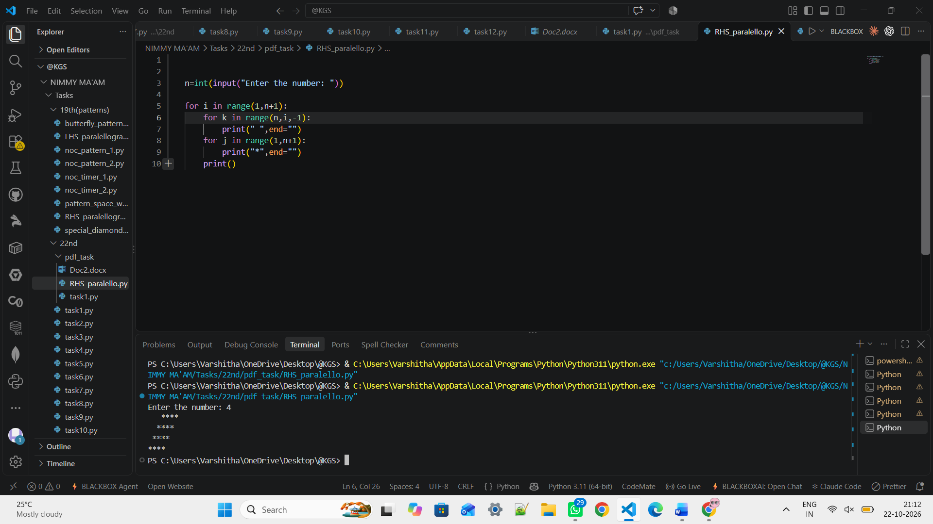

4.
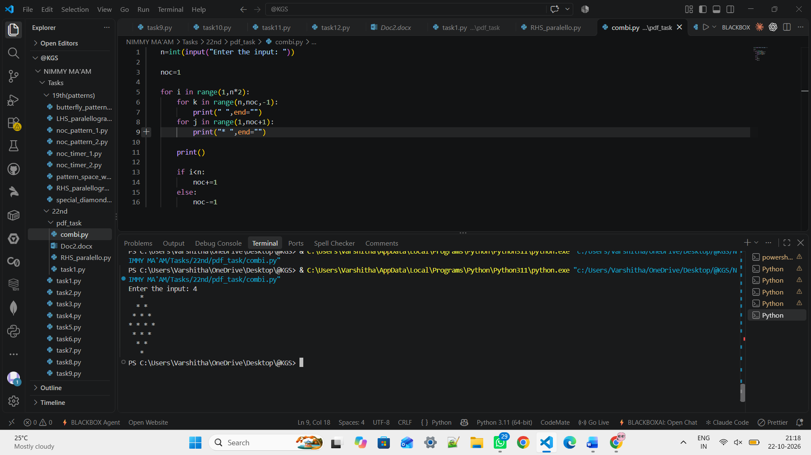

5. 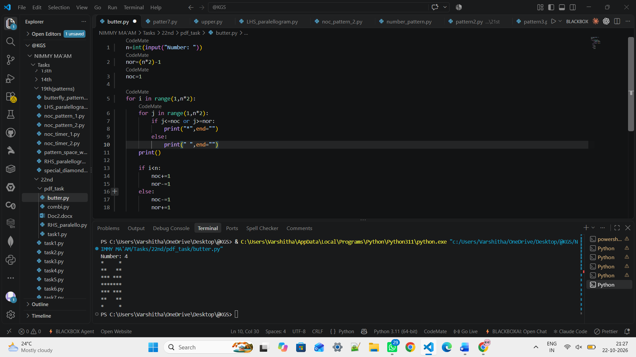

6.
n=int(input("Enter the number: "))

noc=1

for i in range(1,n*2):
for j in range(1,noc+1):
print(j,end="")
print()

if i<n:
noc+=1
else:
noc-=1

# Enter the number: 4
# 1
# 12
# 123
# 1234
# 123
# 12
# 1

7.
n=int(input("Enter the number: "))

noc=1

for i in range(1,n*2):
for k in range(n,noc,-1):
print(" ",end="")
for j in range(noc,1-1,-1):
print(j,end="")
print()

if i<n:
noc+=1
else:
noc-=1

# Enter the number: 5
# 1
# 21
# 321
# 4321
# 54321
# 4321
# 321
# 21
# 1

8.
n=int(input("Enter: "))

count=1

for i in range(1,n+1):
for j in range(1,i+1):
print(count,end=" ")
count+=1
print()

# Enter: 5
# 1
# 2 3
# 4 5 6
# 7 8 9 10
# 11 12 13 14 15

9.
n=int(input("Enter the number: "))

noc=1

for i in range(1,n*2):
for k in range(n,noc,-1):
print(" ",end="")
for j in range(1,noc+1):
print(j,end=" ")
print()

if i<n:
noc+=1
else:
noc-=1

# Enter the number: 5
# 1
# 1 2
# 1 2 3
# 1 2 3 4
# 1 2 3 4 5
# 1 2 3 4
# 1 2 3
# 1 2
# 1

10.
n=int(input("Enter the number: "))

for i in range(1,n+1):
for j in range(1,i+1):
if j%2!=0:
print(1,end=" ")
else:
print(0,end=" ")
print()

# Enter the number: 5
# 1
# 1 0
# 1 0 1
# 1 0 1 0
# 1 0 1 0 1

ALPHABET PATTERNS
1.
n=int(input("Enter: "))

for i in range(1,n+1):
for j in range(1,i+1):

if j%2!=0:
print(chr(64+j),end=" ")
else:
print(chr(64+j),end=" ")
print()

# Enter: 6
# A
# A B
# A B C
# A B C D
# A B C D E
# A B C D E F

2.
n=int(input("Enter the number: "))

for i in range(n,1-1,-1):
for j in range(n,1-1,-1):

if j>i:
print(chr(64+j),end=" ")
else:
print(chr(64+i),end=" ")
print()

# Enter the number: 5
# E E E E E
# E D D D D
# E D C C C
# E D C B B
# E D C B A

3.
n = int(input("Enter: "))

for i in range(1, 2*n):
if i <= n:
noc = n - i + 1 # decreasing part
else:
noc = i - n + 1 # increasing part

for j in range(1, noc+1):
print(chr(64+j), end=" ")
print()

# Enter: 6
# A B C D E F
# A B C D E
# A B C D
# A B C
# A B
# A
# A B
# A B C
# A B C D
# A B C D E
# A B C D E F

4.

