WEEK - 1 TASKS

DAY -01 TASKS

- https://www.geeksforgeeks.org/problems/odd-or-even3618/1

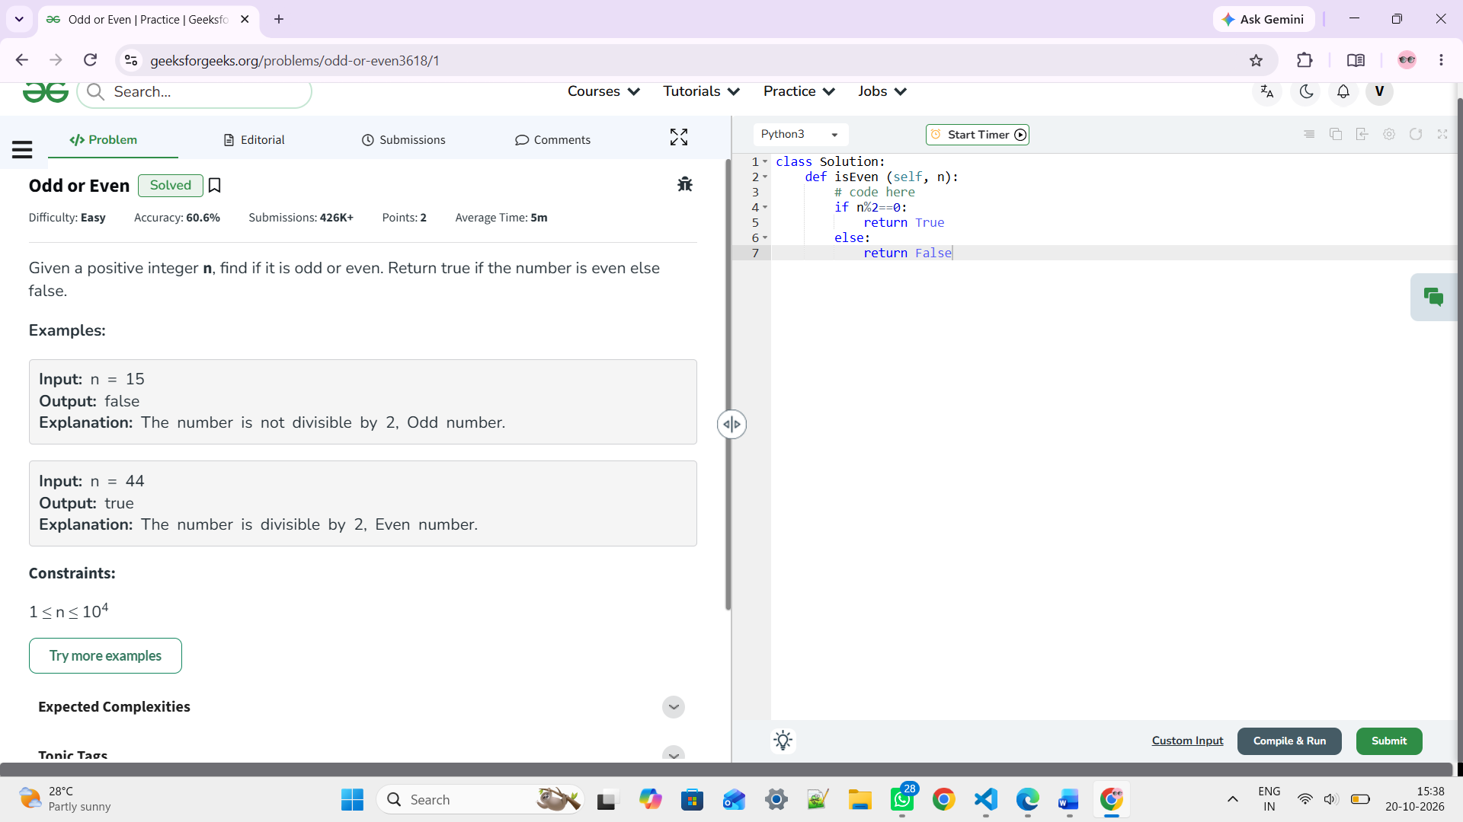

- https://www.hackerearth.com/problem/algorithm/even-or-odd-7/
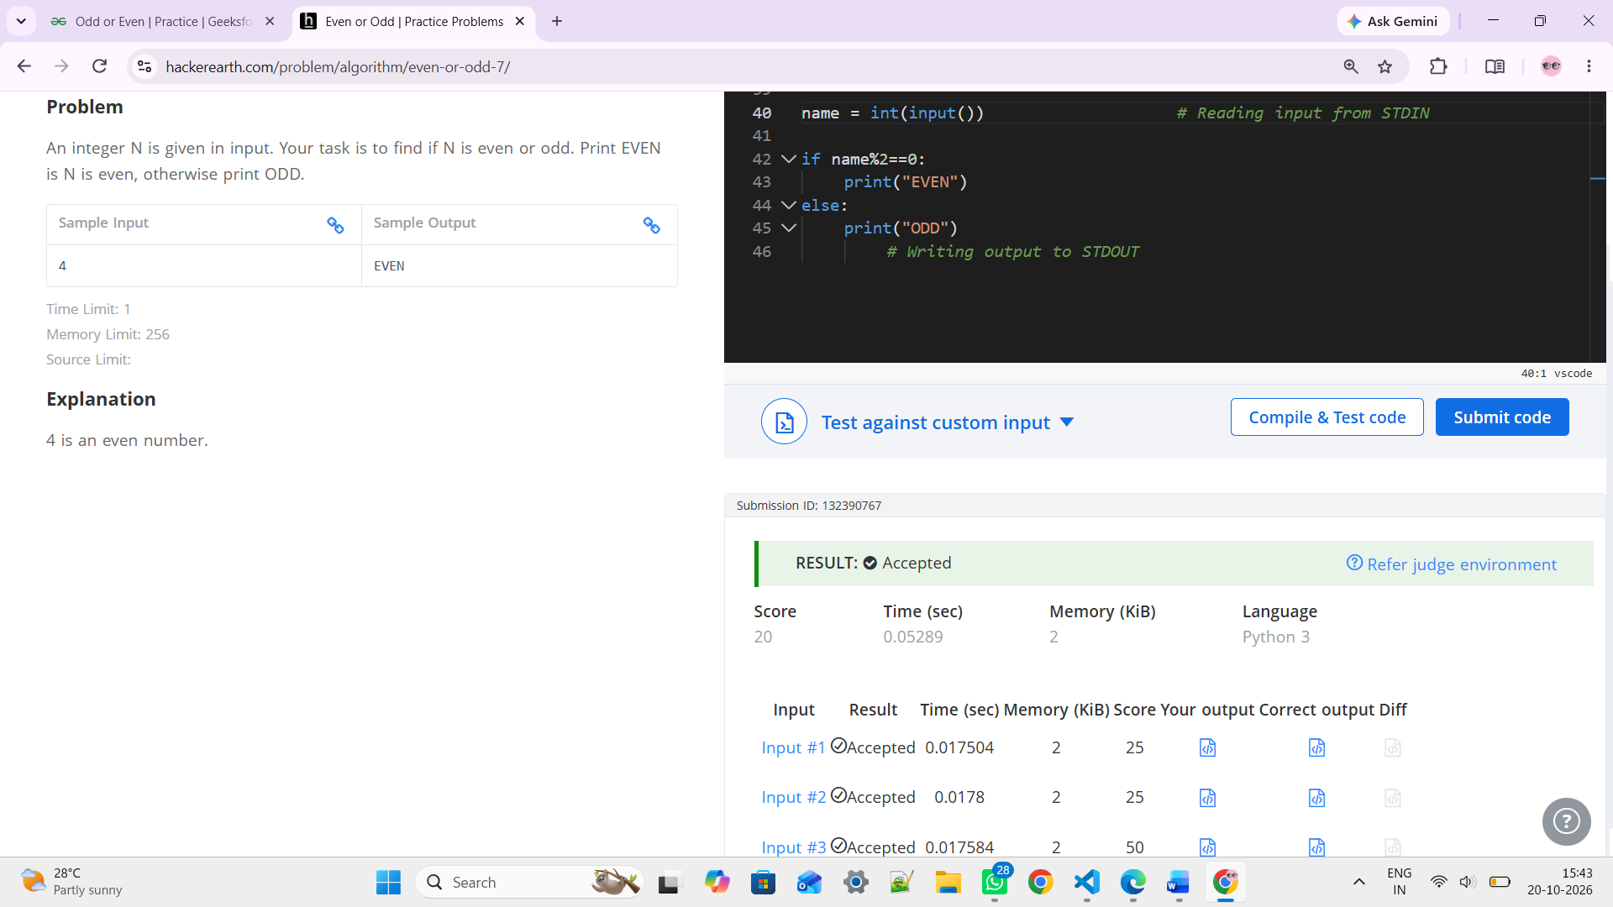

- https://www.hackerearth.com/problem/algorithm/positive-negative-zero-v2-1/

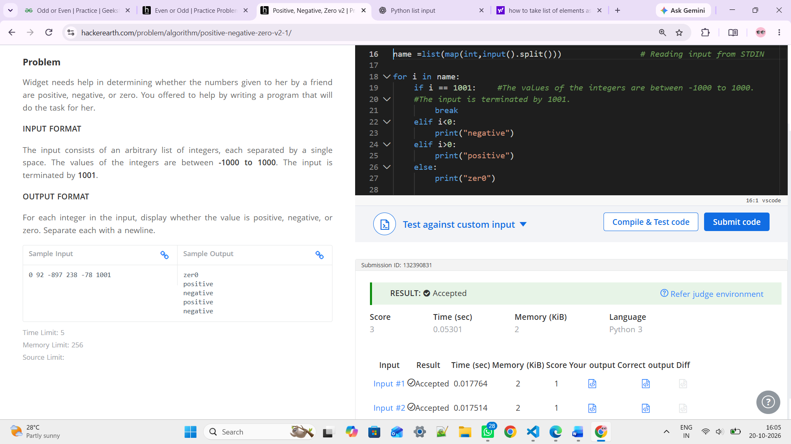

- https://www.geeksforgeeks.org/problems/greatest-of-three-numbers2520/1

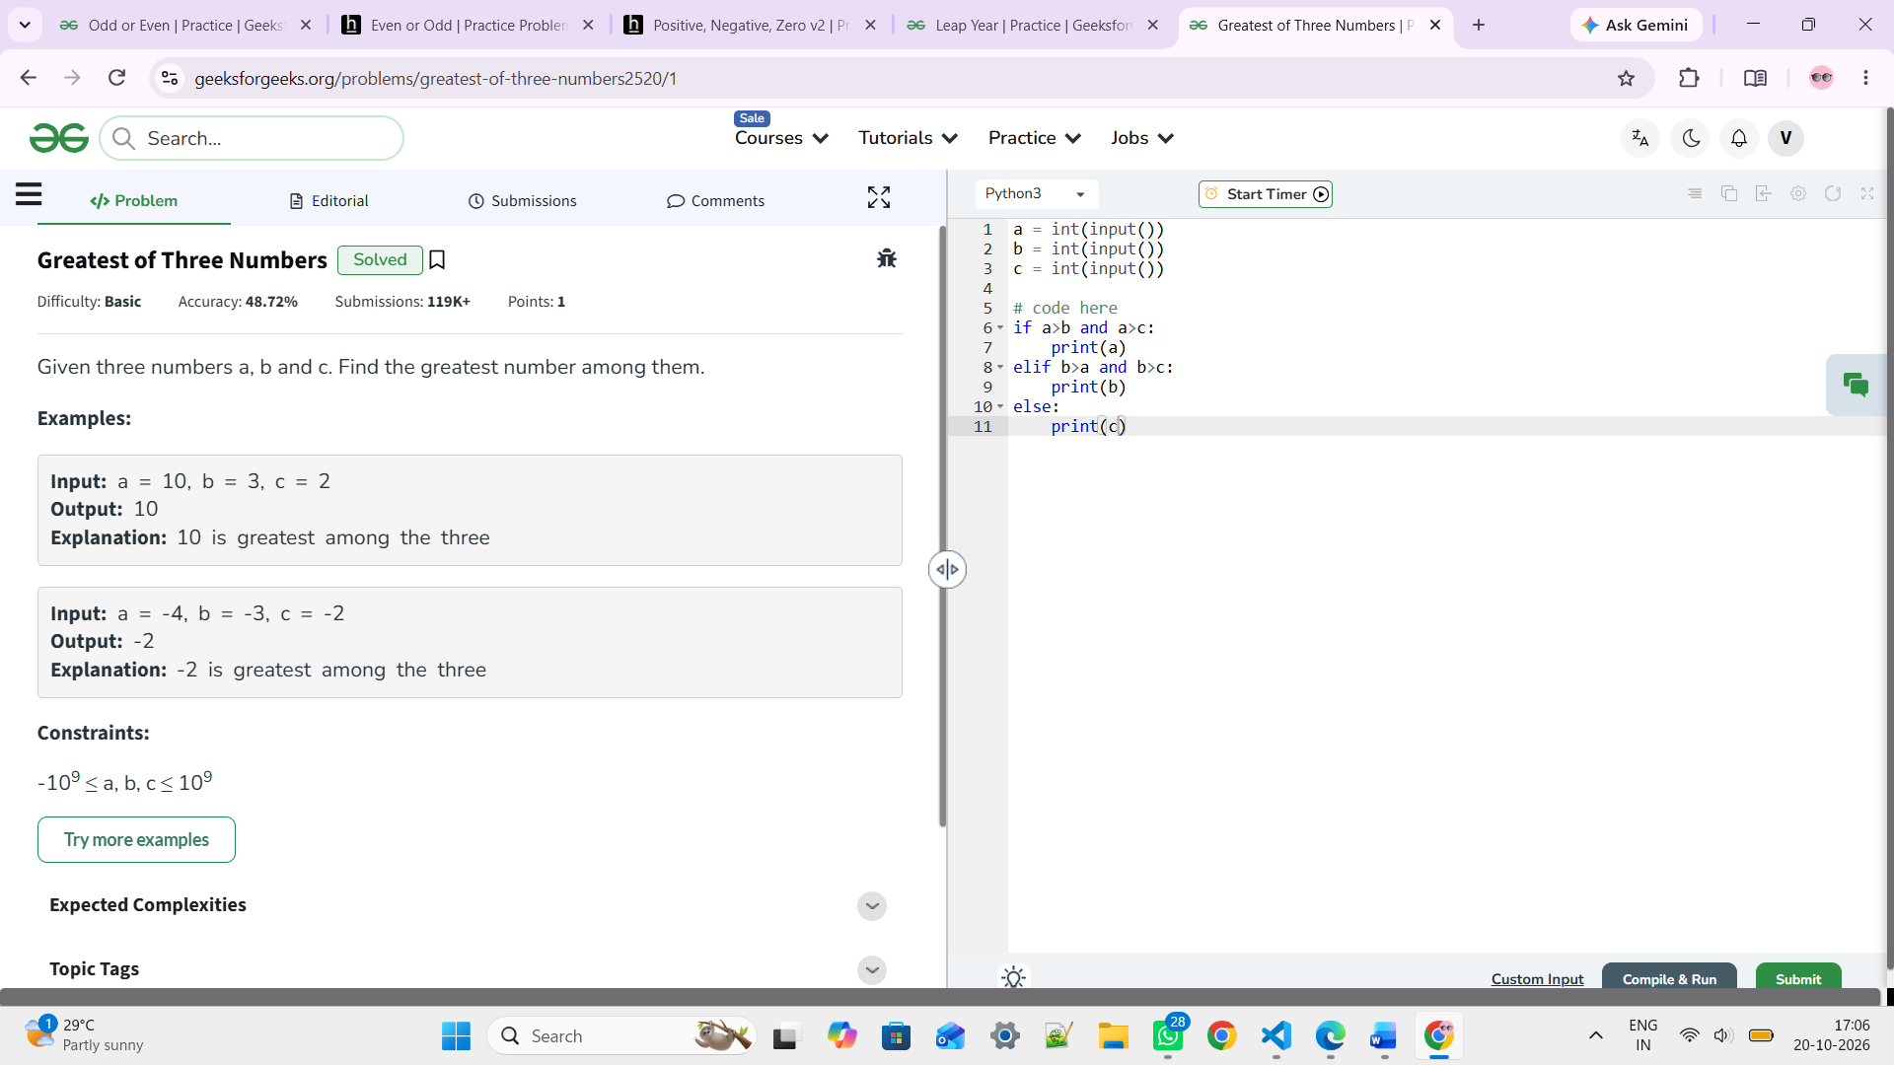

- https://www.geeksforgeeks.org/problems/leap-year0943/1

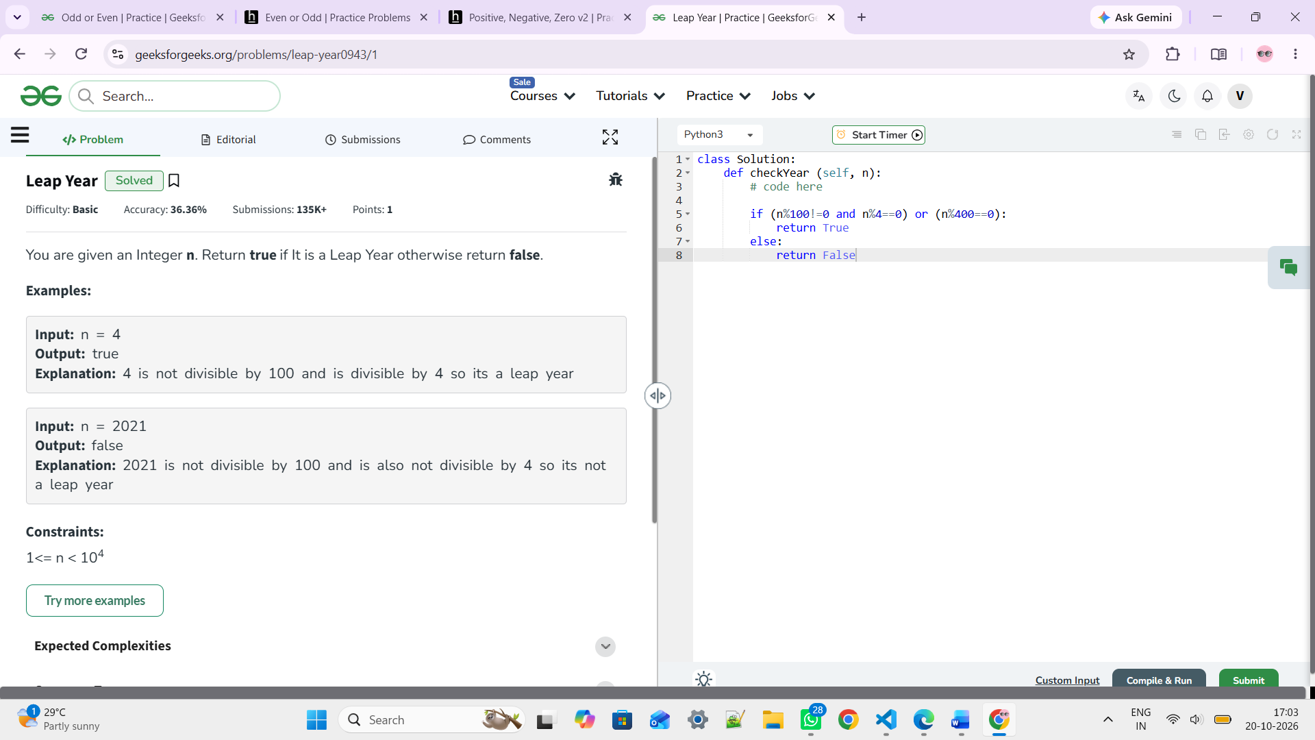

- https://www.geeksforgeeks.org/problems/print-1-to-n-without-using-loops3621/1
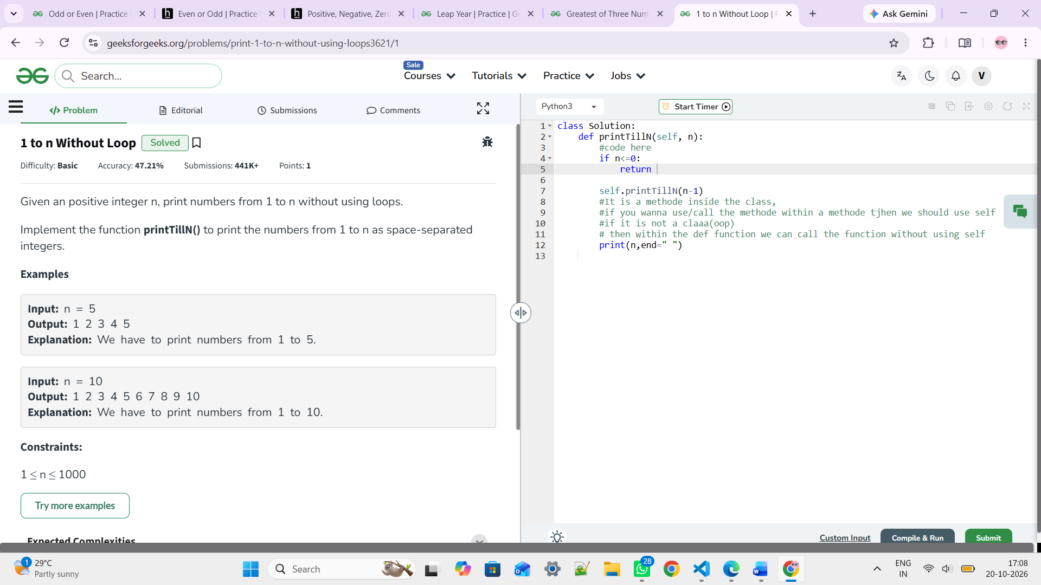

- https://www.geeksforgeeks.org/problems/print-n-to-1-without-loop/1
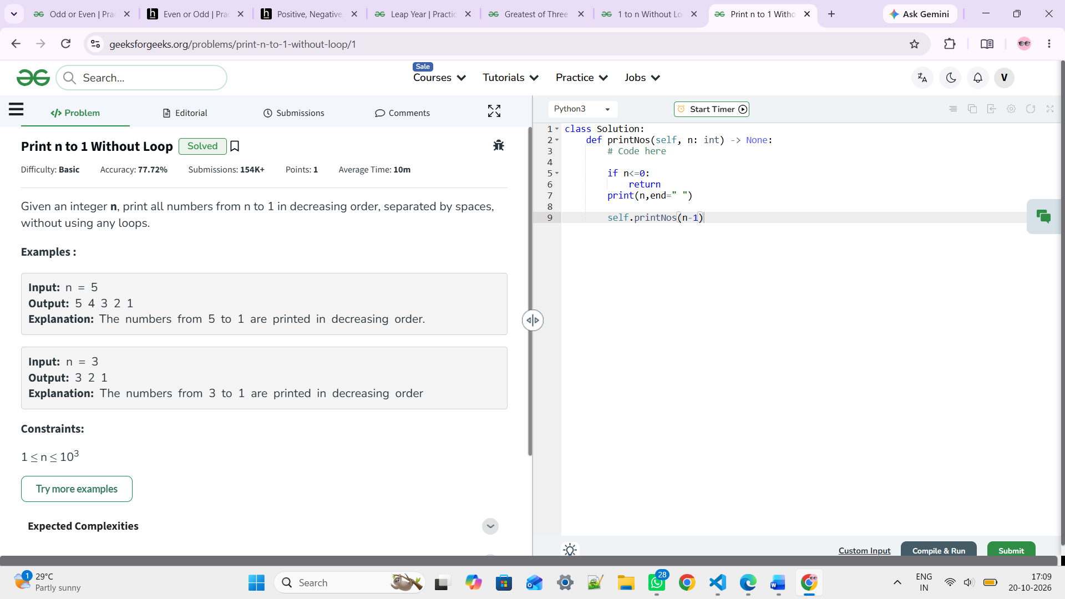

- https://www.geeksforgeeks.org/problems/multiplication-table/1
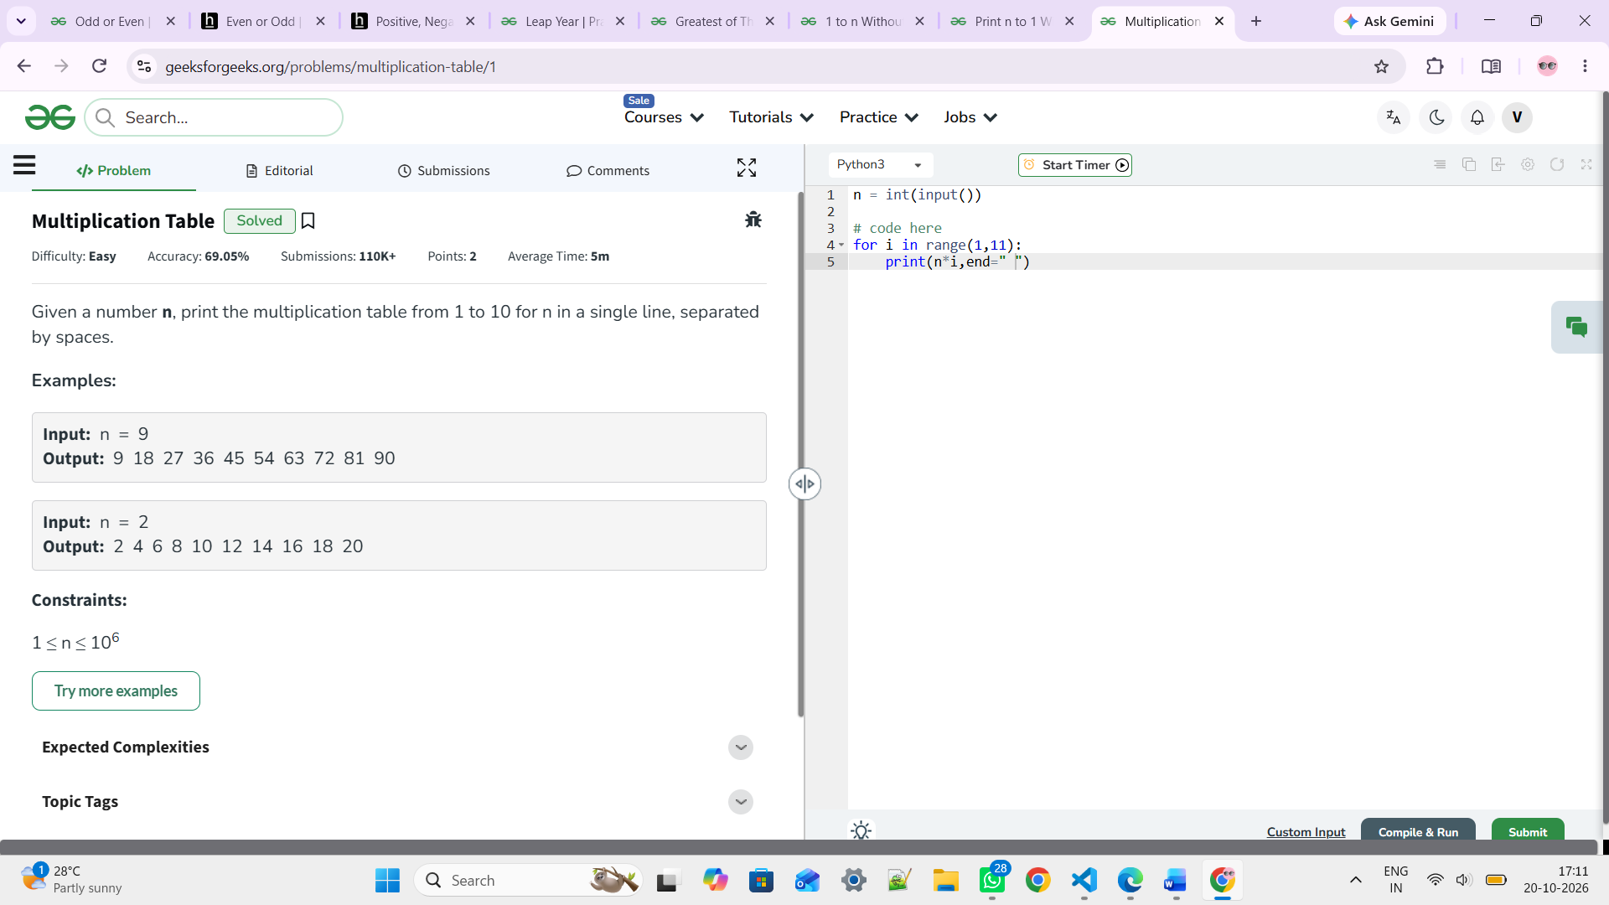

- https://www.geeksforgeeks.org/problems/reverse-coding2452/1
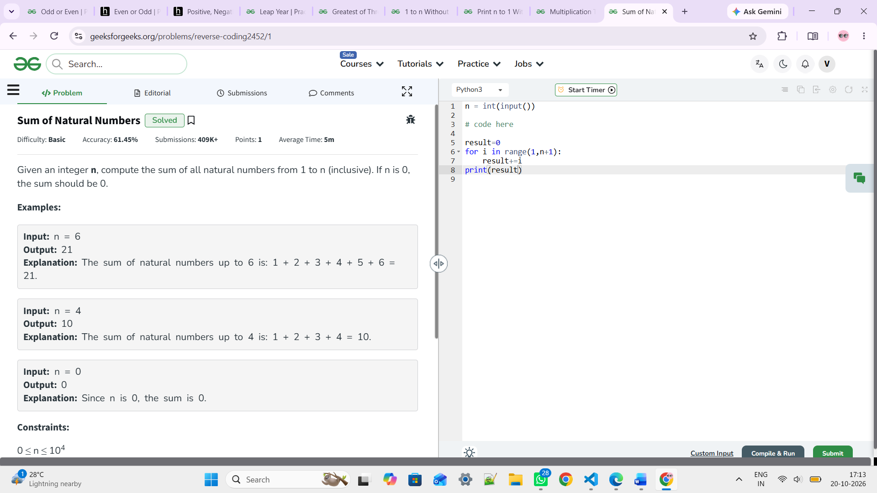

- . https://www.geeksforgeeks.org/problems/calculator/1
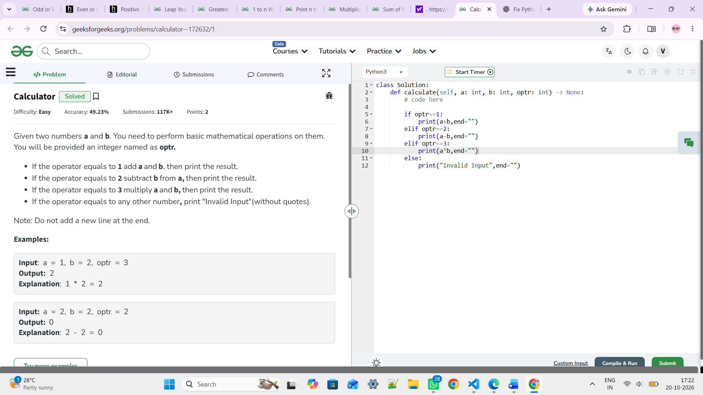

- https://www.geeksforgeeks.org/problems/start-coding-1/1
The "Hello World" program is a common starting point for learning programming.
Complete the code to print: "Hello World"

Solution:- print("Hello World")

- https://www.geeksforgeeks.org/problems/taking-input/1
#math.floor(variable)
#This is a built in method / function in python which will convert the float into floor
#Eg:- 5.5 ----> 5
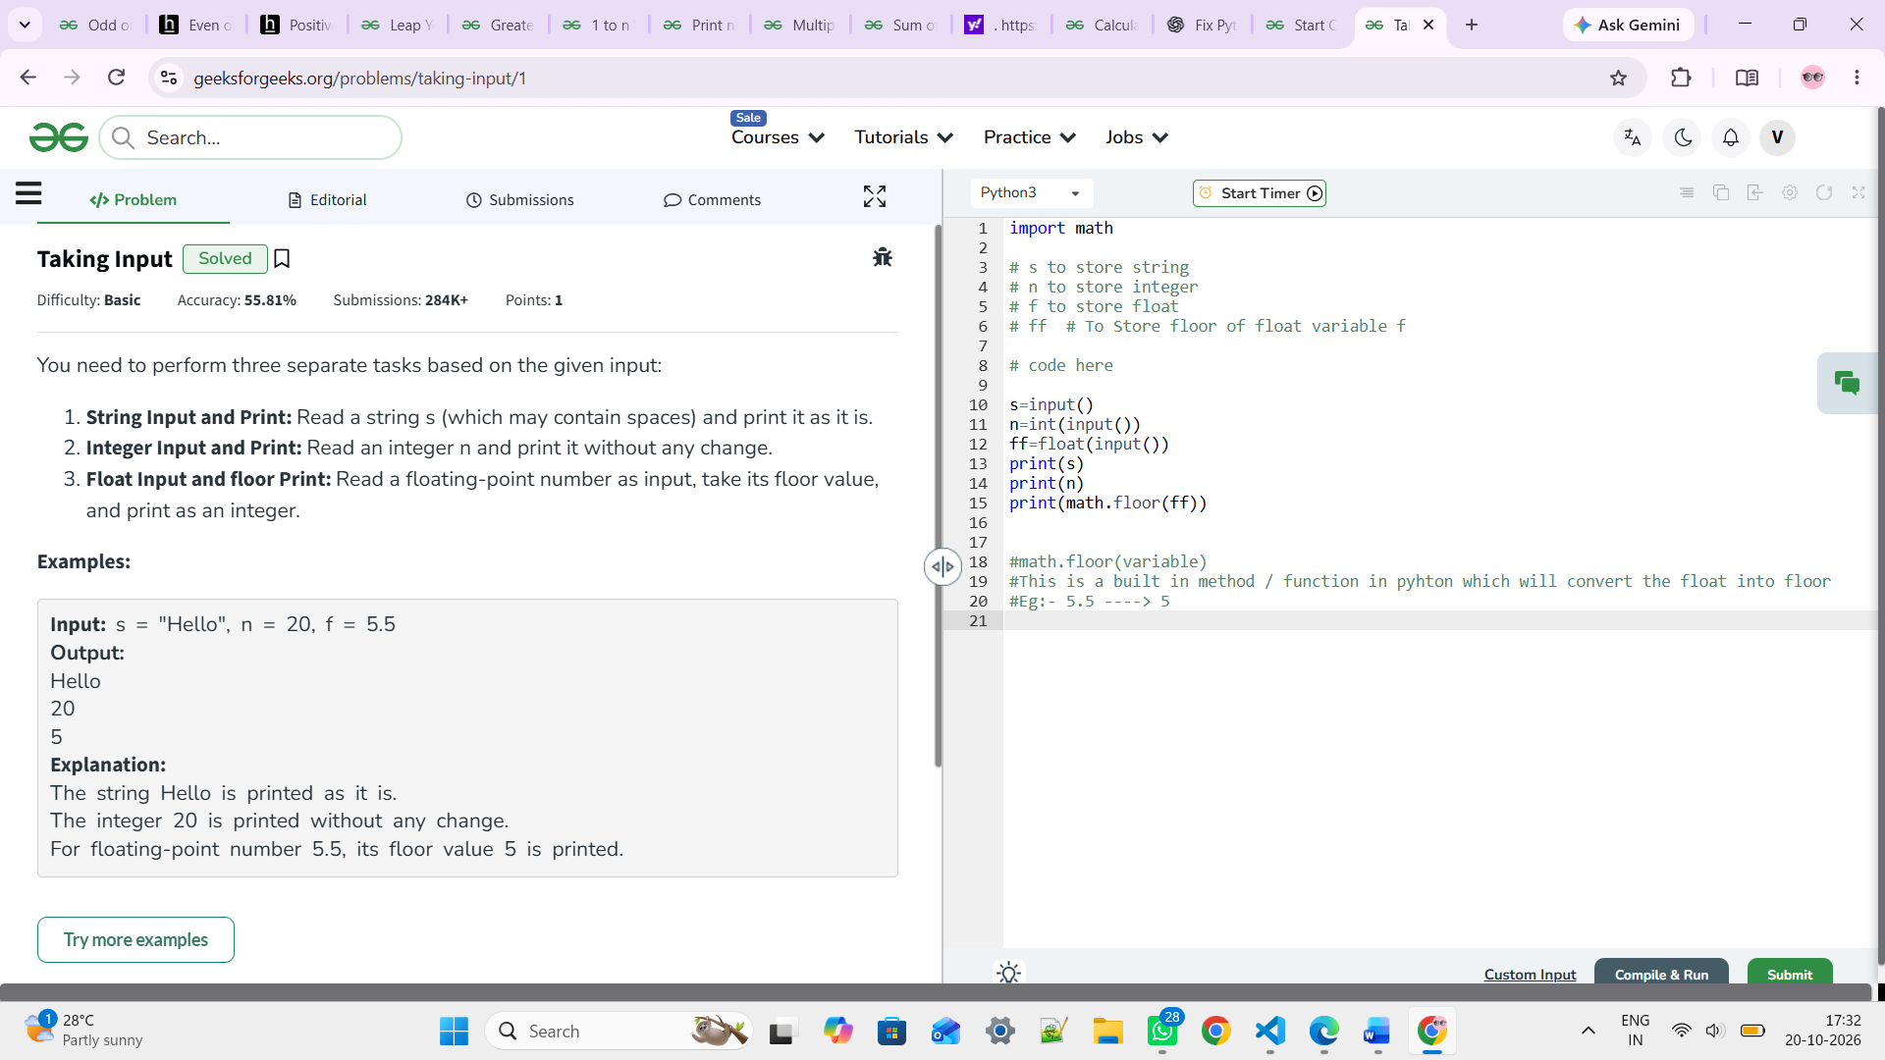

- https://www.hackerrank.com/challenges/read-multiple-lines-input/problem
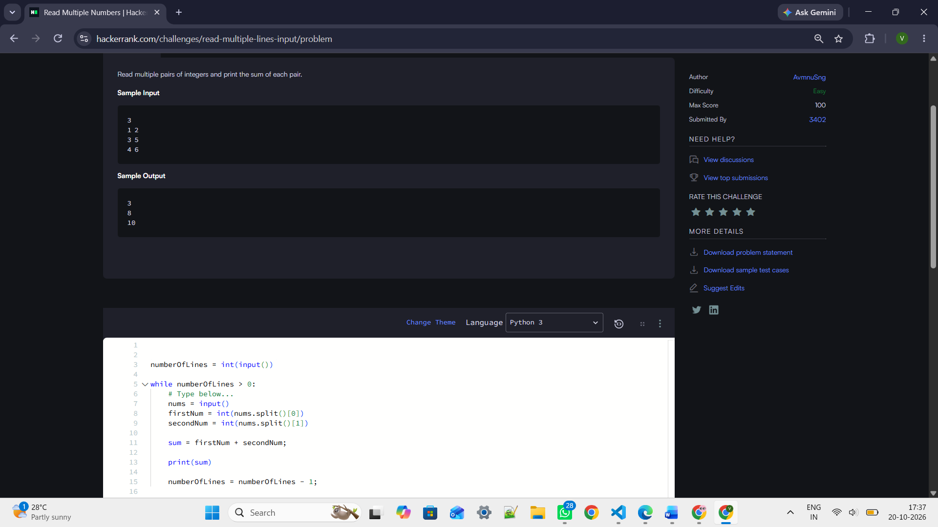

numberOfLines = int(input())

while numberOfLines > 0:
# Type below...
nums = input()
firstNum = int(nums.split()[0])
secondNum = int(nums.split()[1])

sum = firstNum + secondNum;

print(sum)

numberOfLines = numberOfLines - 1;

- https://www.geeksforgeeks.org/problems/swap-the-numbers/1

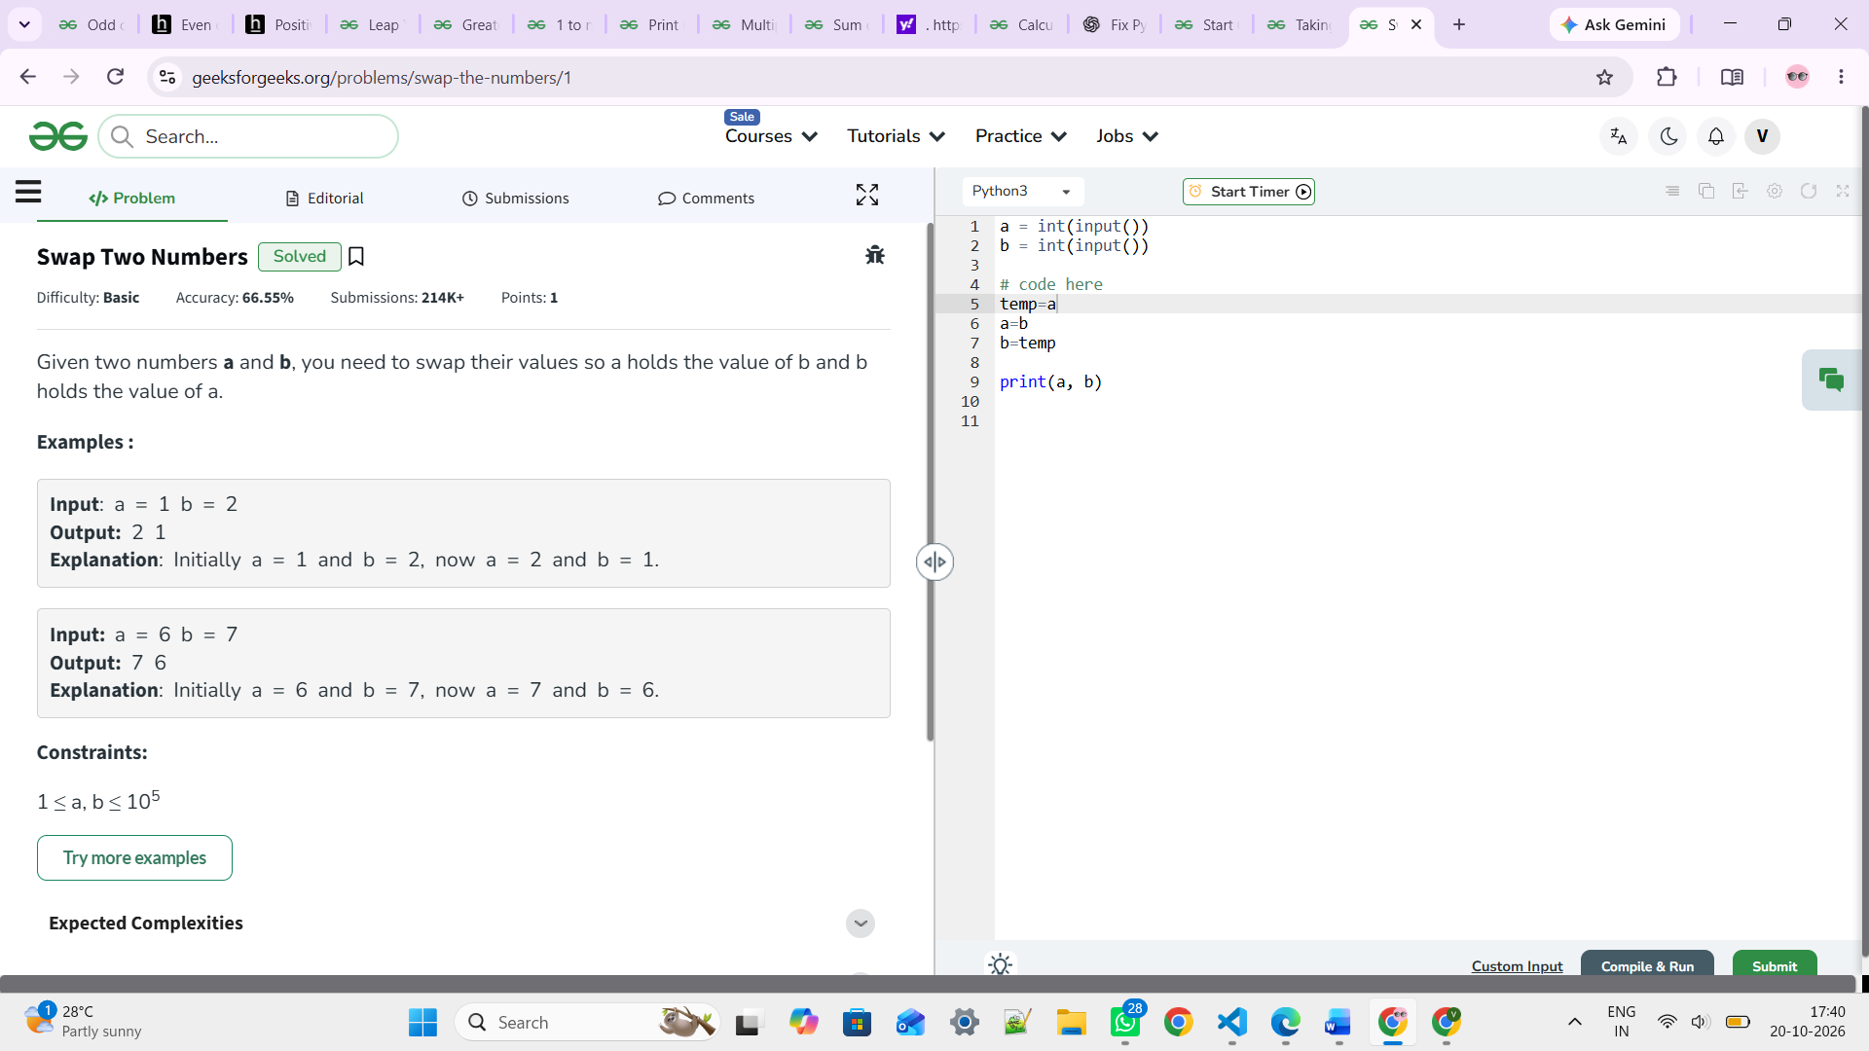

DAY 02 TASKS (LOOPS)

- https://www.geeksforgeeks.org/problems/while-loop/1

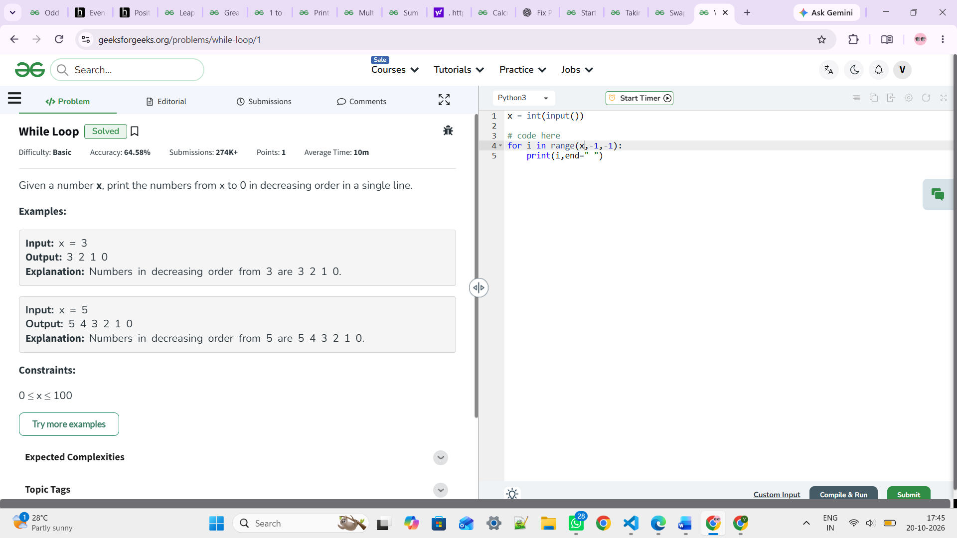

- Imagine processing a list of numbers where you want to skip negative values, but stop completely if you find a zero

print("2. Imagine processing a list of numbers where you want to skip negative values, but stop completely if you find a zero ")

lst=[1,9,-1,9,4,33,-287,-19,84,91,-8,10,-20,0,21,-29,98,100]

for i in lst:
if i<0:
continue
elif i==0:
break
print(i)

- Write a program to keep asking for a number until you enter a negative number. At the end, print the sum of all entered numbers.

print("3. Write a program to keep asking for a number until you enter a negative number. At the end, print the sum of all entered numbers.")

result=0
while True:
n=int(input("Enter the number: "))

if n<0:
break

result+=n
print(result)

- Write a program to ask for a name until the user enters END. Print the name each time. When you are done, print "I am done."

print("Write a program to ask for a name until the user enters END. Print the name each time. When you are done, print I am done.")

while True:

n=input("Enter the name: ")
if n=="END":
break
print("I am done..")

- WANT TO DO

- WAP to print the follow series. 105 98 91 ……….7

print("WAP to print the follow series. 105 98 91 ……….7 ")

for i in range(105,0,-7):
print(i,end=" ")

#for the given input
n=int(input("Enter the number: "))

for i in range(n,0,-7):
print(i,end=" ")

- WAP to display the difference of sum of first “n” odd numbers and first “n” even numbers.

print("WAP to display the difference of sum of first “n” odd numbers and first “n” even numbers.")

n=int(input("Enter the number of odd and even numbers: "))

even_sum=0
odd_sum=0
i=1
while i<=n:
even_sum+=2*i #to print even numbers multiply that I with 2
odd_sum+=2*i-1 #to print even numbers multiply that I with 2 -1
i+=1
print(even_sum - odd_sum) #since it is a difference use ‘-‘

start with 1
Since we don’t know till where we want to iterate use while loop until and unless the i is lesser than or equal to the given input we should iterate.
EG:- if n=2
While i <=n | Even_sum | Odd_sum | Diff ( even_Sum – odd_sum)
Initially i=1, 1<=2:T | 2*i => 2*1 => 2 | 2*i -1=> 2*1 -1=> 1  i +=1 => i=2
I=2 => 2<=2 | 2*2= 4 | 2*2 -1 = 3  I+=1 => 3
i <=2: False so stop

- WAP to display all the numbers between the defined range using while loop.

print("WAP to display all the numbers between the defined range using while loop.")

n=int(input("Enter a number: "))

i=1

while i<=n:
print(i,end=" ")
i+=1

- WAP to enter the numbers till the user wants and at the end it should display the sum of all the entered numbers. The loop should work until the user enter 0.

print("WAP to enter the numbers till the user wants and at the end it should display the sum of all the entered numbers. The loop should work until the user enter 0. ")

result=0
while True:
n=int(input("Enter the number: "))
if n==0:
break
result+=n
print(result)

- WAP to enter the numbers till the user enters 0 and at the end it should display the count of positive number and negative number separately.

print("WAP to enter the numbers till the user enters 0 and at the end it should display the count of positive number and negative number separately.")

count_pos=0
count_neg=0

while True:
n=int(input("Enter the number: "))
if n==0:
break

elif n<0:
count_neg+=1
else:
count_pos+=1

print("Number of positive numbers: ",count_pos)
print("Number of negative numbers: ",count_neg)

- WAP to accept “n” random positive numbers from the user and display the largest and smallest out of it.

print(" WAP to accept “n” random positive numbers from the user and display the largest and smallest out of it. ")

#To find smallest and largest number in a given inputs without using list and build-in function we use this method

n=int(input("Enter number of numbers you want to take: ")) # how many numbers'n' numbers i should take from user

# to compare the next entered number with whom will you compare so take first input / number of elements as a base or initial value for both smallest and greatest
largest=n
smallest=n

#Start with 1
i=1
while i<=n: #until i <= n do this
num=int(input("Enter the number: "))

if num>largest:
largest=num

elif num<smallest:
smallest=num

i+=1

print("Largest number: ",largest)
print("Smallest number: ",smallest)

- WAP to display first “n” values of the following series.

Eg: N = 3 2 22 222
N = 5 2 22 222 2222 22222

print("12. WAP to display first “n” values of the following series. Eg: N = 3 2 22 222 N = 5 2 22 222 2222 22222 ")

n=int(input("Enter the number: "))

str_num="2"

for i in range(1,n+1):
print(str_num*i,end=" ")

- WAP to display natural even numbers starting from “n”.

print("13. WAP to display natural even numbers starting from “n”. ")

n=int(input("ENter the number: "))

i=1

while i<=n:
if i%2==0:
print(i,end=" ")
i+=1

- WAP to swap the numbers present in variables without using the 3rd variable or the standard predefined approach.

print("14. WAP to swap the numbers present in variables without using the 3rd variable or the standard predefined approach. ")

a=int(input("Enter the first number: "))
b=int(input("Enter the second number: "))

a,b=b,a
print("First number after swapping (value of a after swapping): ",a)
print("Second number after swapping (value of b after swapping): ",b)

- Keep asking the user for a password until they get it right, but lock them out after 3 wrong
Note: Let the curr_password be predefined.

print("15. Keep asking the user for a password until they get it right, but lock them out after 3 wrong Note: Let the curr_password be predefined. ")

current_psw="129"

for i in range(1,4):
n=input("Enter your password: ")
if n==current_psw:
print("Correct password.")
break

else:
print("You reached limit of attempt...")

DAY – 3 TASKS [ Numerical Programs ]

- WAL to display all the odd numbers present in a user defined range.
print("1. WAL to display all the odd numbers present in a user defined range. ")

n1=int(input("Enter first number: "))

n2=int(input("Enter Second number: "))

for i in range(n1,n2+1):
if i%2!=0:
print(i,end=" ")

- WAL to print first "n" even numbers.

print("2. WAL to print first n even numbers. ")

def evenNum(n):
if n==0:
return
evenNum(n-1)
print(2*n,end=" ")
n-=1
return

n=int(input("Enter a number: "))
evenNum(n)

- WAL to print first "n" odd numbers.

print("3. WAL to print first n odd numbers. ")

def oddNum(n):
if n==0:
return
oddNum(n-1)
print((2*n)-1,end=" ")

n=int(input("Enter the number: "))
oddNum(n)

