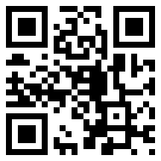
http://drbl.nchc.org.tw

DRBL - Diskless Linux Solution

http://drbl.org

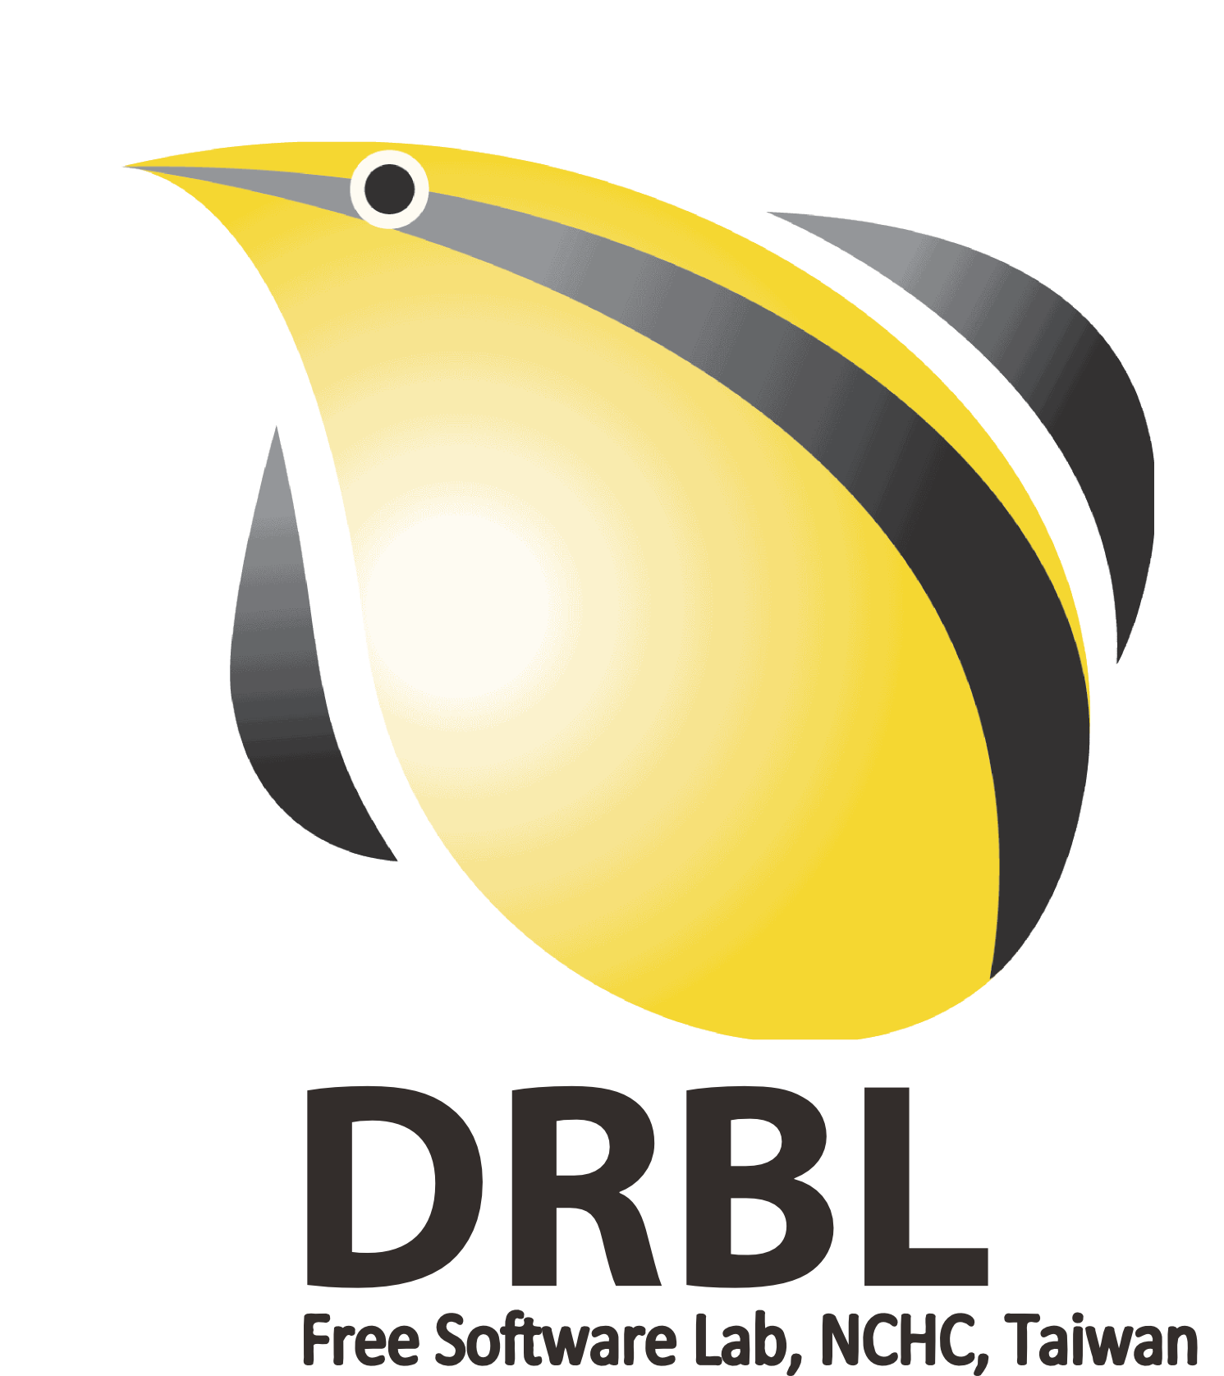
DRBL (Diskless Remote Boot in Linux) provides a diskless or systemless environment for client machines. It works on Debian, Ubuntu, Fedora, Red Hat Enterprise Linux, CentOS, Scientific Linux, and SuSE. DRBL uses distributed hardware resources and makes it possible for clients to fully access local hardware. It also includes Clonezilla SE (Server Edition), a partitioning and disk imaging/cloning utility similar to Symantec ghost. DRBL took home first prize in the "Public Sector Applications" category at the French “Trophees du Libre” (a.k.a. International Free Software Contest) held December 2007.

DRBL Features:
- Peacefully Co-exists with Other OSs !
DRBL uses PXE/etherboot, NFS, and NIS to provide services to client machines so that it is not necessary to install GNU/Linux on the individual client hard drives. Once the DRBL server has been established, the client machines can boot "disklessly" via PXE or Etherboot. DRBL doesn't touch the client hard drives, therefore, other installed OSs (e.g. MS Windows) are unaffected. This is useful, for example, during a phased deployment of GNU/Linux where the user wants the option of booting into MS Windows.
- Simply Install DRBL on a Single Server and all your Clients are Ready To Go !
Using a standard PC, you can transform a group of client PCs into a working GNU/Linux network in two simple steps:
- Download the DRBL package
- Run the install program
In only 30 minutes, all client machines will be ready to run GNU/Linux and all associated packages. No more cloning of client machines one-by-one; just use DRBL !
- Save on Hardware, Budget, and Maintenance Fees!
Hard drives are optional with the DRBL client. If a hard drive is present, the client can be configured to use it as swap or data space while GNU/Linux is installed and configured on the centralized boot server. A lot of time can be saved by configuring the client settings at the boot server when using the DRBL centralized boot environment. This gives the system administrator more control over what software configurations are running on each client.

http://clonezilla.nchc.org.tw
Clonezilla - The Free and Open Source Software for Disk Imaging and Cloning

http://clonezilla.org

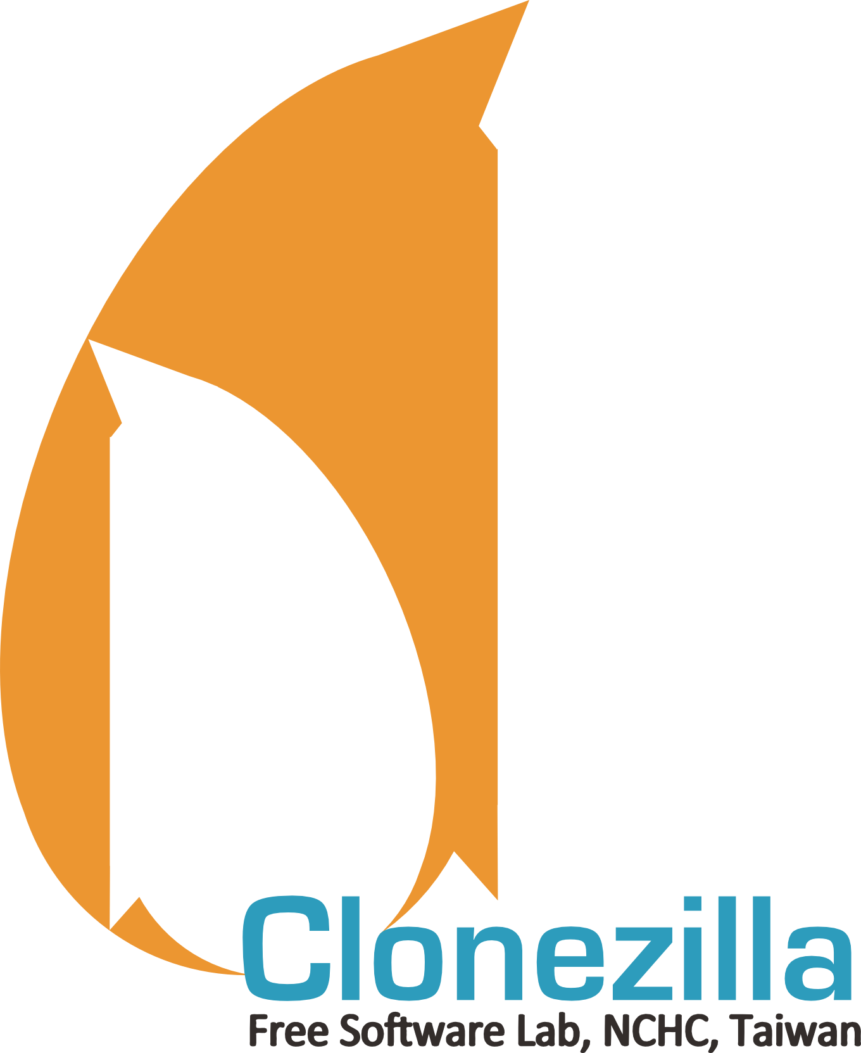
You're probably familiar with the popular proprietary commercial package, Norton Ghost®, and its Open Source counterpart, Partition Image. The problem with these two software packages is that they take a lot of time to massively clone a single system to many computers. You've also probably heard of Symantec's solution to this problem, Symantec Ghost Corporate Edition® with Multicasting. Well, now there is an Open Source clone system (OCS) solution called Clonezilla with Unicasting and Multicasting!

Clonezilla, based on DRBL, Partclone, and UDPcast, allows you to do bare metal backup and recovery. Two types of Clonezilla are available, Clonezilla Live and Clonezilla Server Edition (Clonezilla SE). Clonezilla Live is suitable for single machine backup and restoring whereas Clonezilla SE is used for massive deployment (i.e. it can clone many computers – 40 plus!--simultaneously!) Clonezilla saves and restores only the used blocks on the hard disk. This increases its cloning efficiency. In the NCHC's computer classroom, Clonezilla SE was used to clone 41 computers simultaneously! It took only 10 minutes to clone a 5.6 GBytes system image to all 41 computers using multicasting !
Clonezilla Features:
- Free (GPL) Software.
- Clonezilla supports the following file systems: ext2/3/4, reiserfs, reiser4, XFS, JFS, btrfs HFS+, UFS, FAT, NTFS, VMFS (version 3/5) and Minx. It is able to clone or image GNU/Linux, Mac OS, BSD serial, MS Windows, VMWare ESX(i) and Minix. For these file systems, only the used blocks in the partition are saved and restored. For unsupported file systems, a sector-to-sector copy is done by dd in Clonezilla.
- LVM2, under GNU/Linux, is supported (although LVM version 1.0 is not).
- Clonezilla SE supports Multicast.
- Boot loader, including grub (version 1/2) and syslinux, could be reinstalled.
- Unattended mode: Almost all steps can be done via commands and options.
- One image could be restored to multiple local devices.
- The image file can be on local disk, ssh server, samba server, or NFS server.
- DRBL-Winroll, another free software developed by the NCHC, can be used to automatically change the hostname, group, network, SID(need third party tool) of a cloned MS Windows machine.

