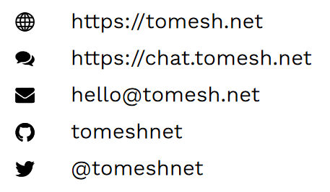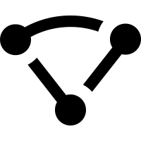

**We help communities to create better networks that rely on open source and peer-to-peer technologies, while promoting digital literacy and personal privacy.**

An eclectic group of volunteers, we like to envision, design, build, deploy, test, experience and share our ideas for more human-scale & human-friendly patterns of connection, communication and community.

Toronto Mesh also reaches out to and connects with an international community of like-minded people working together to increase access & literacy and expand your choices for digital technologies that enrich your life, your family and your community.

**Toronto Mesh**



**We help communities to create better networks that rely on open source and peer-to-peer technologies, while promoting digital literacy and personal privacy.**

An eclectic group of volunteers, we like to envision, design, build, deploy, test, experience and share our ideas for more human-scale & human-friendly patterns of connection, communication and community.

Toronto Mesh also reaches out to and connects with an international community of like-minded people working together to increase access & literacy and expand your choices for digital technologies that enrich your life, your family and your community.

**Toronto Mesh**



**We help communities to create better networks that rely on open source and peer-to-peer technologies, while promoting digital literacy and personal privacy.**

An eclectic group of volunteers, we like to envision, design, build, deploy, test, experience and share our ideas for more human-scale & human-friendly patterns of connection, communication and community.

Toronto Mesh also reaches out to and connects with an international community of like-minded people working together to increase access & literacy and expand your choices for digital technologies that enrich your life, your family and your community.

**Toronto Mesh**



**We help communities to create better networks that rely on open source and peer-to-peer technologies, while promoting digital literacy and personal privacy.**

An eclectic group of volunteers, we like to envision, design, build, deploy, test, experience and share our ideas for more human-scale & human-friendly patterns of connection, communication and community.

Toronto Mesh also reaches out to and connects with an international community of like-minded people working together to increase access & literacy and expand your choices for digital technologies that enrich your life, your family and your community.

**Toronto Mesh**