UDP Socket Test Port for TTCN-3 Toolset with TITAN, Function Specification

Contents
1 Introduction 2
1.1 Revision history 2
1.2 How to Read this Document 2
1.3 Scope 2
1.4 References 3
1.5 Abbreviations 3
1.6 Terminology 3
2 General 3
3 Function Specification 4
3.1 Implementation 4
3.1.1 Module structure 4
3.2 Configuration 4
3.3 Operation mode 4
3.4 Start Procedure 5
3.5 Sending/Receiving UDP ASPs 5
3.5.1 UDP ASPs sent by the test port 5
3.5.2 UDP ASPs received by the test port 5
3.6 Logging 6
3.7 Error Handling 6
3.8 Closing Down 6
3.9 Limitations 6

Introduction

Revision history

Date | Rev | Characteristics | Prepared
2003-11-19 | PA1 | First draft version | ETHJGI
2004-01-13 | A | Updated after review | ETHJGI
2004-02-13 | PB1 | Local and remote address usage modification | ETHZJZ
2004-02-16 | B | Updated after review | ETHJGI
2004-09-07 | PC1 | Added advanced mode | ETHGASZ
2004-09-16 | C | Updated after review | ETHGASZ

How to Read this Document
This is the Function Specification for the UDP test port. The UDP test port is developed for the TTCN-3 Toolset with TITAN according to the Requirement Specification [5]. This document is intended to be read together with Product Revision Information [3] and the User’s Guide [4].

Scope
The purpose of this document is to specify the functionality of the UDP test port. The document is primarily addressed to the end users of the product. Basic knowledge of TTCN-3 and TITAN TTCN-3 Test Executor is valuable when reading this document (see [1] and [2]).
This document is based on specifications of User Datagram Protocol (UDP) defined by RFC 768 [6].

References

ETSI ES 201 873-1 (2002)
The Testing and Test Control Notation version 3. Part 1: Core Language

1/1553-CRL 113 200 Uen
User Documentation for the TITAN TTCN-3 Test Executor

109 21-CNL 113 346-1 Uen
UDP Socket Test Port for TTCN-3 Toolset with TITAN, Product Revision Information

198 17-CNL 113 346 Uen
UDP Socket Test Port for TTCN-3 Toolset with TITAN, User Guide

5/1056-200/FCP 11 265 TTCN 3
Functional Test System Requirement Specification for GSN

RFC 768 (1980)
User Datagram Protocol

Abbreviations
API Application Programming Interface
ASP Abstract Service Primitive
RTE Run-Time Environment
SUT System Under Test
TTCN-3 Testing and Test Control Notation version 3
UDP User Datagram Protocol

Terminology
-

General
The UDP Test Port makes it possible to execute test suites towards a SUT. The test port offers UDP primitives to the test suite and communicates with the SUT.
The communication between the UDP test port and the TITAN RTE is done by using the API functions described in [2]. The UDP protocol messages are then transferred by the UDP test port to the SUT.
Figure 1. below shows the overview of the system:
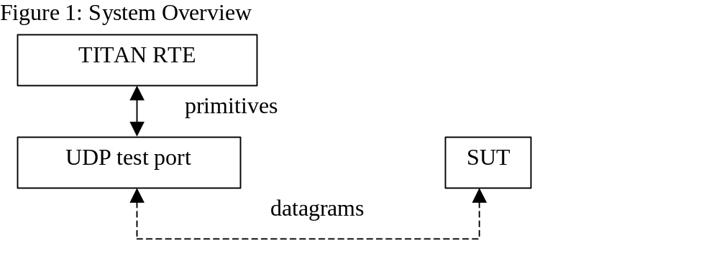

Function Specification

Implementation
The UDP layer is implemented in UNIX kernel. The test port implements the communication between UNIX UDP sockets and the TTCN-3 UDP ASPs.

Module structure
The UDP test port is implemented in the following TTCN-3 blocks:
- UDPasp_Types.ttcn
- UDPasp_PortType.ttcn
The file UDPasp_Types.ttcn defines the UDP ASPs. The port type is defined in UDPasp_PortType.ttcn.
The C++ implementation of the test port is contained in the following files:
- UDPasp_PT.hh
- UDPasp_PT.cc

Configuration
The configuration of the UDP test port is done by the TITAN RTE configuration file. The description of the specific parameters can be found in the UDP test port user’s guide [4].

Operation mode
There are two operation modes of the test port
- Basic mode: The test port provides a simple ASP interface towards the TITAN RTE. This interface is compatible with the previous versions of the test port interface.
- Advanced mode: The advanced ASP interface provides the following port operations: open socket, close socket, send and receive data. One test port can handle multiple UDP sockets.

Start Procedure
After the configuration is done, the user has to make sure that the target system is up and running. When the executable test suite is started it initializes the UDP socket. After the initialization is ready, the transmission of the ASPs can begin.

Sending/Receiving UDP ASPs
When the communication between the UDP test port and the target system is set up, the test port starts transferring the UDP primitives towards the TITAN RTE and UDP datagrams towards the SUT.

UDP ASPs sent by the test port
The UDP test port is able to send the following UDP primitives in basic mode:
- ASP_UDP
The UDP test port is able to send the following UDP primitives in advanced mode:
- ASP_UDP_message
- ASP_UDP_open_result

UDP ASPs received by the test port
The UDP test port is able to receive the following type of UDP primitives in basic mode:
- ASP_UDP
The UDP test port is able to receive the following type of UDP primitives in advanced mode:
- ASP_UDP_message
- ASP_UDP_open
- ASP_UDP_close

Logging
The type of information that will be logged can be categorized into two groups. The first one consists of information that shows the flow of the internal execution of the test port, e.g. important events, which function that is currently executing etc. The second group deals with presenting valuable data, e.g. presenting the content of a PDU. The logging printouts will be directed to the RTE log file. The user is able to decide whether logging is to take place or not by setting appropriate configuration data, see [4].

Error Handling
Erroneous behaviour detected during runtime is shown on the console and directed into the RTE log file. The following two types of messages are handled:
- Errors: information about errors detected is provided. If an error occurs the execution of the test case will stop immediately and the socket will be closed.
- Warnings: information about warnings detected is provided. The execution continues after the warning is shown.

Closing Down
After the test port has executed all test cases it will stop automatically. It will close down the UDP socket towards the SUT and terminate.
The execution of the test suite can be stopped at any time by pressing <Ctrl>-c. Before the executable terminates the socket is closed down.

Limitations
The operating system is Solaris 5.8.
The maximal length of the UDP data is 65536 bytes.

