Creating the Google Maps API

-First, visit this url.

<https://console.cloud.google.com/apis/credentials?project=sonorous-path-292207&folder=&organizationId>=

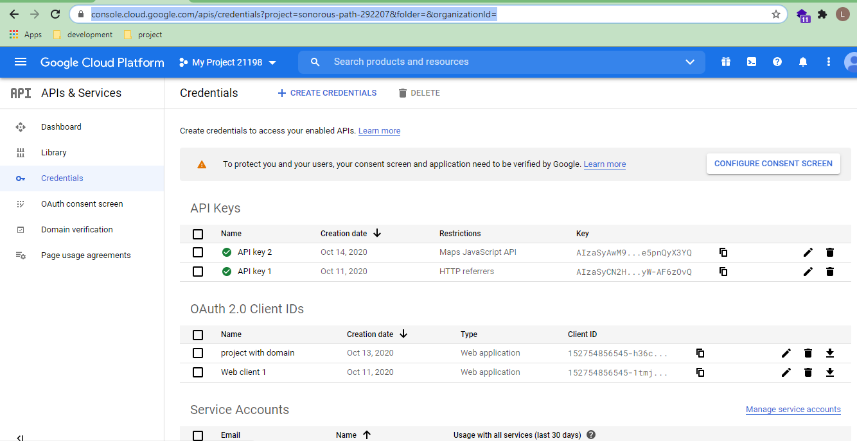

-And we can click ‘API key’ item, thus new key will create.

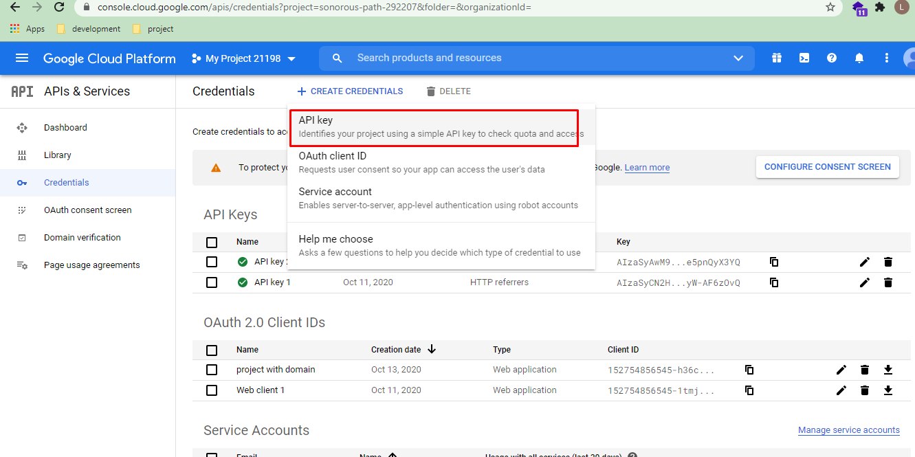

-And then click the ‘close’ button.

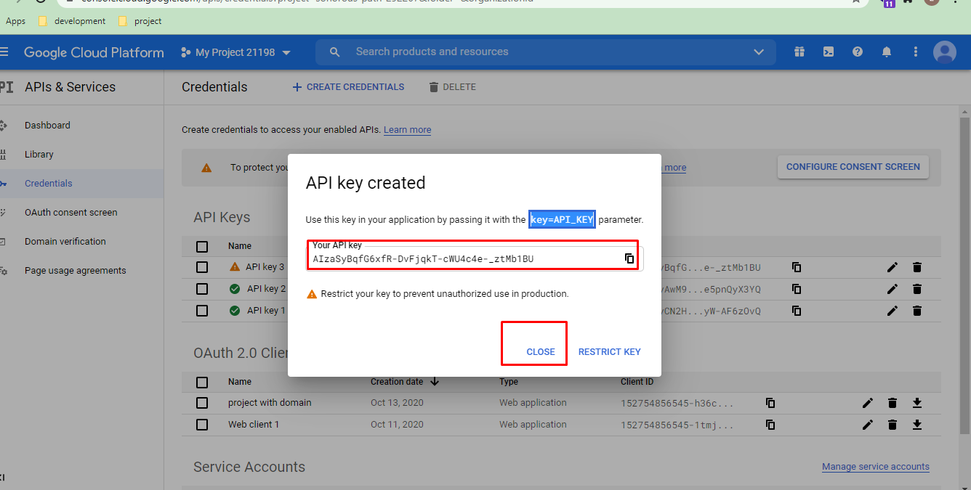

-Now that we can click ‘edit’ button, we can edit about the key.

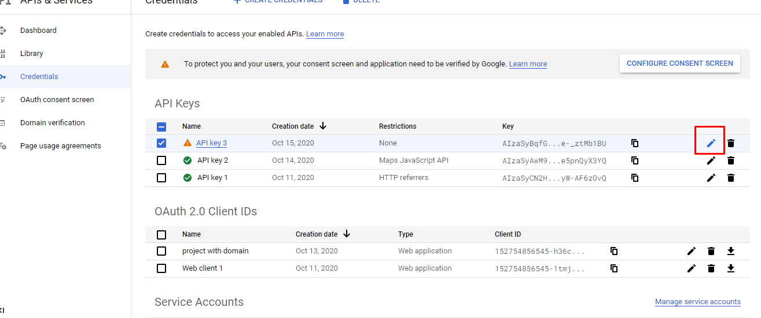

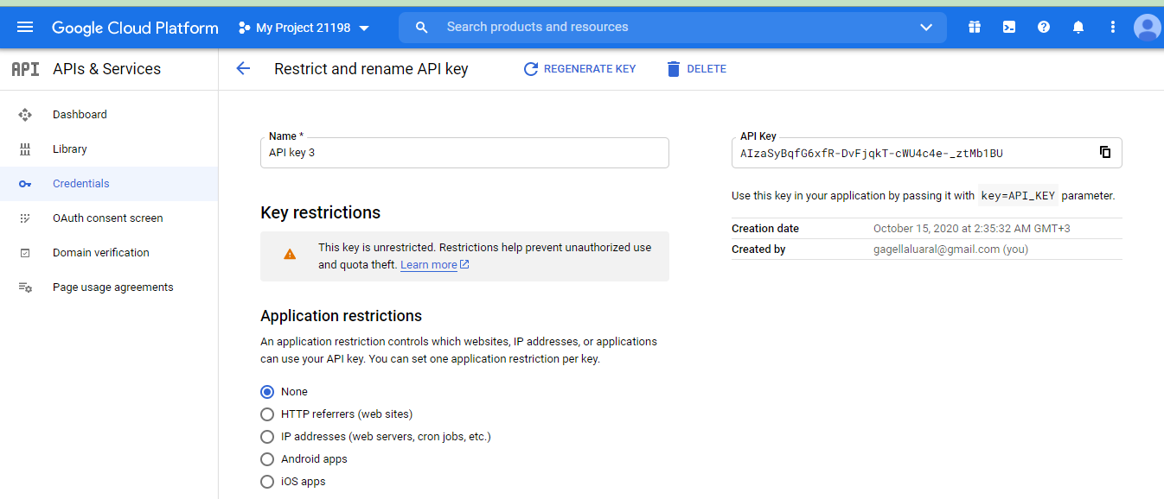

-https://console.cloud.google.com/marketplace/browse?q=maps%20javascript%20api&project=sonorous-path-292207

In that url, we can see three items.  
We can click each item and it should be enable.

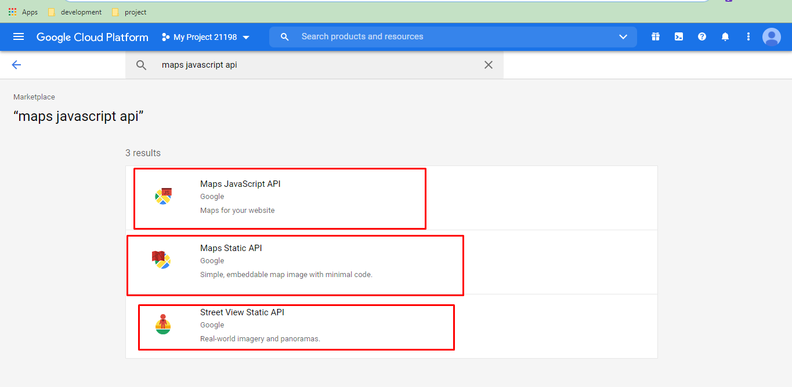

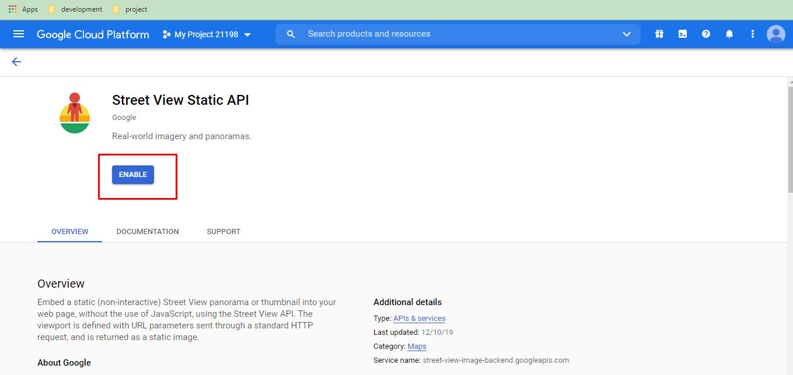

-Then,

<https://console.cloud.google.com/apis/credentials/key/98ba654e-1b17-42c8-b8d3-0a3ac8194930?folder=&organizationId=&project=sonorous-path-292207>

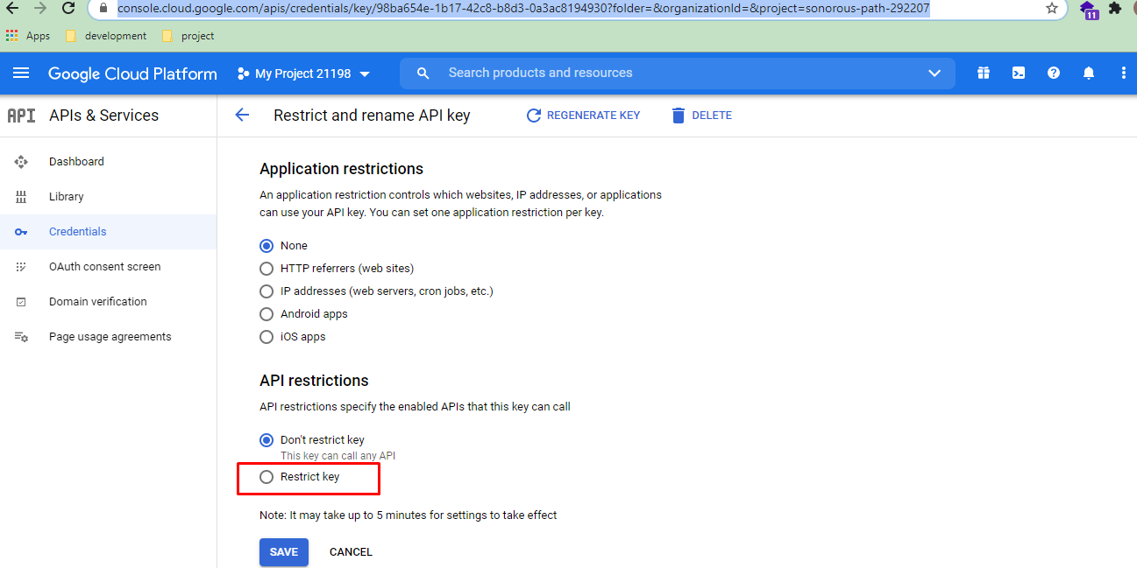

We should select a Restrict key option.

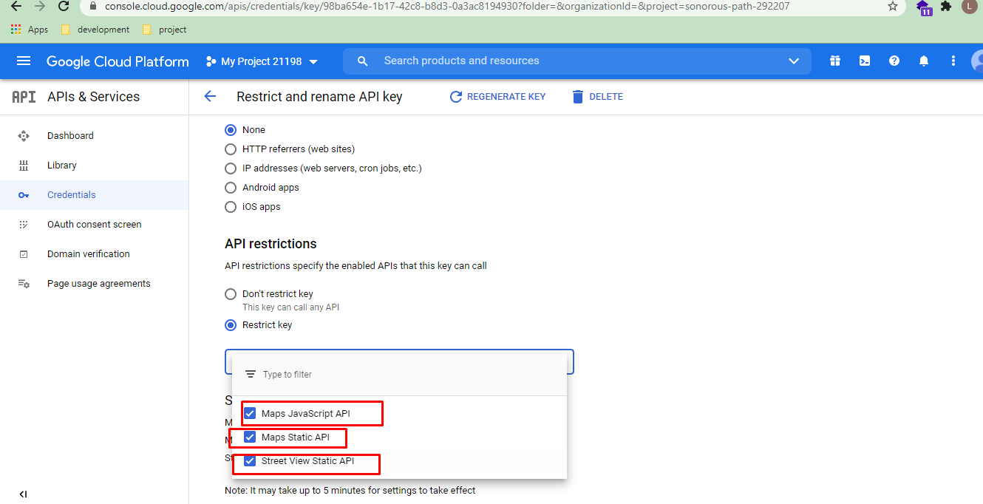

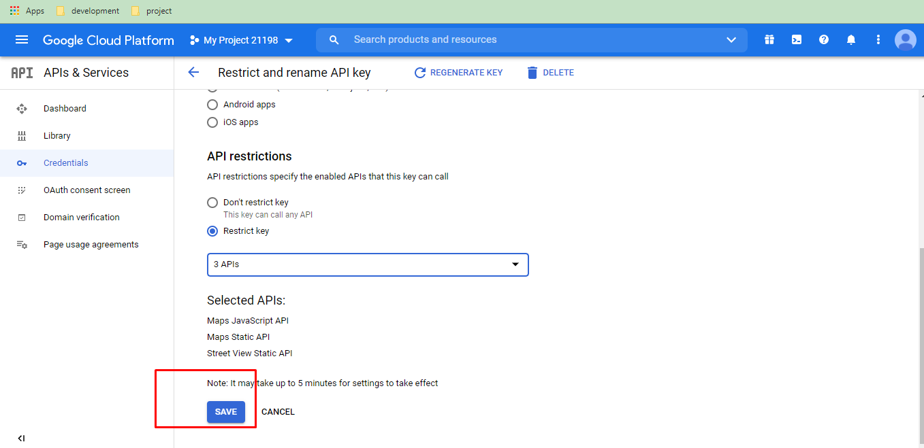

-And we should save the changes.

-So we can use that key. 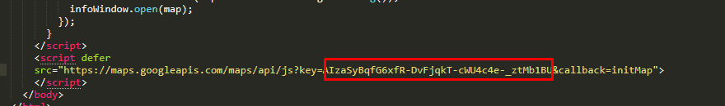

-If we apply with following ways,we can see under errors.

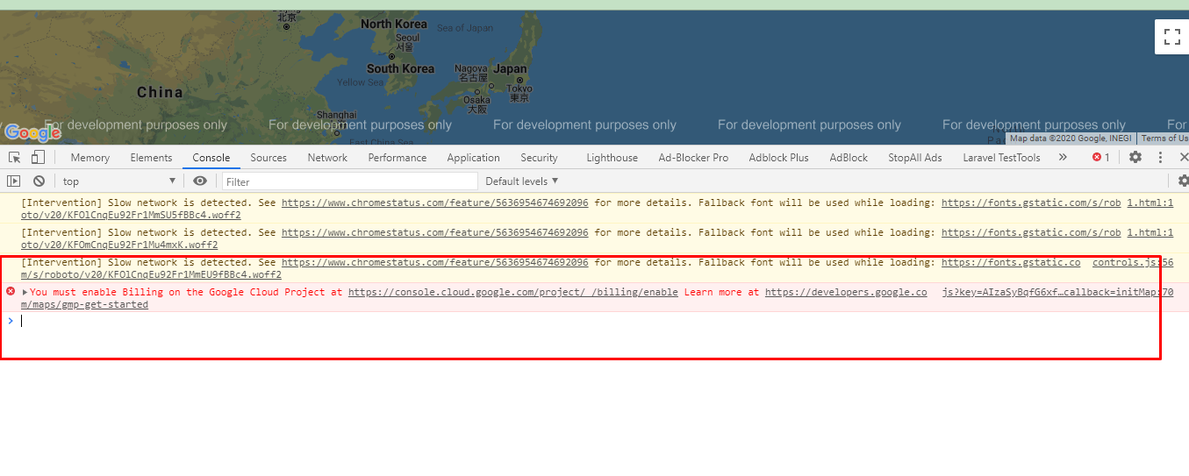

-

<https://console.cloud.google.com/projectselector/billing/enable>

For using the right key, we can click a project.

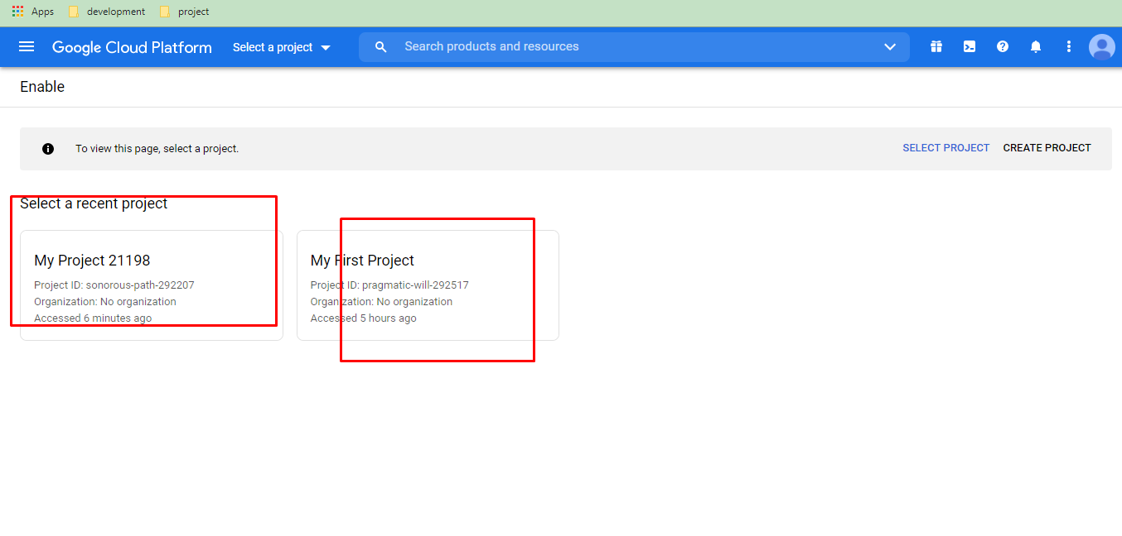

-Also we can create billing account.

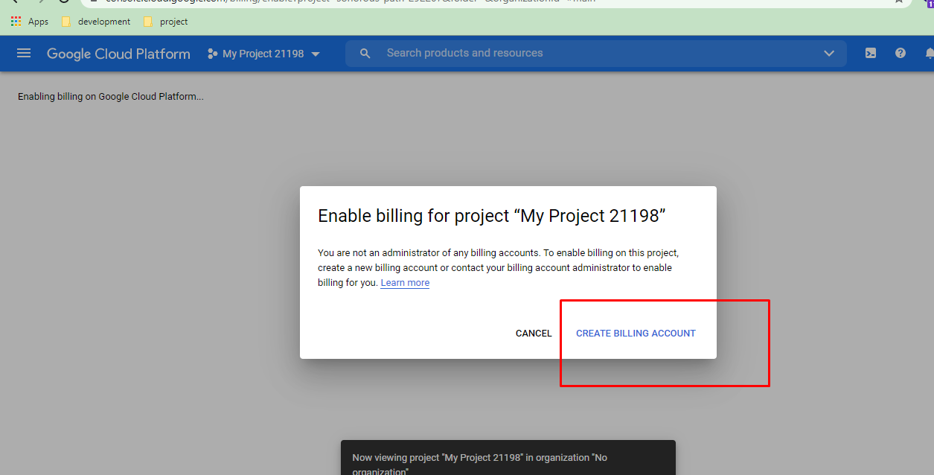

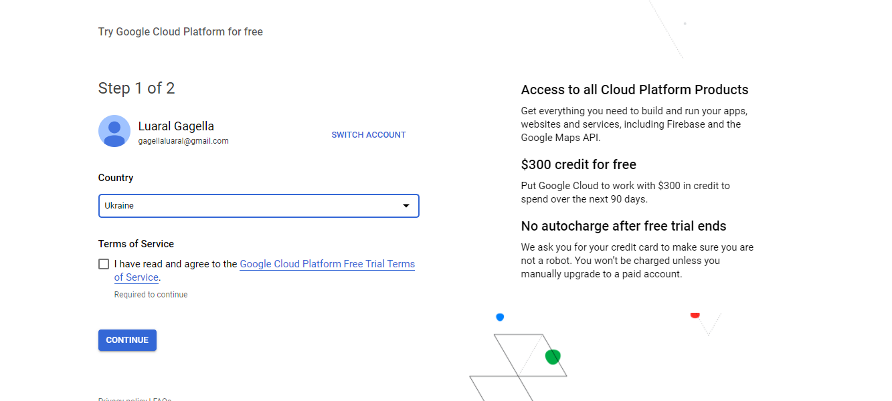

End