

Kidney: The Last Stand is a multiplayer tower defense game created by Jacques Deguine, Meena Shah, Maggie Fero, Colin Hunt, and Mario Gumina. It is a cooperative game designed to teach you about on the immune system while you work with your team to defend the kidney against infection.



Recommended for 1-4 players. Ages 7+.

**Game Rules**

Work with your teammates to defend the kidney against the infection. The game ends when you kill ten infection cards’ worth of Bacteria or a Bacterium makes it to the bottom end of the board infecting the bloodstream. If a Bacterium makes it from the top of the board to the bottom, Bacteria win. If you kill all Bacteria, the immune system wins!

*Setup*:

1. Choose a difficulty level.   
   If you would like to play the easiest version of the game, use the green infection cards.   
   For most games, use the blue cards.   
   For an added challenge, you can try using the red cards.   
   If you feel like you’re in-between levels, you can mix together cards of multiple colors, but be sure not to pick more than ten!
2. Shuffle the Infection cards of your chosen color and place these in the Infection Cards area on the board.
3. Shuffle the Immune Cell cards.
4. Deal 3 Immune Cell cards to each player. Your cards are your own and cannot be given or traded to other players, but you don’t need to hide them, because you’re all on the same team. Place the rest of the Immune Cell cards on the labeled area of the board.
5. Beginning with the youngest player and moving to their left, take turns until either all ten cards’ Bacteria are dead or one makes it to the end of the board.

*Game play:*

1. At the beginning of each turn, move all Bacteria currently on the board down one square toward the bloodstream.
2. If infection cards remain, flip over the top card and add bacteria to the top row as shown on the card.
3. The player places one Immune Cell card in any space on the board that does not have an immune cell card.
4. Immune Cells attack! Remove any Bacteria that are eaten or attacked by the Immune Cells currently on the board.
5. Draw a new Immune Cell card.

**Frequently Asked Questions:**

* **What if a Bacterium lands on my B-cell?** B-cells can’t attack Bacteria on or past their square.
* **Can I make a drinking game?** We do not recommend this. However, if you must, first remove all medium (blue) and hard (red) cards.
* **What if I can’t play any cards?** You can skip playing a card for the turn, or you can discard all of your cards and draw new ones instead of placing an Immune Cell. Bacteria still move down, and any Immune Cells already on the board still attack.
* **What does “adjacent” mean for Neutrophils and T-cells?** It means that the square is directly above, below, to the right of, or the left of the square where you play the card.
* **What is the shape of a Neutrophil’s attack?** Neutrophils attack in a cross shape, centered on the square where you place the Neutrophil. This means it clears all Bacteria and Immune Cells in the squares directly above, below, to the right of, or to the left of the square where you play the card. Remember, Neutrophils only activate during the attack step if there is a Bacterium on the same square.
* **What if I kill all of the bacteria before we flip ten infection cards?** You keep playing! Good job staying on top of disease, though!
* **What if a Macrophage is next to two T-cells? Do the effects stack?** Nope! The Macrophage can only eat a maximum of two Bacteria per turn, even with helpful T-cells’ assistance.
* **What if two Macrophages are next to one T-cell? Can each Macrophage eat two Bacteria per turn?** Yes! Each Macrophage benefits from the T-cell.

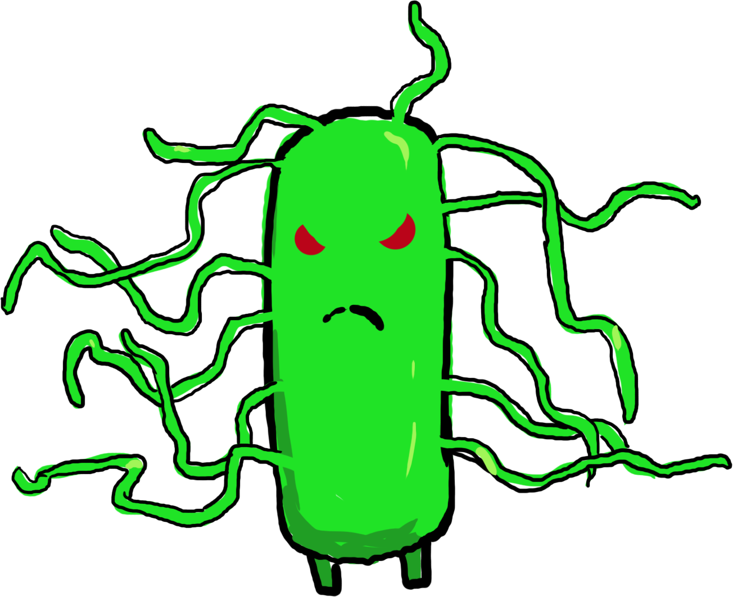

**Mutations**:

* Instead of using Bacteria pieces, use candy. If your Immune Cell eats a Bacterium, you get to eat the candy!
* If you want to make the game harder without moving to a harder card color, try removing a few Neutrophil cards or playing without placing any cards in the first row.
* Try with different numbers of infection cards. Removing infection cards makes the game shorter, and adding some can add more germ-busting fun!
* If you win too easily, require a macrophage on the board to support each B-cell you play.



1-4 Players

Ages 7 and up

A multiplayer collaborative tower defense game to protect

the body from infection

**Bacteria move down toward the bloodstream.**

Turn Steps:

1. Move Bacteria down toward the bloodstream.
2. Flip Infection card and add new Bacteria.
3. Place an Immune Cell to defend the body.
4. Immune Cells attack!
5. Draw a new Immune Cell card.

**Defend the bloodstream**

If Bacteria make it to here then it is game over

**Bacteria and immune cells in adjacent**

**Bacteria and immune cells in adjacent**

**Bacteria and immune cells in adjacent**

**Bacteria and immune cells in adjacent**

**Bacteria and immune cells in adjacent**

**Bacteria and immune cells in adjacent**

**Bacteria and immune cells in adjacent**

**Bacteria and immune cells in adjacent**

**Bacteria and immune cells in adjacent**

**Bacteria and immune cells in adjacent**

**Bacteria and immune cells in adjacent**

**Bacteria and immune cells in adjacent**

**I can remove one Bacterium from**

**the two spaces in front of me.**

**I can remove one Bacterium from**

**the two spaces in front of me.**

**I can remove one Bacterium from**

**the two spaces in front of me.**

**I can remove one Bacterium from**

**the two spaces in front of me.**

**I can remove one Bacterium from**

**the two spaces in front of me.**

**I can remove one Bacterium from**

**the two spaces in front of me.**

**I can remove one Bacterium from**

**the two spaces in front of me.**

**I can remove one Bacterium from**

**the two spaces in front of me.**

**I can remove one Bacterium from**

**the two spaces in front of me.**

**I can remove one Bacterium from**

**the two spaces in front of me.**

**I can remove one Bacterium from**

**the two spaces in front of me.**

**I can remove one Bacterium from**

**the two spaces in front of me.**