CURATORIAL REVIEW & INTERACTIVE INTERPRETATION / VERSION 0.1

The Royal Ring
Research-master review + digital annotation experience
A visitor-facing design that opens the original photograph onto the political, human and animal systems behind the 1911 royal hunting spectacle.
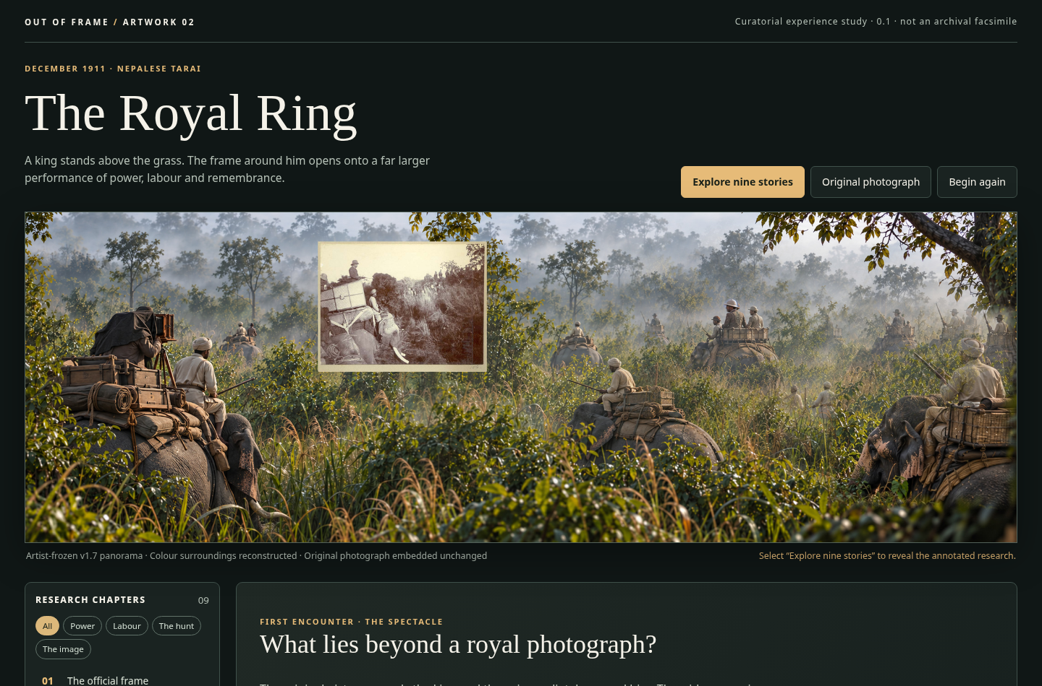
Figure 1. Initial visitor view: no markers, no imposed geometry, and no claim that the colour field is recovered film.
DECISION / 31 OCTOBER 2026
Accept Master Annotation Packet v0.5 as the current interpretive and research reference. Freeze the artwork at v1.7. Treat this digital prototype as an editorial and interaction study—not a public publication or a substitute for rights checks.

1 Research packet review
VERDICT · ADOPT WITH BOUNDED PUBLICATION CLEAN-UP
Master Annotation Packet v0.5 has a complete nine-part annotation system, a source register, and an explicit division between first encounter and explanatory discovery. It should remain the single source of truth for public annotation copy, with earlier v0.1–v0.4 packets archived as version history.

What is now authoritative
Content | Review result
GV-01 and original photographic source | The user-supplied 737 × 569 JPEG is fixed. The PNG master preserves its pixels at x1282–2018 and y128–696 (inclusive).
Nine GV-01–GV-09 cards | All have a public annotation, further context, evidence classifications, a location/scene anchor and restrictions on unsupported claims.
Three named participants | Chandra Shumsher, Duke of Teck and Ernest Brooks are treated with explicit B/D distinctions; Brooks is not credited with verified authorship of GV-01.
Audience interpretation | Recognition of the ring without explanation is not required; the annotations reveal the method.
Artwork state | The 4344 × 1448 v1.7 composition is frozen by artistic approval; no design changes to panorama are authorised here.

Editorial items before publication
- Merge or cross-reference R12 and R31, both of which point to the series-level working concept. Do not remove the underlying concept file.
- Keep the Duke’s T hotspot as a subsidiary story within GV-03, not a new tenth core card. Distinguish the guest’s documented attendance from his conjectured placement.
- Check external archive links, image reproduction rights, and the distinction between Herzog & Higgins album/studio credits and a specific frame’s photographer.
- Do not imply that publication-ready additional archival plates are already licensed. Related source links can be used while secondary images await permissions.

2 The visitor journey
Design principle: the artwork creates curiosity; the research changes what the viewer believes they are seeing. Do not force a single interpretation or label the image before it has been encountered.
Moment | Visitor sees / does | Meaning
01 · Encounter | Full-width frozen panorama without hotspot symbols; minimal curatorial introduction. | Spectacle, hierarchy, scale and atmosphere come first.
02 · Discover | Visitor elects to “Explore nine stories”; restrained numbered markers appear. | The person chooses to investigate rather than receiving a lecture.
03 · Investigate | Each marker opens the verbatim public annotation, plus optional evidence and sources. | The hidden histories of labour, politics, the hunt, animals and image-making emerge.
04 · Compare | Original photograph toggle isolates the unchanged GV-01 reproduction. | Boundary between archival evidence and artist reconstruction becomes tangible.
05 · Reflect | GV-09 returns the viewer to the afterlife of photographs and trophies. | The spectacle becomes a question about what society chose to commemorate.

Navigation and reading levels
The nine stories are not mandatory in sequence. Visitors can select any anchor, browse a numbered list, or filter by Power / Labour / The hunt / The image. Each card has three reading levels: “The story” (public text), “Evidence & limits” (research and cautions), and “Sources” (numbered references).
DEFAULT CURATORIAL TEXT
“A king stands above the grass. The frame around him opens onto a far larger performance of power, labour and remembrance.”
This intentionally withholds a hunting-ring explainer until the visitor chooses GV-03.

3 Interface proposal & example
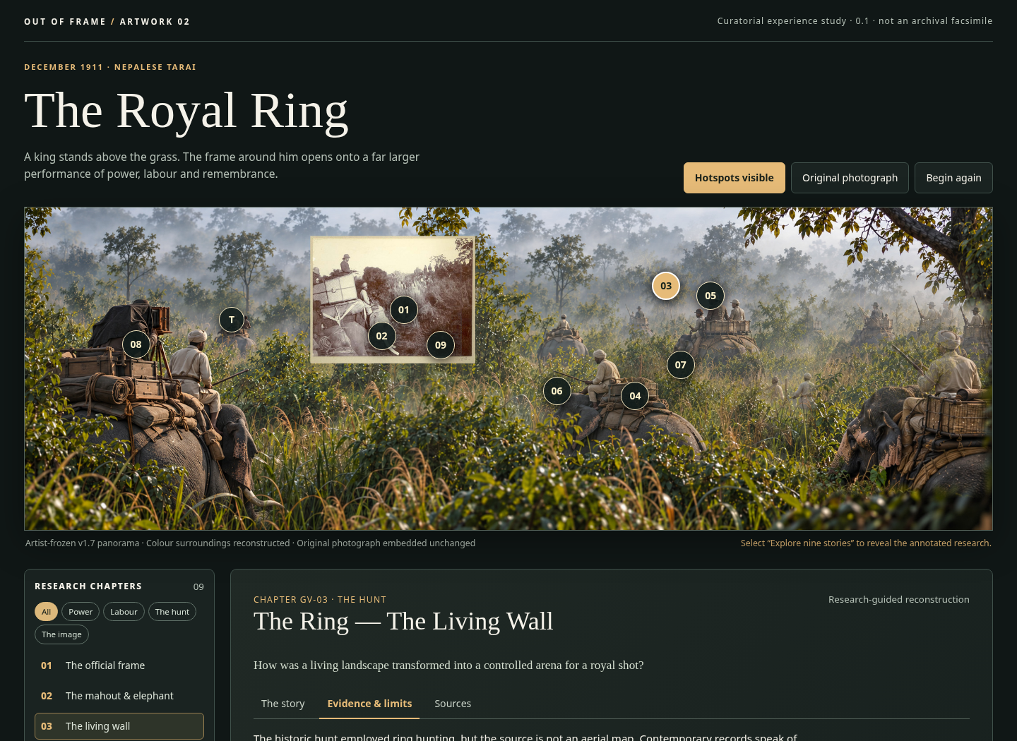
Figure 2. Selected GV-03 in the working browser prototype: a thin research overlay; explanatory material lives outside the artwork.

Interaction contract
- Initial hero is clean. The original art pixels are never repainted by interface labels; dots are an independent HTML overlay switched on by visitor action.
- Hotspot markers map the v0.5 interpretive anchors, not proven coordinates of people or animals on 18–28 December 1911.
- Selecting GV-03 explains the ring; the Duke’s optional “T” marker opens a named-guest clarification within that chapter.
- The “Original photograph” control switches to the authentic JPEG in isolation, rather than synthesising a wider sepia scene.
- GV-04, GV-06 and GV-09 can link to separate documentary material without inserting fictional trackers, tiger kills or trophy carcasses into the frozen panorama.

4 Nine stories and their best digital anchors
ID | Story | Anchor | Interpretive action
01 | The Royal View | Source rectangle | Compare original ↔ reconstructed surroundings
02 | The Mahout and Elephant | Head/rider inside original | Direct visibility versus missing personal credit
03 | The Living Wall | Mounted middle-distance arc | Explain ring technique; Duke T sub-story
04 | Trackers and Shikaris | Central vegetation / contextual link | Describe preparation; no invented named tracker
05 | The Host’s Power | Chandra, middle-right | Political authority, guest and host research
06 | Elephants as Infrastructure | Working tack and platforms | Elephant supply and care records
07 | The Tiger’s Ground | Concealed centre | Absence, animal agency, no fabricated tiger
08 | The Royal Image | Brooks at camera, left | Documented photographer; unproven frame authorship
09 | Commemorating Power | Original image + linked records | Trophy albums and afterlife of the shot

How much evidence should appear by default?
One or two sentences of interpretive disclosure belong in every opened card; grades A/B/C/D should be accessible with one action, not plastered over the art. Where a chapter contains both direct source observation (A) and imaginative placement (D), display them as separate claim statements rather than an overall “verified” badge.

Special handling of the three named figures
Chandra Shumsher: documented Nepalese host, but middle-right face/pose reconstructed. Duke of Teck: documented participant, but rear-left guest an artistic assignment. Ernest Brooks: documented photographic work in the expedition; the artist chooses him as GV-01 operator although the exposure remains unattributed. No portrait likeness is represented as independently authenticated.

5 Production & accessibility specification

Minimum working implementation
Area | Requirement
Art assets | Keep the untouched v1.7 lossless PNG as source of truth; use a compressed browser derivative for quick loading and the original george.jpg for source-only mode.
Content model | Store stable IDs GV-01–GV-09, headline, exact public annotation, research context, claim-level grades, restrictions, citation keys, theme and marker anchors.
Keyboard | Tab navigation across controls and hotspots, visible focus outlines, correct accessible labels, no essential hover-only information.
Small screens | Allow horizontal pan of the 3:1 image, plus the complete alternative chapter list; never make precise tapping the only way to find a story.
Sources | Open archival reference pages in a new tab, identify each institution, and mark links that lead to third-party websites.
Curatorial transparency | Provide a persistent explanation of original-versus-reconstruction, especially Brooks attribution and reconstructed positions.
Permissions | Do not embed newly retrieved archival photographs in public release until their reproduction conditions are checked.
Quality control | Test controls at 390px, 768px and desktop; verify 9 cards, Duke sub-story, source toggle, keyboard order, alt text and mobile scrolling.

Pre-publication gates
- An editorial review of all nine public annotation texts and every R-source URL.
- Rights review for the original reproduction, full-colour work and optional historical comparison plates.
- Accessible contrast and usability test with real people; comprehension testing measures the usefulness of annotations, not whether visitors already know the ring method.
- Final implementation can add zoom/pan, downloadable source citations, language support and image comparison; the current file is a standalone browser study.

6 Prototype handoff and approval notes

Included working artifacts
The_Royal_Ring_Interactive_Prototype_v0_1.html — self-contained browser file with the approved composition shown as a compressed JPEG display copy. It does not require a server, API or login. The controls switch to the exact original JPEG and display nine v0.5 annotation cards.
The_Royal_Ring_Digital_Prototype_v0_1.zip — packaged HTML, JSON annotation data, original george.jpg, frozen v1.7 lossless PNG and README. It is a design handoff, not a public exhibition deployment.
The_Royal_Ring_Research_Review_and_Digital_Experience_Spec_v0_1.docx — this editorial review and interaction specification.

What is deliberately not in v0.1
- No invented live identities, archival scan attribution or weather claims. The interface does not assert that the panorama is a recovered photograph.
- No additional archival plates, permissions-dependent imagery, reconstructed tiger, animated killing sequence or fabricated historical dialogue.
- No claim that a five-person blind-viewing study took place. The artist explicitly retired spontaneous ring recognition as an approval condition.

Recommended next decision
Approve the interaction concept—clean first view, optional nine research anchors, evidence layering and original-photo toggle—then review the public copy in context. The underlying master packet remains v0.5; digital experience changes should be versioned separately so they cannot silently alter historical research.
SOURCE ANCHORS
Master: Out_of_Frame_The_Royal_Ring_Master_Annotation_Packet_v0_5.docx (sections I–IX).
Frozen art: Royal_Ring_v1_7_Mechanical_Corrections.png (4344 × 1448 px).
Original: george.jpg (737 × 569 px; verified unchanged within v1.7).
ANU: https://openresearch-repository.anu.edu.au/items/4d892cf0-8720-4aa5-8199-172a9e00f0fc
Part III: https://www.oldindianphotos.in/2008/12/king-george-vs-hunting-in-nepal-in_28.html
Rookmaaker (2024): https://brill.com/display/book/9789004691544/BP000039.pdf

