ECE 441
Microprocessors
Instructor: Dr. Jafar Saniie
Teaching Assistant: Weidi Jia

Final Project Report:
MONITOR PROJECT
05/03/10

By: Malav Shah

Acknowledgement: I would like to thank Dr.Jafar Saniie, instructor of ECE 441 (Microcomputers) for designing the curriculum of the course which provided us with immense and deep understanding of 68000 microprocessor. I would also like to thank ECE 441 T.A, Weidi Jia for providing his input during the lab and giving support during the entire course work.

Table of Contents

Abstract 2
1-) Introduction 2
2-) Monitor Program 3
2.1-) Command Interpreter 4
2.1.1-) Flowchart 5
2.1.2-) 68000 Assembly Code 5

2.2-) Debugger Commands 6
A. HELP Command 6
B.MDSY Command 7
C.DECI Command 7
D. GOTO Command 8
E. QUIT Command 8
F. FILL Command 9
G. MOVE Command 10
H. MCHG Command 10

3) Conclusions 19
4) References 20

Abstract

Various 68000 simulators and assembler are available in the market which helps us to write program in 68K assembly language and display memory, address and data registers. 68000 Monitor Project allows user to perform basic debugging functions using command prompt window developed in the Easy 68K IDE and displays the contents of memory locations, data and address registers on monitor window.

1) Introduction

The objective of the project is to design monitor program written in 68000 assembly language programming. The monitor window allows us to write various command and should be able to execute basic debugger functions, such as memory display, memory sort, memory change, block fill, block move, Hex to Decimal conversion. Also, it permits us to do exception handling and move content of address and data register to the designated stack crated by user during the program and display on the monitor window.

First we will examine how the command interpreter works in detail and then we will describe how each debugger command is implemented each functions and the exceptions.
The entire code is given in appendix with local comments.

Prompt

Command Interpreter

Debugger Command

Monitor Display

2) Monitor Program

The 68K monitor program first display the prompt on the window and then when user enter the command on monitor window and if that command matches with the user defined command, go to command subroutine, and perform required task according to debugger function . A screenshot of monitor window with prompt is shown below.

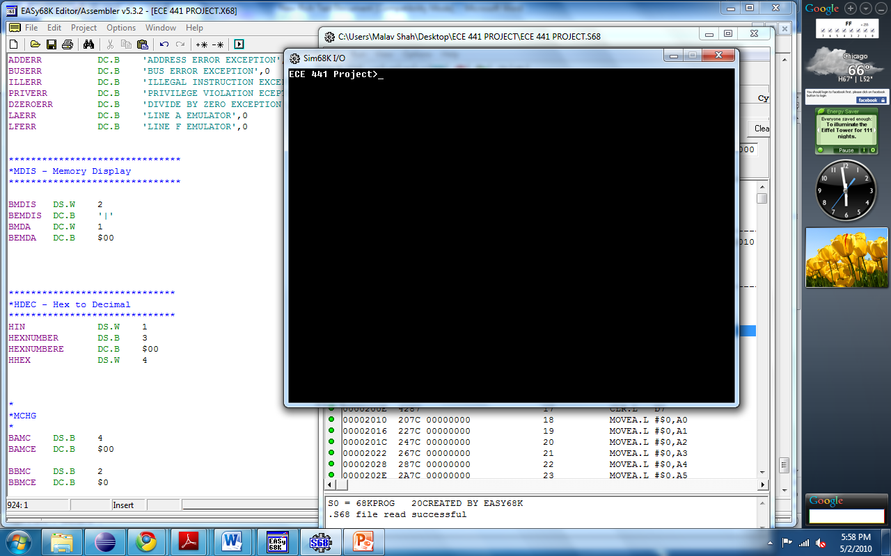

Figure 2.1. Monitor program-Prompt Window

2.1) Command Interpreter

The Command Interpreter identifies which command is entered and then branches to subroutine for executing particular command. It compares the input for all the commands in the command table and when there is no match, it displays an error message.
COMMAND TABLE is a pointer where ASCII code of each command names.
INPUT BUFFER is a buffer where the input command with the arguments is stored.
First, we clear all the address and data register.
Then we store the entire command line in INPUT BUFFER.
Then we make copy of command from INPUT buffer and store it into address register A2
We compare command with the ASCII code of that command in COMMAND TABLE; if there is match we jump to the command subroutine; if there is no match we compare command with the ASCII code of next command in COMMAND TABLE and if command is does not match any of the command’s ASCII code in the COMMAND TABLE then we display error message and jump back to beginning of command prompt.

2.1.1-)

Algorithm and Flowchart

Display Prompt
(ECE 441 PROJECT >)

Clear INPUT BUFFER, address
And data register

NO
Is space entered? Command start with
Space
Yes

Get command line and store
Into CMD BUFFER and copy

Is Command length including Yes Error message
Command line > 25?

No
Wrong Command
Is SPACE Yes
Or CR ?
No

Compare command If match
With ASCII code of command jump to command subroutine

Compare command with No
Next command ASCII code

Code for Command Interpreter:

ORG $2000

ORG $2000

* clear all data and address register
BEGIN CLR.L D0
CLR.L D1
CLR.L D2
CLR.L D3
CLR.L D4
CLR.L D5
CLR.L D6
CLR.L D7
MOVEA.L #$0,A0
MOVEA.L #$0,A1
MOVEA.L #$0,A2
MOVEA.L #$0,A3
MOVEA.L #$0,A4
MOVEA.L #$0,A5
MOVEA.L #$0,A6

LEA CMDPROMPT,A1 * display CMDPROMPT ECE 441 PROJECT>
MOVE.B #14,D0
TRAP #15

MOVE.B #5,D0 * enter space after CMDPROMPT
TRAP #15
MOVE.B #$20,D2 * check if space is entered or not
CMP D2,D1
BEQ IN * if space entered , input command
ERR2 LEA ERROR2,A1 * else error : Command start with space
MOVE.B #14,D0
TRAP #15
BRA BEGIN * CMDPROMPT again user

IN LEA INPUT,A1 * input command
LEA INPUTEND,A3
MOVE.B #2,D0
TRAP #15

CMLNT MOVE.B #25,D4 * check if commnad lenght inluding commnadline is more than 25 char
CMP D4,D1
BGT ERR3
ERR MOVEA.L A1,A2 * copy inputbuffer address to A2
CMPI.B #$00,(A2) * if byte at input buffer is 00 (no command entered)
BEQ ERR1 * dispaly error
CLR.L D5

******* GET COMMAND FROM INPUT BUFFER ***********
PLINE MOVE.B (A2)+,D5 ; move ascii code of command from input buffer to D5
CMPI.B #NULL,(A2) ; is it equal to NULL
BEQ ALLCMD ; if equal go to label ALLCMD
CMPI.B #SPACE,(A2) ; if not comapre with SPACE
BEQ ALLCMD ; if equal go to label ALLCMD
ROL.L #8,D5 ; rotate D5.L to get ASCII code of next command
CMPA.L A2,A3 ; if command address greater than end of command address
BGE PLINE ; back to PLINE to get next ASCII code of command

ERR3 LEA ERROR3,A1 * Dispaly Error Message if command lenght is more tahn 25
MOVE.B #14,D0
TRAP #15
BRA BEGIN

ALLCMD CMPI.L #HELPUPPERCASE,D5 ; Check if command is HELP
BEQ HELP ; jump to HELP subroutine
CMPI.L #helplowercase,D5
BEQ HELP
CMPI.L #MEMDISPLAY,D5 ; Check if command is MDSY
BEQ MDSY ; jump to MDSY subroutine
CMPI.L #mdisplylower,D5
BEQ MDSY
CMPI.L #HEXDEC,D5 ; check if command is DECI
BEQ HDEC ; jump to HDEC subroutine
CMPI.L #hexdeclower,D5
BEQ HDEC
CMPI.L #SORT,D5 ; check if it is SORT
BEQ SORTNUMBER
CMPI.L #sortlower,D5
BEQ SORTNUMBER
CMPI.L #BFILL,D5 ; check if it is BFILL
BEQ BFIL
CMPI.L #bfilllower,D5
BEQ BFIL
CMPI.L #MEMCHAGE,D5 ; check if it is MEMCHANGE
BEQ MEMORYCHG
CMPI.L #changelower,D5
BEQ MEMORYCHG
CMPI.L #BMOVE,D5 ; checj if it is MOVE
BEQ MOVE
CMPI.L #movelower,D5
BEQ MOVE
CMPI.L #QUITPROG,D5 ; check if it QUITPROG
BEQ EXIT
CMPI.L #quitlowercase,D5
BEQ EXIT
CMPI.L #GOCMD,D5 ; check if it is GOCMD
BEQ GOTO
CMPI.L #golower,D5
BEQ GOTO
BRA ERR1 ; if not match any command error1

ERR1 LEA ERROR1,A1
MOVE.B #14,D0
TRAP #15
BRA BEGIN
BRA BEGIN

2.2) Debugger Commands

A. HELP
Screenshot of HELP command

Help command displays all available command including HELP command.

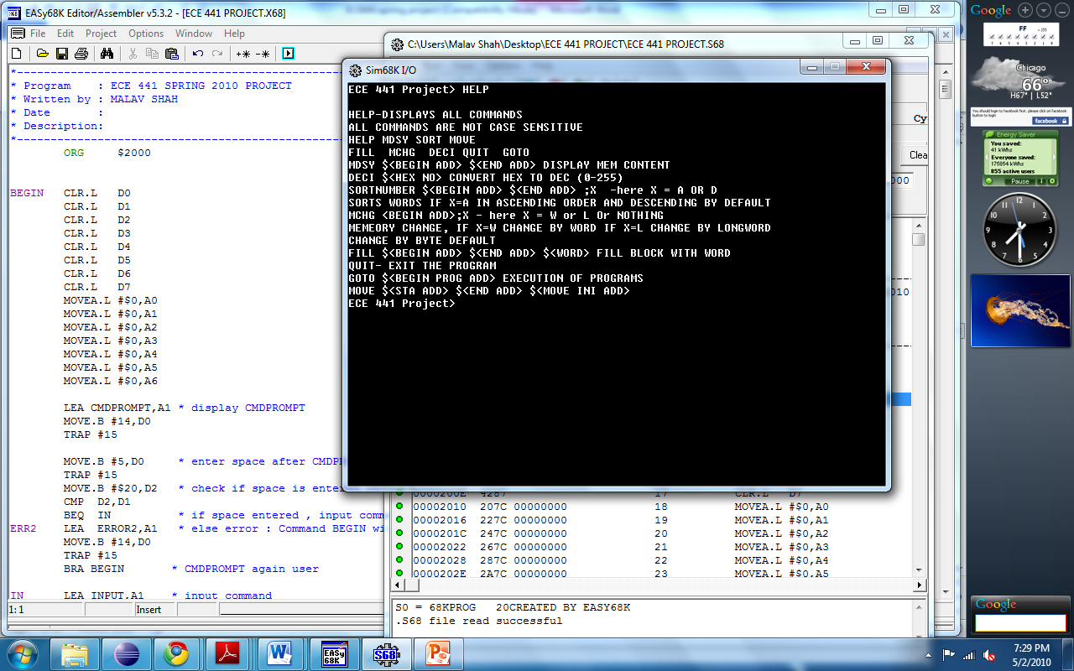

Compare ASCII code
of command match
HELP or help jump to HELP subroutine
Display all commands
No match

Compare with next
commnad

code for HELP subroutine:

************* HELP SUBROUTINE ************

HELP LEA CLF,A1
MOVE.B #14,D0
TRAP #15

LEA HELPALL,A1
MOVE.B #14,D0
TRAP #15

LEA NONECASE,A1
MOVE.B #14,D0
TRAP #15

LEA CMDLIST1,A1
MOVE.B #14,D0
TRAP #15

LEA CMDLIST2,A1
MOVE.B #14,D0
TRAP #15

LEA MDISPLAY,A1
MOVE.B #14,D0
TRAP #15

LEA HEXTODEC,A1
MOVE.B #14,D0
TRAP #15

LEA SORT1,A1
MOVE.B #14,D0
TRAP #15

LEA SORT2,A1
MOVE.B #14,D0
TRAP #15

LEA CHANGE,A1
MOVE.B #14,D0
TRAP #15

LEA CHANGE1,A1
MOVE.B #14,D0
TRAP #15

LEA CHANGE2,A1
MOVE.B #14,D0
TRAP #15

LEA BLOCKFILL,A1
MOVE.B #14,D0
TRAP #15

LEA QUIT,A1
MOVE.B #14,D0
TRAP #15

LEA GOCOMMAND,A1
MOVE.B #14,D0
TRAP #15

LEA BLOCKMOVE,A1
MOVE.B #14,D0
TRAP #15

BRA BEGIN

B. MDSY
The MDSP command outputs the address and memory contents from address1 to address2.
Here is the algorithm of this command:

after MDSY or mdsy command

Jump to GET ADDRESS subroutine
Compare if argument begin with SPACE
If not
Jump to error 1: Wrong command
Else compare with $
If not
Jump to error1
Else
Clear D4 and move ASCII code of first address
In to D4
Compare it with NULL
Jump to CHG4
Clear D0,D1,D2
Copy ASCII code of Address into D1
Rotate D1.L by 8
Jump to ASCIITOHEX subroutine
Compare with ASCII code
If match
Jump to HEX number subroutine to get HEX code
Move address to D0
Jump back to GETADDRESS subroutine and do same
Procedure for second address
Move second address to D0

Now, back to MDSY subroutine
Copy address from D0 to A4, A0
Jump to COMPAREADDRESS
If address is in program area (<=$3000)
Error: you are in program area
Else

Code for MDSY subroutine

************* Memory Display ****************

MDSY BSR GETADDRESS
MOVE.L D0,A4
MOVE.W A4,A0
BSR ADDRESSCOMPARE
BSR GETADDRESS
MOVE.L D0,A5
MOVE.W A5,A0
BSR ADDRESSCOMPARE
DIS MOVE.L A4,D0

LEA BMDIS,A3
BSR PNT4HX

MOVE.B (A4),D0
LEA BMDA,A3
BSR PNT2HX

LEA BMDIS,A1
MOVE.B #14,D0
TRAP #15

LEA BMDA,A1
LEA BEMDA,A3
MOVE.B #18,D0
TRAP #15

ADDA.L #1,A4
CMPA.L A4,A5
BGE DIS

BRA BEGIN

Screenshot of MDSY command

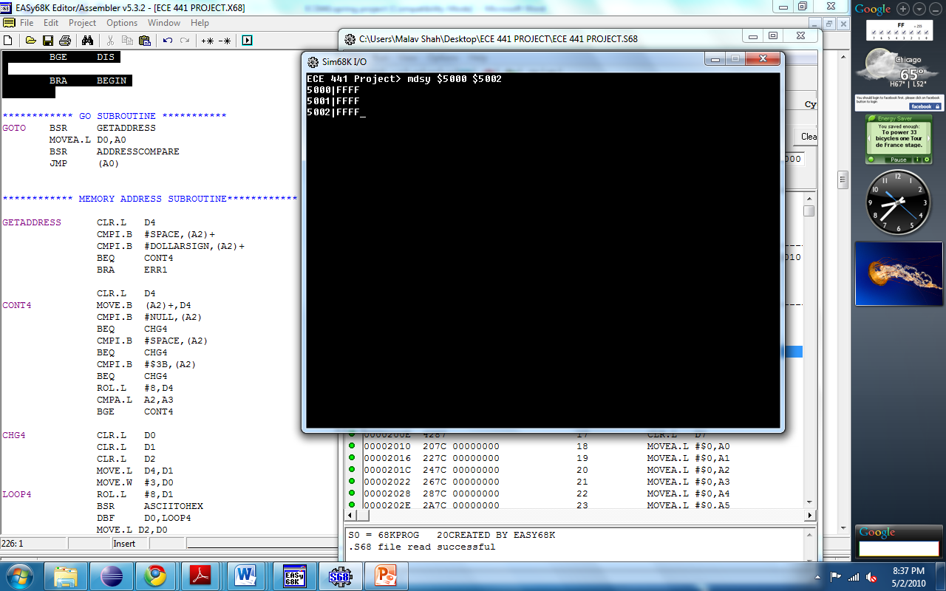

C. DECI

Code for DECI command (Hex to Decimal :0-255)

*********HEXTODEC SUBROUTINE********
HDEC CMPI.B #$20,(A2)+
CMPI.B #DOLLARSIGN,(A2)+
BEQ CONT3
BRA ERR1

CLR.L D4
CONT3 MOVE.B (A2)+,D4
CMPI.B #NULL,(A2)
BEQ CHG3
CMPI.B #SPACE,(A2)
BEQ CHG3
ROL.L #8,D4
CMPA.L A2,A3
BGE CONT3

CHG3 CLR.L D0
CLR.L D1
CLR.L D2
MOVE.B #$00,(HEXNUMBER)
MOVE.B #$00,(HEXNUMBER+1)
MOVE.B #$00,(HEXNUMBER+2)
MOVE.L D4,D1
MOVE.W D4,(HIN)
MOVE.W #3,D0
LOOP3 ROL.L #8,D1
BSR ASCIITOHEX
DBF D0,LOOP3
MOVE.L D2,D6

LEA HEXNUMBER,A1
BSR DECIMAL
CLR.L D1
LEA HEXNUMBER,A1
MOVE.B #18,D0
TRAP #15
BRA BEGIN

DECIMAL CLR.L D0 ;CLEAR D0, D1, D2
CLR.L D1
CLR.L D2

LEA HEXNUMBER,A4 ;MOVE STARING ADDRESS OF NUM A4
MOVE.B D6,D0 ;MOVE D6 TO D0
MOVE.B D6,D1 ;MOVE D6 TO D1

DIVU.W #100,D0 ;DIVIDE D0 BY 100 AND STORE IN D0
MOVE.B D0,(A4)+ ;MOVE D0 TO (A4) AND INCERMENT

MULS.W #100,D0 ;TIMES D0 BY 100 AND STORE IN D0
SUB.W D0,D1 ;SUBTRACT D1 BY D0
MOVE.B D1,D2 ;MOVE D1 TO D2
DIVU.W #10,D1 ;DIVIDE D1 BY 10
MOVE.B D1,(A4)+ ;MOVE D1 TO (A4) AND INCERMENT

MULS.W #10,D1 ;TIMES D1 BY TEN
SUB.W D1,D2 ;SUBTRACT D2 BY D1
MOVE.B D2,(A4)+ ;MOVE D2 IN (A4) AND INCERMENT

DEC2ASC LEA HEXNUMBER,A4 ;MOVE THE ADDRESS OF NUM TO A1
ADDI.B #$30,(A4)+ ;ADD $30 TO (A4) AND INCERMENT
ADDI.B #$30,(A4)+ ;ADD $30 TO (A4) AND INCERMENT
ADDI.B #$30,(A4)+

RTS

Screenshot of DECI command

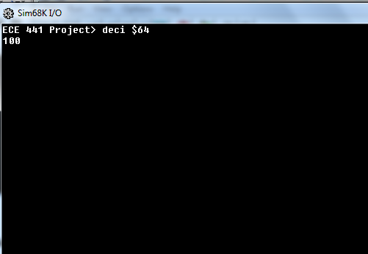

D. GOTO
Code for GOTO command

**** GO SUBROUTINE ***********
GOTO BSR GETADDRESS
MOVEA.L D0,A0
BSR ADDRESSCOMPARE
JMP (A0)

Screenshot of GOTO command

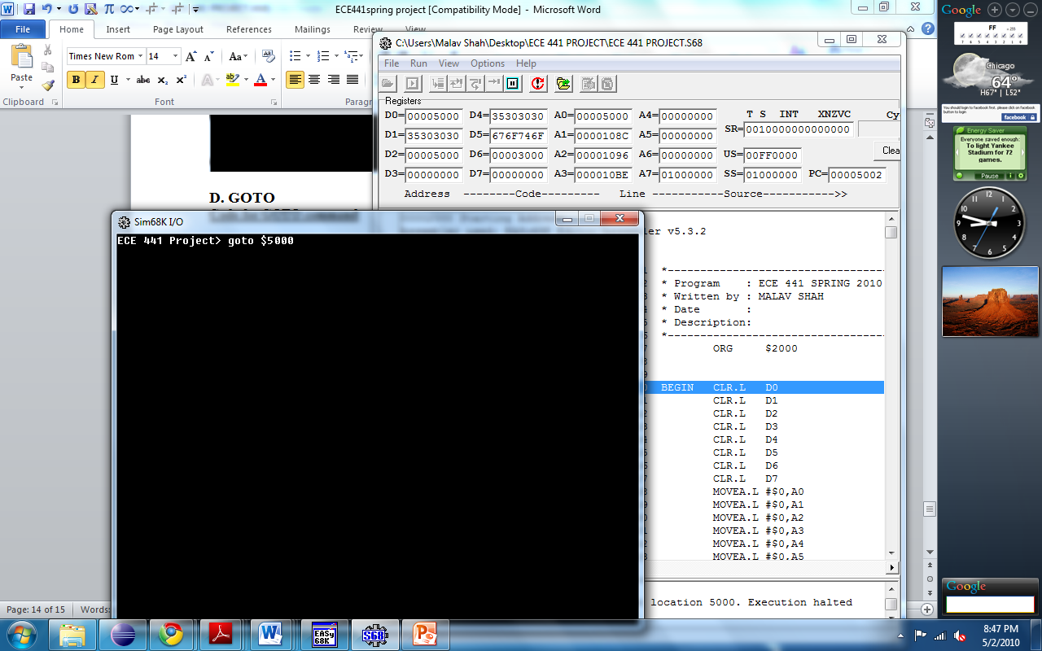

E. QUIT

Code of QUIT command

*********** EXIT PROGRAM ***********
EXIT MOVE.B #9,D0
TRAP #15

Screenshot of QUIT

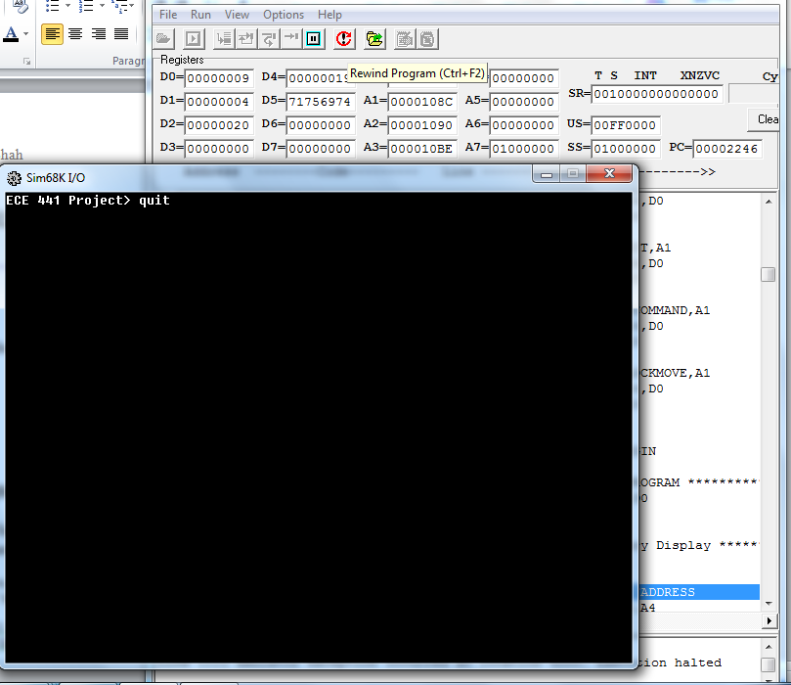

F. FILL

Code for FILL command

*** BLOCKFILL SUBROUTINE ****************************
BFIL BSR GETADDRESS
MOVE.L D0,A0
MOVE.W D0,D3
BSR ADDRESSCOMPARE

BSR GETADDRESS
MOVE.L D0,A1
MOVE.W A1,A0
BSR ADDRESSCOMPARE
MOVE.W D3,A0

CLR.L D4
CMPI.B #$20,(A2)+
CONT6 MOVE.B (A2)+,D4
CMPI.B #$00,(A2)
BEQ CHG5
CMPI.B #$20,(A2)
BEQ CHG5
CMPI.B #$3B,(A2)
BEQ CHG5
ROL.L #8,D4
CMPA.L A2,A3
BGE CONT6

CHG5 CLR.L D0
CLR.L D1
CLR.L D2
MOVE.L D4,D1
MOVE.W #3,D0
LOOP9 ROL.L #8,D1
BSR ASCIITOHEX
DBF D0,LOOP9
MOVE.L D2,D0

BFLOOP MOVE.W D0,(A0)+
CMPA.L A0,A1
BGE BFLOOP
BRA BEGIN

Screenshot of FILL

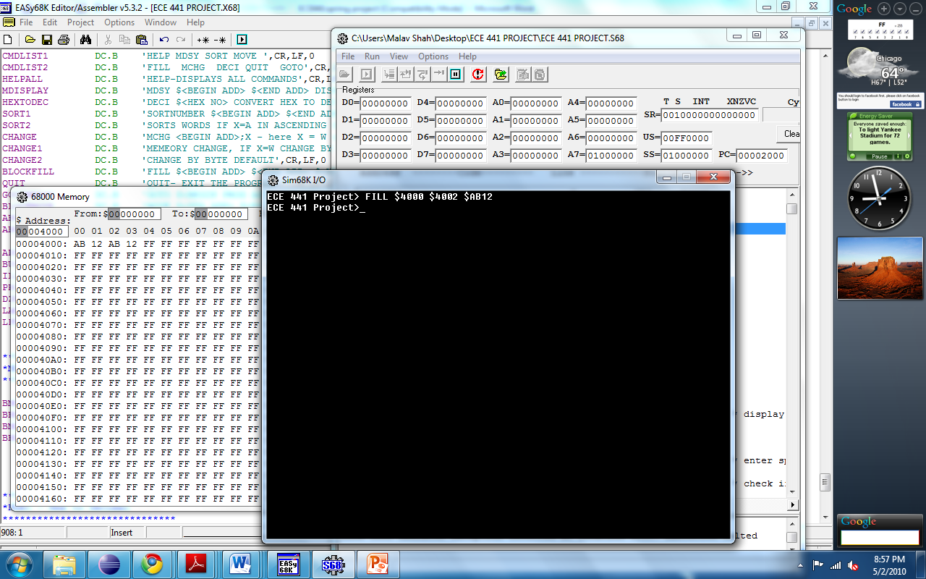

G. BLOCK MOVE

Code of MOVE command

********BLOCK MOVE SOUBROUTINE ******************************
MOVE BSR GETADDRESS
MOVE.L D0,A4
BSR GETADDRESS
MOVE.L D0,A5
BSR GETADDRESS
MOVE.L D0,A6

MOVE.L A4,D0
MOVE.L A5,D1
MOVE.B (A4),(A6)
CMPA A4,A5
BEQ BACK1
BACK ADD.L #$1,A4
ADD.L #$1,A6
MOVE.B (A4),(A6)
CMPA A4,A5
BEQ BACK1
JMP BACK

BACK1 BRA BEGIN

******** BLOCKFILL SUBROUTINE ****************************
BFIL BSR GETADDRESS
MOVE.L D0,A0
MOVE.W D0,D3
BSR ADDRESSCOMPARE

BSR GETADDRESS
MOVE.L D0,A1
MOVE.W A1,A0
BSR ADDRESSCOMPARE
MOVE.W D3,A0

CLR.L D4
CMPI.B #$20,(A2)+
CONT6 MOVE.B (A2)+,D4
CMPI.B #$00,(A2)
BEQ CHG5
CMPI.B #$20,(A2)
BEQ CHG5
CMPI.B #$3B,(A2)
BEQ CHG5
ROL.L #8,D4
CMPA.L A2,A3
BGE CONT6

CHG5 CLR.L D0
CLR.L D1
CLR.L D2
MOVE.L D4,D1
MOVE.W #3,D0
LOOP9 ROL.L #8,D1
BSR ASCIITOHEX
DBF D0,LOOP9
MOVE.L D2,D0

BFLOOP MOVE.W D0,(A0)+
CMPA.L A0,A1
BGE BFLOOP
BRA BEGIN

Screenshot of MOVE command

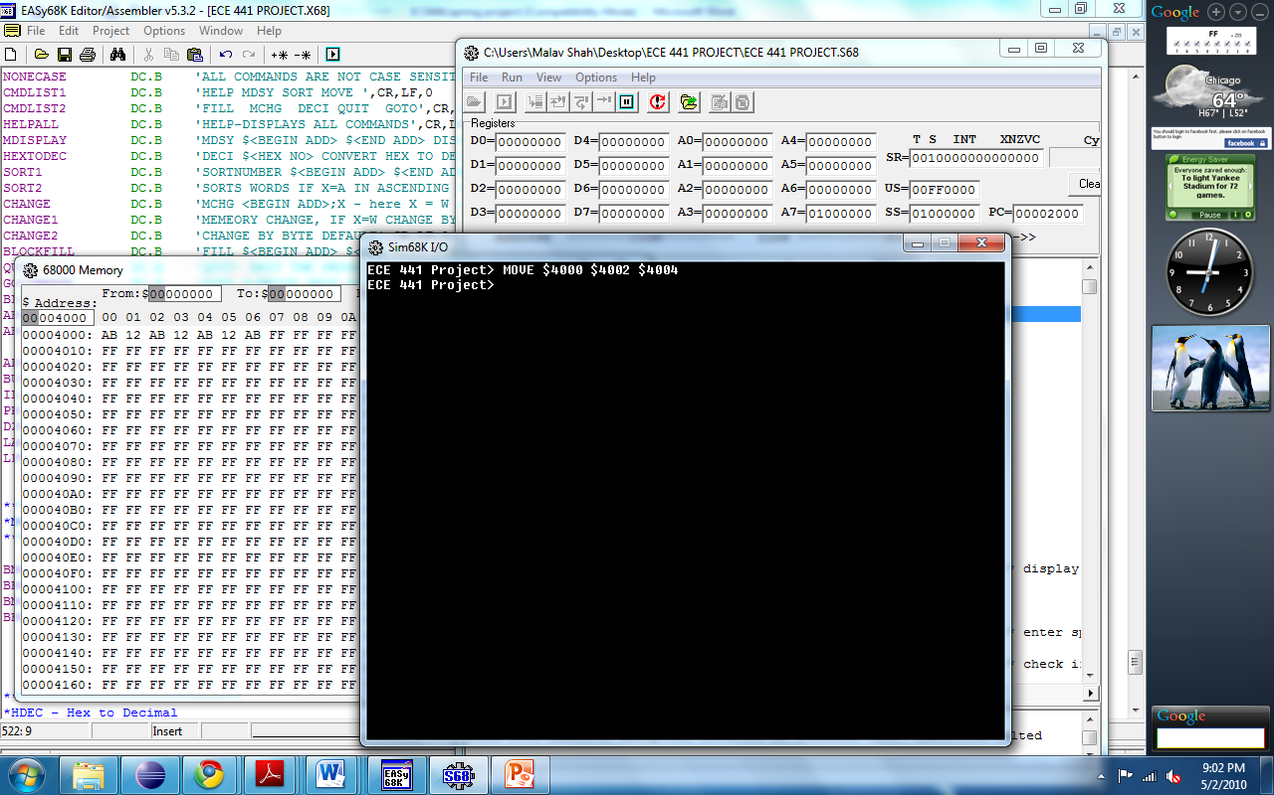

H.MCHG

Code for MCHG command

************MEMORY CHANGE SUBROUTINE***********************

MEMORYCHG BSR GETADDRESS
MOVEA.L D0,A0

CMPI.B #$3B,(A2)+
CMPI.B #$57,(A2)
BEQ WORD
CMPI.B #$4C,(A2)
BEQ LONG

REPB MOVE.L #$0,(BMCIN)
MOVE.L #$0,(BMCIN1)
MOVE.L A0,D0
MOVE.L A0,D6
LEA BAMC,A3
BSR PNT4HX
MOVE.B (A0)+,D0

LEA BBMC,A3
BSR PNT2HX

LEA BAMC,A1
MOVE.B #18,D0
TRAP #15

LEA BSPACE,A1
MOVE.B #14,D0
TRAP #15

LEA BBMC,A1
MOVE.B #18,D0
TRAP #15

LEA BFOR,A1
MOVE.B #14,D0
TRAP #15

LEA BMCIN,A1
MOVE.B #2,D0
TRAP #15

CMPI.L #$2E000000,(BMCIN)
BNE CHGB
BRA BEGIN

CHGB CLR.L D0
CLR.L D1
CLR.L D2
MOVE.W (BMCIN),D1
MOVE.W #3,D0
LOOP5 ROL.L #8,D1
BSR ASCIITOHEX
DBF D0,LOOP5
MOVE.L D2,D0
MOVEA.L D6,A1
MOVE.B D0,(A1)
BRA REPB

WORD MOVE.L $0,(BMCIN)
MOVE.L $0,(BMCIN1)
MOVE.L A0,D0
MOVE.L A0,D6
LEA BAMC,A3
BSR PNT4HX
MOVE.W (A0)+,D0

LEA BWMC,A3
BSR PNT4HX

LEA BAMC,A1
MOVE.B #18,D0
TRAP #15

LEA BSPACE,A1
MOVE.B #14,D0
TRAP #15

LEA BWMC,A1
MOVE.B #18,D0
TRAP #15

LEA BFOR,A1
MOVE.B #14,D0
TRAP #15

LEA BMCIN,A1
MOVE.B #2,D0
TRAP #15

CMPI.L #$2E000000,(BMCIN)
BNE CHGW
BRA BEGIN

CHGW CLR.L D0
CLR.L D1
CLR.L D2
MOVE.L (BMCIN),D1
MOVE.W #3,D0
LOOP6 ROL.L #8,D1
BSR ASCIITOHEX
DBF D0,LOOP6
MOVE.L D2,D0
MOVEA.L D6,A1
MOVE.W D0,(A1)
BRA WORD

LONG MOVE.L $0,(BMCIN)
MOVE.L $0,(BMCIN1)
MOVE.L A0,D0
MOVE.L A0,D6
LEA BAMC,A3
BSR PNT4HX
MOVE.L (A0)+,D0

LEA BLMC,A3
BSR PNT8HX

LEA BAMC,A1
MOVE.B #18,D0
TRAP #15

LEA BSPACE,A1
MOVE.B #14,D0
TRAP #15

LEA BLMC,A1
MOVE.B #18,D0
TRAP #15

LEA BFOR,A1
MOVE.B #14,D0
TRAP #15

LEA BMCIN,A1
MOVE.B #2,D0
TRAP #15

CMPI.L #$2E000000,(BMCIN)
BNE CHGL
BRA BEGIN

CHGL CLR.L D5
CLR.L D0
CLR.L D1
CLR.L D2
MOVE.L (BMCIN),D1
MOVE.W #3,D0
LOOP7 ROL.L #8,D1
BSR ASCIITOHEX
DBF D0,LOOP7
MOVE.L D2,D0
MOVE.W D0,D5
SWAP.W D5

CLR.L D0
CLR.L D1
CLR.L D2
MOVE.L (BMCIN),D1
MOVE.W #3,D0
LOOP8 ROL.L #8,D1
BSR ASCIITOHEX
DBF D0,LOOP8
MOVE.L D2,D0
MOVE.W D0,D5
MOVEA.L D6,A1
MOVE.L D5,(A1)
BRA LONG

Screenshot of MCHG command

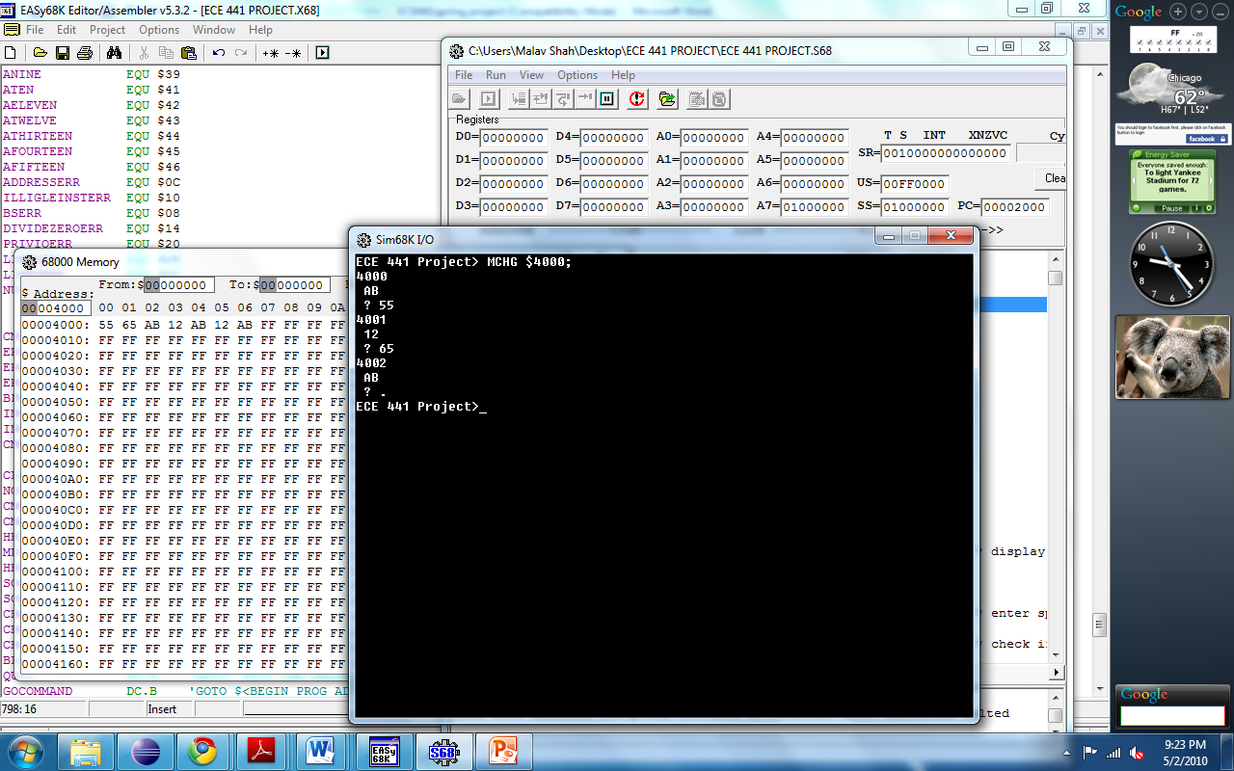

Complete Code
ORG $2000

* clear all data and address register
BEGIN CLR.L D0
CLR.L D1
CLR.L D2
CLR.L D3
CLR.L D4
CLR.L D5
CLR.L D6
CLR.L D7
MOVEA.L #$0,A0
MOVEA.L #$0,A1
MOVEA.L #$0,A2
MOVEA.L #$0,A3
MOVEA.L #$0,A4
MOVEA.L #$0,A5
MOVEA.L #$0,A6

LEA CMDPROMPT,A1 * display CMDPROMPT ECE 441 PROJECT>
MOVE.B #14,D0
TRAP #15

MOVE.B #5,D0 * enter space after CMDPROMPT
TRAP #15
MOVE.B #$20,D2 * check if space is entered or not
CMP D2,D1
BEQ IN * if space entered , input command
ERR2 LEA ERROR2,A1 * else error : Command start with space
MOVE.B #14,D0
TRAP #15
BRA BEGIN * CMDPROMPT again user

IN LEA INPUT,A1 * input command
LEA INPUTEND,A3
MOVE.B #2,D0
TRAP #15

CMLNT MOVE.B #25,D4 * check if commnad lenght inluding commnadline is more than 25 char
CMP D4,D1
BGT ERR3
ERR MOVEA.L A1,A2 * copy inputbuffer address to A2
CMPI.B #$00,(A2) * if byte at input buffer is 00 (no command entered)
BEQ ERR1 * dispaly error
CLR.L D5

******* GET COMMAND FROM INPUT BUFFER ***********
PLINE MOVE.B (A2)+,D5 ; move ascii code of command from input buffer to D5
CMPI.B #NULL,(A2) ; is it equal to NULL
BEQ ALLCMD ; if equal go to label ALLCMD
CMPI.B #SPACE,(A2) ; if not comapre with SPACE
BEQ ALLCMD ; if equal go to label ALLCMD
ROL.L #8,D5 ; rotate D5.L to get ASCII code of next command
CMPA.L A2,A3 ; if command address greater than end of command address
BGE PLINE ; back to PLINE to get next ASCII code of command

ERR3 LEA ERROR3,A1 * Dispaly Error Message if command lenght is more tahn 25
MOVE.B #14,D0
TRAP #15
BRA BEGIN

ALLCMD CMPI.L #HELPUPPERCASE,D5 ; Check if command is HELP
BEQ HELP ; jump to HELP subroutine
CMPI.L #helplowercase,D5
BEQ HELP
CMPI.L #MEMDISPLAY,D5 ; Check if command is MDSY
BEQ MDSY ; jump to MDSY subroutine
CMPI.L #mdisplylower,D5
BEQ MDSY
CMPI.L #HEXDEC,D5 ; check if command is DECI
BEQ HDEC ; jump to HDEC subroutine
CMPI.L #hexdeclower,D5
BEQ HDEC
CMPI.L #SORT,D5 ; check if it is SORT
BEQ SORTNUMBER
CMPI.L #sortlower,D5
BEQ SORTNUMBER
CMPI.L #BFILL,D5 ; check if it is BFILL
BEQ BFIL
CMPI.L #bfilllower,D5
BEQ BFIL
CMPI.L #MEMCHAGE,D5 ; check if it is MEMCHANGE
BEQ MEMORYCHG
CMPI.L #changelower,D5
BEQ MEMORYCHG
CMPI.L #BMOVE,D5 ; checj if it is MOVE
BEQ MOVE
CMPI.L #movelower,D5
BEQ MOVE
CMPI.L #QUITPROG,D5 ; check if it QUITPROG
BEQ EXIT
CMPI.L #quitlowercase,D5
BEQ EXIT
CMPI.L #GOCMD,D5 ; check if it is GOCMD
BEQ GOTO
CMPI.L #golower,D5
BEQ GOTO
BRA ERR1 ; if not match any command error1

ERR1 LEA ERROR1,A1
MOVE.B #14,D0
TRAP #15
BRA BEGIN

************* HELP SUBROUTINE ************

HELP LEA CLF,A1
MOVE.B #14,D0
TRAP #15

LEA HELPALL,A1
MOVE.B #14,D0
TRAP #15

LEA NONECASE,A1
MOVE.B #14,D0
TRAP #15

LEA CMDLIST1,A1
MOVE.B #14,D0
TRAP #15

LEA CMDLIST2,A1
MOVE.B #14,D0
TRAP #15

LEA MDISPLAY,A1
MOVE.B #14,D0
TRAP #15

LEA HEXTODEC,A1
MOVE.B #14,D0
TRAP #15

LEA SORT1,A1
MOVE.B #14,D0
TRAP #15

LEA SORT2,A1
MOVE.B #14,D0
TRAP #15

LEA CHANGE,A1
MOVE.B #14,D0
TRAP #15

LEA CHANGE1,A1
MOVE.B #14,D0
TRAP #15

LEA CHANGE2,A1
MOVE.B #14,D0
TRAP #15

LEA BLOCKFILL,A1
MOVE.B #14,D0
TRAP #15

LEA QUIT,A1
MOVE.B #14,D0
TRAP #15

LEA GOCOMMAND,A1
MOVE.B #14,D0
TRAP #15

LEA BLOCKMOVE,A1
MOVE.B #14,D0
TRAP #15

BRA BEGIN

*********** EXIT PROGRAM ***********
EXIT MOVE.B #9,D0
TRAP #15

************* Memory Display ****************

MDSY BSR GETADDRESS
MOVE.L D0,A4
MOVE.W A4,A0
BSR ADDRESSCOMPARE
BSR GETADDRESS
MOVE.L D0,A5
MOVE.W A5,A0
BSR ADDRESSCOMPARE
DIS MOVE.L A4,D0

LEA BMDIS,A3
BSR PNT4HX

MOVE.B (A4),D0
LEA BMDA,A3
BSR PNT2HX

LEA BMDIS,A1
MOVE.B #14,D0
TRAP #15

LEA BMDA,A1
LEA BEMDA,A3
MOVE.B #18,D0
TRAP #15

ADDA.L #1,A4
CMPA.L A4,A5
BGE DIS

BRA BEGIN

************ GO SUBROUTINE ***********
GOTO BSR GETADDRESS
MOVEA.L D0,A0
BSR ADDRESSCOMPARE
JMP (A0)

************ MEMORY ADDRESS SUBROUTINE************

GETADDRESS CLR.L D4
CMPI.B #SPACE,(A2)+
CMPI.B #DOLLARSIGN,(A2)+
BEQ CONT4
BRA ERR1

CLR.L D4
CONT4 MOVE.B (A2)+,D4
CMPI.B #NULL,(A2)
BEQ CHG4
CMPI.B #SPACE,(A2)
BEQ CHG4
CMPI.B #$3B,(A2)
BEQ CHG4
ROL.L #8,D4
CMPA.L A2,A3
BGE CONT4

CHG4 CLR.L D0
CLR.L D1
CLR.L D2
MOVE.L D4,D1
MOVE.W #3,D0
LOOP4 ROL.L #8,D1
BSR ASCIITOHEX
DBF D0,LOOP4
MOVE.L D2,D0

RTS

********** ASCII TABLE **********

ASCIITOHEX CMPI.B #NULL,D1
BEQ NOTZERO
CMPI.B #AZERO,D1
BEQ ZERO
CMPI.B #AONE,D1
BEQ ONE
CMPI.B #ATWO,D1
BEQ TWO
CMPI.B #ATHREE,D1
BEQ THRE
CMPI.B #AFOUR,D1
BEQ FOUR
CMPI.B #AFIVE,D1
BEQ FIVE
CMPI.B #ASIX,D1
BEQ SIX
CMPI.B #ASEVEN,D1
BEQ SEV
CMPI.B #AEIGHT,D1
BEQ OCT
CMPI.B #ANINE,D1
BEQ NINE
CMPI.B #ATEN,D1
BEQ TEN
CMPI.B #AELEVEN,D1
BEQ ELE
CMPI.B #ATWELVE,D1
BEQ TEW
CMPI.B #ATHIRTEEN,D1
BEQ THRT
CMPI.B #AFOURTEEN,D1
BEQ FORT
CMPI.B #AFIFTEEN,D1
BEQ FIVT

NOTZERO RTS

ZERO ROL.L #4,D2
ADDI.L #$00,D2
RTS
ONE ROL.L #4,D2
ADDI.L #$01,D2
RTS
TWO ROL.L #4,D2
ADDI.L #$02,D2
RTS
THRE ROL.L #4,D2
ADDI.L #$03,D2
RTS
FOUR ROL.L #4,D2
ADDI.L #$04,D2
RTS
FIVE ROL.L #4,D2
ADDI.L #$05,D2
RTS
SIX ROL.L #4,D2
ADDI.L #$06,D2
RTS
SEV ROL.L #4,D2
ADDI.L #$07,D2
RTS
OCT ROL.L #4,D2
ADDI.L #$08,D2
RTS
NINE ROL.L #4,D2
ADDI.L #$09,D2
RTS
TEN ROL.L #4,D2
ADDI.L #$A,D2
RTS
ELE ROL.L #4,D2
ADDI.L #$B,D2
RTS
TEW ROL.L #4,D2
ADDI.L #$C,D2
RTS
THRT ROL.L #4,D2
ADDI.L #$D,D2
RTS
FORT ROL.L #4,D2
ADDI.L #$E,D2
RTS
FIVT ROL.L #4,D2
ADDI.L #$F,D2
RTS

*********************************
*
* PRINT HEX ROUTINES
*
*
**********************************
*
PNT8HX SWAP D0 ;FLIP REG HALVES
BSR.S PNT4HX ;DO TOP WORD
SWAP D0 ;NOW DO LOWER WORD
BRA.S PNT4HX

PNT6HX SWAP D0 ;FLIP REGISTER HALVES
BSR.S PNT2HX
SWAP D0 ;FLIP BACK REG HALVES

PNT4HX MOVE.W D0,D1 ;SAVE IN TEMP
ROR.W #8,D0 ;GET BITS 15-8 INTO LOWER BYTE
BSR.S PNT2HX ;PRINT IT
MOVE.W D1,D0 ;PULL IT BACK

PNT2HX MOVE.W D0,D2 ;SAVE IN TEMP REG
ROXR.W #4,D0 ;FORM UPPER NIBBLE
BSR.S PUTHEX ;PUT ASCII INTO PRINT BUFFER
MOVE.W D2,D0 ;GET BACK FROM TEMP

PUTHEX ANDI.B #$0F,D0 ;SAVE LOWER NIBBLE
ORI.B #$30,D0 ;CONVERT TO ASCII
CMPI.B #$39,D0 ;SEE IF IT IS>9
BLE.S SAVHEX
ADD #7,D0 ;ADD TO MAKE 10=>A
SAVHEX MOVE.B D0,(A3)+ * CHANGE ;PUT IT IN PRINT BUFFER
RTS

*********HEXTODEC SUBROUTINE********
HDEC CMPI.B #$20,(A2)+
CMPI.B #DOLLARSIGN,(A2)+
BEQ CONT3
BRA ERR1

CLR.L D4
CONT3 MOVE.B (A2)+,D4
CMPI.B #NULL,(A2)
BEQ CHG3
CMPI.B #SPACE,(A2)
BEQ CHG3
ROL.L #8,D4
CMPA.L A2,A3
BGE CONT3

CHG3 CLR.L D0
CLR.L D1
CLR.L D2
MOVE.B #$00,(HEXNUMBER)
MOVE.B #$00,(HEXNUMBER+1)
MOVE.B #$00,(HEXNUMBER+2)
MOVE.L D4,D1
MOVE.W D4,(HIN)
MOVE.W #3,D0
LOOP3 ROL.L #8,D1
BSR ASCIITOHEX
DBF D0,LOOP3
MOVE.L D2,D6

LEA HEXNUMBER,A1
BSR DECIMAL
CLR.L D1
LEA HEXNUMBER,A1
MOVE.B #18,D0
TRAP #15
BRA BEGIN

DECIMAL CLR.L D0 ;CLEAR D0, D1, D2
CLR.L D1
CLR.L D2

LEA HEXNUMBER,A4 ;MOVE STARING ADDRESS OF NUM A4
MOVE.B D6,D0 ;MOVE D6 TO D0
MOVE.B D6,D1 ;MOVE D6 TO D1

DIVU.W #100,D0 ;DIVIDE D0 BY 100 AND STORE IN D0
MOVE.B D0,(A4)+ ;MOVE D0 TO (A4) AND INCERMENT

MULS.W #100,D0 ;TIMES D0 BY 100 AND STORE IN D0
SUB.W D0,D1 ;SUBTRACT D1 BY D0
MOVE.B D1,D2 ;MOVE D1 TO D2
DIVU.W #10,D1 ;DIVIDE D1 BY 10
MOVE.B D1,(A4)+ ;MOVE D1 TO (A4) AND INCERMENT

MULS.W #10,D1 ;TIMES D1 BY TEN
SUB.W D1,D2 ;SUBTRACT D2 BY D1
MOVE.B D2,(A4)+ ;MOVE D2 IN (A4) AND INCERMENT

DEC2ASC LEA HEXNUMBER,A4 ;MOVE THE ADDRESS OF NUM TO A1
ADDI.B #$30,(A4)+ ;ADD $30 TO (A4) AND INCERMENT
ADDI.B #$30,(A4)+ ;ADD $30 TO (A4) AND INCERMENT
ADDI.B #$30,(A4)+

RTS
*************BLOCK MOVE SOUBROUTINE ******************************
MOVE BSR GETADDRESS
MOVE.L D0,A4
BSR GETADDRESS
MOVE.L D0,A5
BSR GETADDRESS
MOVE.L D0,A6

MOVE.L A4,D0
MOVE.L A5,D1
MOVE.B (A4),(A6)
CMPA A4,A5
BEQ BACK1
BACK ADD.L #$1,A4
ADD.L #$1,A6
MOVE.B (A4),(A6)
CMPA A4,A5
BEQ BACK1
JMP BACK

BACK1 BRA BEGIN

******** BLOCKFILL SUBROUTINE ****************************
BFIL BSR GETADDRESS
MOVE.L D0,A0
MOVE.W D0,D3
BSR ADDRESSCOMPARE

BSR GETADDRESS
MOVE.L D0,A1
MOVE.W A1,A0
BSR ADDRESSCOMPARE
MOVE.W D3,A0

CLR.L D4
CMPI.B #$20,(A2)+
CONT6 MOVE.B (A2)+,D4
CMPI.B #$00,(A2)
BEQ CHG5
CMPI.B #$20,(A2)
BEQ CHG5
CMPI.B #$3B,(A2)
BEQ CHG5
ROL.L #8,D4
CMPA.L A2,A3
BGE CONT6

CHG5 CLR.L D0
CLR.L D1
CLR.L D2
MOVE.L D4,D1
MOVE.W #3,D0
LOOP9 ROL.L #8,D1
BSR ASCIITOHEX
DBF D0,LOOP9
MOVE.L D2,D0

BFLOOP MOVE.W D0,(A0)+
CMPA.L A0,A1
BGE BFLOOP
BRA BEGIN

********* SORTING SUBROUTINE****************************
SORTNUMBER BSR GETADDRESS
MOVEA.L D0,A0
BSR GETADDRESS
MOVEA.L D0,A1
MOVE.L A0,D0
MOVE.L A1,D1
CMPI.B #$20,(A2)+
BNE DSEND
CMPI.B #$3B,(A2)+
BNE DSEND
CMPI.B #$41,(A2)+
BEQ ASSEND

DSEND SUB.L D0,D1
DIVU #2,D1
MOVE.L D1,D0
ADD.L #4,D0
SUB.L #1,D1
MOVE.L D1,D4
MOVEA.L A1,A4
MOVEA.L A1,A5

MOVE.L A1,A6
BRA CAMP
SONEXT MOVE.L D4,D1
MOVEA.L A5,A6
MOVEA.L A5,A1
SUBA.L #2,A6

CAMP MOVE.W (A1),D2
MOVE.W (A6),D3
CMP.W D2,D3
BLE SWAP
SUBA.L #2,A6
SUBA.L #2,A1

MAYBE DBF D1,CAMP

DBF D0,SONEXT

BRA BEGIN

SWAP MOVE D3,(A1)
MOVE D2,(A6)
BRA MAYBE

ASSEND SUB.L D0,D1
DIVU #2,D1
MOVE.L D1,D0
ADD.L #4,D0
SUB.L #1,D1
MOVE.L D1,D4
MOVEA.L A1,A4
MOVEA.L A1,A5

MOVE.L A1,A6
BRA CAMPA
SANEXT MOVE.L D4,D1
MOVEA.L A5,A6
MOVEA.L A5,A1
SUBA.L #2,A6

CAMPA MOVE.W (A1),D2
MOVE.W (A6),D3
CMP.W D2,D3
BGE SWAPA
SUBA.L #2,A6
SUBA.L #2,A1

MAYBEA DBF D1,CAMPA

DBF D0,SANEXT

BRA BEGIN

SWAPA MOVE D3,(A1)
MOVE D2,(A6)
BRA MAYBEA

********* ADDRESS COMAPRE SUBROUTINE ************
ADDRESSCOMPARE CLR.L D6
MOVE.W #$3000,D6
CMPA D6,A0
BLE BFILERR
RTS
BFILERR LEA BFERR,A1
MOVE.B #14,D0
TRAP #15
BRA BEGIN

************MEMORY CHANGE SUBROUTINE***********************

MEMORYCHG BSR GETADDRESS
MOVEA.L D0,A0

CMPI.B #$3B,(A2)+
CMPI.B #$57,(A2)
BEQ WORD
CMPI.B #$4C,(A2)
BEQ LONG

REPB MOVE.L #$0,(BMCIN)
MOVE.L #$0,(BMCIN1)
MOVE.L A0,D0
MOVE.L A0,D6
LEA BAMC,A3
BSR PNT4HX
MOVE.B (A0)+,D0

LEA BBMC,A3
BSR PNT2HX

LEA BAMC,A1
MOVE.B #18,D0
TRAP #15

LEA BSPACE,A1
MOVE.B #14,D0
TRAP #15

LEA BBMC,A1
MOVE.B #18,D0
TRAP #15

LEA BFOR,A1
MOVE.B #14,D0
TRAP #15

LEA BMCIN,A1
MOVE.B #2,D0
TRAP #15

CMPI.L #$2E000000,(BMCIN)
BNE CHGB
BRA BEGIN

CHGB CLR.L D0
CLR.L D1
CLR.L D2
MOVE.W (BMCIN),D1
MOVE.W #3,D0
LOOP5 ROL.L #8,D1
BSR ASCIITOHEX
DBF D0,LOOP5
MOVE.L D2,D0
MOVEA.L D6,A1
MOVE.B D0,(A1)
BRA REPB

WORD MOVE.L $0,(BMCIN)
MOVE.L $0,(BMCIN1)
MOVE.L A0,D0
MOVE.L A0,D6
LEA BAMC,A3
BSR PNT4HX
MOVE.W (A0)+,D0

LEA BWMC,A3
BSR PNT4HX

LEA BAMC,A1
MOVE.B #18,D0
TRAP #15

LEA BSPACE,A1
MOVE.B #14,D0
TRAP #15

LEA BWMC,A1
MOVE.B #18,D0
TRAP #15

LEA BFOR,A1
MOVE.B #14,D0
TRAP #15

LEA BMCIN,A1
MOVE.B #2,D0
TRAP #15

CMPI.L #$2E000000,(BMCIN)
BNE CHGW
BRA BEGIN

CHGW CLR.L D0
CLR.L D1
CLR.L D2
MOVE.L (BMCIN),D1
MOVE.W #3,D0
LOOP6 ROL.L #8,D1
BSR ASCIITOHEX
DBF D0,LOOP6
MOVE.L D2,D0
MOVEA.L D6,A1
MOVE.W D0,(A1)
BRA WORD

LONG MOVE.L $0,(BMCIN)
MOVE.L $0,(BMCIN1)
MOVE.L A0,D0
MOVE.L A0,D6
LEA BAMC,A3
BSR PNT4HX
MOVE.L (A0)+,D0

LEA BLMC,A3
BSR PNT8HX

LEA BAMC,A1
MOVE.B #18,D0
TRAP #15

LEA BSPACE,A1
MOVE.B #14,D0
TRAP #15

LEA BLMC,A1
MOVE.B #18,D0
TRAP #15

LEA BFOR,A1
MOVE.B #14,D0
TRAP #15

LEA BMCIN,A1
MOVE.B #2,D0
TRAP #15

CMPI.L #$2E000000,(BMCIN)
BNE CHGL
BRA BEGIN

CHGL CLR.L D5
CLR.L D0
CLR.L D1
CLR.L D2
MOVE.L (BMCIN),D1
MOVE.W #3,D0
LOOP7 ROL.L #8,D1
BSR ASCIITOHEX
DBF D0,LOOP7
MOVE.L D2,D0
MOVE.W D0,D5
SWAP.W D5

CLR.L D0
CLR.L D1
CLR.L D2
MOVE.L (BMCIN),D1
MOVE.W #3,D0
LOOP8 ROL.L #8,D1
BSR ASCIITOHEX
DBF D0,LOOP8
MOVE.L D2,D0
MOVE.W D0,D5
MOVEA.L D6,A1
MOVE.L D5,(A1)
BRA LONG

*

********* LOOKUP TABLE **************

ORG $1000

STACK EQU $3000
STACKA0 EQU $3050
CR EQU $0D
SPACESIGN EQU $20
LF EQU $0A
SPACE EQU $20
DOLLARSIGN EQU $24

************ COMMAND TABLE **********

HELPUPPERCASE EQU $48454C50
helplowercase EQU $68656C70
MEMDISPLAY EQU $4D445359
mdisplylower EQU $6D647379
HEXDEC EQU $44454349
hexdeclower EQU $64656369
QUITPROG EQU $51554954
quitlowercase EQU $71756974
GOCMD EQU $474F544F
golower EQU $676F746F
BMOVE EQU $4D4F5645
movelower EQU $6D6F7665
BFILL EQU $46494C4C
bfilllower EQU $66696C6C
SORT EQU $534F5254
sortlower EQU $736F7274
MEMCHAGE EQU $4D434847
changelower EQU $6D636867

AZERO EQU $30
AONE EQU $31
ATWO EQU $32
ATHREE EQU $33
AFOUR EQU $34
AFIVE EQU $35
ASIX EQU $36
ASEVEN EQU $37
AEIGHT EQU $38
ANINE EQU $39
ATEN EQU $41
AELEVEN EQU $42
ATWELVE EQU $43
ATHIRTEEN EQU $44
AFOURTEEN EQU $45
AFIFTEEN EQU $46
ADDRESSERR EQU $0C
ILLIGLEINSTERR EQU $10
BSERR EQU $08
DIVIDEZEROERR EQU $14
PRIVIOERR EQU $20
LINEAERR EQU $28
LINEFERR EQU $2C
NULL EQU $00

CMDPROMPT DC.B 'ECE 441 Project>',0
ERROR1 DC.B 'AHA! Wrong Command',CR,LF,0
ERROR2 DC.B 'Command BEGIN with space',CR,LF,0
ERROR3 DC.B 'Hmm! You reached maximum command lenght',CR,LF,0
BFERR DC.B 'You are accessing program area',CR,LF,0
INPUT DS.B 50
INPUTEND DC.B $00
CMDBUF DS.B 10

CLF DC.B CR,LF,0
NONECASE DC.B 'ALL COMMANDS ARE NOT CASE SENSITIVE',CR,LF,0
CMDLIST1 DC.B 'HELP MDSY SORT MOVE ',CR,LF,0
CMDLIST2 DC.B 'FILL MCHG DECI QUIT GOTO',CR,LF,0
HELPALL DC.B 'HELP-DISPLAYS ALL COMMANDS',CR,LF,0
MDISPLAY DC.B 'MDSY $<BEGIN ADD> $<END ADD> DISPLAY MEM CONTENT',CR,LF,0
HEXTODEC DC.B 'DECI $<HEX NO> CONVERT HEX TO DEC (0-255)',CR,LF,0
SORT1 DC.B 'SORTNUMBER $<BEGIN ADD> $<END ADD> ;X -here X = A OR D',CR,LF,0
SORT2 DC.B 'SORTS WORDS IF X=A IN ASCENDING ORDER AND DESCENDING BY DEFAULT',CR,LF,0
CHANGE DC.B 'MCHG <BEGIN ADD>;X - here X = W or L Or NOTHING',CR,LF,0
CHANGE1 DC.B 'MEMEORY CHANGE, IF X=W CHANGE BY WORD IF X=L CHANGE BY LONGWORD',CR,LF,0
CHANGE2 DC.B 'CHANGE BY BYTE DEFAULT',CR,LF,0
BLOCKFILL DC.B 'FILL $<BEGIN ADD> $<END ADD> $<WORD> FILL BLOCK WITH WORD',CR,LF,0
QUIT DC.B 'QUIT- EXIT THE PROGRAM ',CR,LF,0
GOCOMMAND DC.B 'GOTO $<BEGIN PROG ADD> EXECUTION OF PROGRAMS',CR,LF,0
BLOCKMOVE DC.B 'MOVE $<STA ADD> $<END ADD> $<MOVE INI ADD>',CR,LF,0
ABUF DS.W 2
ABUFE DC.B $00

ADDERR DC.B 'ADDRESS ERROR EXCEPTION',0
BUSERR DC.B 'BUS ERROR EXCEPTION',0
ILLERR DC.B 'ILLEGAL INSTRUCTION EXCEPTION',0
PRIVERR DC.B 'PRIVILEGE VIOLATION ECEPTION',0
DZEROERR DC.B 'DIVIDE BY ZERO EXCEPTION',0
LAERR DC.B 'LINE A EMULATOR',0
LFERR DC.B 'LINE F EMULATOR',0

*******************************
*MDIS - Memory Display
*******************************

BMDIS DS.W 2
BEMDIS DC.B '|'
BMDA DC.W 1
BEMDA DC.B $00

******************************
*HDEC - Hex to Decimal
******************************
HIN DS.W 1
HEXNUMBER DS.B 3
HEXNUMBERE DC.B $00
HHEX DS.W 4

*
*MCHG
*
BAMC DS.B 4
BAMCE DC.B $00

BBMC DS.B 2
BBMCE DC.B $0

BWMC DS.W 2
BWMCE DC.B $00

BLMC DS.L 2
BLMCE DC.B $00

BFOR DC.B ' ? '
BFORE DC.B $00

BMCIN DS.L 1
BMCIN1 DS.L 1
BMCINE DC.B $00
BSPACE DC.B ' '
BSPACEE DC.B $00

END BEGIN ; last line of source

3) Conclusion
In this project, we manage to implement a simple monitor program with debugger commands and also the exception routines. The entire code is smaller than 3K as specified in the description of the project.

4) References

[1] J. Saniie, SANPER-1 Educational Lab Unit: User’s Manual and Lab Experiment”, Illinois Institute of
Technology, 1990
[2] “MC68000 Educational Computer Board User’s Manual”
[3] (1986) The EASY 68K IDE website. [Online]. Available: http://www.easy68k.com/

