Test Results

Case#1

test case #2 – R28<Primary>
input: 144444444444444444444444444444444444444444 + 1
results:
The test passed since the program will crash as expected
why?:
Program will crash not due to the procedure_Primary function but due to the lexical analyzer.
Since the long data type is treated as one token.

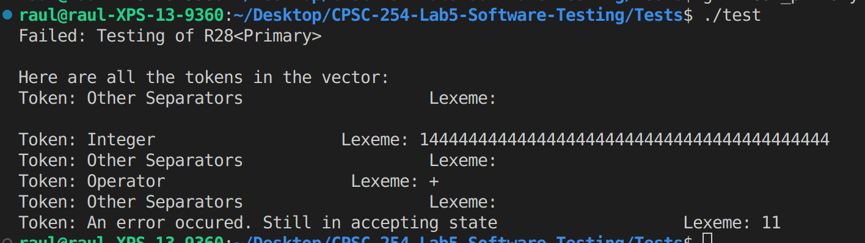

test case #3 – R13<IF>
input:
if(a>b && c==b)
{a=c;
return;}
results:
The test passed since the program will crash as expected
why?:
Program will crash not due to the procedure_If function but due to the lexical analyzer.
Since there are two conditions

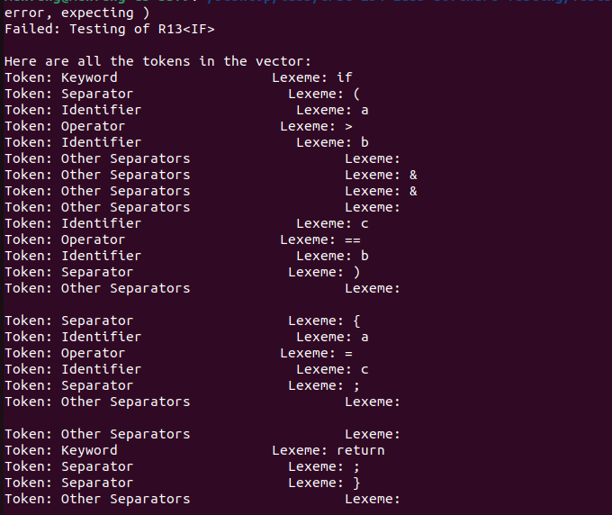

test case #4 – R9<While>
input:

