**Access Bonus Summary**

* Found on remittance advice (RA)

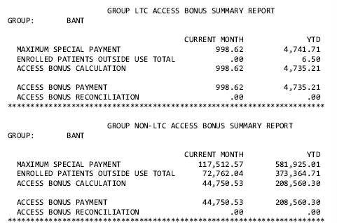

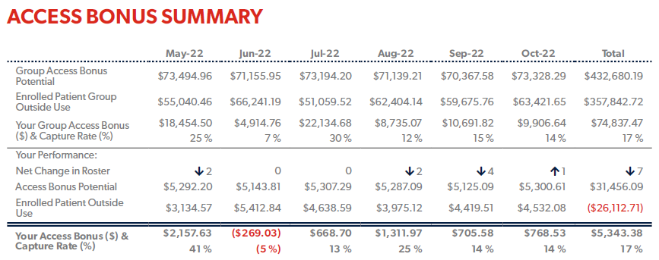

**Group’s performance:**

Group Access bonus potential = Maximum special payment (sum of both LTC and Non-LTC) from group (BANT in this case)

Enrolled patient group outside use = Enrolled patient outside use total (sum of both LTC and Non-LTC) from group (BANT in this case)

Your group access bonus $ = Access bonus payment (sum of both LTC and Non-LTC)

Your group access bonus % = Access bonus payment / Group Access bonus potential * 100%

**Your performance:**

Net change in roster = total number of enrolled patients (derived from roster list as XML)

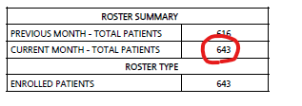

Access bonus potential = Maximum special payment (LTC + non LTC) found in Payment summary report for the individual provider (BANT-037699 in this case)

Enrolled patient outside use = Enrolled patients outside use total (LTC + non LTC)

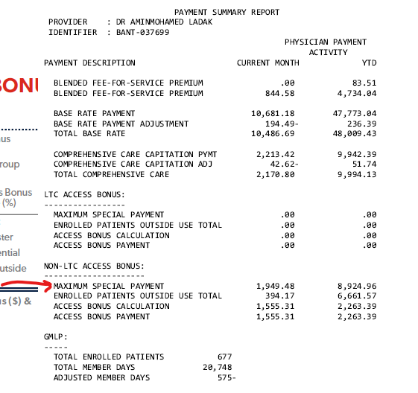

—

**Outside Use Report**

* Data found in OU - Raw
* Patient must be in the list of enrolled patients from the roster report, if they are not enrolled, do not include them
* Must be compiled from the first date they were rostered (found on the “Roster start column”)

HCN = health number

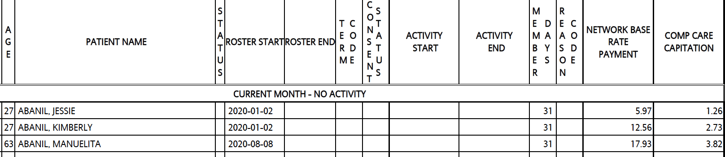

**Annual capitation** = sum(network base rate payment + comp care capitation) / member days * 365 days

Example: Abanil, Jessie = (5.97 + 1.26)/31 = 0.233225806451613 * 365 days = 85.12

This should be very close to the excel sheet of annual capitation when you look at the sum of BR and CC for this age and sex.

Example: Abanil, Jessie is 27 year old male:

Age BR CC

| 27 | 70.28 | 14.89 |
| --- | --- | --- |

= 85.17 – very close

Outside Use = total sum of all OU items in the OU report

Capitation = capitation days we would lose if we terminated this patient using formula below

Example:

Abanil, Jessie

Roster started 2020-01-02

Earliest outside use was 2023-10-11, latest date was 2023-10-16

End of the current cycle month 2023-10-31

One item in the enrolled inclusive billing A007A billed on 2023-10-12 (it is marked as 0.00 on the DCP sheet)

Capitation / day = 0.23 (see above)

Ideal end day for this patient is 1 day prior to the earliest OU date or earliest enrolled inclusive billing day, here in this case it is 10-11.

So you lose everything from 10-12 to 10-31 = 19 capitation days = 0.23 * 19 = $4.37 * -1 as you are considering the math of how much we will gain from terminating this patient

Capitation in this example = -$4.37

–

**Shadow billing top up** = total sum of enrolled inclusive billings

In the DCP file, these billings will be marked as $0 (these are called “in-basket” billings)

But they actually are paid out as 19.4% of the full value as “shadow billings”, however, if we terminate this patient, we are paid 100%, so the top up is 80.6%

To calculate the top up, we take all the codes and match them to their full value on the billing list:

<https://sgfp.ca/pages/168-2023-billing-guide>

A007 is marked zero, but actual value is $37.95

So in this example: top up = 37.95 * 0.806 = $30.5877

–

**% return** = (outside use + shadow billing top up) / total annual capitation

So for the above example: if the OU totaled to $100.00

% return = ($100 + $30.5877) / $85.12 *100% = 153% (rounded to nearest whole)

**Net revenue** = OU + capitation (negative value) + shadow billing top up

–

**Information on the right:**

List all OU service dates and codes on the side, and dates and service codes of enrolled inclusive codes on the right (e.g. in this example the Oct 12 A007 billing) as well

Recommended date to remove = only remove if the % return exceed 100%, otherwise don’t recommend removal and don’t bother listing here, if it exceeds 100% then recommend one day before the first day of outside use, or 1 day before the first date of billing in the DCP

In this example: Day to remove Jessie is Oct 12, 2023

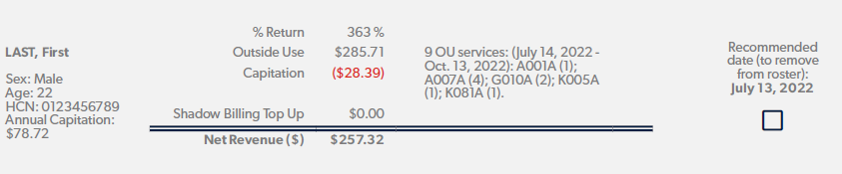

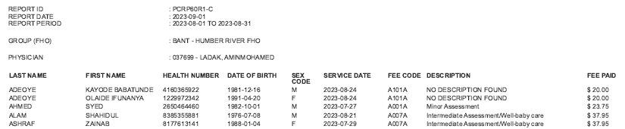

**FHO High Needs Use Summary**

We track your FFS billing on non rostered patients below. Remember, a FHO doctor is allotted $55,950.00 per fiscal year ($4662.50 per month) for FFS on non rostered patients.

FFS Hard Cap = Total $ since april 2022 is year to date (found in RA)

FFS cap amount = 55,950.00 or if threshold reduction is none, set to infinite as they are exempt (found in RA)

Good to calculate amount remaining which is = FFS cap amount minus year to date threshold reduction (found in RA)



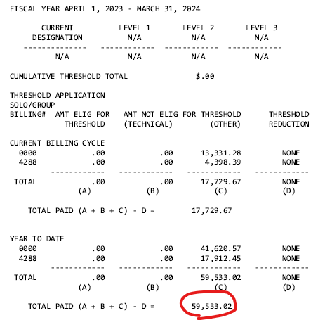

**Top Patients Contributing to High Needs**

All billings from DCP cumulatively contribute to this.

HCN = Health number

Full name = “

Annual capitation = from calculator based on age and sex

Shadow billing top up = 85% of the total billings on DCP

Capitation = Annual capitation - 19.4% of shadow billing from DCP - outside use

Net revenue = shadow billing top up + outside use

% return = net revenue / annual capitation * 100%

Double dipper = outside use amount total

Recommended date to remove = only remove if the % return exceed 100%, otherwise don’t recommend removal, if it exceeds 100% then recommend one day before the first day of outside use, or 1 day before the first date of billing in the DCP so long as the 85% top up is greater than the capitation amount (take annual / 365 days = daily capitation) accrued between this and the first OU event

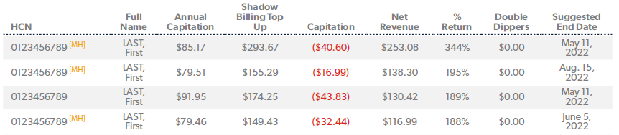

**Patient Monthly Access Percentage**

In person vs. virtual visits.

Look at DCP file and look at the number of K300/K301 codes, these codes are billed at the same time as another code to indicate what service was rendered virtually. Only visits without K300/K301 attached are non-virtual. Compute the % virtual = # of K300/K301 visits / total number of visits only for enrolled patients (e.g. patients on the Roster List).

**Out of Basket Report**

**DIABETES**

Fiscal year (first month ever recorded to present month, refresh every 12 months)

10.5% of roster size = optimal diabetes

Looking in DCP for K030A and Q040A codes, optimal amount for Q040 is number of K030A divided by 4

Value of K030 = 41.25 and Q040 = 61.20

One year timer starts for K030A after first K030. Every 4th visit K030A can be billed with Q040, list all patients with their latest Q040A service date and all K030A since that Q040. If no Q040 code since the last 3 x K030 **or** if Q040 code pre-dates the earliest of the last 3 x K030, suggest bill Q040 using the first of the last 3 K030A codes. If patient has 2 x K030A and requires only 1 more K030 within this year to be eligible for Q040 billing, suggest to recall patient.

**SMOKING CESSATION**

16% of roster size = optimal smoking cessation

Optimal ratio is K039:Q042:E079 1:1:0.5

Looking in DCP for E079 and K039 and Q042

Looking for patients with diagnostic code of 496

Eligible for initial discussion = number of patients with dx code 496 in dcp file * 15.85

Eligible for follow up visit = number of patient with E079 but no K039 * 34.10

Missed billing follow up visit add on = number of patients with K039 but without Q042 in the same date * 7.65

List all patients that meet this criteria in table

**Heart Failure**

Optimal ratio = 2% of roster size

Looking for patients with 410, 412, 413, 415, 426, 427, 428, 429 dx codes * 127.50

Looking for patients with past q050 that haven’t had one billed this year yet * 127.50

List table of patients

**General Education**

Fibromyalgia

Optimal = look for patients with dx code 795 or 726 * k037a

Actual = number of patients billed k037a

List table of patients

**Sexually transmitted disease**

Optimal = look for patients with dx 097, 098, 099, 100 who were not billed K028 * 69.10

Actual = number of patients billed K028

**Neurocognitive Assessment**

Optimal = look for patients with dx 850, 854 who were not billed K032 * 69.10

Actual = number of K032

**Out of basket general counselling (after 3 K013s)**

Optimal = look for patients with 3 x K013s in a year who who were billed a fourth k013 instead of K033 * 48.65

**Special Premium and Bonuses**

Year to date vs. maximum for all categories

**Intra FHO adjustment**

Take all DCPs, for all network college visits that paid out zero, calculate number for each enrolled provider and multiple by $35. Put in tabular form like:

Provider #: xxxxxx

| Network colleague | # of visits * $35 |
| --- | --- |
| xxxxxx |  |
| xxxxxx |  |
| … |  |

**Preventative Care Summary**

**Influenza Vaccine Targets enrolled patients who are 65+ years old as of December 31st and have received a flu vaccine by January 31st**

**Service Codes: G590A, Q690A, Q691A**

**Tracking code: Q130A (Use this code when your patient informs you that they have received their flu shot elsewhere)**

Report on % of patients that have the above criteria that do not have any of the service codes above by January 31st of every year.

**Pap Smear Targets enrolled female patients between the ages of 21 to 69 who are sexually active and have received a pap smear in the 3.5 years prior to March 31st**

G365A, L713A, L643A, E430A, E431A, Q678A,

○ Tracking code Q011A (Use this code when you receive the patient’s completed pap smear report)

○ Exclusion code Q140A (Exclusions apply for women who have had a hysterectomy, or who are being tested for cervical diseases that preclude regular screening Pap tests and also any female who is not sexually active)

Report on % of patients (Excluding any that have Q140A) that have the above criteria that do not have any of the service codes above by March 31, 2023.

**Mammography Targets enrolled female patients between the ages of 50 to 74 who have had a mammogram in the 2.5 years prior to March 31st**

X178A, X178B, X178C, X185A, X185B, X185C

Tracking code Q131A (Use this code when you receive the patient’s completed mammogram report)

Exclusion code Q141A(Exclusions apply for women who have had a mastectomy, or who are being treated for clinical breast disease)

Report on % of patients (Excluding any that have Q141A) that have the above criteria that do not have any of the service codes above by March 31, 2023.

**Childhood Immunizations Targets enrolled patients between the ages of 2.5 to 3.5 years old who have received all applicable immunizations by 2.5 years of age prior to March 31st**

G538A, Q688A, Q689A, G840A, G841A, G844A, G845A, G846A and G848A

○ Tracking code Q132A

Report on % of patients that have the above criteria by March 31, 2023.

**Colorectal Screening Targets enrolled patients between the ages of 50 to 74 who have completed a FIT/Fecal Occult Blood Test (FOBT) in the 2.5 years prior to March 31st**

G004A, L179A, L181A, Q700A

Tracking code Q133A (Use this code when you receive the patient’s completed colorectal screening report)

Exclusion code Q142A (Exclusions apply for patients with known cancer being followed by a physician; with known inflammatory bowel disease; who have had a colonoscopy within the last 10 years; with a history of malignant bowel disease; or with any disease requiring regular colonoscopies for surveillance purposes)

Report on % of patients (Excluding any that have Q142A) that have the above criteria that do not have any of the service codes above by March 31, 2023.

**Roster Management**

Roster size = total # of enrolled patients

Average capitation calculation = age / sex * total value on the annual cpaitation calculator.xlsx file

Roster summary =

Added in reporting period = difference from before this month and this month (negative if less)

Removed by MOH = total of patients with consent status = N

Removed by you = total of any reason code 01 -> 99

Net change = sum

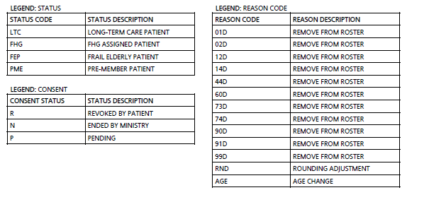

Reasons for termination:

12 Health Number error

14 Patient identified as deceased on ministry database

30 Pre-member / Assigned member ended; now enrolled or registered with photo health card

32 Pre-member / Assigned member ended; now enrolled or registered with photo health card

33 Termination reason cannot be released due to patient confidentiality

41 Patient no longer meets selection criteria for your roster - assigned to another physician

44 Physician ended patient enrolment

51 Patient no longer meets selection requirement for your roster

60 No current eligibility

73 No current eligibility

74 No current eligibility

90 Termination reason cannot be released due to patient confidentiality

91 Termination reason cannot be released due to patient confidentiality

List of patients removed by MOH

List of patients removed by you

List of patients who were added to your roster in this fiscal year

**Rejected Billing - Outstanding Errors**

Summary

* Total revenue outstanding due to rejection = sum of all rejection in all error reports

Outstanding Errors by Month

* Cumulative errors by month THIS CYCLE (e.g. how many old billings are still being rejected)

Outstanding Error by Error Code

* Top number of errors
* Take top 5 error codes

Rejected Billing By Error Explanation

<https://support.dr-bill.ca/en/articles/110016-ontario-physicians-ohip-error-codes>

Convert code to explanation above

List all patients in table format with rejected codes this cycle

**Executive RA Dashboard**

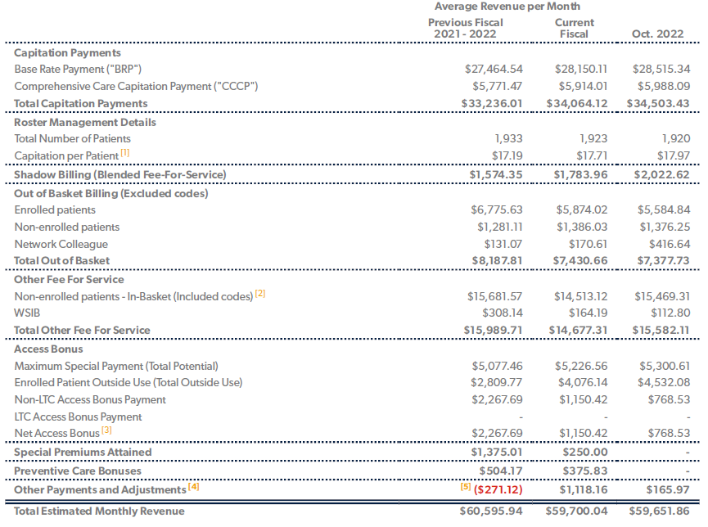

Pull values right from Individual RA Summary to get Average Revenue per Month