[Translated from Swedish to English - www.onlinedoctranslator.com](https://www.onlinedoctranslator.com/en/?utm_source=onlinedoctranslator&utm_medium=pdf&utm_campaign=attribution)



# Design Specification

FlavorFusion

<Student's Name>

ATTENTION! The section break must not be pushed over to the next page

1

2

## Table of Contents

1. **General information**
   1. Working title for the site
   2. The goal of the site
   3. The target group
   4. Content
2. **Structure**
   1. Which parts
   2. Sitemap
   3. Folder structure
3. **Layout and Design**
   1. Layout
   2. Design

3

1.

General information

1.1.Working title for the site

The site is deployed using netlify https://flavorfusions.netlify.app/

1.2.The goal of the site

This website is designed to provide a recipe interface to its visitor. Anyone can search for different foods items and get their recepi

1.3.The target group

Everyone Fond of Cooking

1.4.Content

This site is contented with Cooking Recipe Details

## 2.Structure

2.1.Which parts

There is a home introductory page with two call to actions. There is a food search part, Category wise search, ingredient wise search and also area wise search

2.2.Sitemap

“/” Home page

“/pages/searchbyname” Food search

“/pages/category” Category

“/pages/area” Area wise search

“/pages/ingredient” Ingredients wise search

1. 3.Folder structure

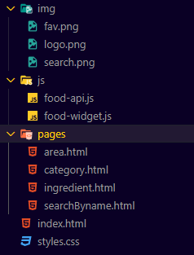

3.Layout and Design

1. 1.Layout

I mostly used flex-box for the layout of the website

3.2.Design

I used raw css for styling.

4