COMSATS UNIVERSITY ISLAMABAD
Lahore Campus | Department of Computer Science

Lab Assignment 1
BUS SEAT RESERVATION SYSTEM
Course: CSC241 – Object-Oriented Programming | Section / Session: BCS | Fall 2026
Instructor: Dr. Muhammad Shahid Bhatti | Total Marks: 10
Suggested Time: 60–75 minutes | Submission Deadline: 10/14/2026 2:32 PM
CLO-4 (CDF v4.0): Implement a small module utilizing Object-Oriented design. Bloom’s Level: C3 – Applying

1. Problem Scenario
A transport company operates buses between Lahore and Islamabad. The company currently manages passenger seat reservations manually and wants a simple Java program to manage the available and reserved seats.
Each bus contains rows of four passenger seats: two seats on the left, an aisle, and two seats on the right. Every seat has a seat number and a reservation status. When a passenger requests a seat, the program should reserve it if it is available. If it is already reserved, the program should display a suitable message. The company also wants to see the seating arrangement and how many seats remain available.
Develop this system using Java classes and objects. Use predefined seat reservations in main(); user input, a GUI, and a database are not required.

2. Required Classes
Seat — represents one passenger seat.
- Private attributes: seatNumber (int) and reserved (boolean).
- Constructor initializes the seat number; every new seat starts as available.
- Methods: reserve() attempts a reservation and returns true/false; isReserved() checks status; getSeatNumber() returns the number.
Bus — owns the collection of seats.
- Private attributes: busNumber (String) and seats (Seat[][]).
- Bus() creates a default bus with 2 rows and 4 seats per row.
- Bus(String busNumber, int rows) creates the named bus with the requested number of rows and 4 seats per row.
- The no-argument constructor must call the parameterized constructor with this(...).
- Methods: displaySeats(), reserveSeat(int seatNumber), and countAvailableSeats().
- The Bus constructor must create every Seat object using nested loops.
Main — contains main() and demonstrates all required operations.

3. Programming Requirements
- Composition: the Bus creates and contains its own Seat objects.
- Use a two-dimensional object array (Seat[][]) and nested-loop iteration.
- Demonstrate overloaded constructors and constructor chaining using this(...).
- Keep fields private. Implement the public methods shown in the UML diagram.
- Use seat numbers from 1 onward; every row contains exactly 4 seats.

4. Student Tasks
- Create bus BUS-101 with 3 rows of 4 seats (12 seats total).
- Initialize all Seat objects in the 2D array and number the seats sequentially from 1.
- Display the initial seating arrangement and the initial number of available seats.
- Reserve seat numbers 2, 6, and 11.
- Attempt to reserve seat number 6 again; show that it is already reserved.
- Display the updated seating arrangement and the number of available seats.
- Create a second bus with Bus() and display its seats to prove the default constructor works.

5. UML Class Diagram
Implement the classes, attributes, constructors, and public method signatures shown below. The filled diamond at the Bus end indicates composition: a Bus creates and owns its Seat objects.
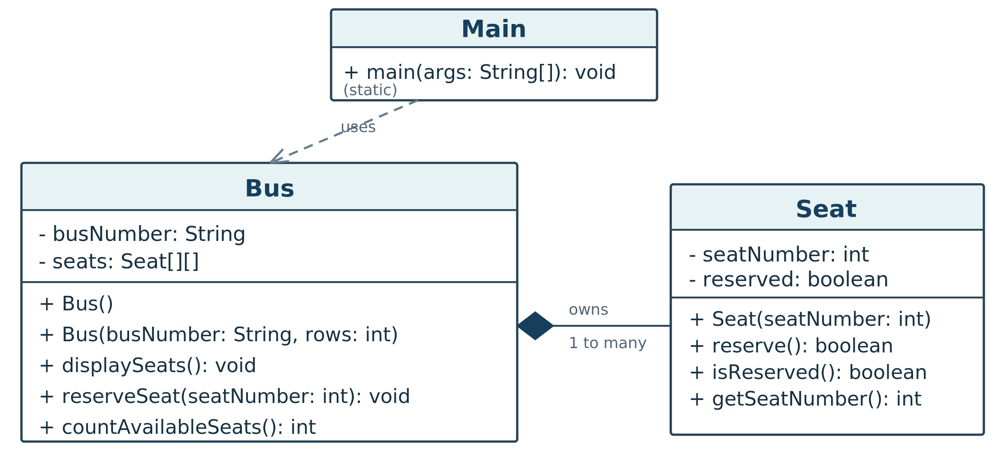
Figure 1. UML class diagram for the Bus Seat Reservation System (+ public; - private).

6. Required Console Output (Sample Run)
Use the console output as the required behavior of your program. Decide which operations should be implemented inside Bus and Seat. Do not print a hard-coded seating map or hard-code availability counts; compute both using the 2D Seat array.
Legend: O = Available, X = Reserved, || = Aisle. Display numbered seats; show the correct status after each reservation. Keep the same sequence and results as below.
Bus Number: BUS-101
Initial Seating Arrangement:
Row 1: 01:O 02:O || 03:O 04:O
Row 2: 05:O 06:O || 07:O 08:O
Row 3: 09:O 10:O || 11:O 12:O
Available Seats: 12
Reserving Seat 2: Successful
Reserving Seat 6: Successful
Reserving Seat 11: Successful
Reserving Seat 6: Already Reserved
Updated Seating Arrangement:
Row 1: 01:O 02:X || 03:O 04:O
Row 2: 05:O 06:X || 07:O 08:O
Row 3: 09:O 10:O || 11:X 12:O
Available Seats: 9
Default Bus:
Row 1: 01:O 02:O || 03:O 04:O
Row 2: 05:O 06:O || 07:O 08:O
Available Seats: 8

7. Suggested Structure for Main.java
The starter below shows the expected order of calls and output. Implement the Seat and Bus classes yourself. In particular, reserveSeat() should print success/failure messages, while countAvailableSeats() returns the computed integer.
public class Main {
public static void main(String[] args) {
Bus bus = new Bus("BUS-101", 3);
System.out.println("Bus Number: BUS-101");
System.out.println("Initial Seating Arrangement:");
bus.displaySeats();
System.out.println("Available Seats: " + bus.countAvailableSeats());

bus.reserveSeat(2);
bus.reserveSeat(6);
bus.reserveSeat(11);
bus.reserveSeat(6);

System.out.println("Updated Seating Arrangement:");
bus.displaySeats();
System.out.println("Available Seats: " + bus.countAvailableSeats());

Bus defaultBus = new Bus();
System.out.println("Default Bus:");
defaultBus.displaySeats();
System.out.println("Available Seats: " + defaultBus.countAvailableSeats());
}
}

8. Evaluation Rubric
Assessment Component | Marks
Code: class design, composition, constructors, arrays, and reservation logic | 7
Output: correct results and successful live demonstration | 3
TOTAL | 10

9. Live Demonstration and ZIP Submission
Each student must compile and run the program in the lab. Be prepared to explain the 2D array, composition, constructor chaining, and how seat availability is calculated. The instructor may request a small change during the demonstration.
Upload ONE ZIP archive containing a folder with your complete Java source files. Keep Seat.java, Bus.java, and Main.java together in that folder so the program can be compiled and run. Do not submit individual .java files separately.
ZIP filename: CSC241_LabAssignment1_RegistrationNumber.zip
ZIP folder structure (example):
CSC241_LabAssignment1_FA26-BCS-001.zip
CSC241_LabAssignment1_FA26-BCS-001/
Seat.java
Bus.java
Main.java
Google Form submission link: https://forms.gle/kParWXt8jXU19rC37
Reminder: Both the live demonstration and upload of the complete ZIP archive are required.

