CSC241

Lecture 02: Advantages of OOP &
the Modern Java Landscape
Detailed Student Notes
Fall 2026 | Department of Computer Science
COMSATS University Islamabad, Lahore Campus
________________________________________
Dr. Muhammad Shahid Bhatti
Assistant Professor | Office H-17
Scope note: Lecture 1 already established programming paradigms and the motivation for OOP. These notes retain only a short bridge on OOP advantages and focus mainly on the Java platform, toolchain, bytecode, JVM execution, portability, JDK/LTS concepts, IDEs, Git, and the source-to-execution pipeline.

Course repository: github.com/mshahidbhatti/CSC241-OOP

Lecture Guide
Section | Topic
1 | Lecture scope and learning outcomes
2 | OOP advantages - a short carry-forward
3 | APIs and frameworks in modern software
4 | The Java technology landscape
5 | Java language and Java SE platform
6 | JVM and JRE concepts
7 | JDK and core development tools
8 | Java source-to-execution pipeline
9 | Bytecode, class loading, interpretation and JIT
10 | Portability: why class files can run across platforms
11 | JDK/LTS cycle, IDEs, Git and GitHub workflow
12 | Live-code examples and diagnostic demonstrations
13 | Common misconceptions
14 | Review questions and quick practice
15 | Lecture summary

1. Lecture scope and learning outcomes
The formal lecture-wise plan places Lecture 2 in Week 1 under the topic Advantages of OOP & the Modern Java Landscape. Its scope includes reusability, maintainability and scalability; OOP in APIs and frameworks; the JDK/LTS release cycle and mainstream IDEs; the Java language, Java SE, JVM, JRE concept and JDK toolchain; and the source-to-execution pipeline from Java source through compilation, bytecode, class loading and JVM execution.
This lecture also supports the CDF emphasis on understanding the evolution and advantages of OOP while keeping the detailed construction of classes and objects for the following lecture.

Learning outcomes
- Differentiate the Java programming language, Java SE platform, JVM, JRE concept, and JDK.
- Trace a Java program from a .java source file to a .class bytecode file and then to JVM execution.
- Explain how standardized bytecode and platform-specific JVM implementations support portability.
- Recognize the purpose of important JDK tools such as javac, java, javap, jar, jshell, javadoc, and jdb.
- Distinguish compile-time failures from runtime failures.
- Explain how an IDE, JDK, Git, and GitHub fit together in a practical Java development workflow.
- Explain why an LTS JDK is usually a sensible baseline for a semester-long teaching environment.
Boundary with Lecture 3: Do not treat this lecture as the formal introduction to class anatomy, object instantiation, fields, methods, this, object identity/state, or reference assignment. Those topics belong to Lecture 3. Tiny Java classes are used here only as vehicles for understanding the Java platform and toolchain.

2. OOP advantages - a short carry-forward
Lecture 1 explained why software development moved beyond purely procedural organization. Lecture 2 keeps only the practical consequences that motivate the Java ecosystem.
Design goal | Practical meaning
Reusability | Use a stable abstraction or component in multiple places instead of solving the same problem repeatedly.
Maintainability | Keep a rule or responsibility in one clear location so a change affects fewer parts of the system.
Scalability | Partition a growing codebase into components with focused responsibilities and explicit boundaries.
Testability | Focused components can be verified in smaller units, making faults easier to isolate.
Extensibility | A stable contract allows new variants or capabilities to be added with less disruption to existing clients.

Important: Using the class keyword does not automatically produce reusable or maintainable software. These benefits depend on good responsibility assignment, meaningful abstractions, and clear public contracts.

3. APIs and frameworks in modern software

3.1 API: your code calls a public contract
An Application Programming Interface (API) exposes types and operations that client code can use without knowing the internal implementation. In Java, familiar examples include String, LocalDate, List, Path, and many other standard library types.
- The client depends on the public contract rather than the hidden implementation.
- The implementation can change internally if the public behavior remains compatible.
- This separation supports reuse and maintainability.
Example: reuse the LocalDate API
import java.time.LocalDate;
public class DeadlineDemo {
public static void main(String[] args) {
LocalDate today = LocalDate.now();
LocalDate quiz = today.plusDays(7);
LocalDate assignment = today.plusDays(14);
System.out.println("Today: " + today);
System.out.println("Quiz: " + quiz);
System.out.println("Assignment: " + assignment);
}
}

Think about it: The program does not implement leap-year rules, month lengths, or year transitions. Those details are hidden behind a meaningful API. This is practical reuse and abstraction.

3.2 Framework: the framework can call your code
A framework provides reusable application structure and controls part of the program lifecycle. Instead of your code always calling a library, the framework may invoke your objects at defined extension points. This inversion of control is common in web, GUI, testing, and enterprise frameworks.
Conceptual contrast: Library/API: your code calls it. Framework: it often controls the lifecycle and calls your application-specific code.

4. The Java technology landscape
The word “Java” is overloaded. Beginners often mix several distinct concepts. Keeping the layers separate makes installation, compilation, debugging, and execution much easier to understand.
Term | Meaning
Java language | The source-level rules: syntax, types, expressions, statements, classes, interfaces, and compile-time language rules.
Java SE | The standard Java platform and its standard APIs, such as java.lang, java.util, java.time, java.io/java.nio, java.net, and java.sql.
JVM | The virtual-machine specification/runtime execution model for class files and bytecode.
JRE concept | Conceptually, the runtime environment: JVM plus runtime libraries and supporting components needed to run Java applications.
JDK | The developer kit: compiler, launcher/runtime, inspection tools, packaging tools, documentation tools, debugger, and related utilities.
Java ecosystem | IDEs, build tools, libraries, frameworks, testing tools, Git integrations, and other tools surrounding the language and platform.

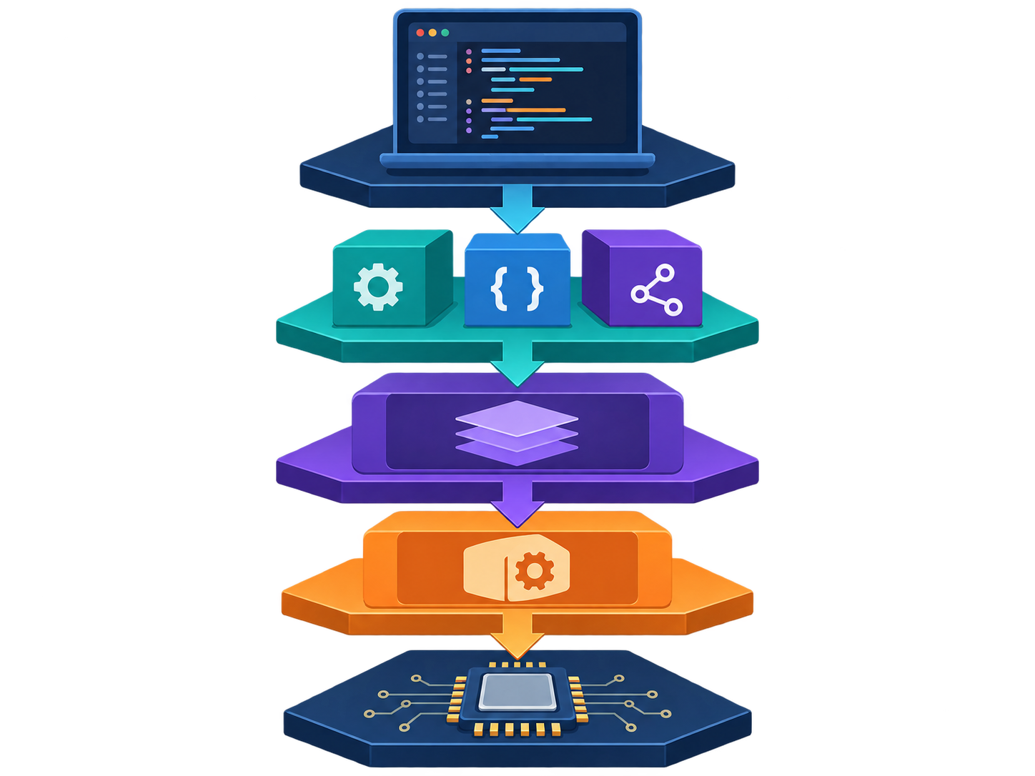
Figure 1. Conceptual technology stack: source code → standard APIs → runtime → operating system → hardware.

5. Java language and Java SE platform

5.1 Java programming language
The Java language defines how source code is written and what source-level constructs mean. A source file normally has the .java extension. The CPU does not directly execute this source text.
Source file: CourseMessage.java
public class CourseMessage {
public static void main(String[] args) {
String course = "CSC241";
System.out.println("Welcome to " + course);
}
}

5.2 Java SE standard APIs
Java becomes productive quickly because a large amount of common functionality is already available in standard APIs.
Package area | Typical role
java.lang | Core types such as String, Object, Math; imported automatically.
java.util | Collections and general-purpose utilities.
java.time | Modern date and time API.
java.io / java.nio | Streams, files, paths, and modern file operations.
java.net | Networking APIs.
java.sql | Database connectivity API (JDBC-related interfaces/classes).

Mini demo: using an existing object-oriented API
public class NameDemo {
public static void main(String[] args) {
String name = "muhammad shahid bhatti";
System.out.println(name.toUpperCase());
System.out.println(name.length());
System.out.println(name.contains("shahid"));
System.out.println(name.replace("shahid", "S."));
}
}

Discussion: We do not need to know the internal algorithm used by toUpperCase(), length(), or replace(). We program against the public behavior promised by String.

6. JVM and JRE concepts

6.1 JVM - the execution abstraction
The Java Virtual Machine (JVM) defines an execution environment for Java class files. A JVM implementation is built for a specific host platform, but compatible Java class files follow a standardized format and instruction set.
- Loads class definitions when needed.
- Links classes by verifying, preparing, and resolving required information.
- Initializes classes when required.
- Executes bytecode, typically using interpretation and/or runtime compilation techniques.
- Provides runtime services such as memory management, thread support, and exception handling.

6.2 A useful five-step JVM mental model
Stage | What it means
1. Load | Find and obtain the class definition.
2. Link | Verify the class, prepare runtime structures, and resolve references as required.
3. Initialize | Perform required class initialization.
4. Execute | Run bytecode; implementations may interpret and/or compile frequently executed code.
5. Manage | Provide memory, threads, exceptions, and other runtime services.

6.3 JRE - concept versus modern packaging
Historically, a Java Runtime Environment (JRE) was commonly distributed as a separate runtime package. Conceptually, the JRE means the JVM plus runtime libraries and supporting components needed to execute Java applications. In modern development workflows, students normally install a JDK, which already includes what is needed to compile and run Java code.
For this course: Know the JRE concept for terminology and exams, but do not assume that you must install a separate JRE in addition to the JDK.

7. JDK and core development tools
The Java Development Kit (JDK) is the developer’s toolkit. An IDE may hide these commands behind buttons and menus, but understanding the underlying tools makes troubleshooting much easier.
Tool | Purpose
javac | Compiles Java source files into class files.
java | Launches a Java application / starts the JVM for the requested main class.
javap | Inspects class structure; with -c it can display bytecode instructions.
jar | Creates or works with Java archive (JAR) files.
jshell | Interactive Java REPL for experimenting with expressions and statements.
javadoc | Generates API documentation from source documentation comments.
jdb | Command-line debugger.
jlink | Builds customized runtime images from selected modules.

7.1 Verify your Java installation
Windows CMD checks
java -version
javac -version
where java
where javac

- java and javac should both be found.
- Their versions should correspond to the intended JDK installation.
- The IDE project SDK should point to the intended JDK.
- Having multiple JDKs installed is not inherently a problem; accidentally selecting the wrong one is.
Course baseline: The current course setup uses JDK 25 LTS as the semester baseline. Release details can change over time, so future cohorts should verify the current supported/LTS landscape before adopting a version.

8. Java source-to-execution pipeline
This is the central execution story of the lecture. You should be able to draw it from memory and explain what each stage contributes.
1  Hello.java  Source | 2  javac  Compiler | 3  Hello.class  Bytecode | 4  Class loader  Load + link | 5  JVM  Execute | 6  Native CPU  Machine execution

8.1 Step 1: write Java source
The programmer writes human-readable source code in a .java file.

8.2 Step 2: javac compiles the source
javac HelloCSC241.java

If compilation succeeds, javac typically creates a .class file containing JVM bytecode and metadata. The result is not a Windows .exe file.

8.3 Step 3: the JVM loads and executes the class
java HelloCSC241

The java launcher starts the runtime, locates the requested class, and begins the JVM execution process.

9. Bytecode, class loading, interpretation and JIT

9.1 Bytecode
A .class file contains a structured representation for the JVM, including bytecode instructions and metadata. Bytecode is neither Java source code nor a direct instruction sequence for one specific CPU architecture.
Inspect bytecode conceptually
javap -c HelloCSC241

Why this matters: The class file acts as an intermediate portable representation. The platform-specific JVM implementation bridges that representation to the actual host operating system and processor.

9.2 Class loading and linking
- Loading: obtain the binary representation of a class and create its runtime representation.
- Linking: verify correctness, prepare runtime structures, and resolve symbolic references as needed.
- Initialization: execute required class initialization before normal use.

9.3 Interpretation and JIT compilation
Modern JVM implementations may begin by executing bytecode directly and may compile frequently executed (“hot”) code into optimized native machine code at runtime. The exact strategy depends on the JVM implementation; the important course concept is that JVM bytecode is executed on the host platform through the JVM runtime.

10. Portability: why class files can run across platforms
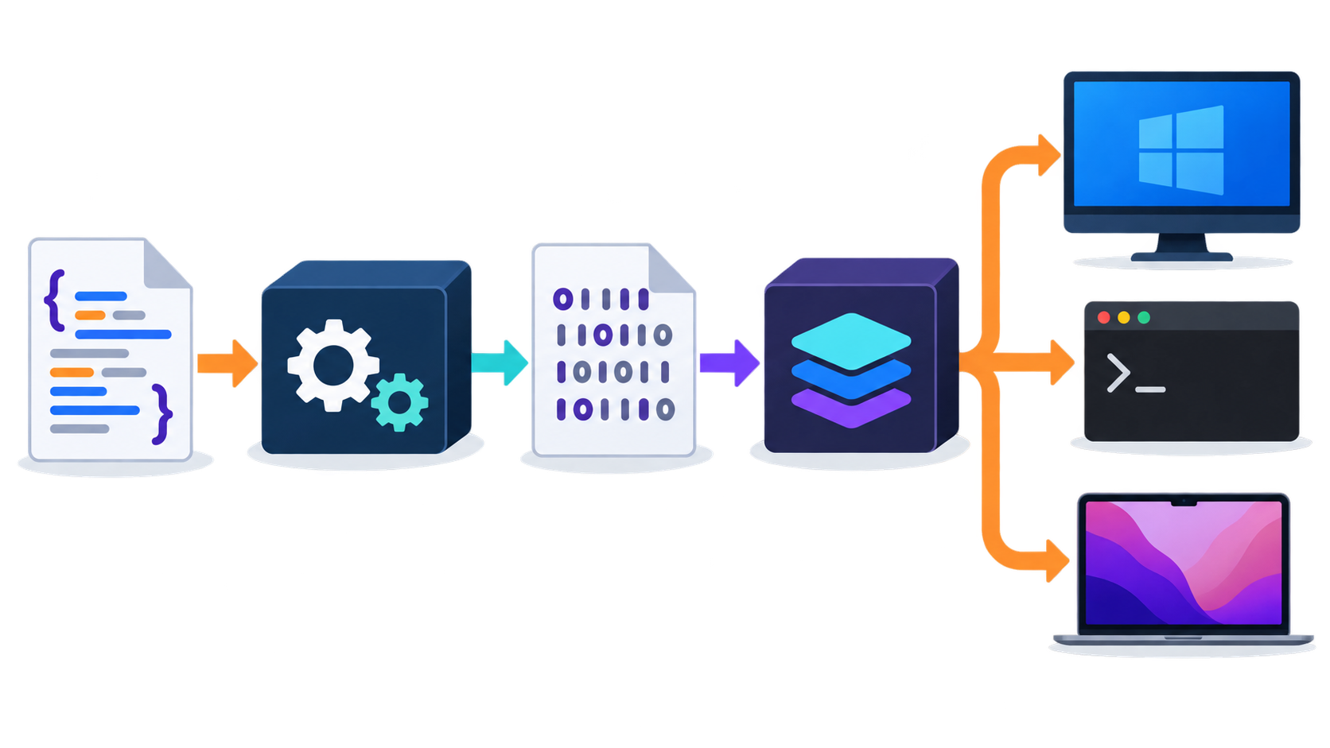
Figure 2. One compiled class-file representation can be executed by compatible JVM implementations on different host platforms.
A useful simplified model is:Java source → bytecode → platform-specific JVM → host OS/CPU
- The compiler targets the JVM class-file format rather than one specific desktop operating system.
- A compatible JVM implementation exists for each supported host platform.
- The same application is portable only if it also avoids incompatible native libraries, OS-specific paths, unavailable dependencies, or other environment assumptions.
Nuance: “Write once, run anywhere” is an architectural goal, not a guarantee that every program is automatically platform-independent. Native dependencies and environment-specific assumptions can reduce portability.

11. JDK/LTS cycle, IDEs, Git and GitHub workflow

11.1 Feature releases and LTS releases
Modern Java uses a regular feature-release cadence. Some releases are designated for Long-Term Support (LTS) by vendors. For a semester-long course, an LTS release is often preferred because it provides a stable baseline for installation, examples, lab machines, and troubleshooting.
Teaching principle: Newest feature release does not necessarily mean best classroom baseline. Stability and consistency across student machines are usually more important than using the newest language/runtime version.

11.2 IDE versus JDK
Component | Role
IDE / editor | Write and navigate code, refactor, run/debug projects, manage project settings, and integrate tools.
JDK | Provides the actual Java compiler/runtime toolchain and command-line utilities.
Git | Tracks local file history and changes.
GitHub | Hosts/shares Git repositories and supports collaboration/publishing workflows.

Remember: IDE ≠ JDK. IntelliJ IDEA, Eclipse, NetBeans, or VS Code can make development easier, but the Java compiler/runtime toolchain comes from the JDK configured for the project.

11.3 Practical course workflow
1. Write or edit Java source in an IDE/editor.
2. Compile and run using the JDK (directly or through the IDE).
3. Use Git to track meaningful local changes.
4. Use GitHub to synchronize/share repository content when required.
5. When Java behaves unexpectedly, verify the active JDK before assuming the program logic is wrong.

12. Live-code examples and diagnostic demonstrations

12.1 Compile and run from the command line
HelloCSC241.java
public class HelloCSC241 {
public static void main(String[] args) {
System.out.println("Welcome to CSC241!");
}
}

Suggested demonstration sequence
dir
javac HelloCSC241.java
dir
java HelloCSC241
javap -c HelloCSC241

The key observation is the appearance of HelloCSC241.class after compilation. This makes the source → bytecode → JVM pipeline visible rather than purely theoretical.

12.2 Compile-time failure
public class ErrorDemo {
public static void main(String[] args) {
int age = "twenty";
System.out.println(age);
}
}

The compiler rejects this program because a String value cannot be assigned to an int variable. The JVM never gets a successfully compiled version of this program to execute.

12.3 Runtime failure
public class ErrorDemo {
public static void main(String[] args) {
int a = 10;
int b = 0;
System.out.println(a / b);
}
}

This source can compile successfully, but execution fails when the JVM reaches integer division by zero. This illustrates the distinction between compile-time checking and runtime behavior.

12.4 Prediction exercise with LocalDate
import java.time.LocalDate;
public class DateChallenge {
public static void main(String[] args) {
LocalDate date = LocalDate.of(2026, 12, 30);
System.out.println(date);
System.out.println(date.plusDays(5));
System.out.println(date.plusMonths(2));
}
}

Student task: Predict the output before running the program. Then explain why using a date API is safer and more maintainable than manually implementing calendar arithmetic.

13. Common misconceptions
Misconception | Correction
“Java and the JVM are the same thing.” | No. Java is the programming language; the JVM is the execution abstraction for class files.
“The JDK is just the Java compiler.” | No. javac is one JDK tool; the JDK also includes the launcher/runtime and many additional development utilities.
“The IDE contains Java.” | An IDE can bundle or help select a JDK, but conceptually the IDE and JDK have different roles.
“A .class file is native machine code.” | No. It contains JVM class-file structures and bytecode, which the JVM executes on the host platform.
“If code compiles, it cannot fail.” | Compilation catches many source/type problems, but runtime problems can still occur.
“Reusability means inheritance.” | No. Reusing standard APIs, composition, libraries, and stable contracts is often more important.
“I always need to install a separate JRE.” | Not in the normal course setup. A JDK already provides the runtime needed to compile and run Java.

14. Review questions and quick practice

14.1 Short-answer review
1. Differentiate Java language, Java SE, JVM, JRE concept, and JDK in one or two sentences each.
2. Draw the source-to-execution pipeline beginning with Hello.java and ending at the native CPU.
3. What does javac produce when compilation succeeds?
4. What is the role of the JVM after a class file has been produced?
5. Why can the same class file potentially run on Windows, Linux, and macOS?
6. Give one example of a compile-time error and one example of a runtime error.
7. What is javap used for conceptually?
8. Why is “IDE ≠ JDK” an important distinction during setup and debugging?
9. Explain one way in which the Java standard APIs support OOP reusability.
10. Why might a course prefer an LTS JDK over a newer non-LTS feature release?

14.2 Command checklist
Command | What to remember
java -version | Check the selected runtime/JDK version used by the java launcher.
javac -version | Check the selected Java compiler version.
javac FileName.java | Compile a Java source file.
java ClassName | Run a compiled class containing an appropriate main method.
javap -c ClassName | Inspect class information and show bytecode instructions.
where java | On Windows, show which java executable is selected from PATH.
where javac | On Windows, show which javac executable is selected from PATH.

15. Lecture summary
- Lecture 2 connects the design motivation for OOP to the Java technology platform used to build and run programs.
- Java language, Java SE, JVM, JRE concept, and JDK are related but distinct concepts.
- javac compiles .java source into .class files containing JVM bytecode.
- The JVM loads, links, initializes, and executes class files while providing runtime services.
- Bytecode plus platform-specific JVM implementations is the foundation of Java portability.
- An IDE improves productivity, while the JDK supplies the Java compiler/runtime toolchain.
- Git tracks local changes; GitHub hosts and shares repositories.
- Lecture 3 begins the formal study of classes and objects.

References used for these notes
- CSC241 Course Description Form (CDF), Version 5.0 - Unit 1: Overview of Object-Oriented Programming.
- CSC241 Teacher Information, Course Description and Lecture-wise Plan - Lecture 2: Advantages of OOP & the Modern Java Landscape.
- CSC241 Lecture 02 revised slide deck - Java platform, toolchain, bytecode, JVM execution, portability and developer workflow.
- Y. Daniel Liang, Introduction to Java Programming, Comprehensive Version (course-recommended text; Chapter 1 for introductory Java platform context).

