11/19/2019

Design Patterns

OOAD Lab 12

D 17F8001

M. Shahid Shakeel

# Factory Pattern

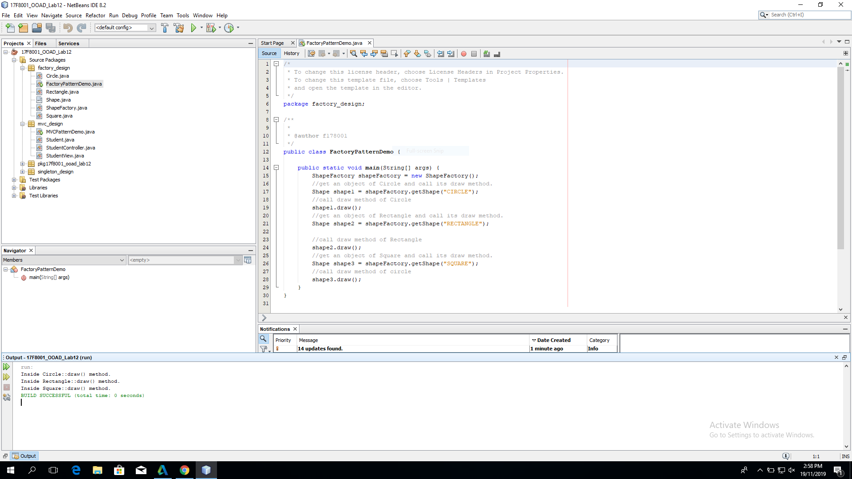

# Singleton Pattern

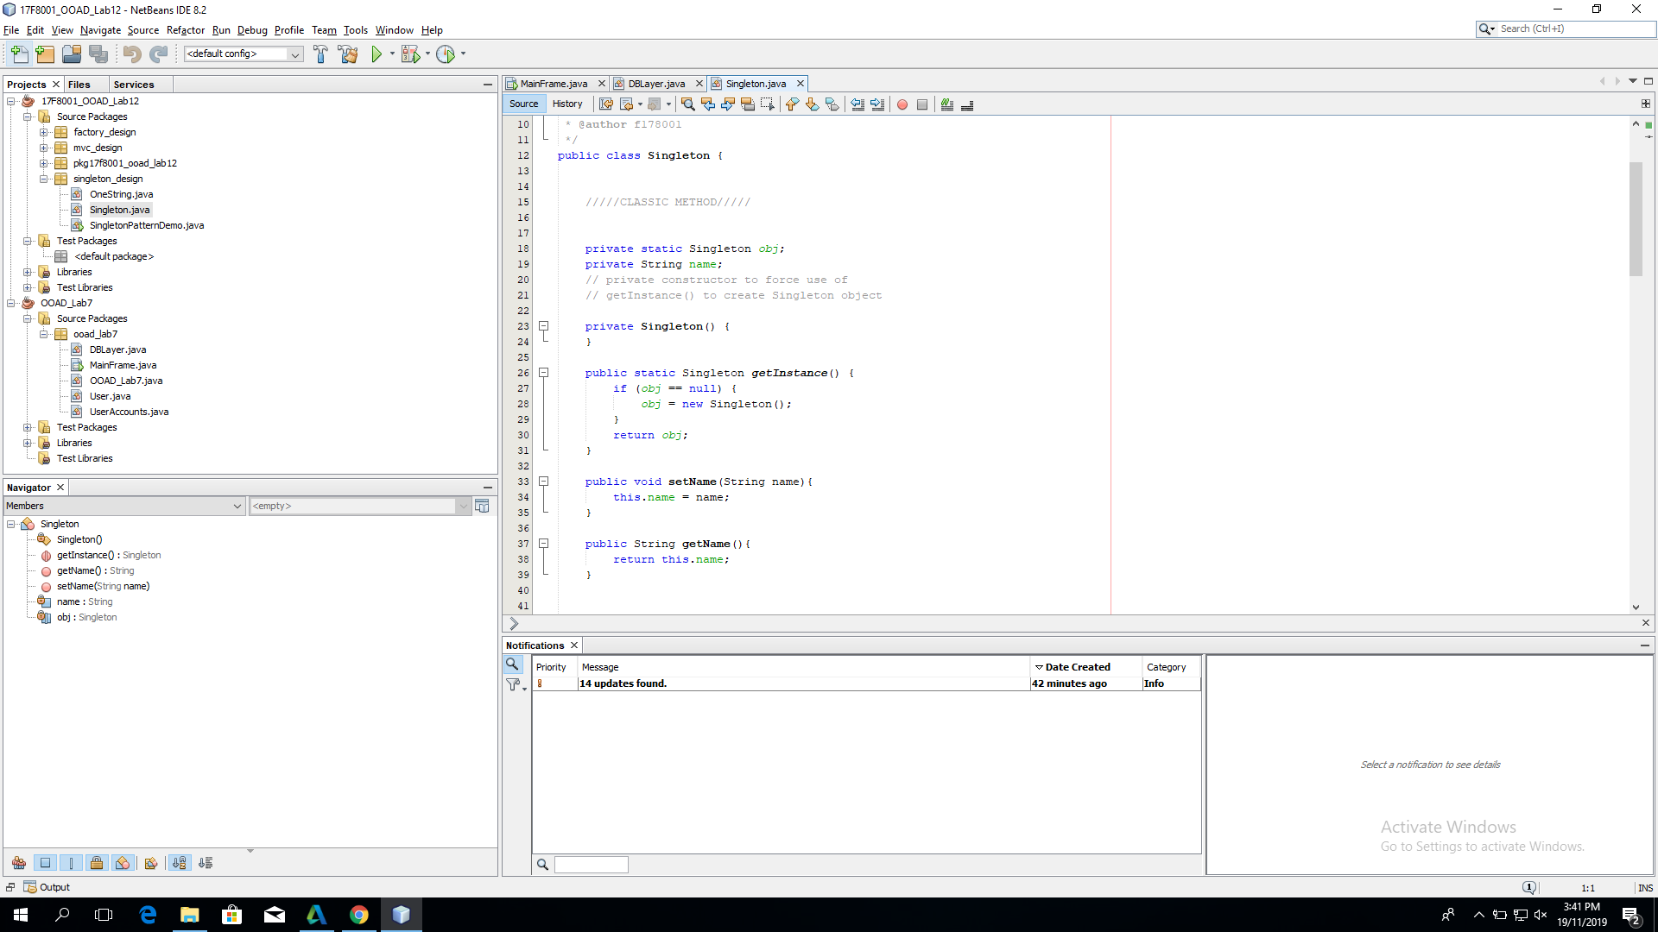

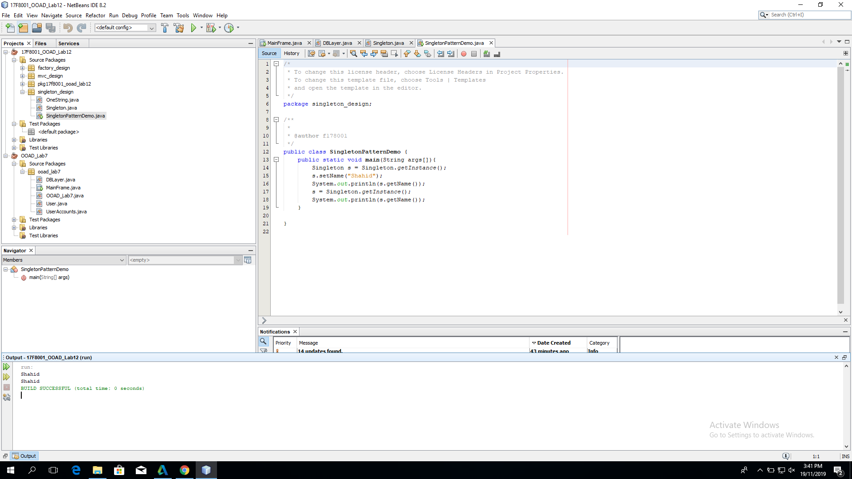

# MVC Pattern

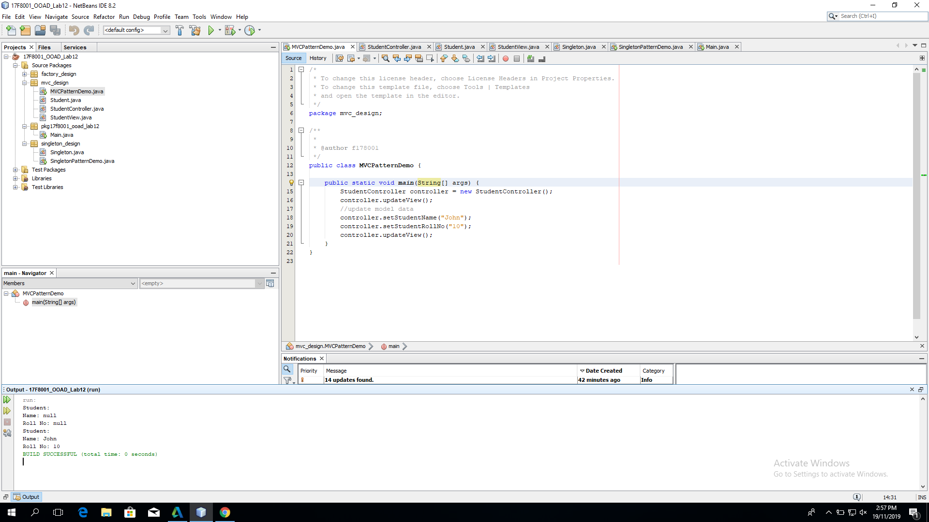

# Database Connectivity Using Singleton Pattern

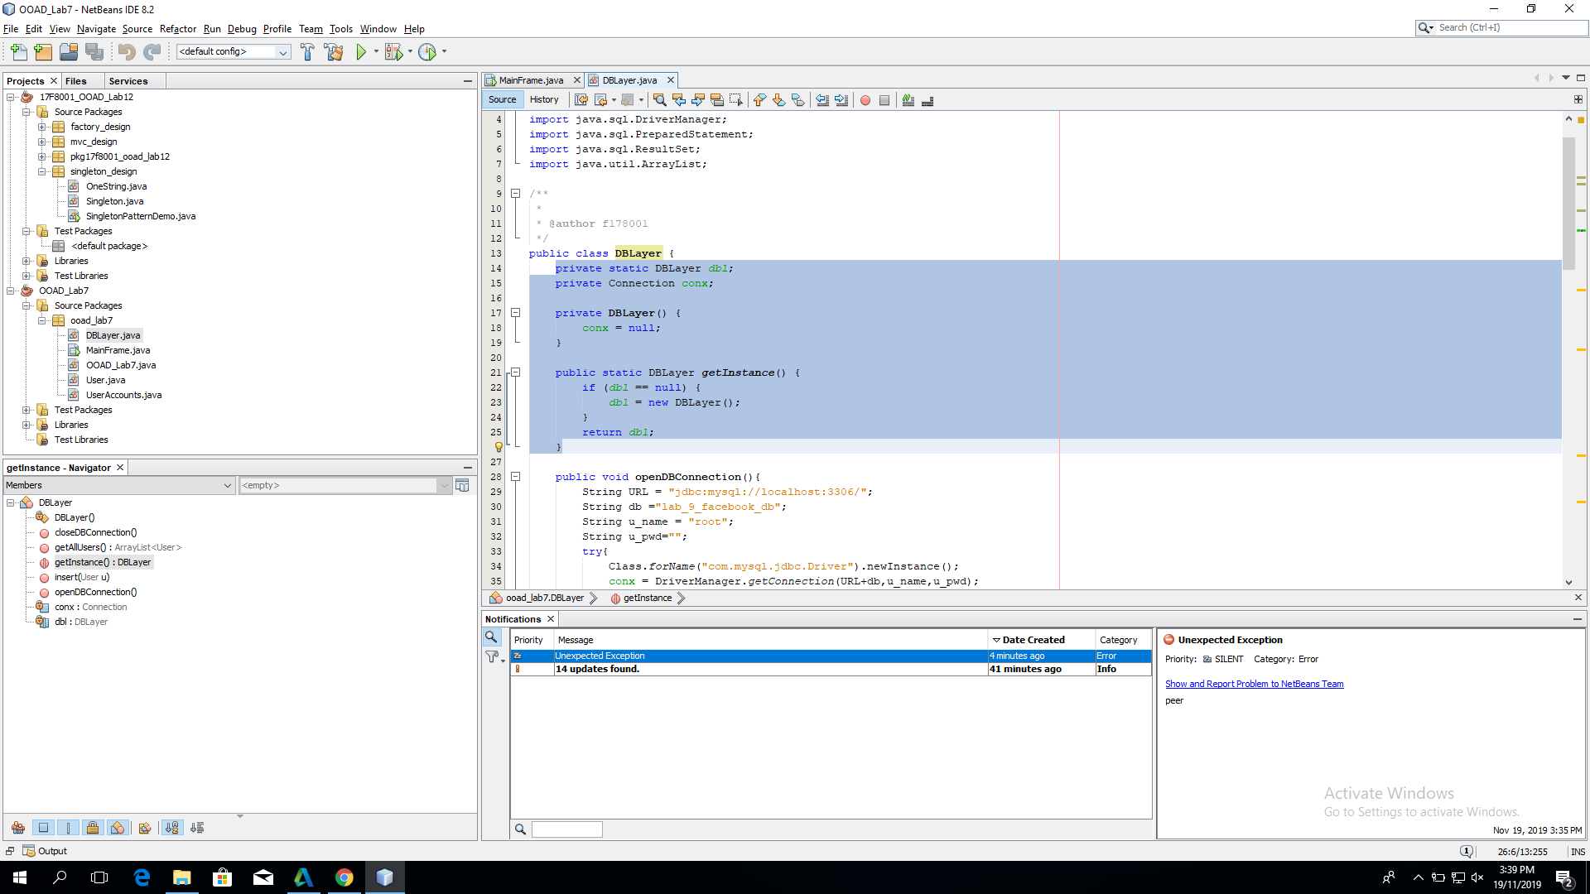

# Instance Calling Database

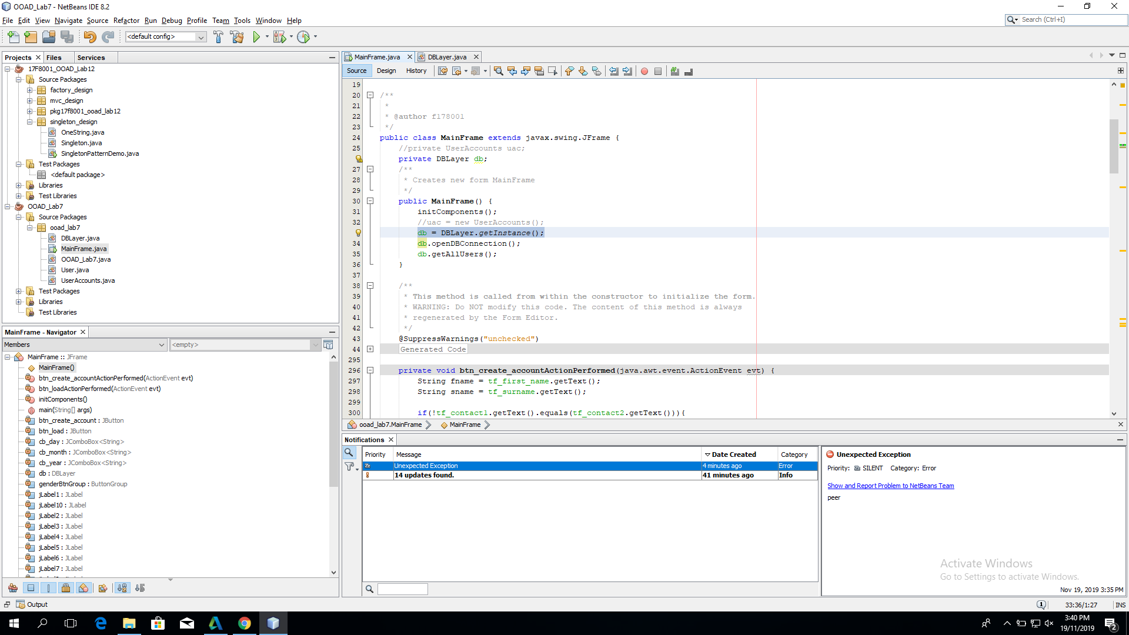

# Working After Applying Singleton Pattern

