# Code Chunks

public CalculatorFrame() {

initComponents();

this.result = 0;

this.prevResult.setText(Integer.toString(this.result));

this.op = 'i';

}

/////////////////////////////////////////////////////////////

private void btnNum1ActionPerformed(java.awt.event.ActionEvent evt) {

textField.setText(textField.getText() + "1");

}

private void btnNum2ActionPerformed(java.awt.event.ActionEvent evt) {

textField.setText(textField.getText() + "2");

}

private void btnSignActionPerformed(java.awt.event.ActionEvent evt) {

int number = Integer.parseInt(textField.getText());

System.out.println(number);

number = 0 - number;

System.out.println(number);

textField.setText(Integer.toString(number));

}

private void btnNum0ActionPerformed(java.awt.event.ActionEvent evt) {

if (!textField.getText().equals(""))

textField.setText(textField.getText() + "0");

}

private void btnNum3ActionPerformed(java.awt.event.ActionEvent evt) {

textField.setText(textField.getText() + "3");

}

private void btnAddActionPerformed(java.awt.event.ActionEvent evt) {

setResult('+');

}

private void btnNum4ActionPerformed(java.awt.event.ActionEvent evt) {

textField.setText(textField.getText() + "4");

}

private void btnNum5ActionPerformed(java.awt.event.ActionEvent evt) {

textField.setText(textField.getText() + "5");

}

private void btnNum6ActionPerformed(java.awt.event.ActionEvent evt) {

textField.setText(textField.getText() + "6");

}

private void btnSubActionPerformed(java.awt.event.ActionEvent evt) {

setResult('-');

}

private void btnNum8ActionPerformed(java.awt.event.ActionEvent evt) {

textField.setText(textField.getText() + "8");

}

private void btnNum9ActionPerformed(java.awt.event.ActionEvent evt) {

textField.setText(textField.getText() + "9");

}

private void btnMulActionPerformed(java.awt.event.ActionEvent evt) {

setResult('*');

}

private void btnNum7ActionPerformed(java.awt.event.ActionEvent evt) {

textField.setText(textField.getText() + "7");

}

private void btnCActionPerformed(java.awt.event.ActionEvent evt) {

textField.setText("");

}

private void btnBackActionPerformed(java.awt.event.ActionEvent evt) {

String str = textField.getText();

str = str.substring(0, str.length() - 1);

textField.setText(str);

}

private void btnDivActionPerformed(java.awt.event.ActionEvent evt) {

setResult('/');

}

private void btnCEActionPerformed(java.awt.event.ActionEvent evt) {

textField.setText("");

prevResult.setText("");

this.result = 0;

}

private void btnEqualActionPerformed(java.awt.event.ActionEvent evt) {

setResult('=');

}

private void btnPointActionPerformed(java.awt.event.ActionEvent evt) {

textField.setText(textField.getText() + ".");

}

/////////////////////////////////////////////////////////////

private void setResult(char op) {

int operand;

if (textField.getText().equals("")) {

operand = 0;

}

else {

operand = Integer.parseInt(textField.getText());

}

switch (this.op)

{

case 'i':

case '+':

this.result += operand;

break;

case '-':

this.result -= operand;

break;

case '*':

this.result *= operand;

break;

case '/':

this.result /= operand;

break;

default:

this.result = operand;

}

if (op == '=') {

prevResult.setText("");

textField.setText(Integer.toString(this.result));

}

else {

prevResult.setText(Integer.toString(this.result));

textField.setText("");

}

this.op = op;

}

/////////////////////////////////////////////////////////////

# Screenshots

## Base Layout, All Numbers

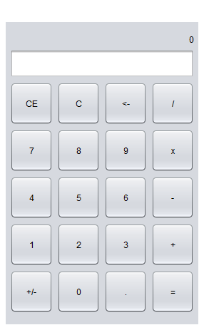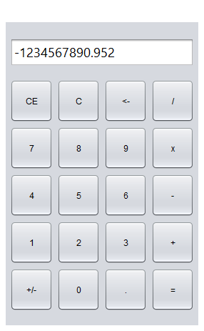

## Addition

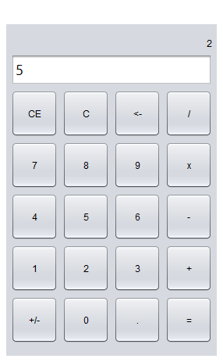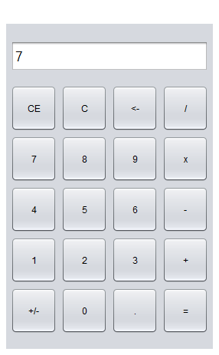

## Subtraction

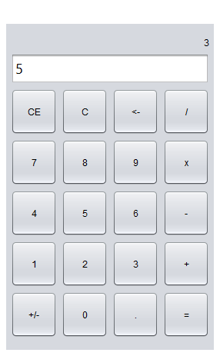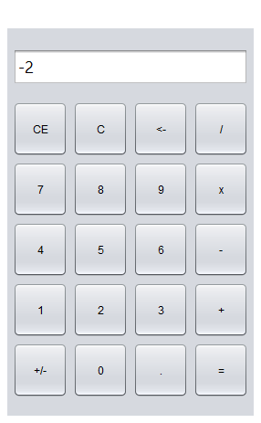

## Multiplication

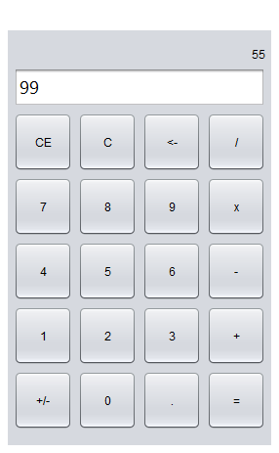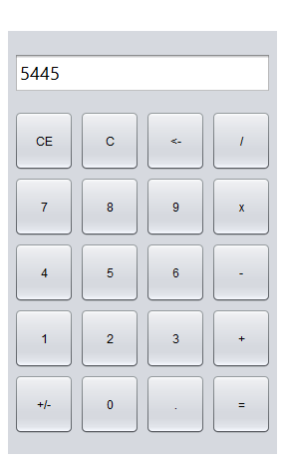

## Division

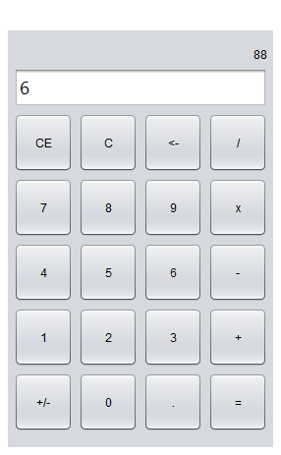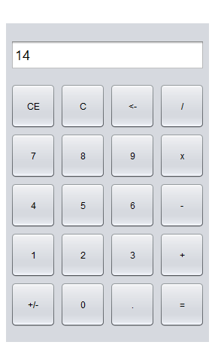

## <-, C, CE

## My Super CalculatorMy Super CalculatorMy Super CalculatorMy Super Calculator