Task 1:

Accuracy: 0.8921

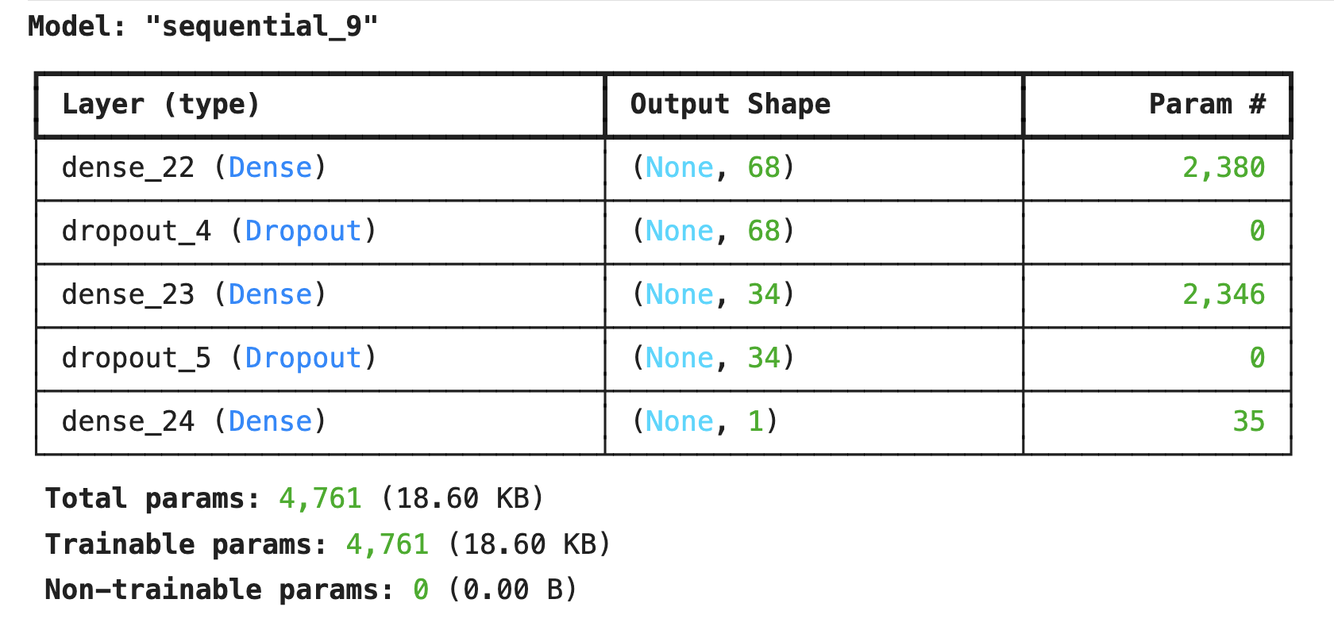

Task 2:

Output 1: 0.81898336

Output 2: 0.81898336