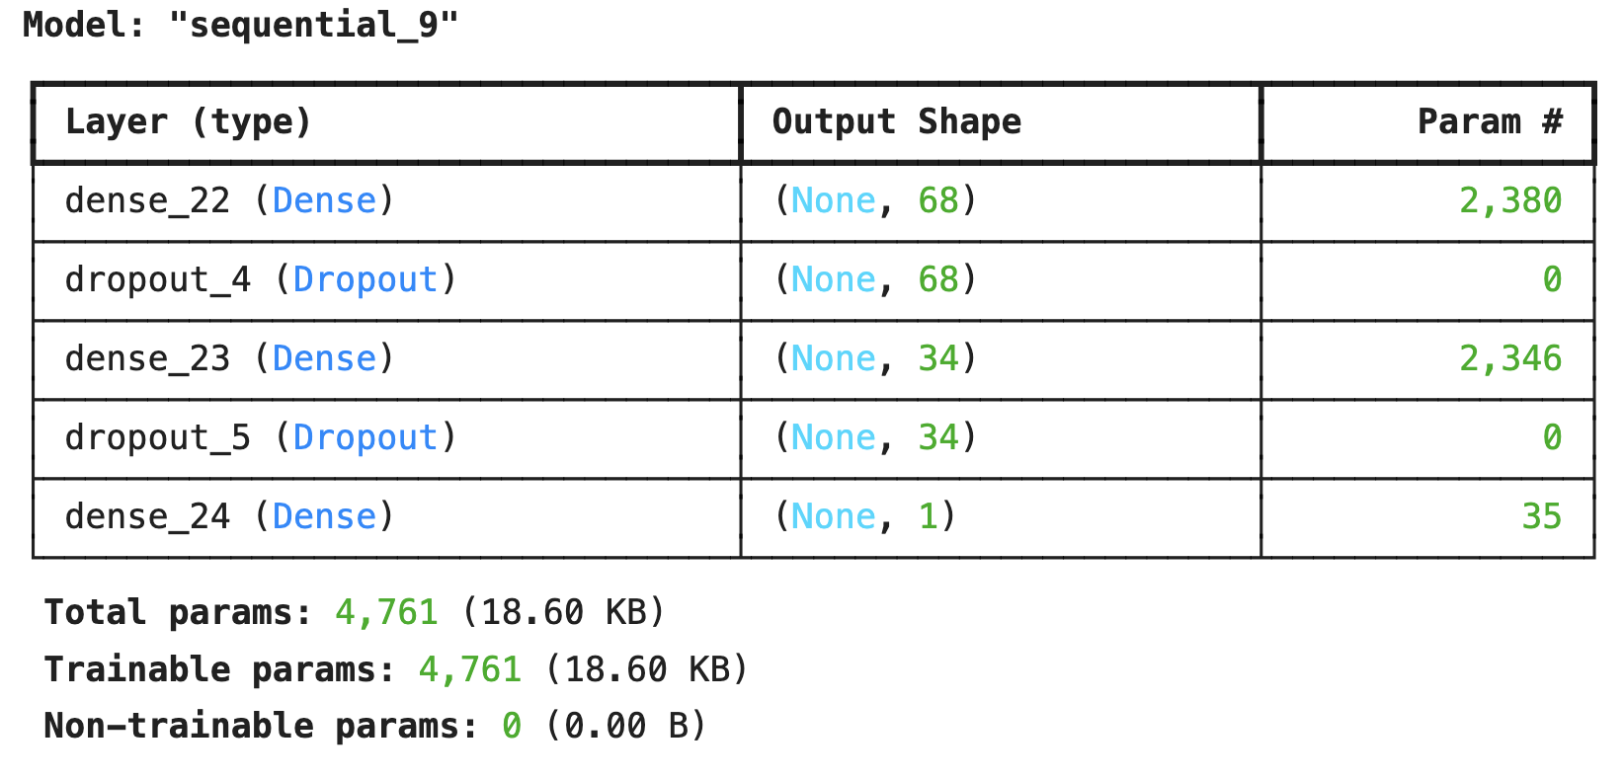

Test Accuracy: 0.8719000220298767