WebTicketing Admin Manual



**Login**

Input the provided user name and password to enter WebTicketing system



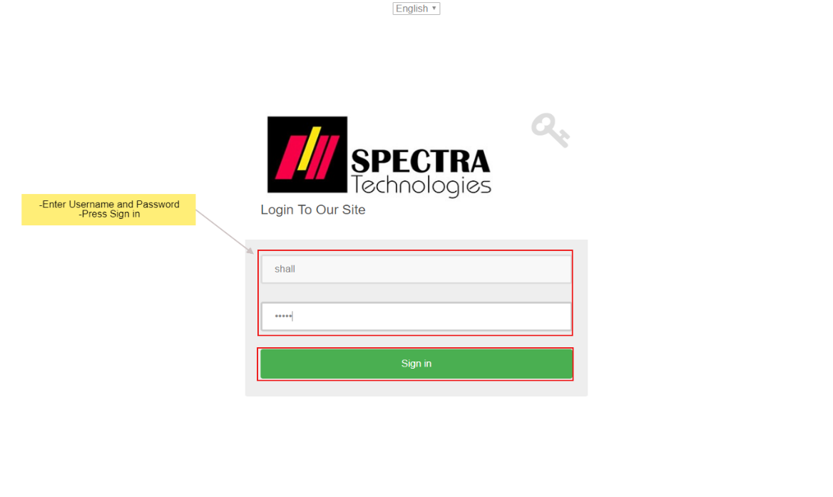

After login, it enters the Home page.

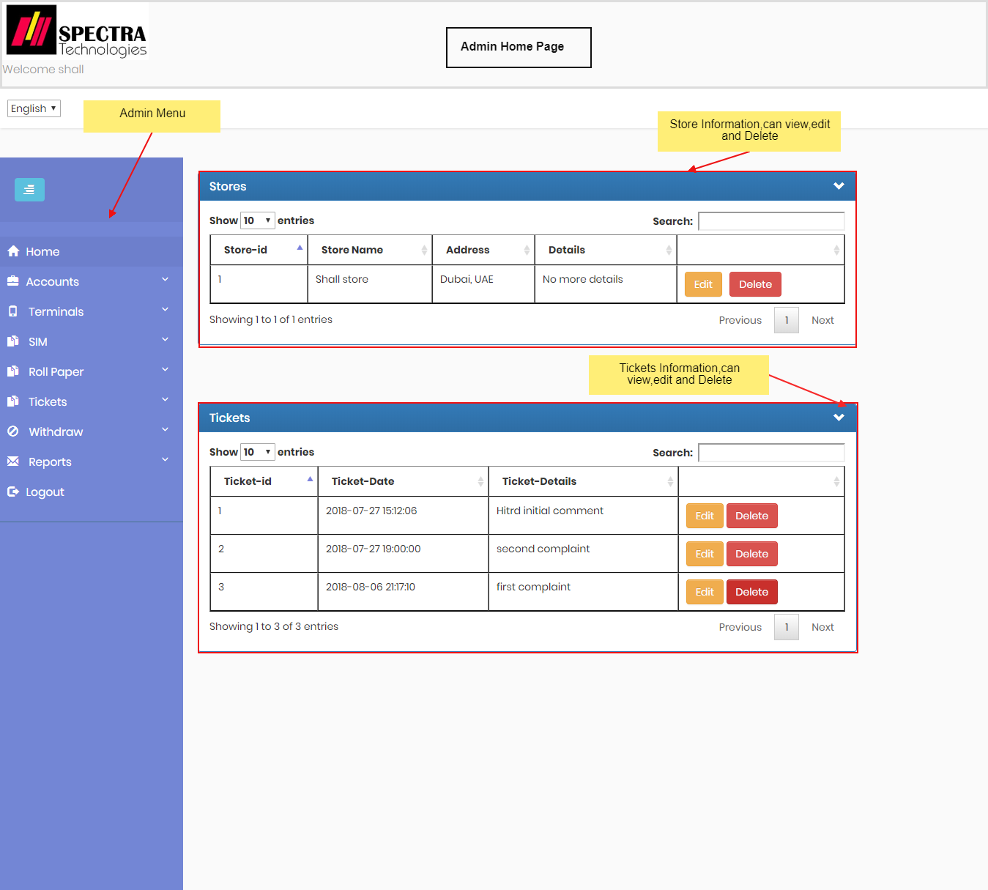

**Technicians Page**

It enter to technicians page, to show technicians information and can navigate to add and edit technician

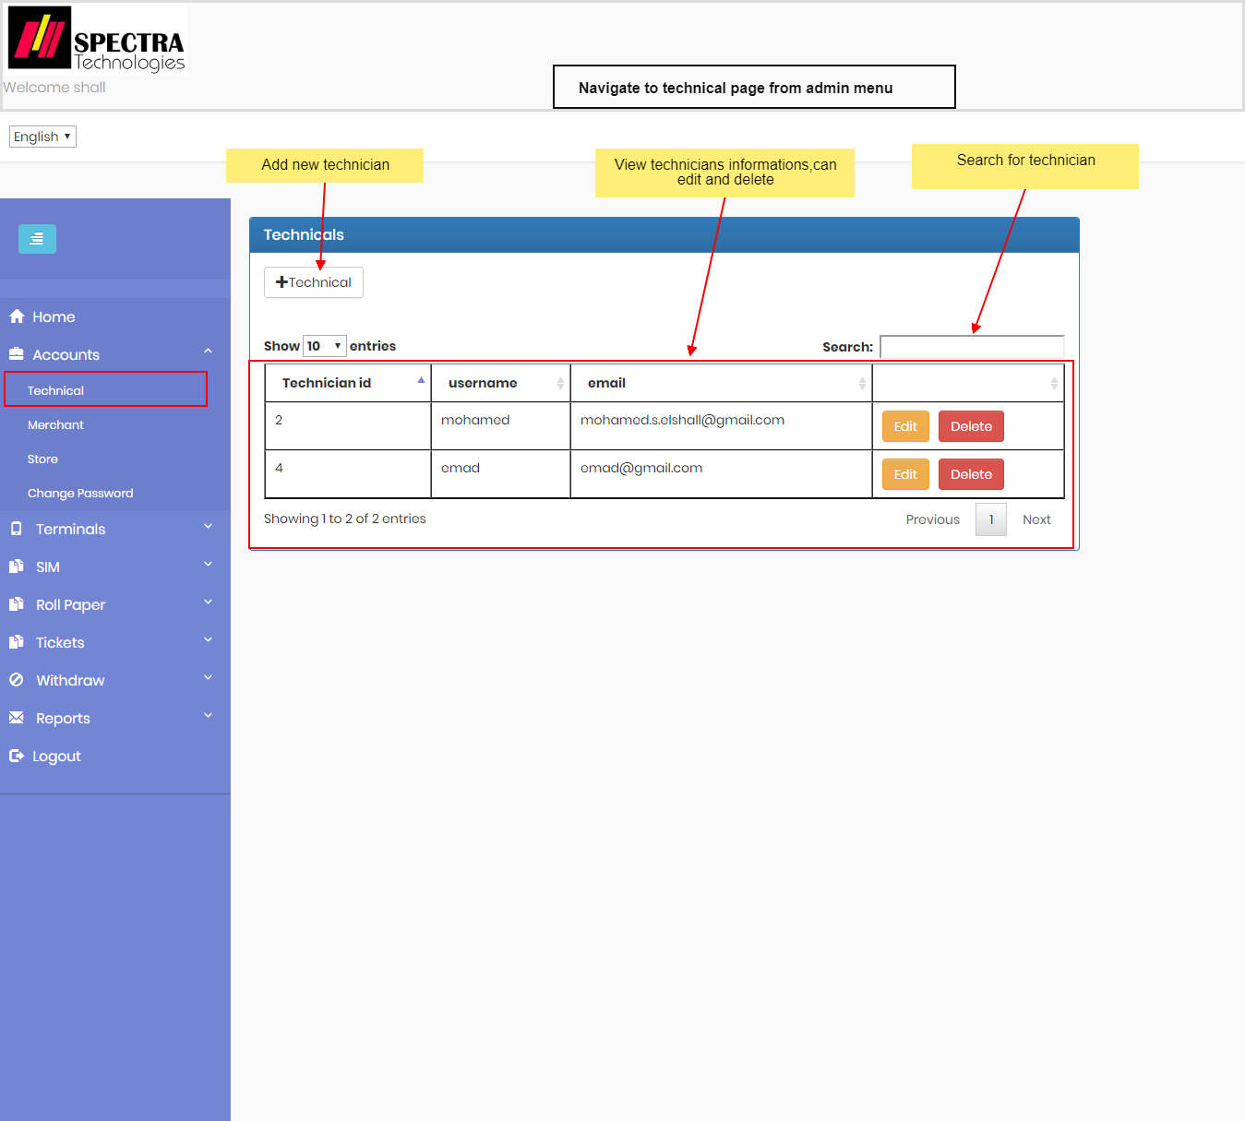

Then he can add or edit technician:

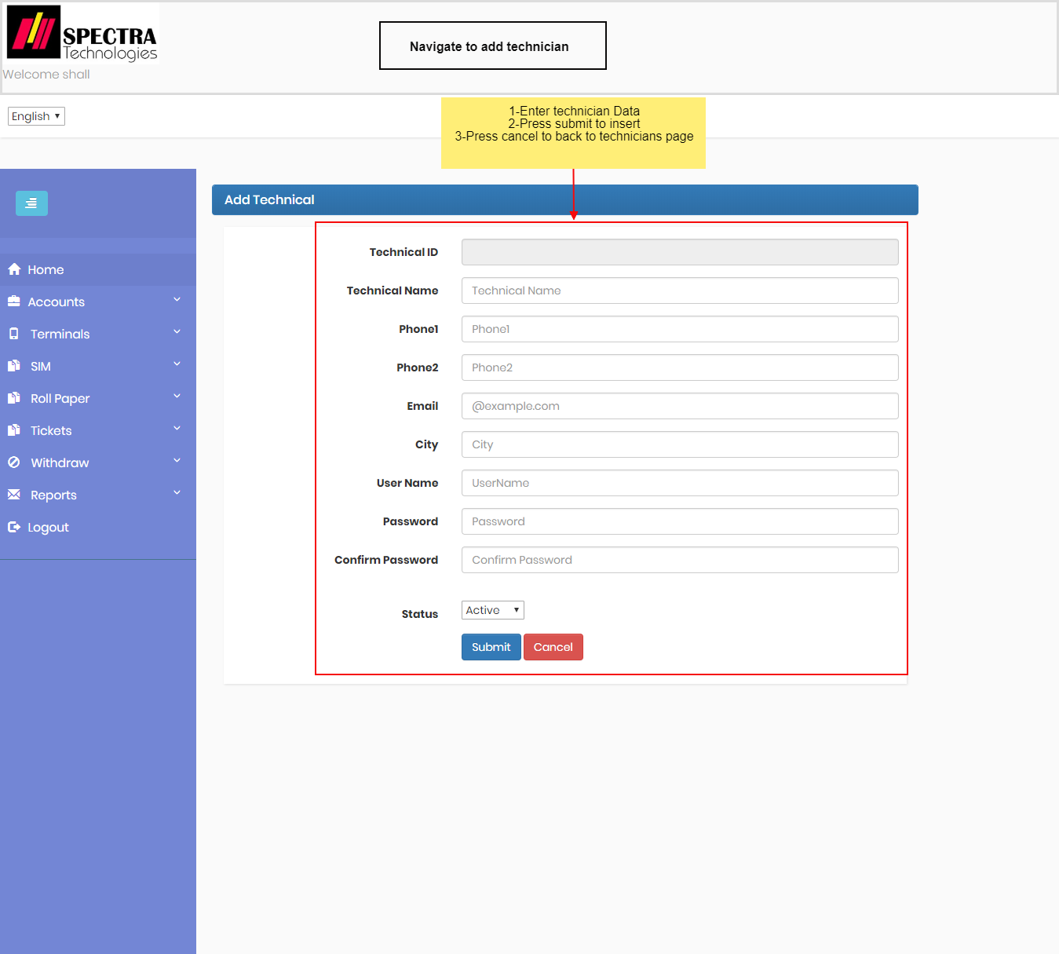

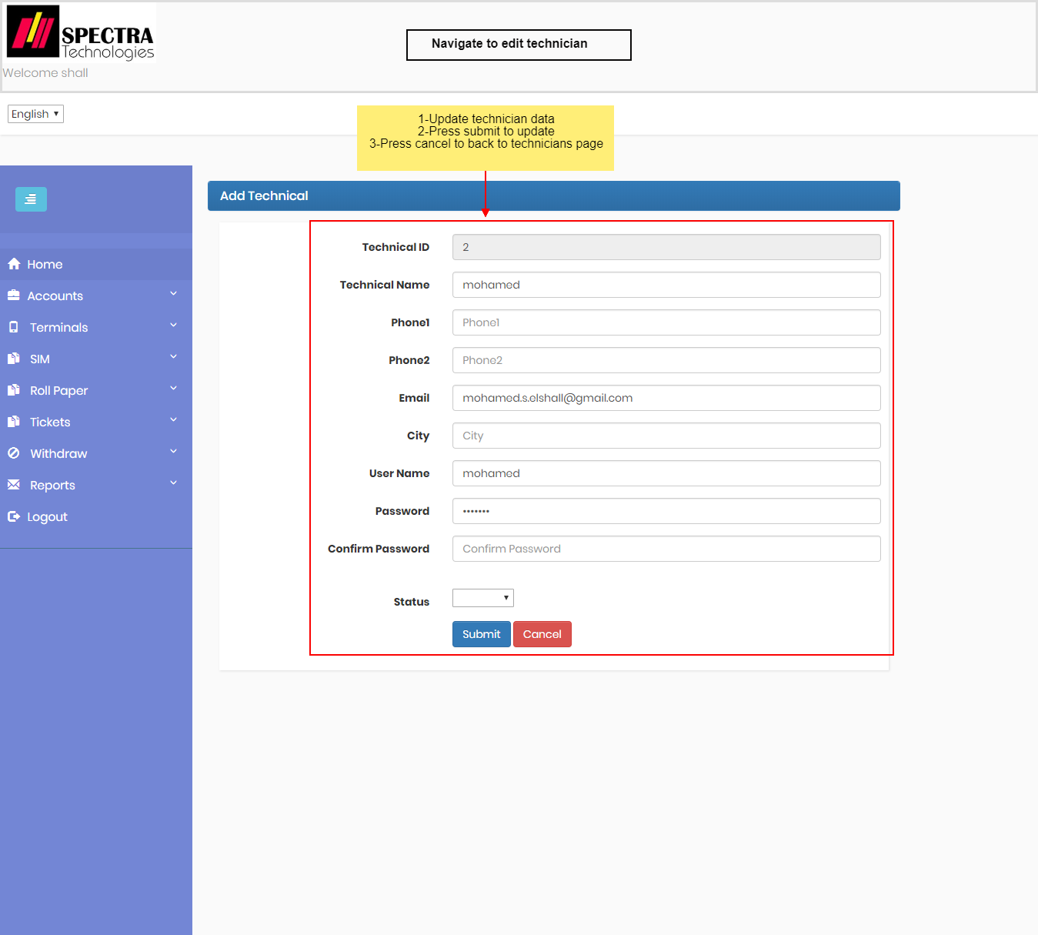

**Merchants Page**

It enter to merchants page, to show merchants information and can navigate to add and edit merchant

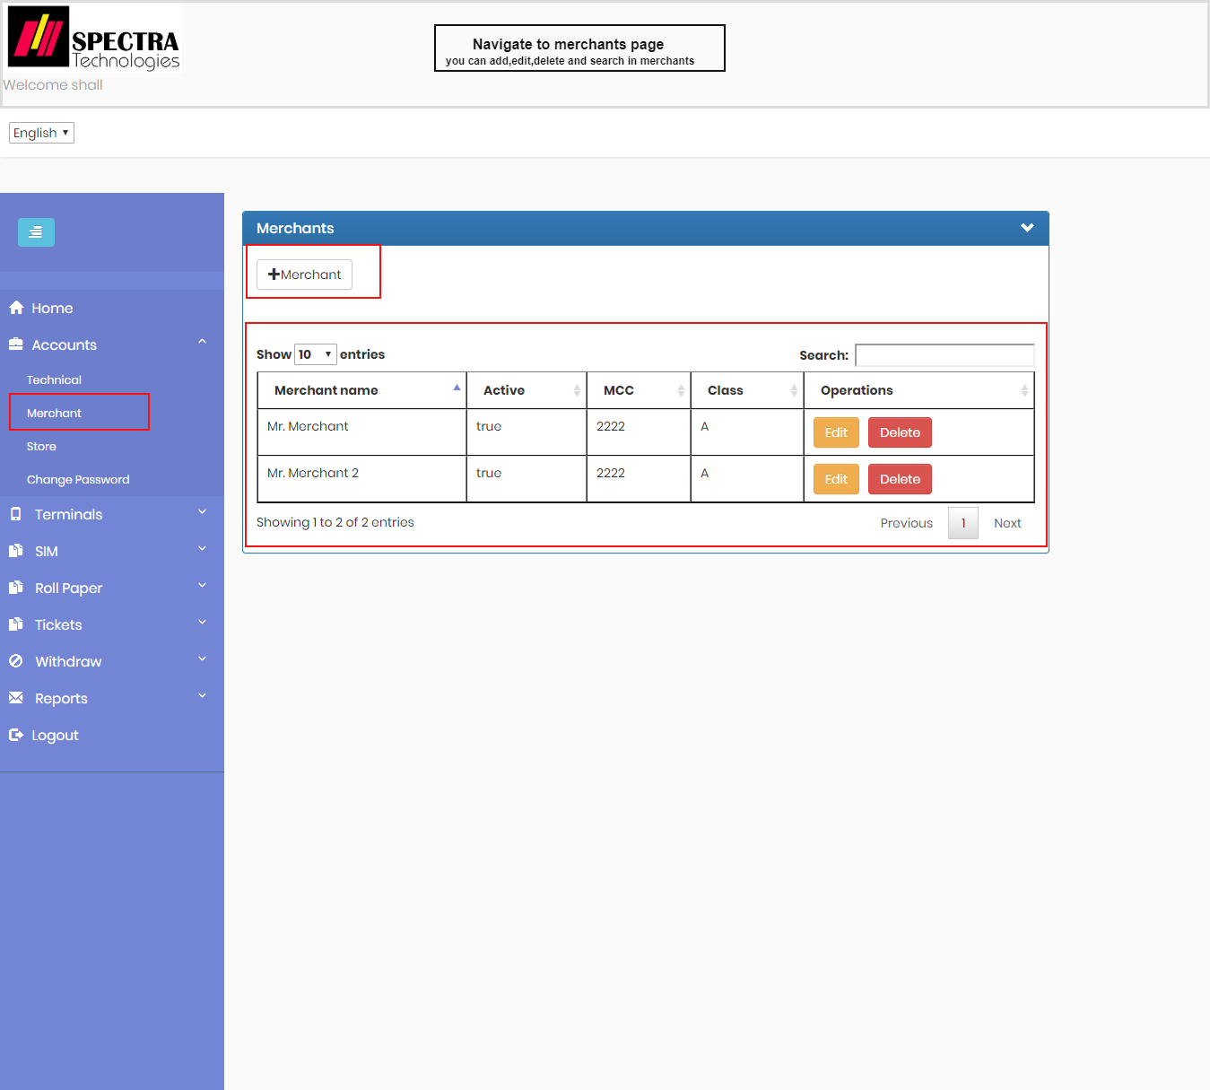

**Stores Page**

It enter to stores page, to show stores information and can navigate to add and edit store

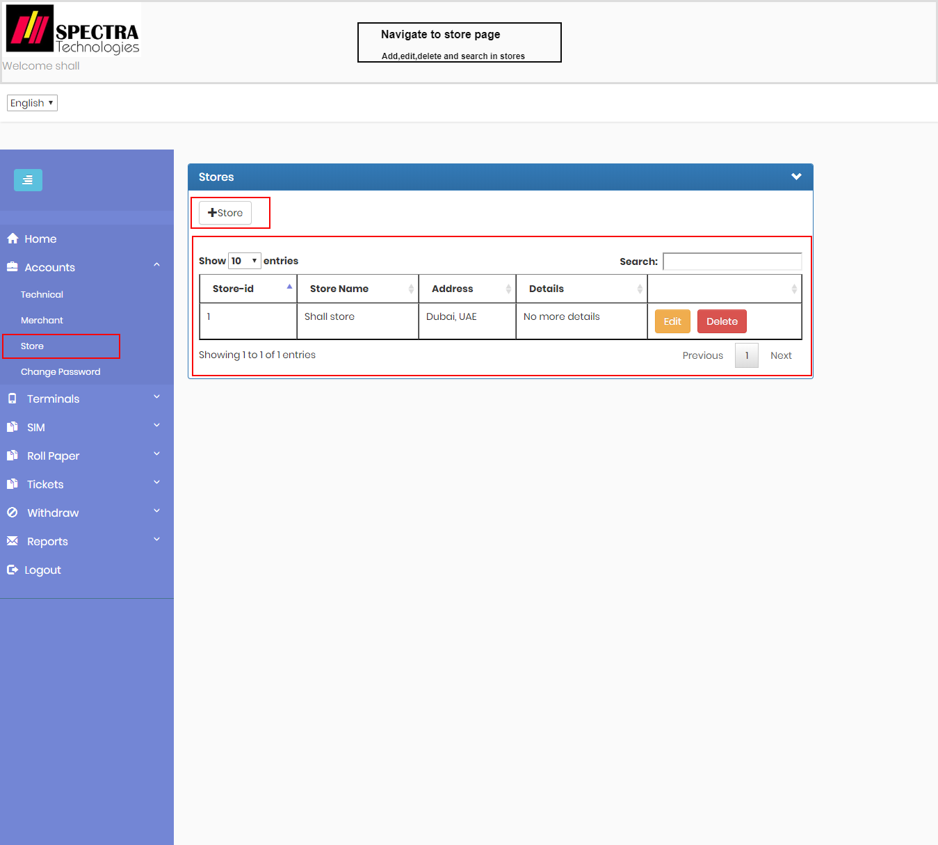

**Terminals Page**

It enter to terminals page, to show terminals information and can navigate to add and edit terminal

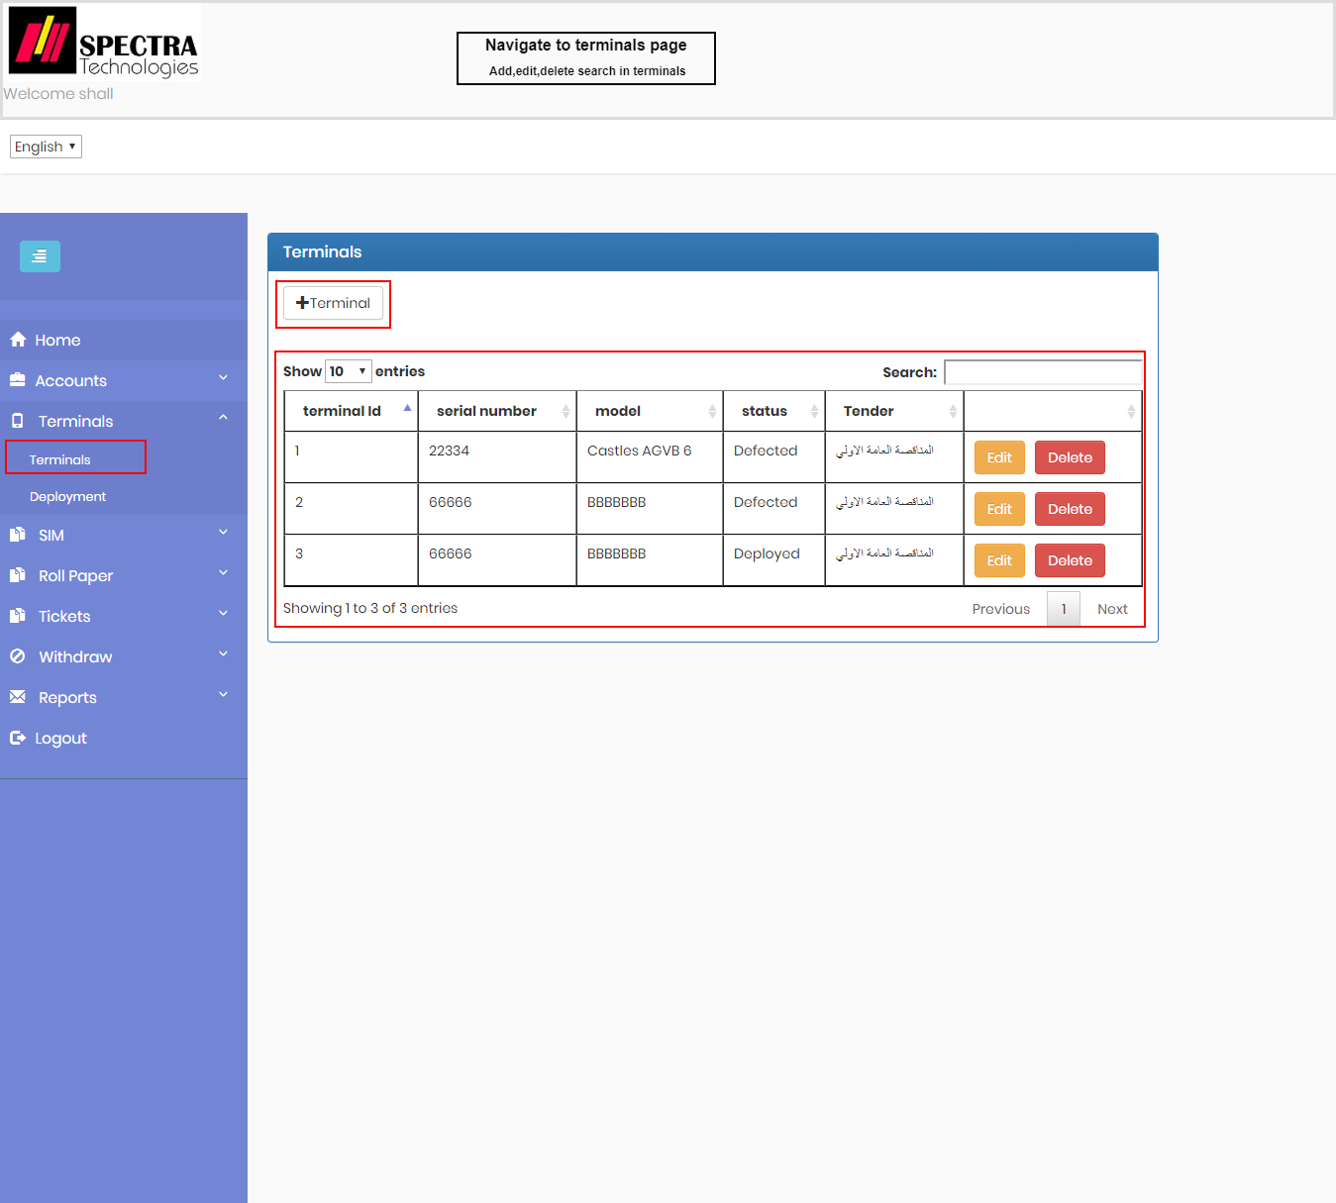

**Deployment Page**

to show terminals have been deployed information and can navigate to add and edit deployment

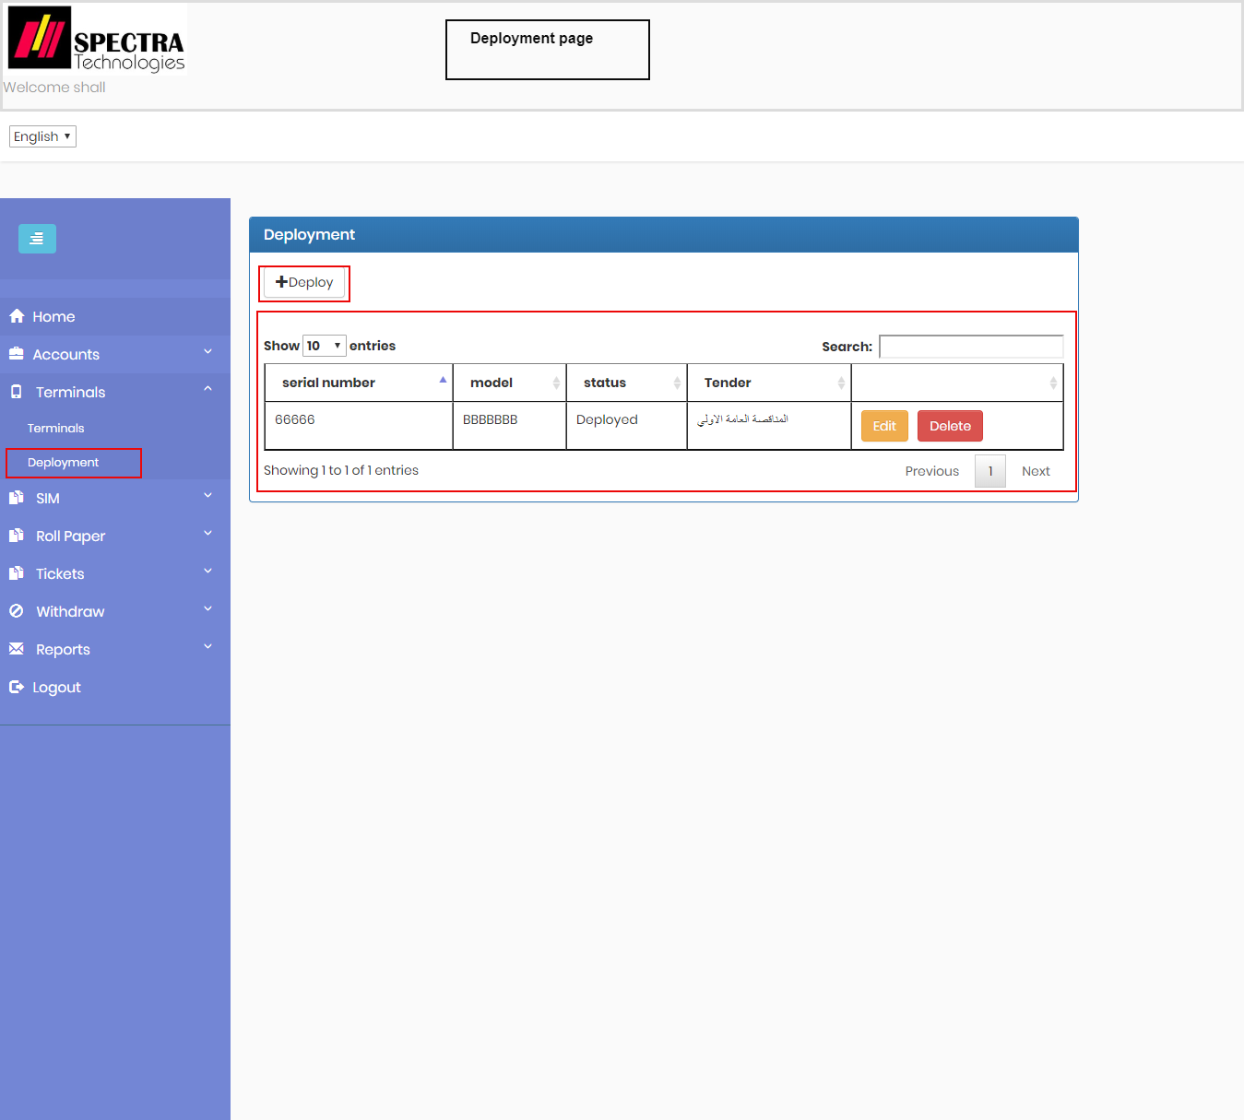

**Add deployment**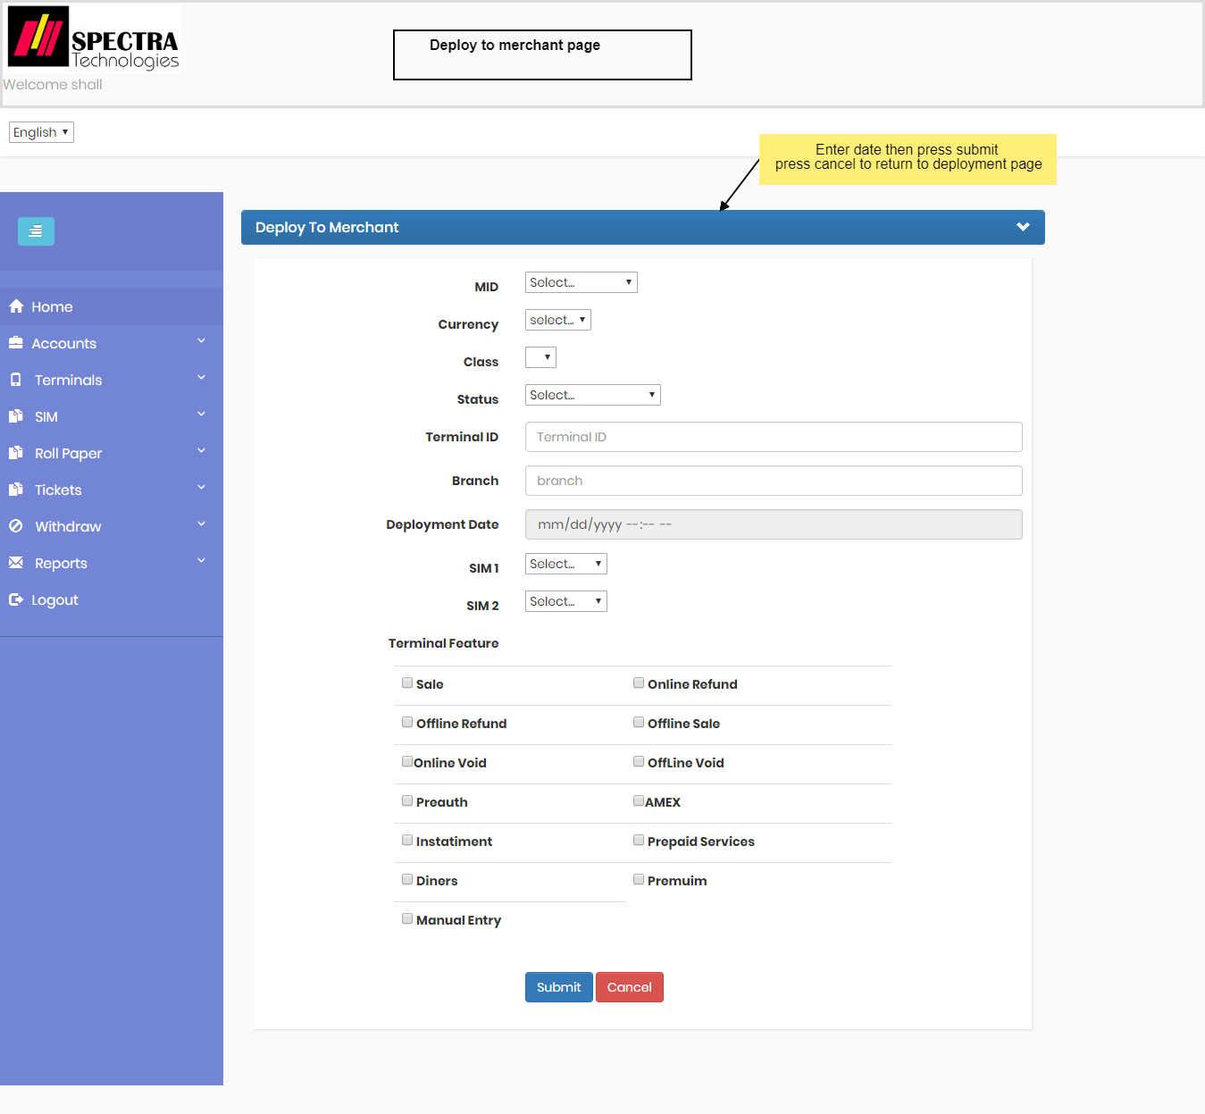

**Assign Tickets Page**

to assign tickets to technician

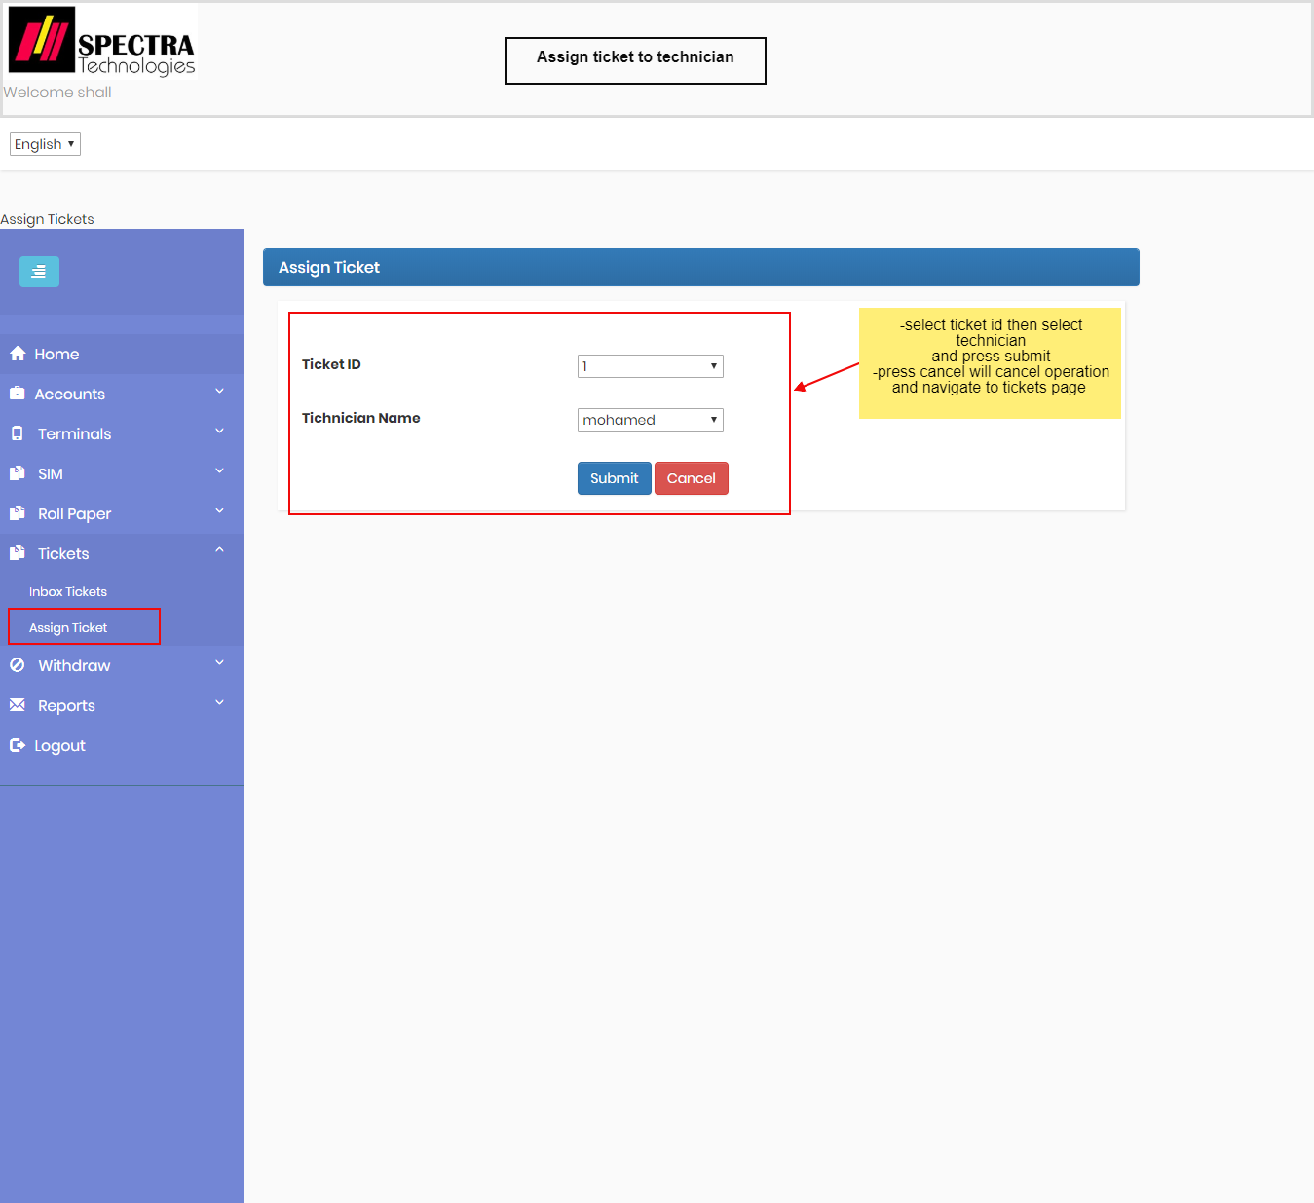

**Withdraw Page**

to add new withdraw

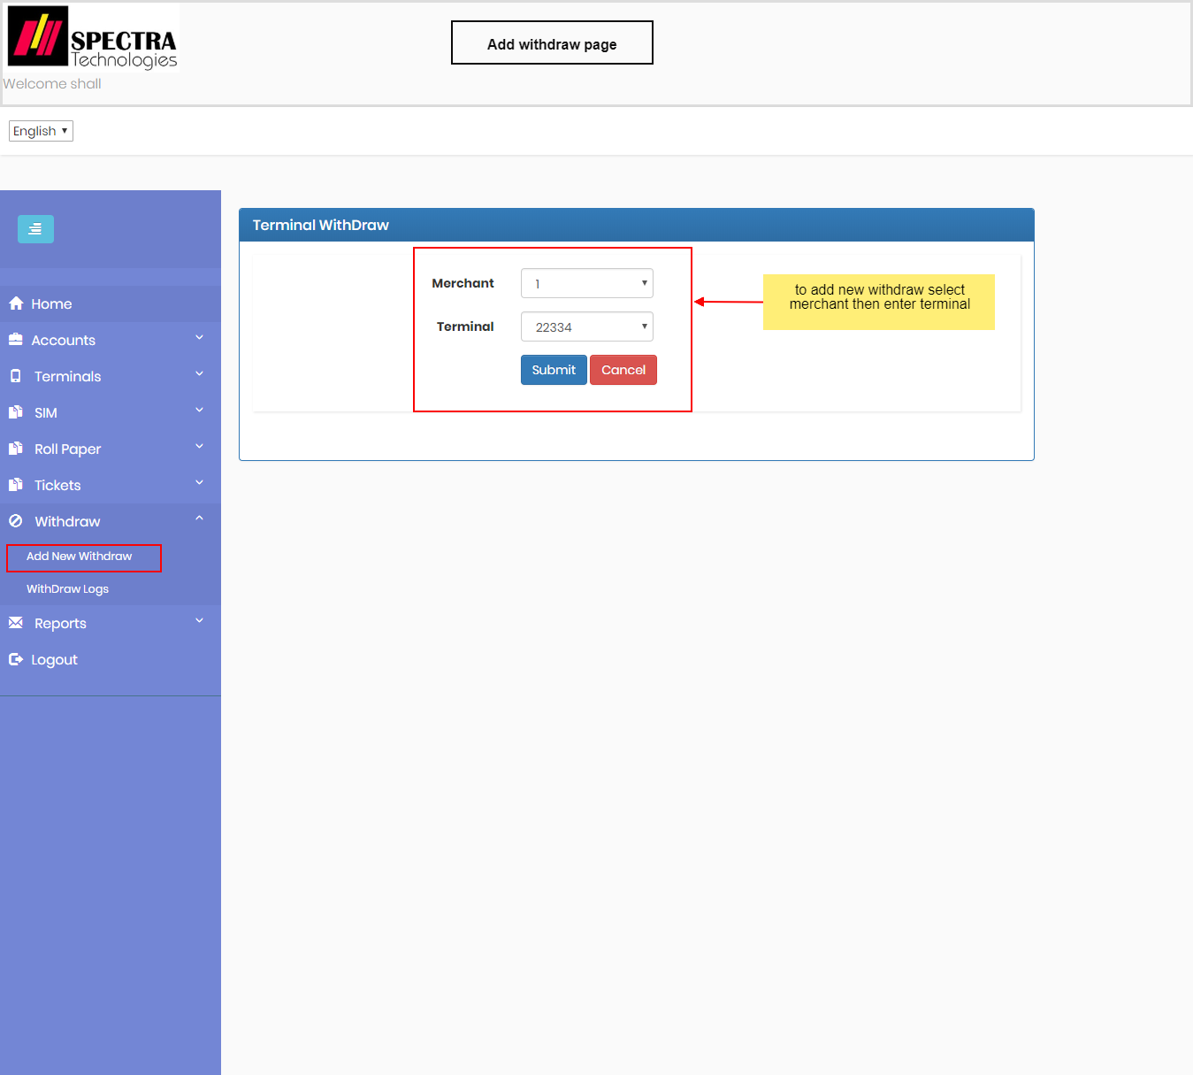

**POS Report**

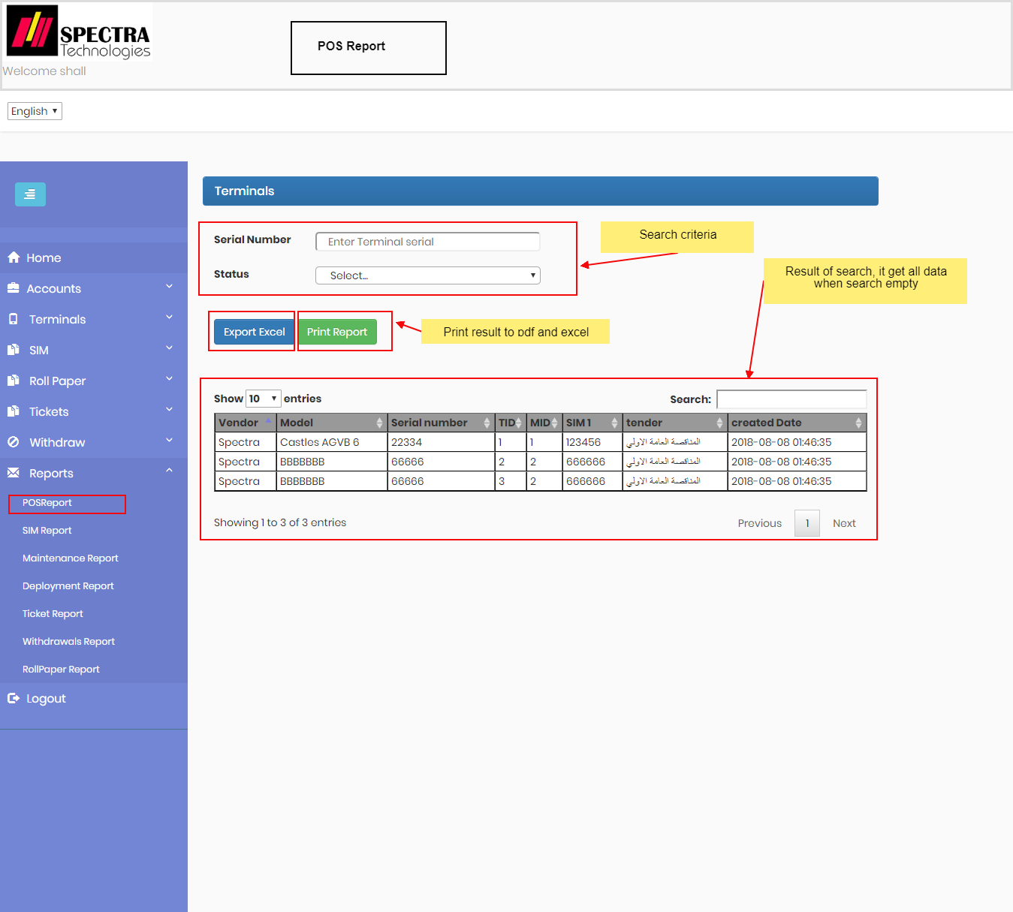

**Change Passsword:**

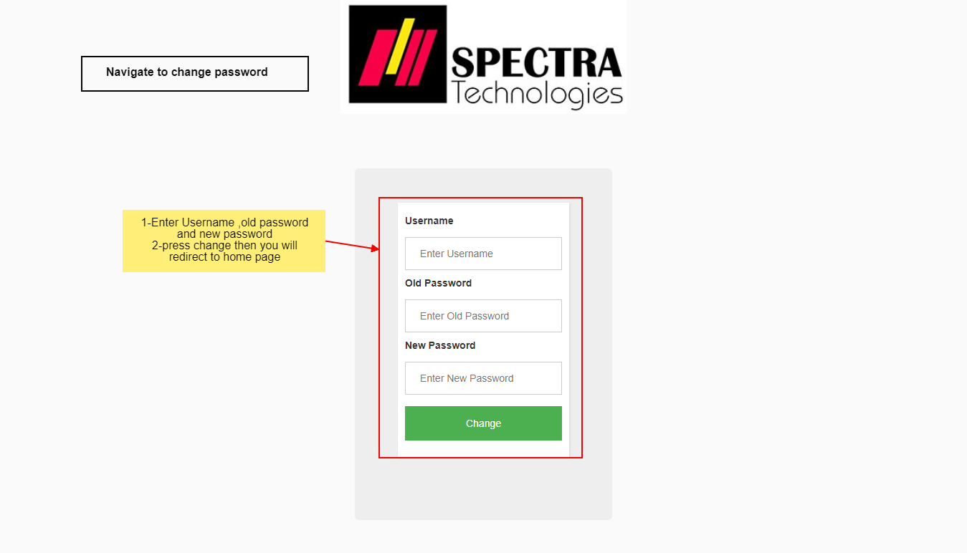

**Logout:**

