Setup windows EC2 Machine:

https://docs.aws.amazon.com/AWSEC2/latest/WindowsGuide/EC2_GetStarted.html

Initial settings so that the basic ping starts between Ansible manager and windows server.

https://stackoverflow.com/questions/21981796/cannot-ping-aws-ec2-instance

Ansible connection for Windows Step by Step setup documentation:
Souce: https://www.ansible.com/blog/connecting-to-a-windows-host

Step 1: Setting up WinRM
With WinRM you can obtain hardware data from WS-Management protocol implementations running on non-Windows operating systems (in this specific case, Linux).
To Connect:
(a) Run this script on remote windows terminal as Administrator: https://raw.githubusercontent.com/ansible/ansible/devel/examples/scripts/ConfigureRemotingForAnsible.ps1
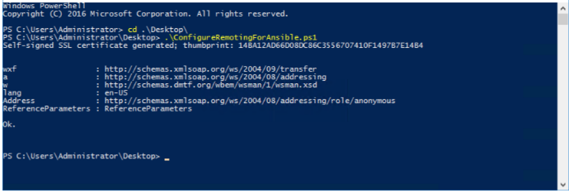

Step 2: Install Pywinrm
On Ansible machine, run:
pip install pywinrm

Step 3: Modify inventory file appropriately:

Below are configuration I did.
Detailed explanations inline:
[Windows]
172.31.33.44 #Pubmic IP
[Windows:vars]
ansible_user=Administrator
ansible_password=l7xqHM)Vy!Cnb;9pQPbk;Dle4Eu6AvGR
ansible_ssh_port=5985
ansible_connection=winrm
ansible_winrm_server_cert_validation=ignore

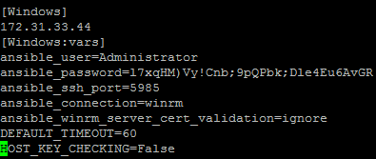
After doing this setup, I got below error:
[ec2-user@ip-172-31-39-150 ~]$ ansible windows -m win_ping
3.16.162.27 | UNREACHABLE! => {
"changed": false,
"msg": "plaintext: HTTPConnectionPool(host='3.16.162.27', port=5985): Max retries exceeded with url: /wsman (Caused by ConnectTimeoutError(<urllib3.connection.HTTPConnection object at 0x7fead4143190>, 'Connection to 3.16.162.27 timed out. (connect timeout=30)'))",
"unreachable": true
}
The error is about connection timeout.
Connection timeout Can be troubleshooted in 3 primary ways:

- Make sure the firewall is not set to block the configured WinRM listener ports
For this, I disabled the firewall on windows EC2 inatance. This was done just for test purpose.
- Ensure that a WinRM listener is enabled on the port and path set by the host vars
To test this, I used command:
winrm enumerate winrm/config/listener
It showed the ports are open
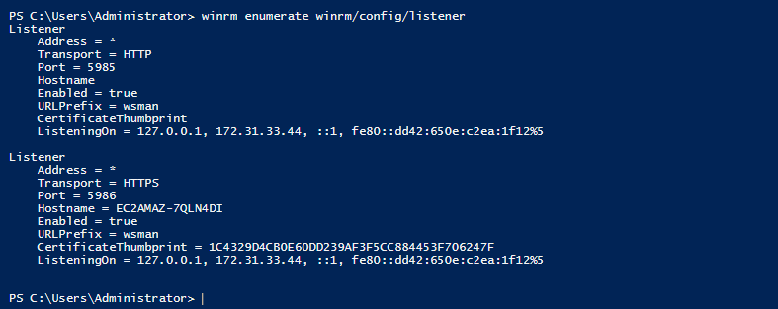

- (3) Ensure that the winrm service is running on the Windows host and configured for automatic start
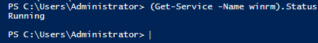
I will revisit for more troubleshoot.
However, since the test allows just to explain the logic of setup code, I am going for it.
I am developing the code and submitting it as role in my github project.
Please note that this code is not tested.

Approach:
To keep the environment clean and do not disturb the already working setup, I created a separate role for windows installation of Android SDK.

Create Role:
ansible-galaxy init Windows_android-sdk

Edit tasks/main.py with the logic for installation

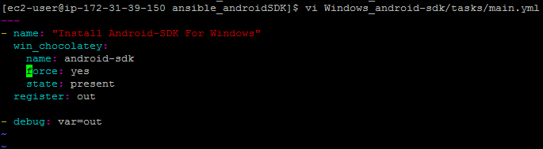
Explanation:
---
- - name: "Install Android-SDK For Windows"
- win_chocolatey:
- name: android-sdk
- force: yes
- state: present
- register: out
- - debug: var=out
Line by line explanations of the above configuration:
- Define the name of the task
- win_chocolatey is the package manager for windows. This is equivalent to yum or apt-get.
- Name of the package is android-sdk
- Forces the install of a package, even if it already is installed.
- When present, will ensure the package is installed.
- Stores the value of the above installation procedure in variable 'out'
- Print the content of 'out' during execution.

Edit the playbook

At the root of the tree, the playbook I have kept as androidSDK.yml
The purposes to keep the logic of windows role in the same playbook was to maintain the structure and syntactical consistency.

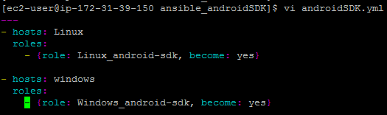
Explanation:
1. ---
- - hosts: Linux
- roles:
- - {role: Linux_android-sdk, become: yes}
- - hosts: windows
- roles:
- - {role: Windows_android-sdk, become: yes}

Lines 1-4: Initialization of playbook and call role Linux_android-sdk to install Android SDK on Linux
- calls windows group of hosts in inventory.
- Roles for windows group
- Call roll Windows_android-sdk with sudo privilege. This role is to install Android SDK on Windows.

Explaining the inventory file

Default inventory file: /etc/ansible/hosts
- [windows]
- 3.16.162.27

- Define the host group called windows
- Define IP address of windows EC2 instance.

Define windows variables in /etc/ansible/group_vars/windows.yml
  - ansible_user=Administraton
  - ansible_password=XXXXXXXXXXX
  - ansible_port=5985
  - ansible_connection=winrm
  - ansible_winrm_server_cert_validation=ignore
Line by line:
    - Define username. Here it is 'Administrator'.
    - 'Define secret password for that use
    - Define WinRM port
    - Define winrm as connection protocol
    - ansible_winrm_server_cert_validation=ignore. This variable tells to ignore the validation of certificate of winrm server. It is used when using default WinRM self-signed certificates

Finally, run the playbook

It passed the Linux part but failed in windows part with connection timelout error.
I will debug this if I get more time by the evaluator.

