1. Install Ansible:

root@instance-2:/home/manish_sharma0201cs/ansible# apt-get install ansible

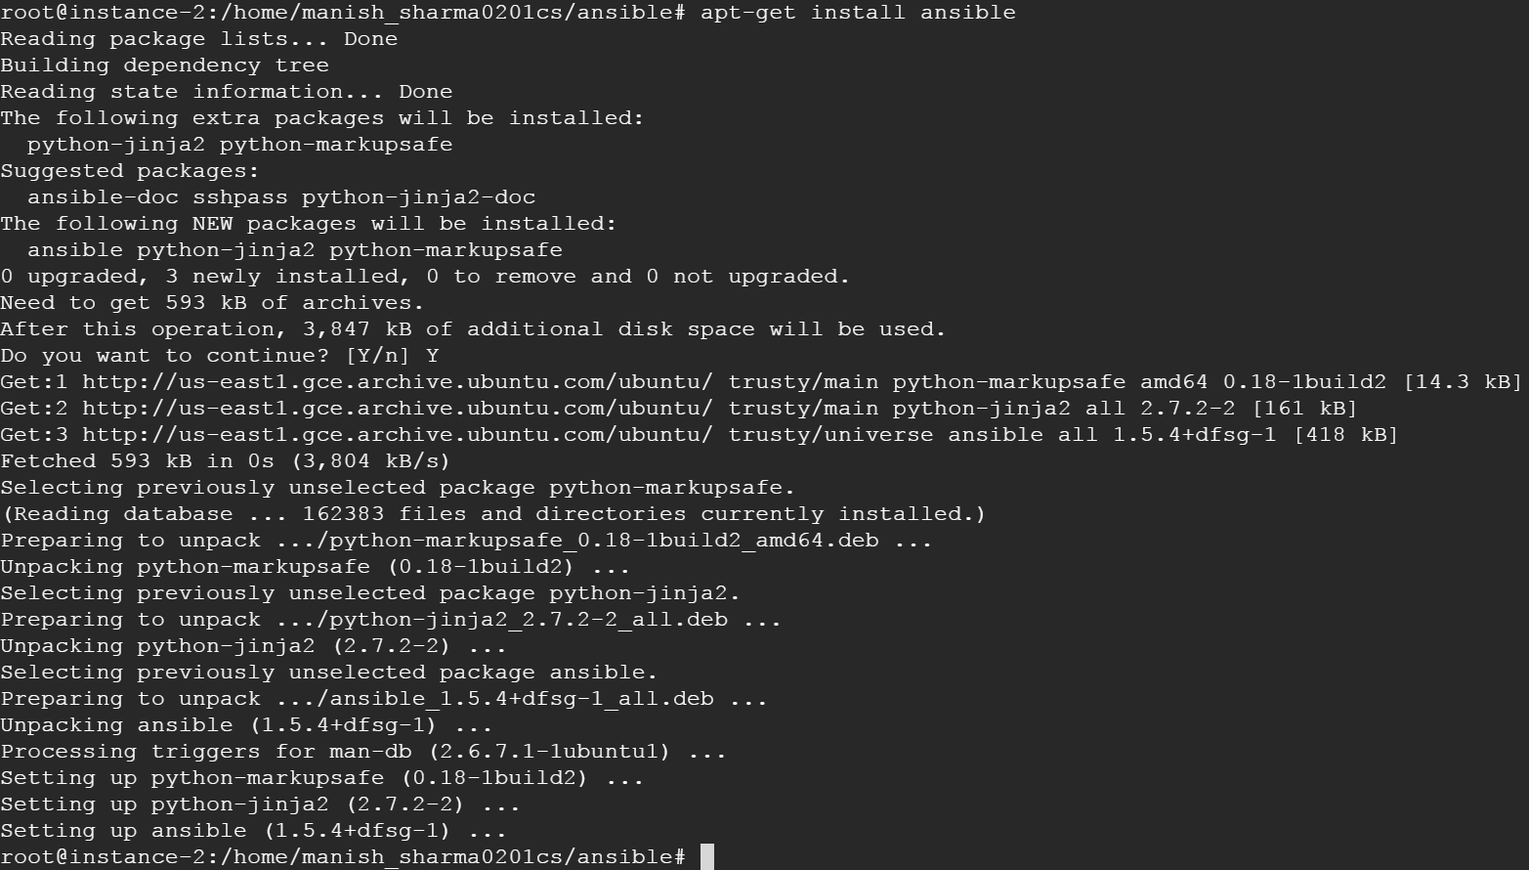

1. Create an ansible user:

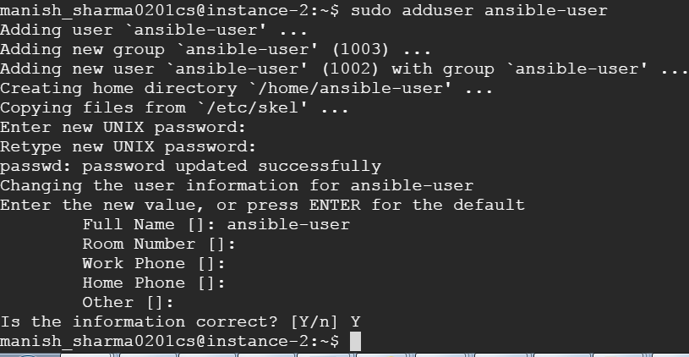

Similarly, create the same user in the managed hosts.

1. Generate ssh key for this user

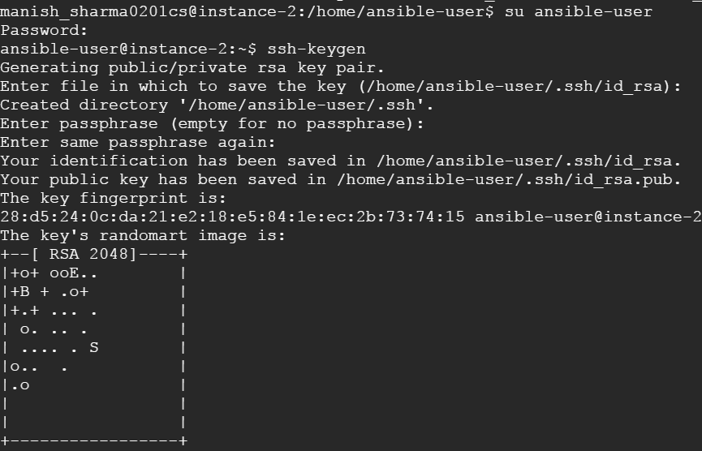

1. Copy this ssh key to managed hosts
2. Add these managed hosts to the config file: /etc/ansible/hosts

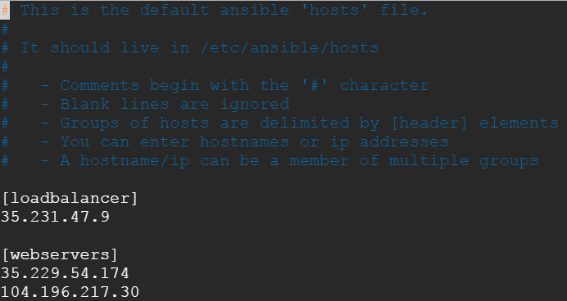

1. Now test the connections:

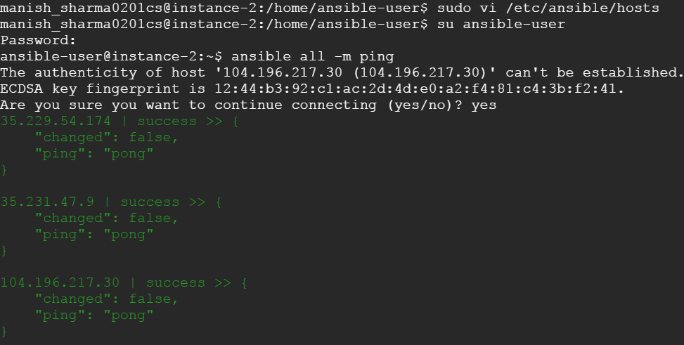

1. Add ansible-user in sudoers file in all these servers

* sudo su
* chmod 755 sudoers
* vi sudoers

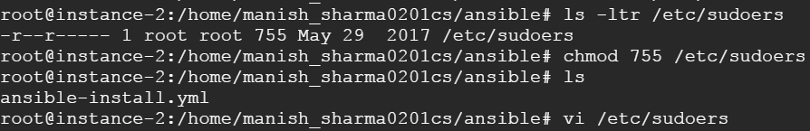



Haproxy playbook  
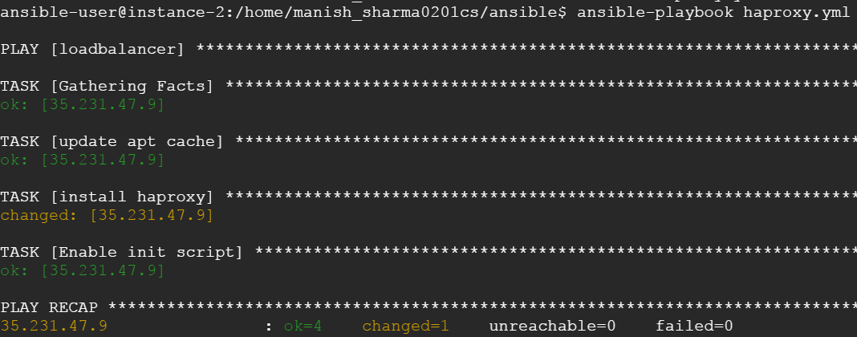

Check if haproxy worked good

