**Task 3**

We have a nested object, we would like a function that you pass in the object and a key and get back the value. How this is implemented is up to you.

**Example Inputs**

object = {“a”:{“b”:{“c”:”d”}}}

key = a/b/c

object = {“x”:{“y”:{“z”:”a”}}}

key = x/y/z

value = a

**Solution** –

Created a script inside scripts directory as json_parser.py

Here I have created a python script that performs the desired task that runs below commands

import json

import sys

a = sys.argv[1]

data = json.loads(a)

key = "[\'" + sys.argv[2].replace("/","\'][\'") + "\']"

query = "data" + key

print("key provided: ", key)

print("The json/dictionary pattern passed: ", data)

print("The final query derived: ", query)

print("The result of the query is: ")

print(eval(query))

It takes json string and key pattern as input and prints the desired output.

**Usage:**

python json_parser.py <json string pattern> <slash separated key pattern>

**Sample Input**

python json_parser.py '{"a":{"b":{"c":"d"}}}' 'a/b/c'



**Sample output**

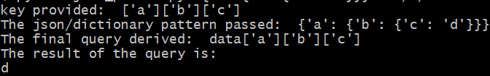

Scope of improvements –

1. Exception handling
2. Usage demo to the user
3. Detect key pattern not slash separated
4. Put the logic inside function