**Closed-loop discovery of High-hardness multi-principal element alloys**

**Figure 1:** Schematic of Closed-Loop discovery of high hardness multi-principal element alloys

Ranked candidate list from PAL 2.0

Update Training Data

Retrain surrogate models

Experimentalists prescreen the recommended alloys

Manufacture and Measure HV

**Objectives:**

The overarching goal of this research is to use newly developed computational tools to discover new high-hardness multi-principal element alloys (MPEA) that are particularly suitable for space actuation. We use the codebase developed in the Clancy Lab, PAL 2.0, as a ‘feedback loop’ with the APL experimental team (led by Dr. Grienger) to perform active discovery of MPEAs, in which the experimental database is used to suggest the next compositions of MPEAs to test and subsequently add to the database and then those results are used for the next ‘cycle’ of machine learning-derived predictions of the next compositions to test.

**Achievements:**

**Figure 2:** Measure Hardness Values for alloy recommendations based on the PAL 2.0 algorithm over two closed-loop cycles.

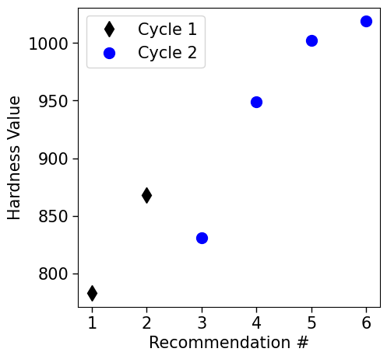

The novel combination of the PAL 2.0 algorithm with experiments in the loop has enabled us to identify high hardness MPEAs within 2-cycles of recommending and manufacturing. We first built predictive chemistry-based models that link the elemental properties to the hardness value of the material. This allowed us to predict the hardness values of materials that were previously unknown. As a result, the first set of recommendations from the PAL 2.0 algorithms resulted in the identification of alloys with hardness values of 868 and 763. Using this information as feedback to relearn the model, the computational team proposed a second set of alloys to manufacture. The experimental team was able to manufacture 10 alloys in the second round of manufacturing in which we were able to identify 3 new alloys with hardness values exceeding 1000. Figure 2 shows the dramatic improvements in the recommendations within just one closed-loop cycle.

To give a context for these improvements, we are exploring a dataset in over 600 alloys out of which we have hardness values for 300. Out of the 300 alloys, only 4 had hardness values above 1000 and within 2 cycles of a chemistry-informed search of the remaining 300 alloys, we have been able to identify another 2 with high hardness. This shows that the proposed approach is powerful in recommending materials with optimal properties within very few feedback cycles thereby accelerating materials discovery.