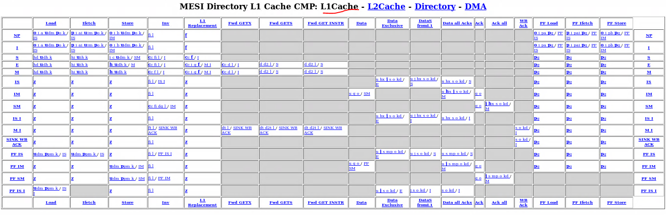

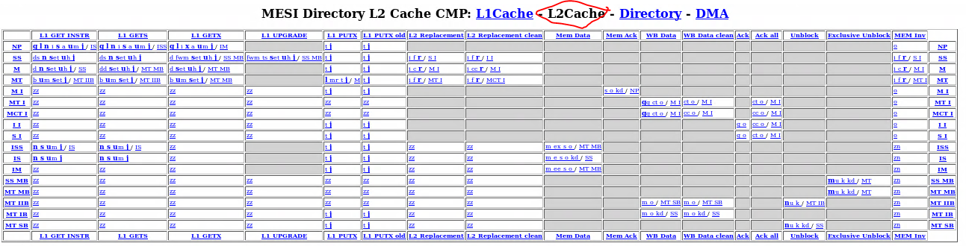

MESI_Two_Level-dir.sm: action(a_sendAck, "a", desc="Send ack to L2") {

MESI_Two_Level-dir.sm: action(d_sendData, "d", desc="Send data to requestor") {

MESI_Two_Level-dir.sm: action(aa_sendAck, "aa", desc="Send ack to L2") {

MESI_Two_Level-dir.sm: action(j_popIncomingRequestQueue, "j", desc="Pop incoming request queue") {

MESI_Two_Level-dir.sm: action(k_popIncomingResponseQueue, "k", desc="Pop incoming request queue") {

MESI_Two_Level-dir.sm: action(l_popMemQueue, "q", desc="Pop off-chip request queue") {

MESI_Two_Level-dir.sm: action(kd_wakeUpDependents, "kd", desc="wake-up dependents") {

MESI_Two_Level-dir.sm: action(qf_queueMemoryFetchRequest, "qf", desc="Queue off-chip fetch request") {

MESI_Two_Level-dir.sm: action(qw_queueMemoryWBRequest, "qw", desc="Queue off-chip writeback request") {

MESI_Two_Level-dir.sm: action(qf_queueMemoryFetchRequestDMA, "qfd", desc="Queue off-chip fetch request") {

MESI_Two_Level-dir.sm: action(p_popIncomingDMARequestQueue, "p", desc="Pop incoming DMA queue") {

MESI_Two_Level-dir.sm: action(dr_sendDMAData, "dr", desc="Send Data to DMA controller from directory") {

MESI_Two_Level-dir.sm: action(qw_queueMemoryWBRequest_partial, "qwp",

MESI_Two_Level-dir.sm: action(da_sendDMAAck, "da", desc="Send Ack to DMA controller") {

MESI_Two_Level-dir.sm: action(z_stallAndWaitRequest, "z", desc="recycle request queue") {

MESI_Two_Level-dir.sm: action(zz_recycleDMAQueue, "zz", desc="recycle DMA queue") {

MESI_Two_Level-dir.sm: action(inv_sendCacheInvalidate, "inv", desc="Invalidate a cache block") {

MESI_Two_Level-dir.sm: action(drp_sendDMAData, "drp", desc="Send Data to DMA controller from incoming PUTX") {

MESI_Two_Level-dir.sm: action(v_allocateTBE, "v", desc="Allocate TBE") {

MESI_Two_Level-dir.sm: action(qw_queueMemoryWBRequest_partialTBE, "qwt",

MESI_Two_Level-dir.sm: action(w_deallocateTBE, "w", desc="Deallocate TBE") {

MESI_Two_Level-dma.sm: action(s_sendReadRequest, "s", desc="Send a DMA read request to memory") {

MESI_Two_Level-dma.sm: action(s_sendWriteRequest, "\s", desc="Send a DMA write request to memory") {

MESI_Two_Level-dma.sm: action(a_ackCallback, "a", desc="Notify dma controller that write request completed") {

MESI_Two_Level-dma.sm: action(d_dataCallback, "d", desc="Write data to dma sequencer") {

MESI_Two_Level-dma.sm: action(t_updateTBEData, "t", desc="Update TBE Data") {

MESI_Two_Level-dma.sm: action(v_allocateTBE, "v", desc="Allocate TBE entry") {

MESI_Two_Level-dma.sm: action(w_deallocateTBE, "w", desc="Deallocate TBE entry") {

MESI_Two_Level-dma.sm: action(p_popRequestQueue, "p", desc="Pop request queue") {

MESI_Two_Level-dma.sm: action(p_popResponseQueue, "\p", desc="Pop request queue") {

MESI_Two_Level-dma.sm: action(zz_stallAndWaitRequestQueue, "zz", desc="...") {

MESI_Two_Level-dma.sm: action(wkad_wakeUpAllDependents, "wkad", desc="wake-up all dependents") {

MESI_Two_Level-L1cache.sm: action(a_issueGETS, "a", desc="Issue GETS") {

MESI_Two_Level-L1cache.sm: action(pa_issuePfGETS, "pa", desc="Issue prefetch GETS") {

MESI_Two_Level-L1cache.sm: action(ai_issueGETINSTR, "ai", desc="Issue GETINSTR") {

MESI_Two_Level-L1cache.sm: action(pai_issuePfGETINSTR, "pai",desc="Issue GETINSTR for prefetch request")

MESI_Two_Level-L1cache.sm: action(b_issueGETX, "b", desc="Issue GETX") {

MESI_Two_Level-L1cache.sm: action(pb_issuePfGETX, "pb", desc="Issue prefetch GETX") {

MESI_Two_Level-L1cache.sm: action(c_issueUPGRADE, "c", desc="Issue GETX") {

MESI_Two_Level-L1cache.sm: action(d_sendDataToRequestor, "d", desc="send data to requestor") {

MESI_Two_Level-L1cache.sm: action(d2_sendDataToL2, "d2", desc="send data to the L2 cache because of M downgrade") {

MESI_Two_Level-L1cache.sm: action(dt_sendDataToRequestor_fromTBE, "dt", desc="send data to requestor") {

MESI_Two_Level-L1cache.sm: action(d2t_sendDataToL2_fromTBE, "d2t", desc="send data to the L2 cache") {

MESI_Two_Level-L1cache.sm: action(e_sendAckToRequestor, "e", desc="send invalidate ack to requestor (could be L2 or L1)") {

MESI_Two_Level-L1cache.sm: action(f_sendDataToL2, "f", desc="send data to the L2 cache") {

MESI_Two_Level-L1cache.sm: action(ft_sendDataToL2_fromTBE, "ft", desc="send data to the L2 cache") {

MESI_Two_Level-L1cache.sm: action(fi_sendInvAck, "fi", desc="send data to the L2 cache") {

MESI_Two_Level-L1cache.sm: action(forward_eviction_to_cpu, "\cc", desc="sends eviction information to the processor") {

MESI_Two_Level-L1cache.sm: action(g_issuePUTX, "g", desc="send data to the L2 cache") {

MESI_Two_Level-L1cache.sm: action(j_sendUnblock, "j", desc="send unblock to the L2 cache") {

MESI_Two_Level-L1cache.sm: action(jj_sendExclusiveUnblock, "\j", desc="send unblock to the L2 cache") {

MESI_Two_Level-L1cache.sm: action(dg_invalidate_sc, "dg",

MESI_Two_Level-L1cache.sm: action(h_load_hit, "hd",

MESI_Two_Level-L1cache.sm: action(h_ifetch_hit, "hi", desc="Notify sequencer the instruction fetch completed.")

MESI_Two_Level-L1cache.sm: action(hx_load_hit, "hx", desc="Notify sequencer the load completed.")

MESI_Two_Level-L1cache.sm: action(hh_store_hit, "\h", desc="Notify sequencer that store completed.")

MESI_Two_Level-L1cache.sm: action(hhx_store_hit, "\hx", desc="Notify sequencer that store completed.")

MESI_Two_Level-L1cache.sm: action(i_allocateTBE, "i", desc="Allocate TBE (isPrefetch=0, number of invalidates=0)") {

MESI_Two_Level-L1cache.sm: action(k_popMandatoryQueue, "k", desc="Pop mandatory queue.") {

MESI_Two_Level-L1cache.sm: action(l_popRequestQueue, "l",

MESI_Two_Level-L1cache.sm: action(o_popIncomingResponseQueue, "o",

MESI_Two_Level-L1cache.sm: action(s_deallocateTBE, "s", desc="Deallocate TBE") {

MESI_Two_Level-L1cache.sm: action(u_writeDataToL1Cache, "u", desc="Write data to cache") {

MESI_Two_Level-L1cache.sm: action(q_updateAckCount, "q", desc="Update ack count") {

MESI_Two_Level-L1cache.sm: action(ff_deallocateL1CacheBlock, "\f", desc="Deallocate L1 cache block. Sets the cache to not present, allowing a replacement in parallel with a fetch.") {

MESI_Two_Level-L1cache.sm: action(oo_allocateL1DCacheBlock, "\o", desc="Set L1 D-cache tag equal to tag of block B.") {

MESI_Two_Level-L1cache.sm: action(pp_allocateL1ICacheBlock, "\p", desc="Set L1 I-cache tag equal to tag of block B.") {

MESI_Two_Level-L1cache.sm: action(z_stallAndWaitMandatoryQueue, "\z", desc="recycle L1 request queue") {

MESI_Two_Level-L1cache.sm: action(kd_wakeUpDependents, "kd", desc="wake-up dependents") {

MESI_Two_Level-L1cache.sm: action(uu_profileInstMiss, "\uim", desc="Profile the demand miss") {

MESI_Two_Level-L1cache.sm: action(uu_profileInstHit, "\uih", desc="Profile the demand hit") {

MESI_Two_Level-L1cache.sm: action(uu_profileDataMiss, "\udm", desc="Profile the demand miss") {

MESI_Two_Level-L1cache.sm: action(uu_profileDataHit, "\udh", desc="Profile the demand hit") {

MESI_Two_Level-L1cache.sm: action(po_observeMiss, "\po", desc="Inform the prefetcher about the miss") {

MESI_Two_Level-L1cache.sm: action(ppm_observePfMiss, "\ppm",

MESI_Two_Level-L1cache.sm: action(pq_popPrefetchQueue, "\pq", desc="Pop the prefetch request queue") {

MESI_Two_Level-L1cache.sm: action(mp_markPrefetched, "mp", desc="Write data from response queue to cache") {

MESI_Two_Level-L2cache.sm: action(a_issueFetchToMemory, "a", desc="fetch data from memory") {

MESI_Two_Level-L2cache.sm: action(b_forwardRequestToExclusive, "b", desc="Forward request to the exclusive L1") {

MESI_Two_Level-L2cache.sm: action(c_exclusiveReplacement, "c", desc="Send data to memory") {

MESI_Two_Level-L2cache.sm: action(c_exclusiveCleanReplacement, "cc", desc="Send ack to memory for clean replacement") {

MESI_Two_Level-L2cache.sm: action(ct_exclusiveReplacementFromTBE, "ct", desc="Send data to memory") {

MESI_Two_Level-L2cache.sm: action(d_sendDataToRequestor, "d", desc="Send data from cache to reqeustor") {

MESI_Two_Level-L2cache.sm: action(dd_sendExclusiveDataToRequestor, "dd", desc="Send data from cache to reqeustor") {

MESI_Two_Level-L2cache.sm: action(ds_sendSharedDataToRequestor, "ds", desc="Send data from cache to reqeustor") {

MESI_Two_Level-L2cache.sm: action(e_sendDataToGetSRequestors, "e", desc="Send data from cache to all GetS IDs") {

MESI_Two_Level-L2cache.sm: action(ex_sendExclusiveDataToGetSRequestors, "ex", desc="Send data from cache to all GetS IDs") {

MESI_Two_Level-L2cache.sm: action(ee_sendDataToGetXRequestor, "ee", desc="Send data from cache to GetX ID") {

MESI_Two_Level-L2cache.sm: action(f_sendInvToSharers, "f", desc="invalidate sharers for L2 replacement") {

MESI_Two_Level-L2cache.sm: action(fw_sendFwdInvToSharers, "fw", desc="invalidate sharers for request") {

MESI_Two_Level-L2cache.sm: action(fwm_sendFwdInvToSharersMinusRequestor, "fwm", desc="invalidate sharers for request, requestor is sharer") {

MESI_Two_Level-L2cache.sm: action(i_allocateTBE, "i", desc="Allocate TBE for request") {

MESI_Two_Level-L2cache.sm: action(s_deallocateTBE, "s", desc="Deallocate external TBE") {

MESI_Two_Level-L2cache.sm: action(jj_popL1RequestQueue, "\j", desc="Pop incoming L1 request queue") {

MESI_Two_Level-L2cache.sm: action(k_popUnblockQueue, "k", desc="Pop incoming unblock queue") {

MESI_Two_Level-L2cache.sm: action(o_popIncomingResponseQueue, "o", desc="Pop Incoming Response queue") {

MESI_Two_Level-L2cache.sm: action(m_writeDataToCache, "m", desc="Write data from response queue to cache") {

MESI_Two_Level-L2cache.sm: action(mr_writeDataToCacheFromRequest, "mr", desc="Write data from response queue to cache") {

MESI_Two_Level-L2cache.sm: action(q_updateAck, "q", desc="update pending ack count") {

MESI_Two_Level-L2cache.sm: action(qq_writeDataToTBE, "\qq", desc="Write data from response queue to TBE") {

MESI_Two_Level-L2cache.sm: action(ss_recordGetSL1ID, "\s", desc="Record L1 GetS for load response") {

MESI_Two_Level-L2cache.sm: action(xx_recordGetXL1ID, "\x", desc="Record L1 GetX for store response") {

MESI_Two_Level-L2cache.sm: action(set_setMRU, "\set", desc="set the MRU entry") {

MESI_Two_Level-L2cache.sm: action(qq_allocateL2CacheBlock, "\q", desc="Set L2 cache tag equal to tag of block B.") {

MESI_Two_Level-L2cache.sm: action(rr_deallocateL2CacheBlock, "\r", desc="Deallocate L2 cache block. Sets the cache to not present, allowing a replacement in parallel with a fetch.") {

MESI_Two_Level-L2cache.sm: action(t_sendWBAck, "t", desc="Send writeback ACK") {

MESI_Two_Level-L2cache.sm: action(ts_sendInvAckToUpgrader, "ts", desc="Send ACK to upgrader") {

MESI_Two_Level-L2cache.sm: action(uu_profileMiss, "\um", desc="Profile the demand miss") {

MESI_Two_Level-L2cache.sm: action(uu_profileHit, "\uh", desc="Profile the demand hit") {

MESI_Two_Level-L2cache.sm: action(nn_addSharer, "\n", desc="Add L1 sharer to list") {

MESI_Two_Level-L2cache.sm: action(nnu_addSharerFromUnblock, "\nu", desc="Add L1 sharer to list") {

MESI_Two_Level-L2cache.sm: action(kk_removeRequestSharer, "\k", desc="Remove L1 Request sharer from list") {

MESI_Two_Level-L2cache.sm: action(ll_clearSharers, "\l", desc="Remove all L1 sharers from list") {

MESI_Two_Level-L2cache.sm: action(mm_markExclusive, "\m", desc="set the exclusive owner") {

MESI_Two_Level-L2cache.sm: action(mmu_markExclusiveFromUnblock, "\mu", desc="set the exclusive owner") {

MESI_Two_Level-L2cache.sm: action(zz_stallAndWaitL1RequestQueue, "zz", desc="recycle L1 request queue") {

MESI_Two_Level-L2cache.sm: action(zn_recycleResponseNetwork, "zn", desc="recycle memory request") {

MESI_Two_Level-L2cache.sm: action(kd_wakeUpDependents, "kd", desc="wake-up dependents") {