ECE 511 Assignment 3

Markov Data Predictor

Vikram Sharma Mailthody

(NetID- vsm2, UIN - 663250535)

Contents

Goals of the Assignment: 3

Software used: 3

Tasks: 3

Introduction: 3

Report organization: 4

Default Branch Predictors: 4

Baseline architecture: 4

Stride Prefetcher: 4

Markov Prefecher: 5

Working principle: 5

Modifications in default repository: 6

Implementation details/pending items: 7

Results: 8

Discussions: 11

Ending thoughts: 12

References: 12

# Goals of the Assignment:

1. Understand different types of data predictors– tagged, stride and Markov
2. Analyze the performance difference between tagged, stride and Markov with MI, MESI coherence protocol
3. Build MSI coherence protocol
4. Analyze how coherence protocol MSI effects the performance

More details of the assignment can be found [here](http://courses.engr.illinois.edu/ece511/secure/homework/assignment2.pdf). [10]

# Software used:

Gem5 and its dependencies

# Tasks:

The assignment requires to submit 2 results (checkpoint and final). Following are the main steps involved for completing the assignment.

1. Use fs.py as the default script for running the full system emulation
2. Section 2 - run fs.py with default L1,L2 cache sizes and in ruby model.
3. Run tagged, stride model with 4 different benchmarks - bodytrack, blackholes, fludanimate, x264 for each of coherence protocol – MI, MESI.
4. Write code for Markov based data predictors
5. Write code for MSI coherence block
6. Run MSI and Markov modes with 4 bench marks.
7. Analyze the data obtained in these configuration and provide comments

For checkpoint – task 1, 2, 3,4 and 6 are completed.

# Introduction:

Gem5 is a computer system simulator platform initially developed at University of Wisconsin-Madison Square (there are several other collaborators like MIT, UMich, ARM, etc). It’s a modular simulator allowing the user to parameterize, extend and rearrange as required. The simulator supports both x86 and ARM ISA allowing the user the flexibility of choice. The simulator is primarily developed using C++ language and scripts to run are typically written in python. There are two main modes of operation when using the simulator – system call emulation mode and full system mode (se and fs respectively). The System call emulation mode is mainly used to simulate a binary file that are linked statically or dynamically. The full system mode runs complete system with choice of operating system to boot in the simulation environment. Further gem5 supports configurable CPU models, pluggable memory systems and device models providing flexibility, availably and enhancing collaboration for the computer system researcher.[1]

For this assignment, we will be using x86 ISA and Full System emulation mode. The primarily goal of this assignment is to understand how data prediction works, different types of predictors and understand importance of coherence protocol. 5 benchmarks are used to measure the hardware requirement, displacement of useful data, coverage, timeliness and effect on bandwidth with each of these predictors.

The checkpoint report would discuss about Markov predictor and analyze its results with existing ones. Further optimization would not be taken care in the checkpoint report. Next report would have information on optimization and also MSI coherence implementation.

# Report organization:

Next section describes about existing predictor results. Followed by Markov predictor design will be discussed. In the next section, Markov predictor design is discussed. Lastly, analyses of these predictors with different bench marks is studied and compared.

# Default Branch Predictors:

## Baseline architecture:

In order to measure the conditional branch predictor accuracy, system design shown in figure 1 is used. It houses:

* 8 core out of order x86 ISA based full system with TimingSimpleCPU configuration
* Ruby model memory and cache
* Vmlinux kernel, Ubuntu OS.
* 8 L2 cache and with crossbar topology.
* DDR3 1600 memory



Figure 1: High level baseline architecture for branch prediction

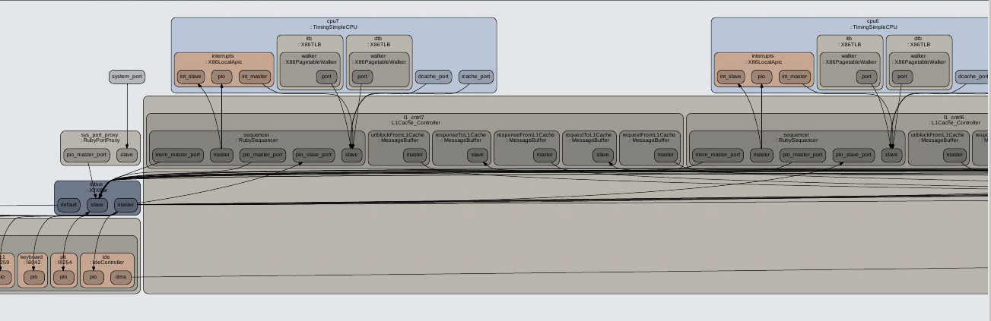

Figure 2: Zoomed version of the same.

## Stride Prefetcher:

The stride prefetcher that is available in gem5 is a cache block address based. The other kind of prefetcher is instruction program counter based. Instruction based prefetcher record the distance between the memory addresses references by a load instruction as well as the last address reference by the load. Next time the same load instruction is fetched, prefetch of last address and stride occurs. However in gem5 current implementation, I believe cache block address based stride prefetching is used. The main benefit of cache block address based prefetching is that it can detect A, A+N, A+2N… addresses. This is accomplished by using stream buffers in current stride implementation. Further, the same stream buffer can be used as data storage block which is what is done in the gem5. Figure 3 shows high level data structure of stride prefetcher.

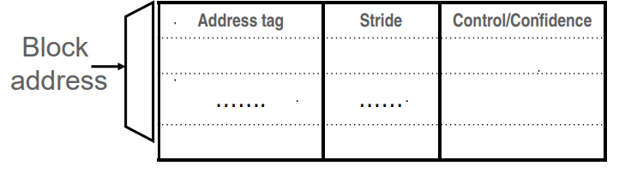

Figure 3:High level view of gem5 stride prefetcher.

Working principle:

1. Each stream buffer can hold one stream of sequentially prefetched cache lines
2. When a load is missed, head of all the stream buffers are checked for address match.
   1. If hit, an enetry from FIFO is popped and cache is updated with data
   2. If miss, allocate a new stream buffer to the miss address. The gem5 implementation does recycle of the stream buffer using LRU policy when full.
   3. Issuance of address will not happen at page boundary
   4. A valid bit is also used to speed up the hit checking.
3. Stream buffer FIFOs are continuously popped with subsequent cache lines whenever there is a room and the bus is not busy.
4. In gem5, prediction mechanism is employed for non-unit strides.

# Markov Prefecher:

Markov prefetcher are advance version of correlation based prefetcher. I basic idea is to predict the next address to be fetched based on recent history of previous address misses and markov model of those recent history transitions. Figure 5 shows the Markov model and Figure 6 represent how it will be implemented in the gem5.

## Working principle:

1. Track the likely next address after seeing a particular address
2. Increase coverage to increase prefetch accuracy. This can be done by prefetching N next addresses. The drop in accuracy can be attributed to arbitrary access patterns that occur in Markov model.
3. Prefetch accuracy can be improved by using longer history. Here in implementation upto 6 history are considered.

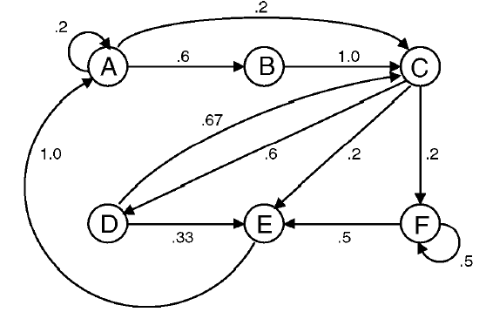

Figure 5: Markov model as described in paper.

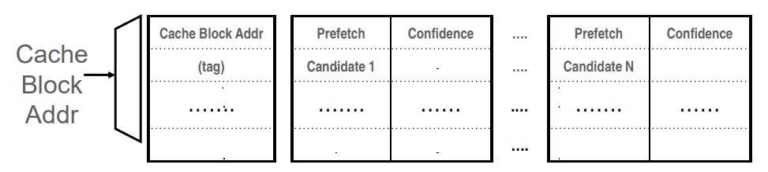

Figure 6: Markov model implemented in gem5.

## Modifications in default repository:

The Markov Prefetcher is designed as per figure 7. It consists for three main components, MarkovTable, M_array and LRU module. Specifics and working of these blocks are listed below:

1. Markov Table: This tracks the history of previous miss and associated tag. The table is of 2D array. Each array is called stream. Each stream has list of miss address information.
2. Least recently used (LRU) algorithm: LRU is used to update the Markov table on every miss address hit or miss. Initially the table is allowed to fill arbitrarily. Once the table becomes full, the prioritization automatically occurs because of LRU. Initial latency of fill up is where maximum error of cache miss can occur. IF the table depth is huge, then initial latency can induce more cache misses and could cause drop in accuracy. However this is not yet tested in current gem5 implementation.
3. M_ARRAY table: This table has list of addresses that needs to be prefetched whenever the bus is free. The table is filled up from a stream from Markov Table where there is miss-Address hit. If the miss address is not found in the markov table, then a new address point is added to markov table and next stride values are also issued from the m_array to improvising the cache miss that can occur. This is done assuming the possibility of latency from converting a stream to marray buffer entry. Although it may consume more bandwidth, this may improve the overall accuracy. (In current implementation, the stride prefetcher has LRU implementation for m_array. I am retaining it to check how the results changed. In next set of results this will be optimized. )
4. Whenever miss is observed in the cache, the address is sent to the M_ARRAY and Markov table to find if it’s a hit. If the M_ARRAY has a hit, then address request was in pending issue. The algorithm issues next prefetch address of the same block to avoid second miss which can occur. This is again under the assumption that there can be a second miss. If the hit was found in the Markov table, then the algorithm just updates the LRU so that priority is updated. If M_ARRAY conveys a miss, then it checks in Markov table if there is a hit. If the hit was found in the Markov table, then the algorithm just updates the LRU so that priority is updated. If miss is reported in the markov table, a new entry is added to the Markov table. Whenever another miss occurs after that address, the pre-miss address is updated to reflect the connection creating a new node in markov chain. If the chain exceeds the maximum node that the table can accommodate then the unused entry is replaced with new element.
5. Address going to page boundaries requires to be avoided when using prefetcher. This is done by checking if page boundary conditions and such requests are dropped.

## Implementation details/pending items:

1. A new data structure is created for the stream with vector size for Pre-miss entry. During construction, the pre-miss array is resized to 4.
2. The depth of the markov table is considered to be of 16. Based on paper, they suggest they use about 1MB of space for Markov implementation. Which translate to about 32K entries in the table (assuming 8B addressing, 4 width – 1024*1024/ 4*8). However this is not considered in current runs yet. This will be taken in account in next report.
3. LRU implementation is done on the array update itself to reduce the additional time
4. Stream conversion to m_array is not very well coded. Currently it is done with a help of for loop. This should be later converted to shifting mechanism or simpler implementation.
5. LRU in m_array requires to be removed as it’s a duplicate.

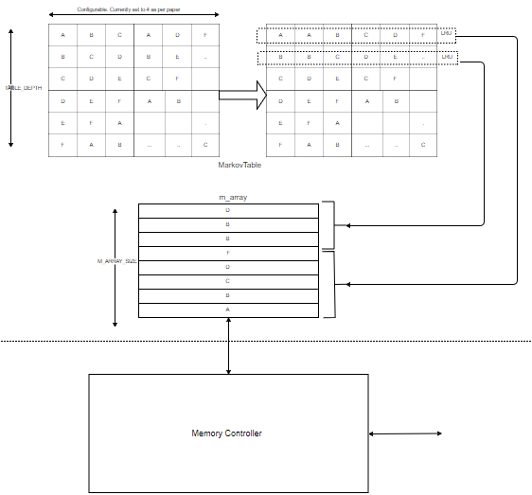

Figure 7: Markov Prefetcher

## Results:

|  |  |  |  |  |  |
| --- | --- | --- | --- | --- | --- |
|  | **MI (only one core worked)** | **no prefetching tagged** | **MESI (multiple core worked)** | | |
|  | **stride** | **stride** | **tagged** | **Markov** |
| BodyTrack | | | | | |
| avg.cache.hits | 275379767 | 61719052 | 478505318 | 61719052 | Could not run - gem5.debug works, not gem5.opt. Time not sufficient |
| avg.cache.miss | 1928389 | 248950 | 9297677 | 248950 |
| avg.cache.access | 277308156 | 61968002 | 487802995 | 61968002 |
| accuracy % | 99.3046043 | 99.59826041 | 98.09396886 | 99.59826041 |
| coverage | 78.91923399 | 97.27852798 | -1.640360561 | 93.47773233 |
| MemBWavgRd | 29.49 | 46.39 | 0.59 | 46.39 |
| MemBWavgWr | 35.03 | 38.44 | 0.73 | 38.44 |
| MCPI | 14.09856962 | 10.18356837 | 12.22811404 | 10.18356837 |
| Blackholes | | | | | |
| avg.cache.hits | 277876202 | 61498945 | 117160015 | 61498945 | Could not run - gem5.debug works, not gem5.opt. Time not sufficient |
| avg.cache.miss | 1359122 | 74692 | 853468 | 74692 |
| avg.cache.access | 279235324 | 61573637 | 118013483 | 61573637 |
| accuracy % | 99.51327003 | 99.87869484 | 99.27680467 | 99.87869484 |
| coverage | 70.84767939 | 99.18348187 | 90.67005713 | 98.04313631 |
| MemBWavgRd | 24.06 | 13.85 | 0.57 | 13.85 |
| MemBWavgWr | 27.89 | 12.65 | 0.8 | 12.65 |
| MCPI | 12.71597773 | 9.898183739 | 10.07219082 | 9.898183739 |
| x264 | | | | | |
| avg.cache.hits | 615592912 | 7434830 | 143087823 | 615592913 | 477048138 |
| avg.cache.miss | 9147623 | 1088468 | 3816924 | 9147623 | 3746497 |
| avg.cache.access | 624740536 | 8523298 | 146904747 | 624740536 | 480794635 |
| accuracy % | 98.53577246 | 87.22949731 | 97.40176946 | 98.53577246 | 99.2207698 |
| coverage | 1 | 88.10108375 | 58.274144 | 0 | 59.044038 |
| MemBWavgRd | 44 | 84 | 5.15 | 44 | 75.12 |
| MemBWavgWr | 52.11 | 42 | 5.07 | 53.95 | 75 |
| MCPI | 18.25502722 | 11.41900957 | 10.43062574 | 18.25502722 | 21.40667934 |
| fluidanimate | | | | | |
| avg.cache.hits | 3564126499 | 2678243 | 693710902 | 3564126499 | 2871504992 |
| avg.cache.miss | 4662140 | 1499535 | 3402812 | 4662140 | 564399 |
| avg.cache.access | 3568788639 | 4177778 | 697113714 | 3568788639 | 2872069391 |
| accuracy % | 99.86936352 | 64.10687691 | 99.51187132 | 99.86936352 | 99.9803487 |
| coverage improvement | 49.03441036 | 83.60738085 | 62.80113424 | 49.03441036 | 87.89399289 |
| MemBWavgRd | 7.97 | 25.2 | 1.02 | 7.97 | 28.3 |
| MemBWavgWr | 8.96 | 17 | 0.99 | 8.96 | 18 |
| MCPI | 12.19341077 | 10.95227499 | 10.58924689 | 12.19341077 | 11.57284288 |

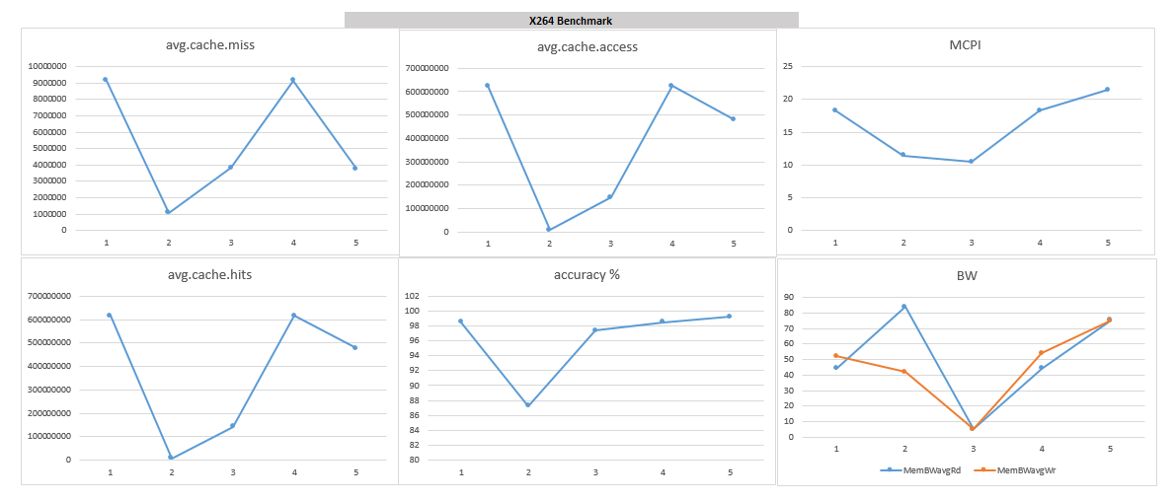

Figure 8: X264 benchmark results

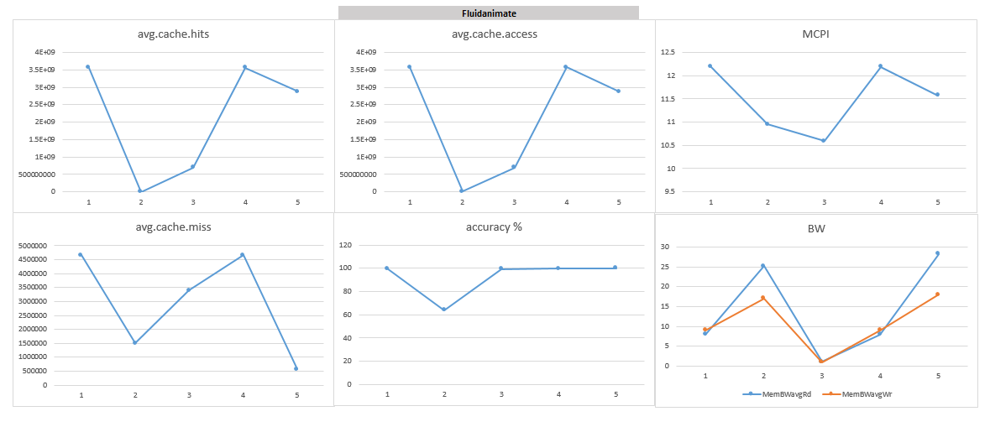

Figure 9: Fluidanimate benchmark results

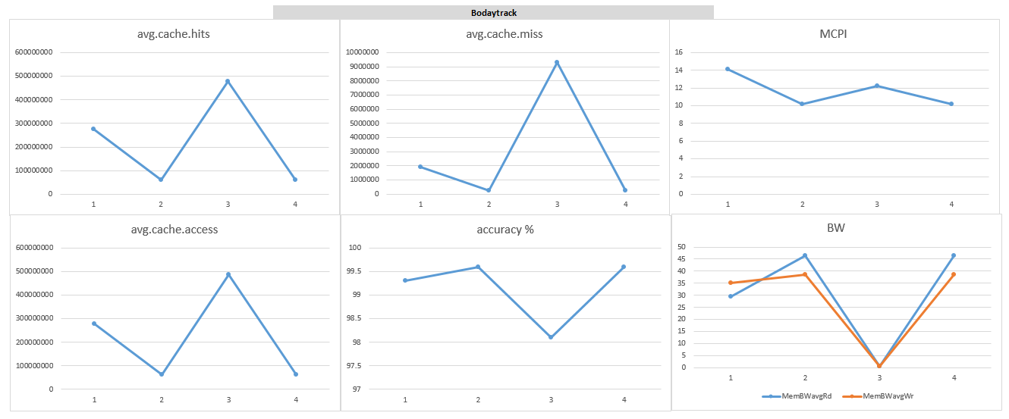

Figure 10: Bodytrack beanchmark results

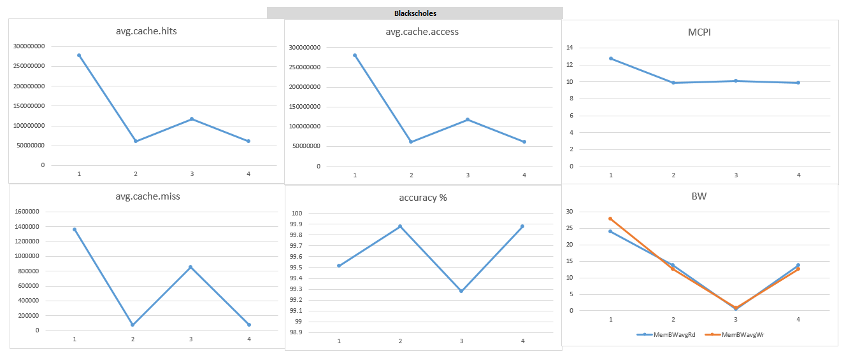

Figure 11: blackscholes benchmark results

## Discussions:

Based on the Table and figures following points can be derived:

* Current implementation of Markov prefetcher induces lot more requests than the other prefetcher which is clearly visible in the graph 3,4,5 in x264. (similar for fluidanimate). This is occurring primarily due to more addresses getting enqeueued in prefetch stage and can be confirmed from MCPI graph. Whenever the bus is free, the memory controller schedules memory request. Current implementation should have added a minimum of 4X more memory requests[4]. However it is introducing more than 7x memory requests. The additional bandwidth I suspect is due to current implementation of m_array table where LRU is not required. Ideally the highest priority in the markov table should be sent as memory request. But current implementation does not guarantee that due to the presence of LRU.
* Displacement of useful data is definitely increased in Markov implementation. Increased bandwidth is not translating to average cache access which means that there are lot of unnecessary data just being requested for no purposes. This can introduce latency for required data for the processor and slow the process down. Considering total simulation time, then markov based took about 10% more simulation time over stride implementation. (Note this is not gem5 time, it is compute time inside gem5 that is been discussed).
* Third main observation (not captured in table) goes over non-LRU implementation of the Markov table. In this configuration, the performance of Markov prefetcher was way low with accuracy of 85%. This can be attributed to wrong priorities of miss addresses getting accessed. With LRU on markov Table, accuracy improved by about 15%. The LRU implementation was done as per suggestion in paper and non-LRU implementation statistical data is not provided in the report.
* For calculation of coverage, I considered MI_stride x264 benchmark as baseline. ( although I agree that is not correct since each benchmark has different compute and one needs to check with respect to each other, however I wanted to understand how benchmark data effect the prefetcher accuracy and hence I took this approach). Coverage is average cache miss relativistic to baseline. It is quite interesting to see that coverages significantly varies across different cache coherence and prefetcher implementation but is similar across all benchmarks. Secondly, coherence has a say on coverage. This can be attributed to how different individual coherence is achieved. The MESI introduce two new state – E and S. However, S state is the reason why the coverage is improved. In the given coherence scheme, prefetching scheme has variations. It is interesting to note that the Markov prefetcher has highest coverage even with LRU implementation. In [4], they did mention that the coverage would be increased for markov and is similar to current observation.
* Markov Prefetcher does provide better cache hits over stride and is very similar to observation in 4. This can be attributed to two main points – Markov table and more requests for different address.
* Timeliness is subjective to discuss in current implementation for two possible reasons. Timeliness depends on cache coherence and also depends on how much useful data have been displaced. Hence, I disagree with [4] definition. However, for sake of discussion, I have measured timeliness as per [4] definition. For x264, Markov model does take maximum MCPI and is expected given that more memory request are being performed and useful data has been displaced. Although LRU should have fixed this issue but memory controller can drop the prefetch request at run time.

# Ending thoughts:

* The first part of the assignment was way more complicated than previous assignments. Further, there were so many directionless points. I felt that the complication was not worth the 3% of grade associated with it as it consumed lot of quality time of other projects, coursework and research. The timeline and quantity of work are not defined well for checkpoint.
* It turns out that the misaddress can be zero. This scenarios requires special handling in the code.
* I found a strange issue and have not figure out a fix yet. Gem5.opt crashes whenever I run normally. However, gem5.debug works smoothly for the given benchmark and code. I am yet to trace the real issue and hence I could not report the statistics for bodytrack and blackscholes. The benchmark runs are hardly any relevant since the observation across benchmarks is consistent based. The only difference that can be seen is the coverage across different benchmarks however, it does have a consistent behavior as discussed in previous section.

# Next Steps:

1. Implement MSI
2. Fix bug issues in Markov prefetcher
3. Optimize markov prefetcher.

# References:

1. Gem5.org
2. [www.learning.gem5.org/book/index.html](http://www.learning.gem5.org/book/index.html)
3. <http://courses.engr.illinois.edu/ece511/secure/homework/assignment3.pdf>
4. D. Joseph and Dirk Grunwald, “Prefetching using Markov Predictor”