**Workflowy**

**(Requirements and Specification Document)**

**Group no.”4”**

SriHarsha Majeti - 15114044

Miryala Harshavardhan-15114045

Sanju Prabhath Reddy-15114042

Utsav Mangal-15114075

Dinesh Reddy-15114026

**Project Abstract**

* Workflowy is a beautiful tool for lists and notes.
* It’s simple enough for a shopping list and powerful enough to run a company
* Used to store infinitely nested lists,tag and filter them
* Can add,edit,delete and save a note or a list
* Supports text search

**Document Revision History**

* **Alpha version** - for test team

Expected release date : 10/04/2017

* **Beta version** - to users for review

Expected release date : 15/04/2017

* **Final version** - Final product

Expected release date : 20/04/2017

If the customer is still not satisfied , further more versions will be released depending on the requirement.

**Customer**

* George R.R.Martin-the writer of “A song of Ice and Fire”.
* There are lots of characters in the book and it’s so clumbersome to remember them in an unordered fashion.
* Customer wants to store all characters in a list and also make some notes about each character.
* Customer also wants to note his regular chores as he is a busy person.
* The main customer is George Martin. Also the project aims at open market as it can also be used to store things about some project a person is focused on like

like all work, ideas,notes related to the project, bug tracking,product planning.

**Competitive LandScape**

* Since an application like Workflowy is extremely useful, there are various competitors in the market some on the basis of country and some on the basis of Industry.
* Some of them are :

1. Checkvist
2. Dynalist
3. Mindomo
4. Calculist

* Among various competitors there will be some differences, some are strengths and some weaknesses.
* Identifying the strengths of others helps ensure we design a competitive solution.
* Identifying weaknesses of others allows us to consider these as potential areas of differentiation.
* Following are some weaknesses and strengths of workflowy with respect to its competitors.

**Weaknesses:**

1. For example, Checkvist has a different selection model (to allow two-letter keyboard shortcuts), multiple lists support, file attachments, due dates/calendar integration, Markdown with code highlighting.
2. Dynalist has a live Demo
3. Mindomo has an upper hand as - you can switch from the outline view to the mind map view
4. Calculist has some workflowy features along with calculation features similar to a spreadsheet program like Microsoft Excel or Google Sheets.

**Strengths:**

1. It has infinitely nestable lists, zooming, expanding/collapsing.
2. It also has a command mode (macros, essentially), custom keyboard shortcuts, import/export CSV data, templates for common lists, LaTeX for math notation.

* Even through all these competitions workflow still is preferred by many.
* According to a survey on best , workflowy still stayed in third place.

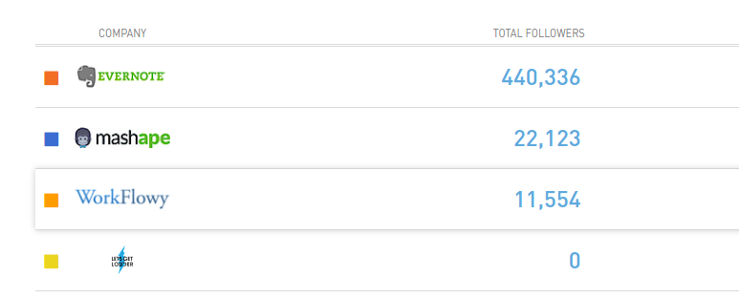

* The current patent status is not clearly mentioned.

**System Requirements**

* A User friendly Interface.0
  + Simple to understand and access at the same time.
  + Hierarchical and zoomable listings.
  + Additional features like edit,delete,note,nested lists.
* Data structures to store the complex and huge data given by various users.
* Optimisation of the storage of data and re-usage of the same to prevent corruption of the data even in the worst case.
* A Database to store the organised data in the servers.
* Making sure the database and application run along well with each other.

* Client Requirements are :
  + Browser like Google Chrome. Avoid internet explorer because of non-compatibility with further technical requirements.
  + Linux or Windows Operating System.
  + Atleast 512MB RAM.
  + At least 100MB of Secondary Memory.
* Server Requirements :
  + Linux or Windows
  + Tangible amount of RAM
  + Estimated Memory depending on usage.
* Security and Privacy :
  + Without a secure database anyone can easily manipulate data of others.
  + Two factor authentication can be made available to customers.
  + Using **https** instead of **http** will make a more secure database.
  + Having a SSL certificate will ensure data integrity,authentication and encryption.
* User Interface Requirements:

A good browser like google chrome will ensure the following features.

* + Infinitely nested lists
  + Tag and filter list items
  + Add notes to any of the lists
  + Zoomable nested lists.
* Other Requirements include html,css,javascript ..
* MySQL,PHP(store the data in servers and retrieve the data when a user logs in).
* Backend requirements Backbone Nodejs , React DOM, Socket I/O,Express.

Use Case Diagram..

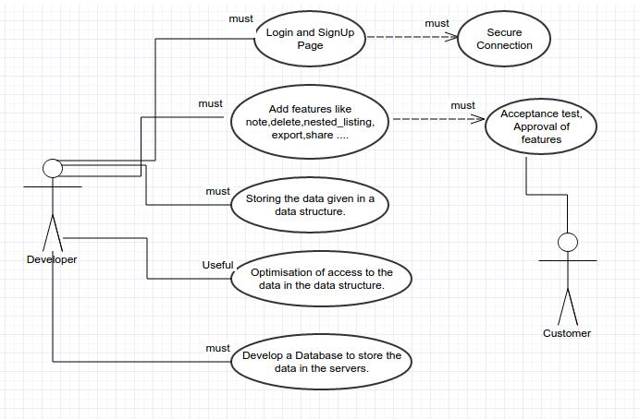

**Checklist**

* Have all the viewpoints of all the stakeholders been taken into account?

**- Yes**

* Do the requirements completely specify what the function of the program should be?

**- Yes**

* Are all non-functional requirements (e.g. speed, memory, capacity) specified?

**- Yes**

* If there are requirements imposed by the environment in which the program will be used? Are those requirements specified?

**- Yes**

* Do the requirements avoid specifying a solution or a design?

**- Yes**

* Are separate requirements listed separately and not lumped together?

**- Yes**

* Are the requirements clear and precise, not ambiguous?

**- Yes**

* Are the requirements consistent, no contradictions?

**- Yes**

* Are the requirements accompanied by a rationale or justification?

**- Yes**

* Are the requirements given in a consistent format?

**- Yes**

* Are the requirements properly prioritized?

**- Yes**

* How is the notation in the document? Are graphical and mathematical notation used appropriately? Is the technical jargon kept to a minimum?

**- Not much of ISO terminology is used,it’s kept simple so that everyone**

**can understand.**

* Does the requirements document make good use of scenarios and use cases?

**- Yes**

* Are the requirements realistic?

**- Yes**

* Are the requirements verifiable?

**- Yes**