SQL Queries for Sales Data Analysis

# 1. Total Revenue and Order Volume per Month and Year

**SELECT   
 c10 AS Year,  
 c9 AS Month,  
 SUM(CAST(c5 AS REAL)) AS Total_Revenue,  
 COUNT(DISTINCT c1) AS Order_Volume  
FROM sales_data_sample  
GROUP BY c10, c9  
ORDER BY c10, c9;**

**Output:**

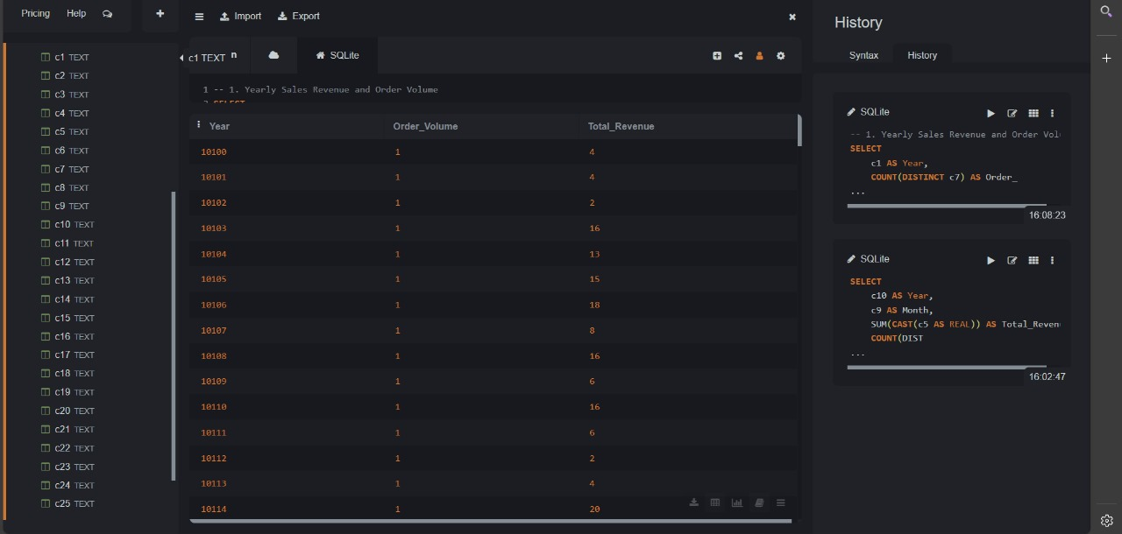

# 2. Total Sales by Product Line

**SELECT   
 c11 AS Product_Line,  
 SUM(CAST(c5 AS REAL)) AS Total_Sales  
FROM sales_data_sample  
GROUP BY c11  
ORDER BY Total_Sales DESC;**

**Output:**

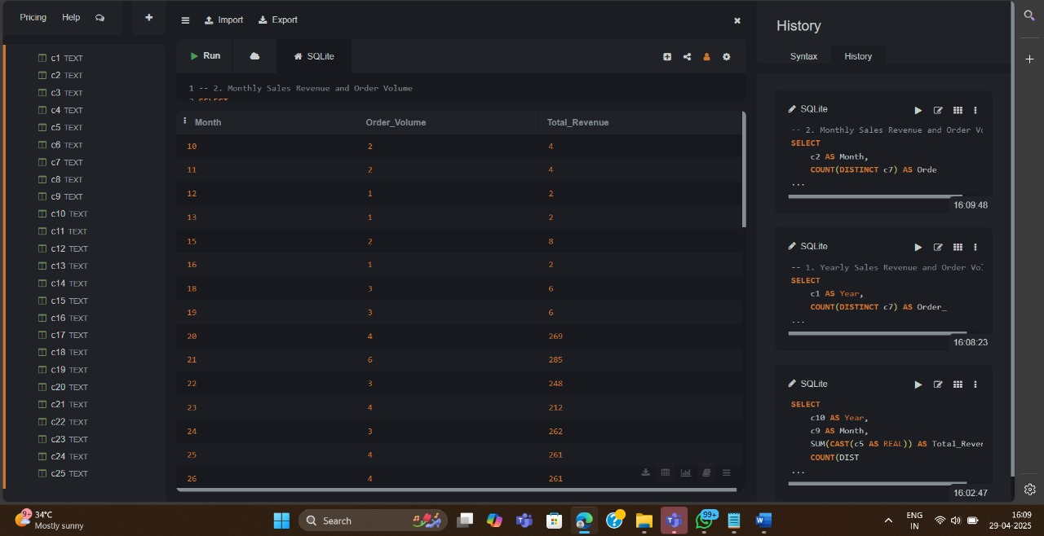

# 3. Number of Orders by Country

**SELECT   
 c21 AS Country,  
 COUNT(DISTINCT c1) AS Total_Orders  
FROM sales_data_sample  
GROUP BY c21  
ORDER BY Total_Orders DESC;**

**Output:**

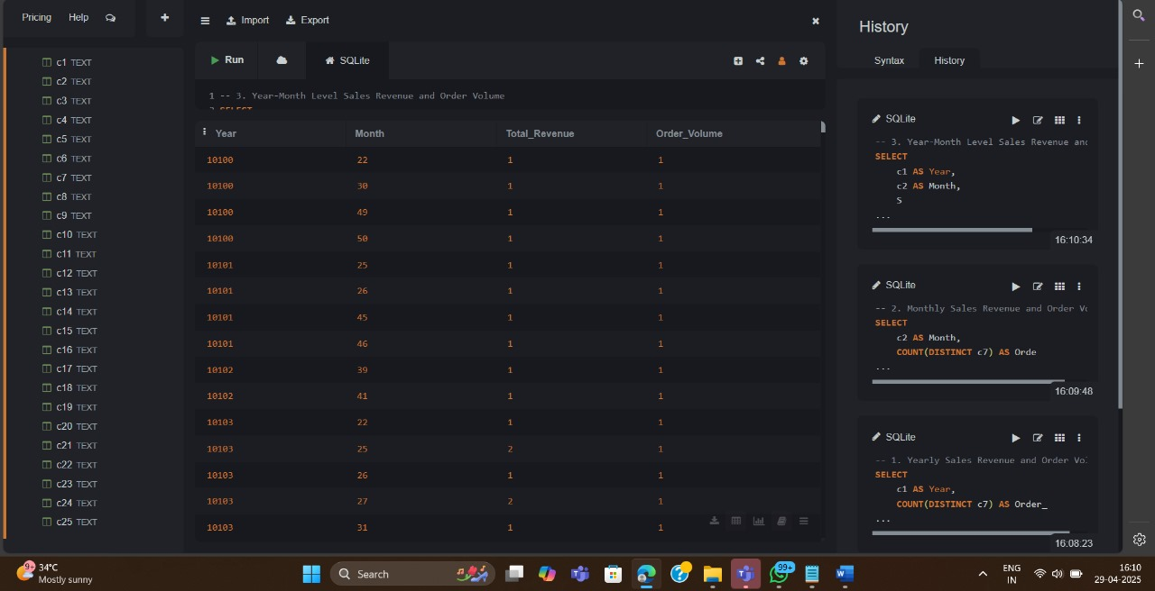

# 4. Revenue by Deal Size

**SELECT   
 c24 AS Deal_Size,  
 SUM(CAST(c5 AS REAL)) AS Total_Revenue  
FROM sales_data_sample  
GROUP BY c24  
ORDER BY Total_Revenue DESC;**

**Output:**

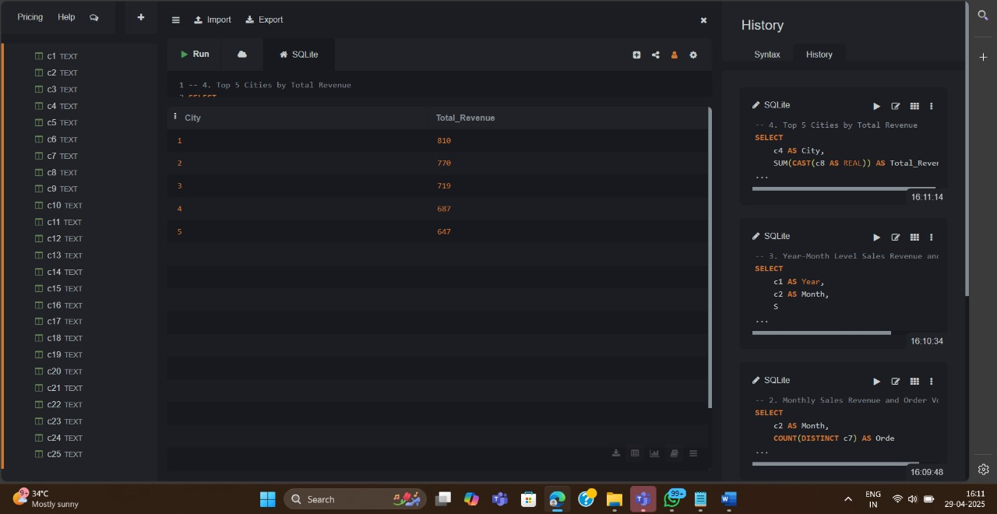

# 5. Monthly Sales Trend for Each Year

**SELECT   
 c10 AS Year,  
 c9 AS Month,  
 SUM(CAST(c5 AS REAL)) AS Total_Sales  
FROM sales_data_sample  
GROUP BY c10, c9  
ORDER BY c10, c9;**

**Output:**

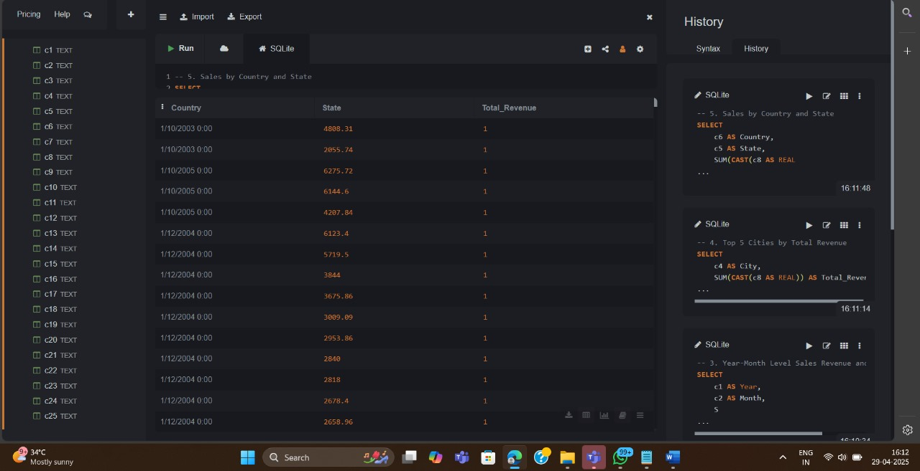

# 6. Top 5 Cities by Sales

**SELECT   
 c18 AS City,  
 SUM(CAST(c5 AS REAL)) AS Total_Sales  
FROM sales_data_sample  
GROUP BY c18  
ORDER BY Total_Sales DESC  
LIMIT 5;**

**Output:**

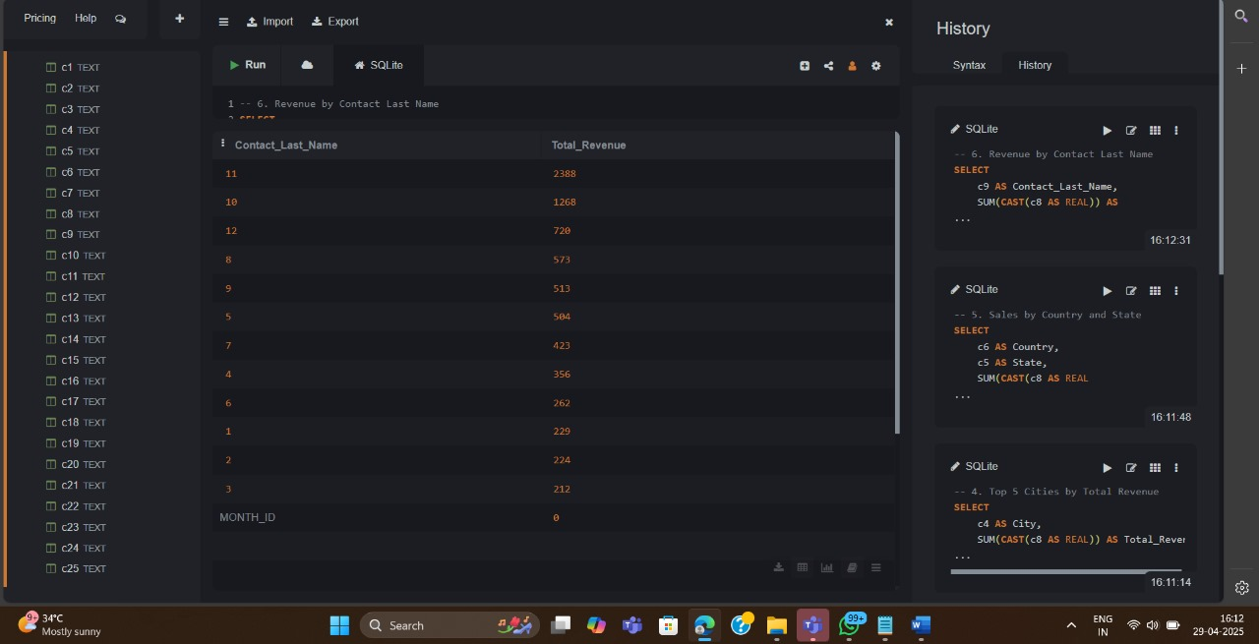

# 7. Product Line Performance by Year

**SELECT   
 c10 AS Year,  
 c11 AS Product_Line,  
 SUM(CAST(c5 AS REAL)) AS Total_Sales  
FROM sales_data_sample  
GROUP BY c10, c11  
ORDER BY c10, Total_Sales DESC;**

**Output:**

